# Osquery内置表：services

## 524、Xbox Live Networking Service (XboxNetApiSvc)

### 要求

**Disable the Service 'Xbox Live Networking Service (XboxNetApiSvc)'**

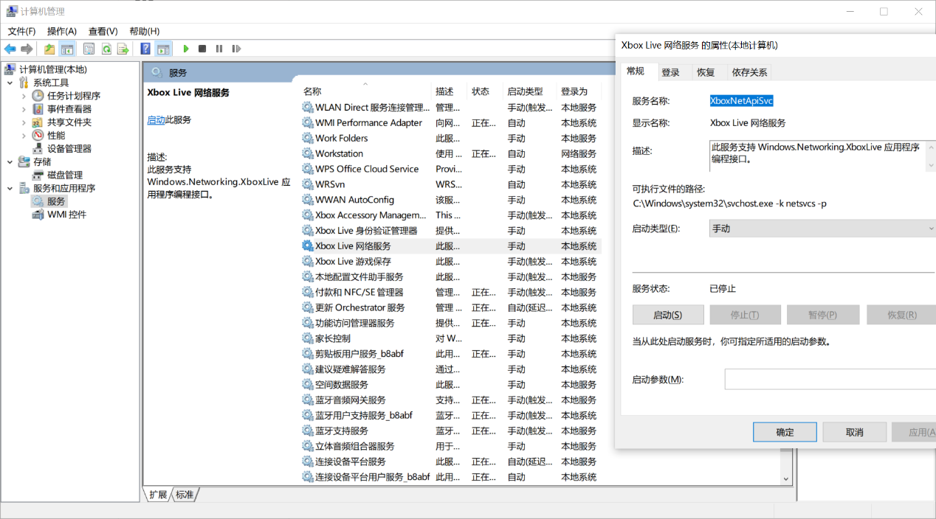

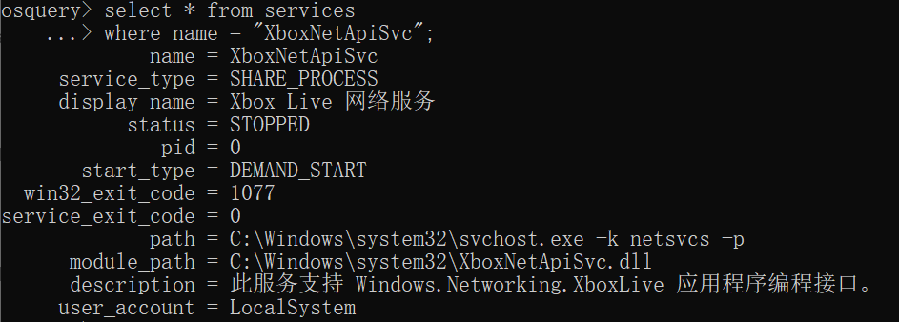

关闭服务：status = STOPPED

开启服务：status = RUNNING

### 检查语句

select status from services

where name = "XboxNetApiSvc";

### 检查结果

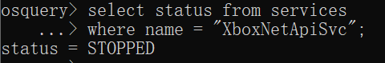

status = STOPPED，则该检查项通过。

### GO

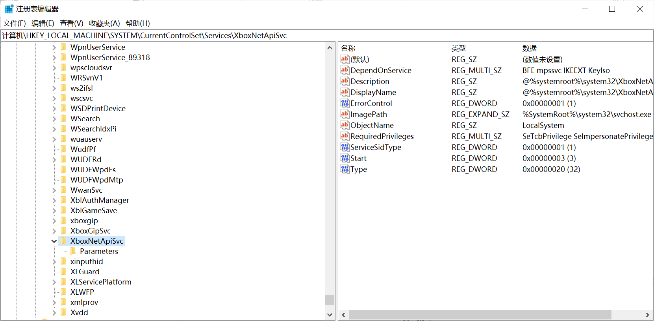

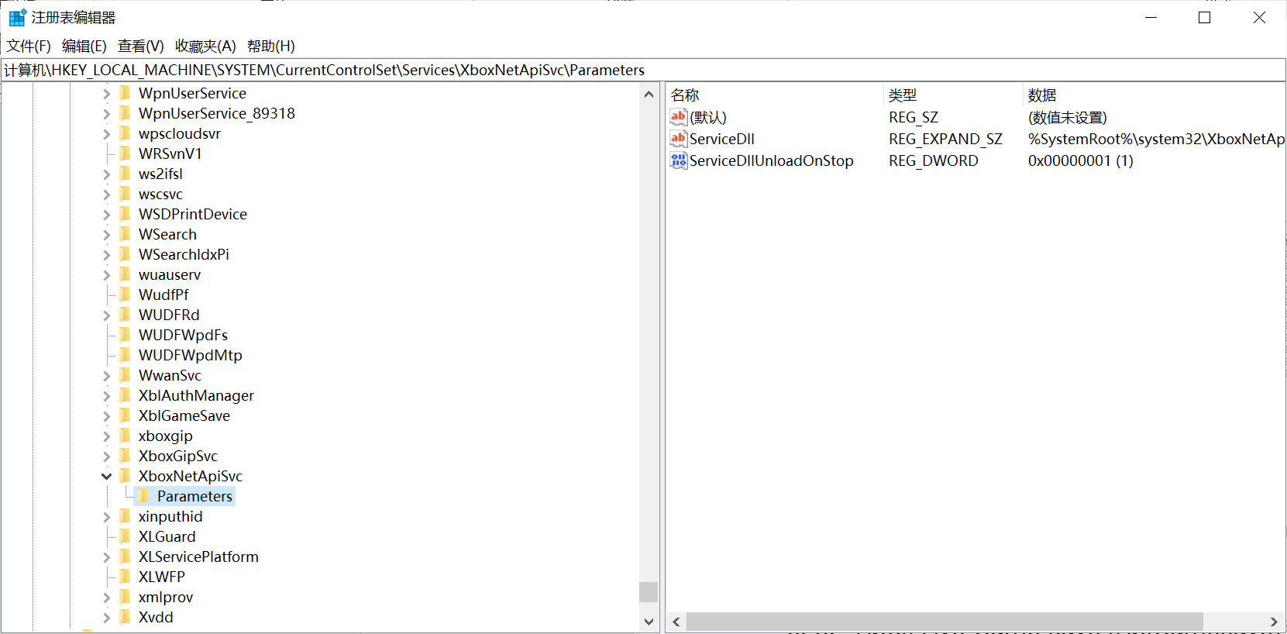

## 523、Xbox Live Game Save (XblGameSave)

### 要求

**Disable the Service 'Xbox Live Game Save (XblGameSave)'**

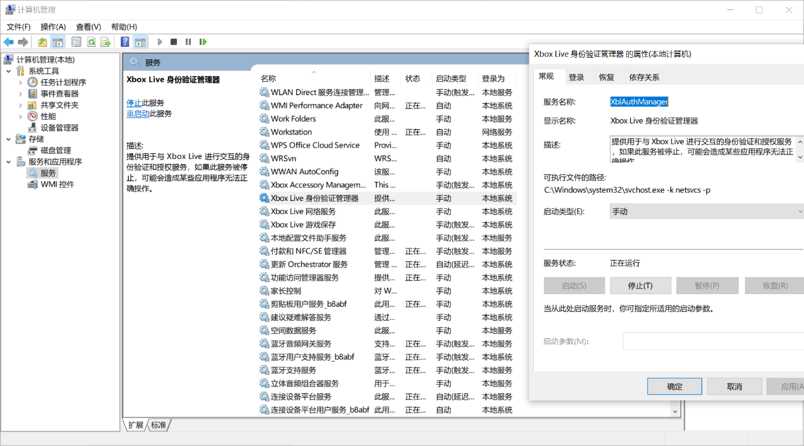

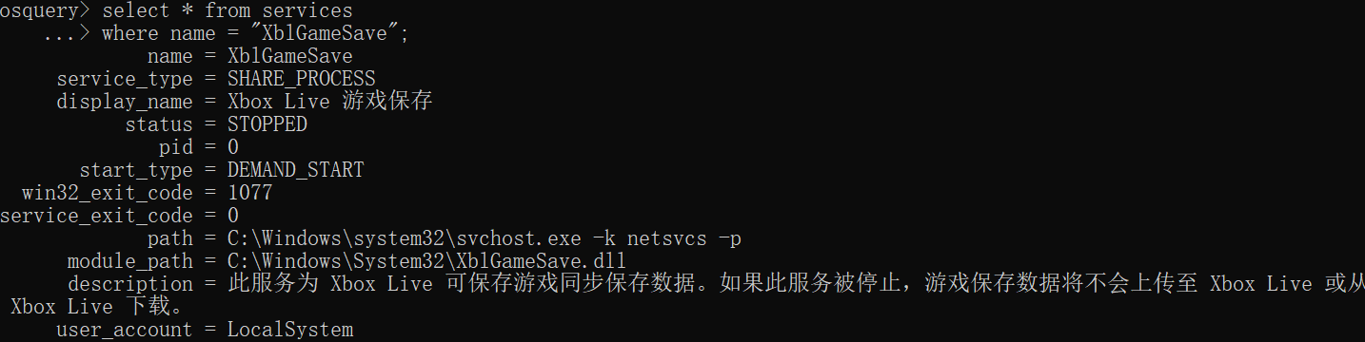

关闭服务：status = STOPPED

开启服务：status = RUNNING

### 检查语句

select status from services

where name = "XblGameSave";

### 检查结果

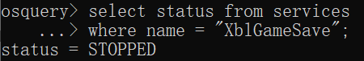

status = STOPPED，则该检查项通过。

## 522、Xbox Live Auth Manager (XblAuthManager）

### 要求

**Disable the service 'Xbox Live Auth Manager (XblAuthManager)'.**



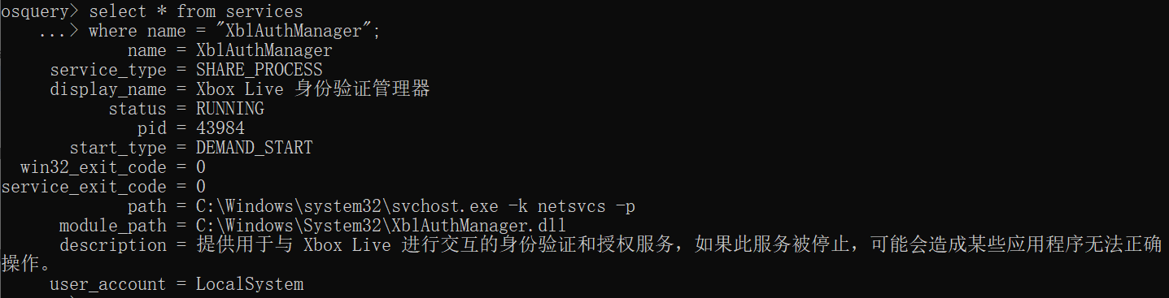

关闭服务：status = STOPPED

开启服务：status = RUNNING

### 检查语句

select status from services

where name = "XblAuthManager";

### 检查结果

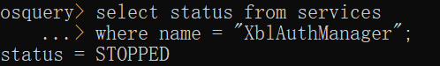

status = STOPPED，则该检查项通过。

## 520、Xbox Accessory Management Service (XboxGipSvc)

### 要求

**Disable the service 'Xbox Accessory Management Service (XboxGipSvc)'.**

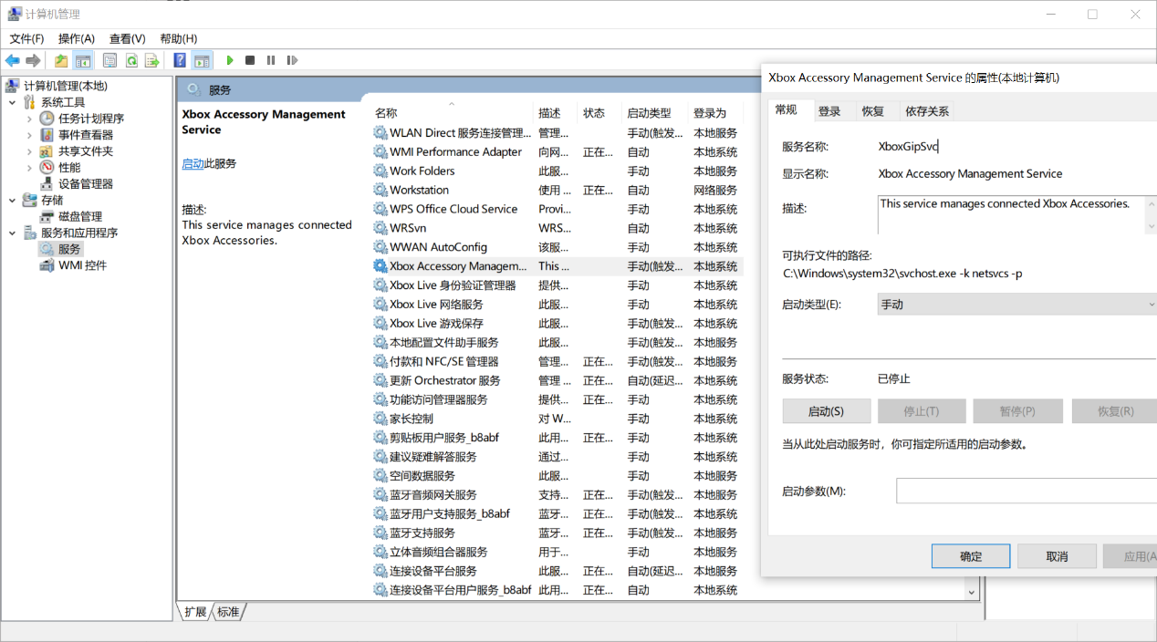

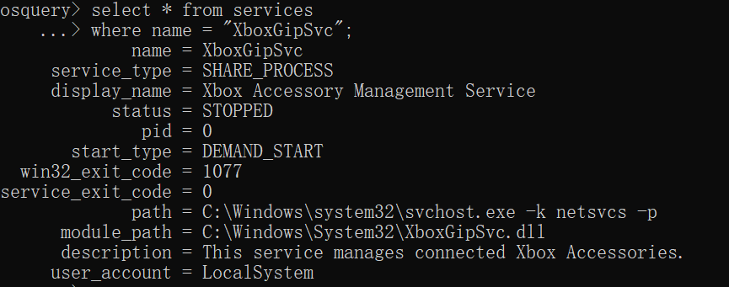

关闭服务：status = STOPPED

开启服务：status = RUNNING

### 检查语句

select status from services

where name = "XboxGipSvc";

### 检查结果

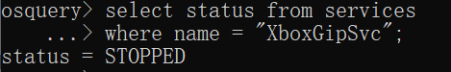

status = STOPPED，则该检查项通过。

## 519、Disable the service 'Remote Access Auto Connection Manager (RasAuto)'.

### 要求

Disable the service 'Remote Access Auto Connection Manager (RasAuto)'.

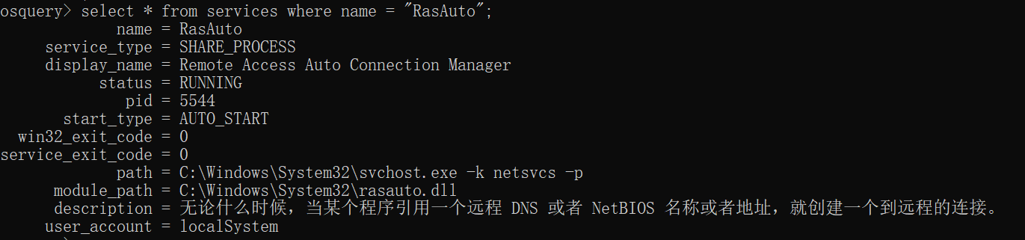

关闭服务：status = STOPPED

开启服务：status = RUNNING

### 检查语句

select status from services

where name = "RasAuto";

### 检查结果

status = STOPPED，则该检查项通过。

## 518、Disable the service 'Microsoft iSCSI Initiator Service (MSiSCSI)'.

### 要求

Disable the service 'Microsoft iSCSI Initiator Service (MSiSCSI)'.

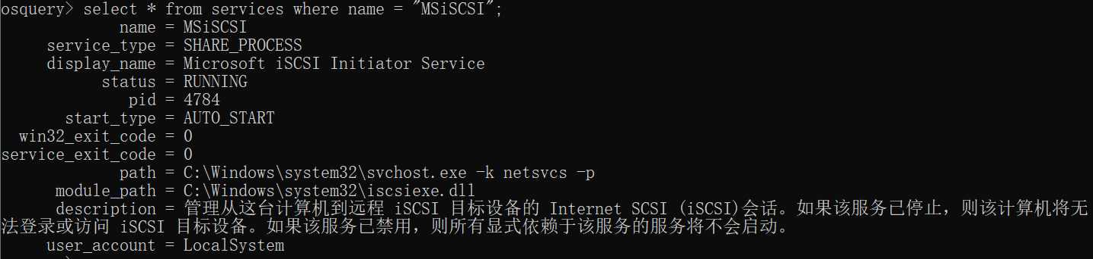

关闭服务：status = STOPPED

开启服务：status = RUNNING

### 检查语句

select status from services

where name = "MSiSCSI";

### 检查结果

status = STOPPED，则该检查项通过。

## 517、Disable the service 'LxssManager (LxssManager)'.

### 要求

Disable the service 'LxssManager (LxssManager)'.

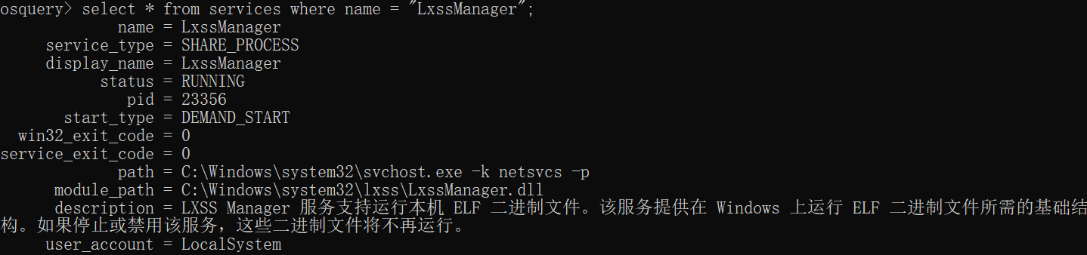

关闭服务：status = STOPPED

开启服务：status = RUNNING

### 检查语句

select status from services

where name = "LxssManager";

### 检查结果

status = STOPPED，则该检查项通过。

## 515、Disable the service 'Geolocation Service (lfsvc)'.

### 要求

Disable the service 'Geolocation Service (lfsvc)'.

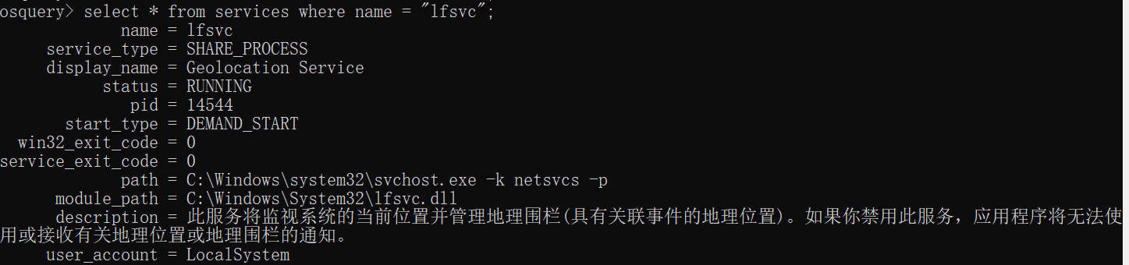

关闭服务：status = STOPPED

开启服务：status = RUNNING

### 检查语句

select status from services

where name = "lfsvc";

### 检查结果

status = STOPPED，则该检查项通过。

## 514、Disable the service 'Downloaded Maps Manager (MapsBroker)'.

### 要求

Disable the service 'Downloaded Maps Manager (MapsBroker)'.

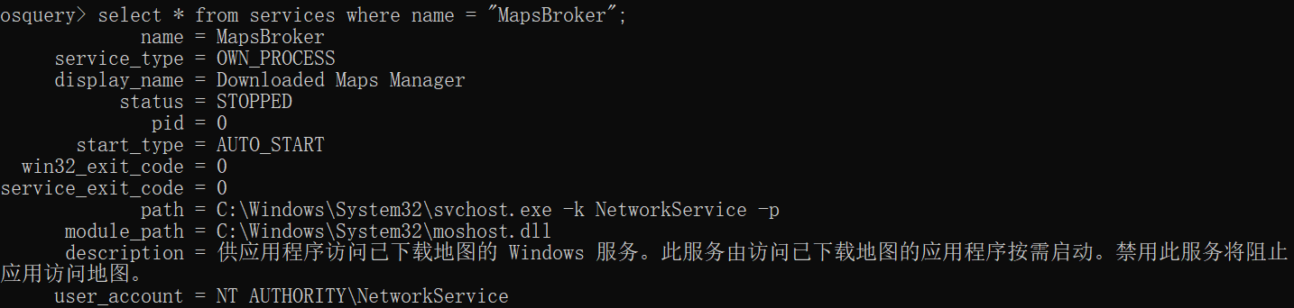

关闭服务：status = STOPPED

开启服务：status = RUNNING

### 检查语句

select status from services

where name = "MapsBroker";

### 检查结果

status = STOPPED，则该检查项通过。

## 513、Disable the service 'Bluetooth Audio Gateway Service (BTAGService)'.

### 要求

Disable the service 'Bluetooth Audio Gateway Service (BTAGService)'.

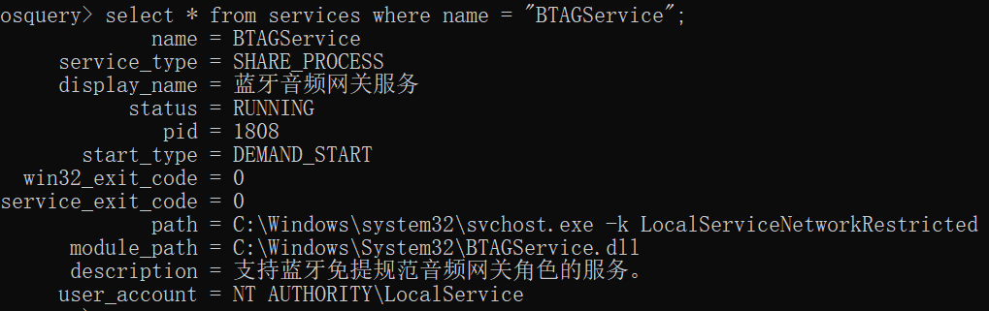

关闭服务：status = STOPPED

开启服务：status = RUNNING

### 检查语句

select status from services

where name = "BTAGService";

### 检查结果

status = STOPPED，则该检查项通过。

## 512、Disable the service 'Bluetooth Support Service (bthserv)'.

### 要求

Disable the service 'Bluetooth Support Service (bthserv)'.

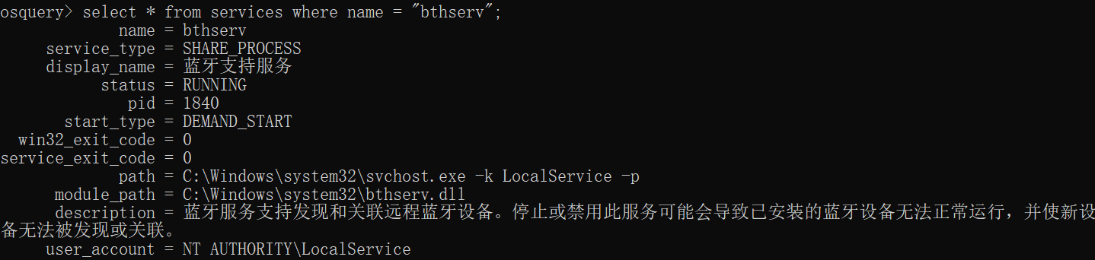

关闭服务：status = STOPPED

开启服务：status = RUNNING

### 检查语句

select status from services

where name = "bthserv";

### 检查结果

status = STOPPED，则该检查项通过。

# 组策略

## 问题（GUID随机）

HKCU\Software\Microsoft\Windows\CurrentVersion\Group Policy Objects下面有一串随机的数字，怎么定位？

一个GPO由两部分组成的：组策略容器（GPC）和组策略模板（GPT)，

GPC与GPT之间由GPO的GUID保持关联，由GPC的gPCFileSysPath记载对应组策略模板具体位置，指示客户机下载组策略模板文件。

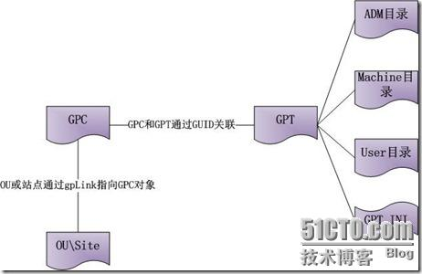

## 计算机配置（管理模板）

### 开始菜单和任务栏

#### 501、Enable the policy *Turn off notifications network usage*.

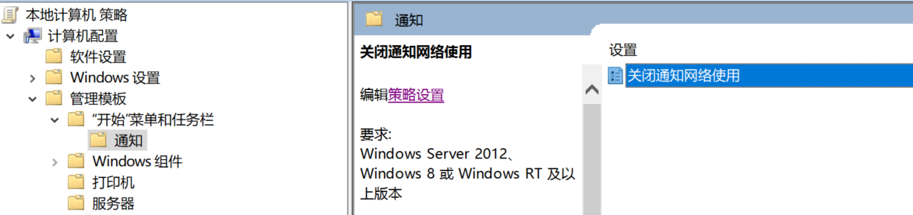

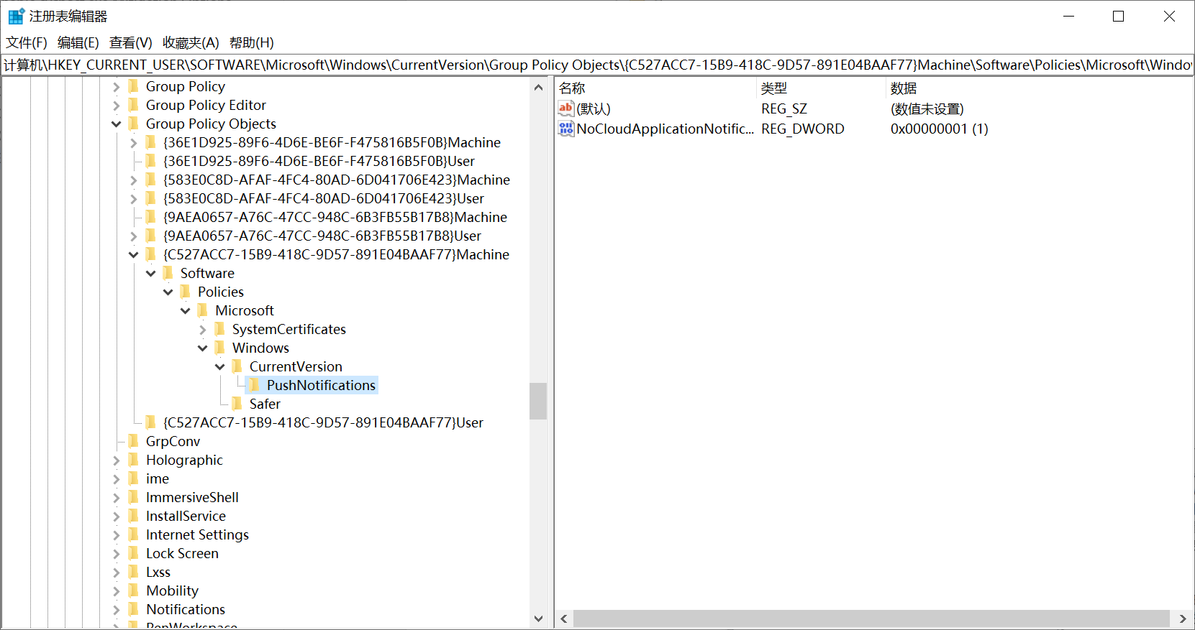

##### 检查语句

select data from registry

where key like

"HKEY_CURRENT_USER\SOFTWARE\Microsoft\Windows\CurrentVersion\Group Policy Objects\%Machine%\Software\Policies\Microsoft\Windows\CurrentVersion\PushNotifications" and name = "NoCloudApplicationNotification";

##### 检查结果

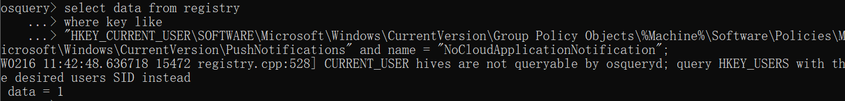

data = 1，则该检查项通过。

### Windows组件

#### 511、Disable Cloud Search（示例）

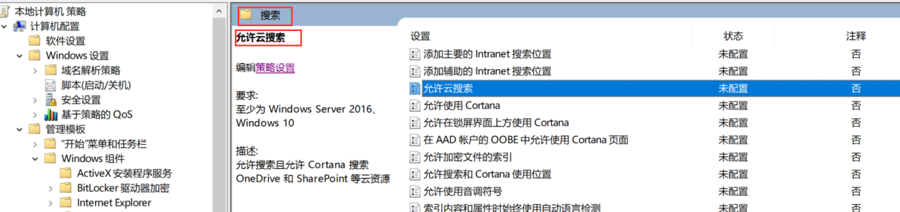

**组策略对象：**

select * from registry

where key = "HKEY_CURRENT_USER\SOFTWARE\Microsoft\Windows\CurrentVersion\Group Policy Objects";

**具体的组策略：**

select * from registry

where key =

"HKEY_CURRENT_USER\SOFTWARE\Microsoft\Windows\CurrentVersion\Group Policy Objects\{8BC0A175-1361-4771-9D37-EF31B1B5951D}Machine\Software\Policies\Microsoft\Windows\Windows Search";

**模糊搜索：**

select data from registry

where key like

"HKEY_CURRENT_USER\SOFTWARE\Microsoft\Windows\CurrentVersion\Group Policy Objects\%Machine%\Software\Policies\Microsoft\Windows\Windows Search" and name = "AllowCloudSearch";

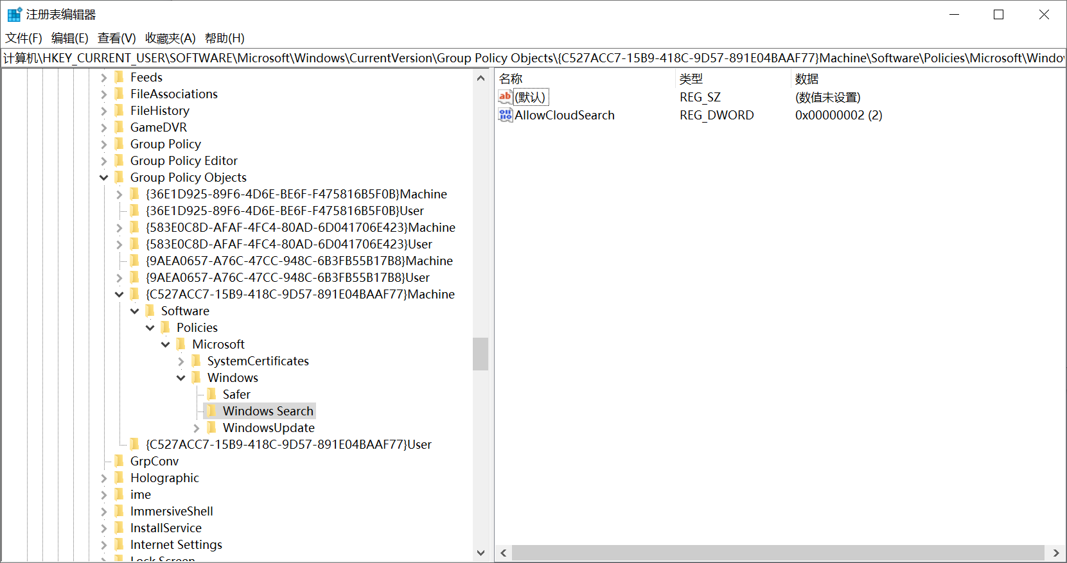

##### 检查语句

select data from registry

where key like

"HKEY_CURRENT_USER\SOFTWARE\Microsoft\Windows\CurrentVersion\Group Policy Objects\%Machine%\Software\Policies\Microsoft\Windows\Windows Search" and name = "AllowCloudSearch";

##### 检查结果

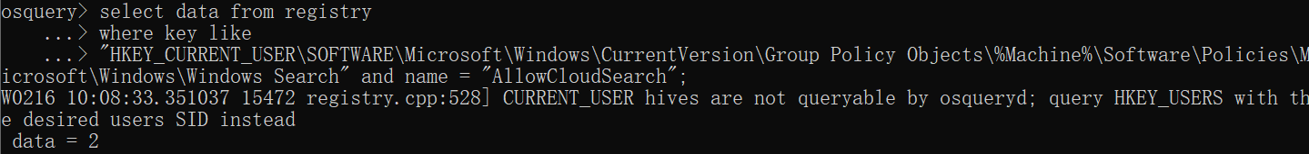

data = 2，则该检查项通过。

#### 509、Disable the _Windows Tips_ notifications.

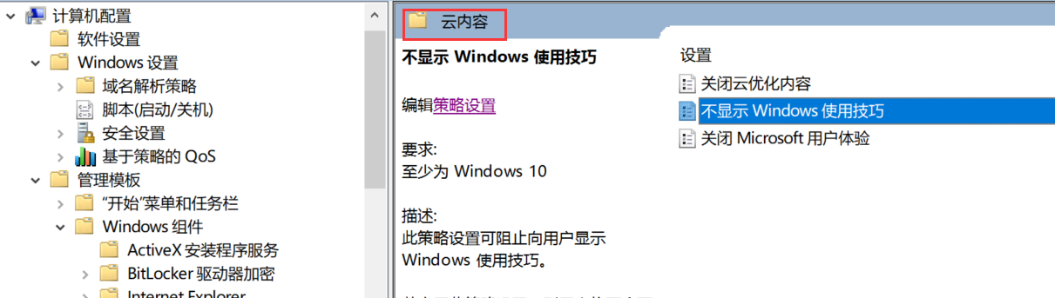

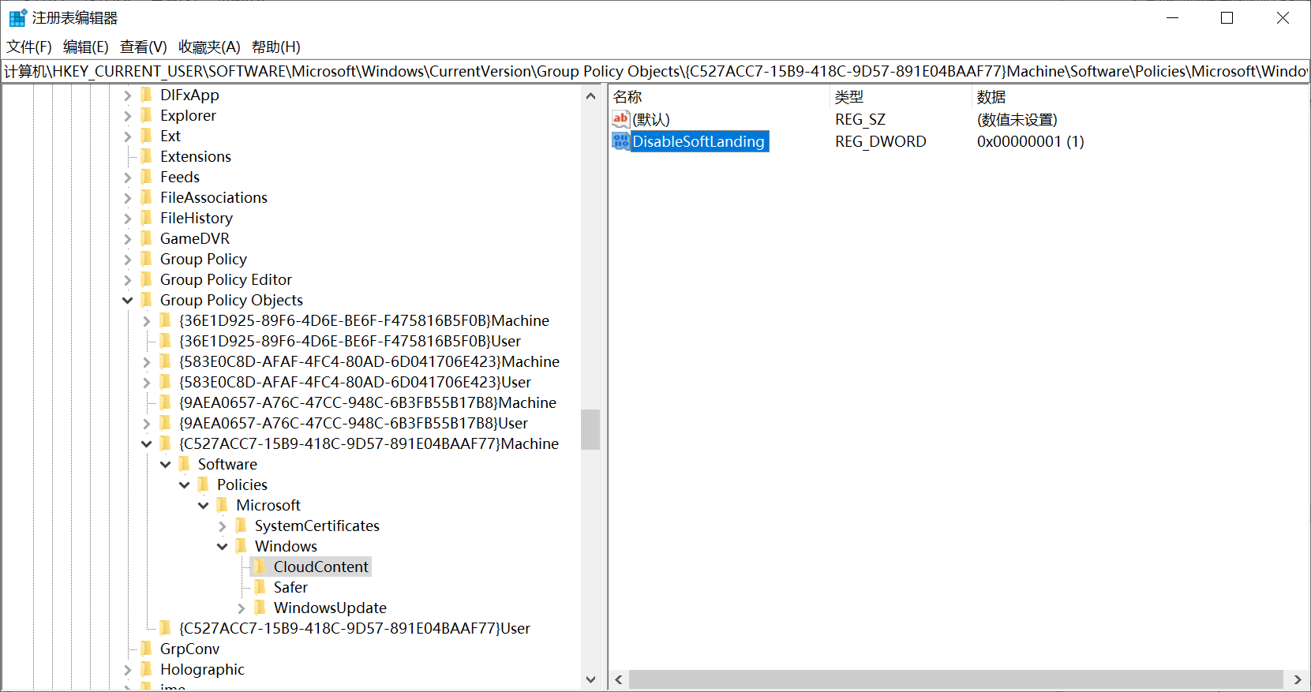

##### 检查语句

select data from registry

where key like

"HKEY_CURRENT_USER\SOFTWARE\Microsoft\Windows\CurrentVersion\Group Policy Objects\%Machine%\Software\Policies\Microsoft\Windows\CloudContent" and name = "DisableSoftLanding";

##### 检查结果

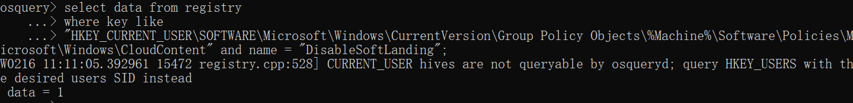

data = 1，则该检查项通过。

#### 499、Do Not Allow This PC to Be Projected to

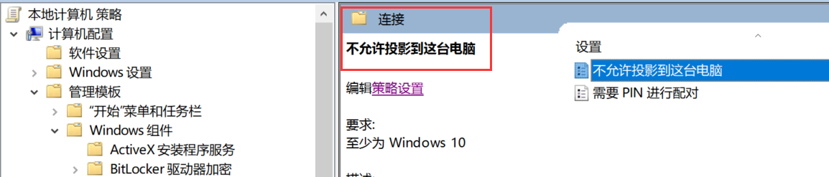

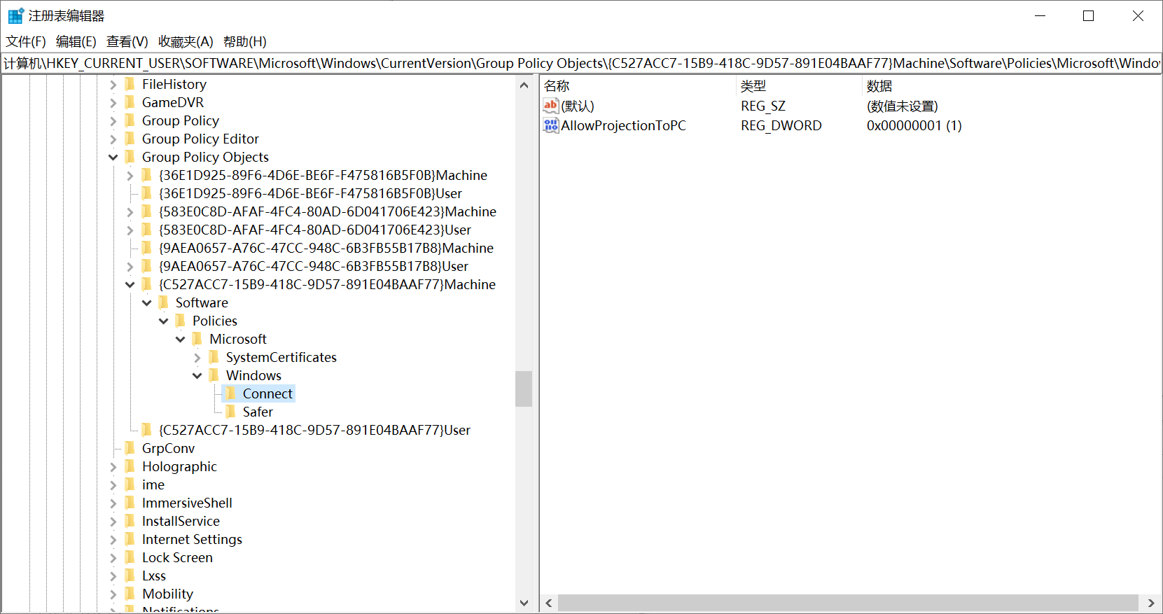

##### 检查语句

select data from registry

where key like

"HKEY_CURRENT_USER\SOFTWARE\Microsoft\Windows\CurrentVersion\Group Policy Objects\%Machine%\Software\Policies\Microsoft\Windows\Connect" and name = "AllowProjectionToPC";

##### 检查结果

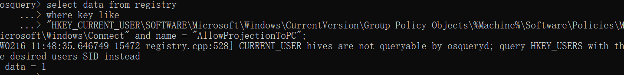

data = 1？

#### 495、Disable the policy _Allow companion device for secondary authentication_.

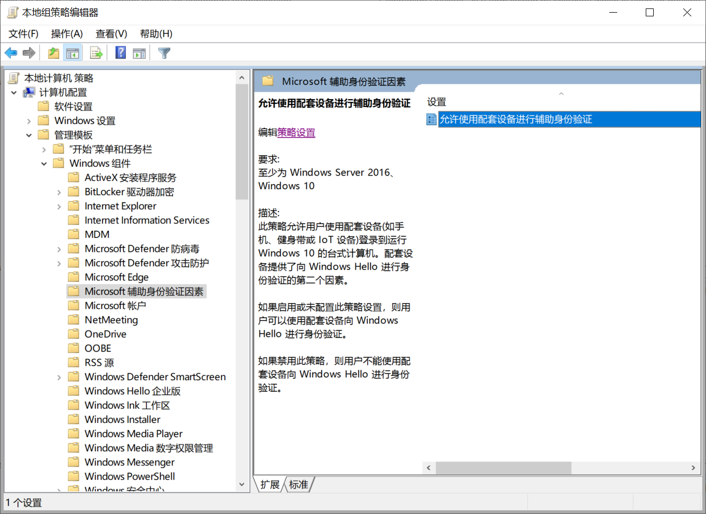

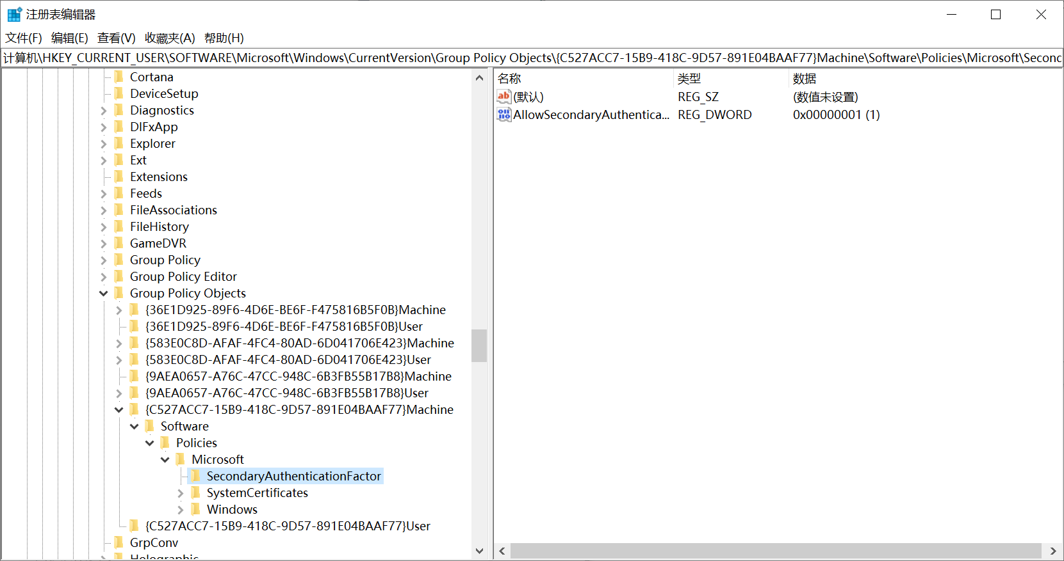

##### 检查语句

select data from registry

where key like

"HKEY_CURRENT_USER\SOFTWARE\Microsoft\Windows\CurrentVersion\Group Policy Objects\%Machine%\Software\Policies\Microsoft\SecondaryAuthenticationFactor" and name = "AllowSecondaryAuthenticationDevice";

##### 检查结果



data = 1，则该检查项通过。

#### 489-487

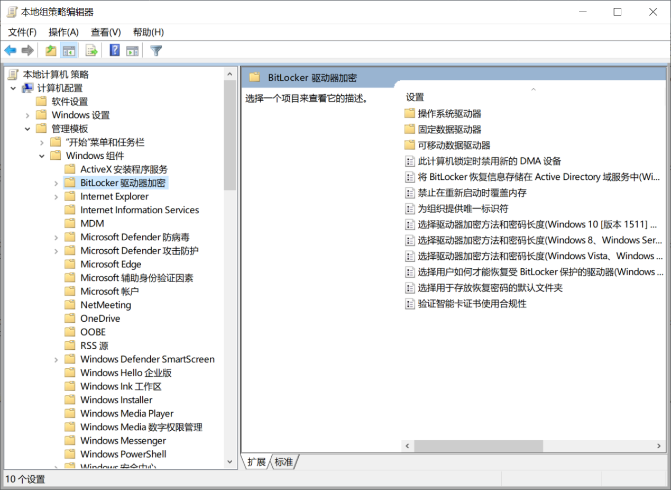

**489、Disable Hardware-based Encryption for BitLocker removable data drives**

**检查语句**

select data from registry

where key like

"HKEY_CURRENT_USER\SOFTWARE\Microsoft\Windows\CurrentVersion\Group Policy Objects\%Machine%\Software\Policies\Microsoft\FVE" and name = "RDVHardwareEncryption";

**检查结果**

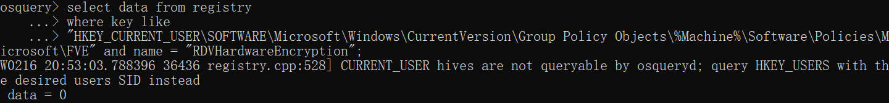

data = 0，则该检查项通过。

**488、Disable Hardware-based Encryption for BitLocker operating system drives**

select data from registry

where key like

"HKEY_CURRENT_USER\SOFTWARE\Microsoft\Windows\CurrentVersion\Group Policy Objects\%Machine%\Software\Policies\Microsoft\FVE" and name = "OSHardwareEncryption";

**检查结果**

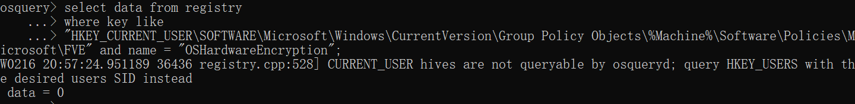

data = 0，则该检查项通过。

**487、Disable Hardware-based Encryption for BitLocker fixed data drives**

select data from registry

where key like

"HKEY_CURRENT_USER\SOFTWARE\Microsoft\Windows\CurrentVersion\Group Policy Objects\%Machine%\Software\Policies\Microsoft\FVE" and name = "FDVHardwareEncryption";

**检查结果**

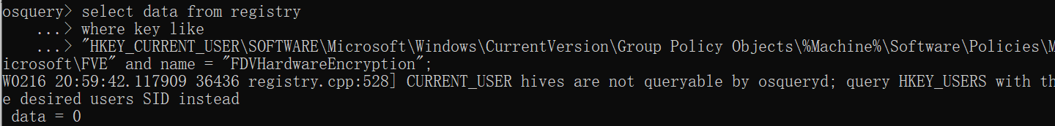

data = 0，则该检查项通过。

#### 469、Ensure 'Prevent the usage of OneDrive for file storage' is set to 'Enabled'

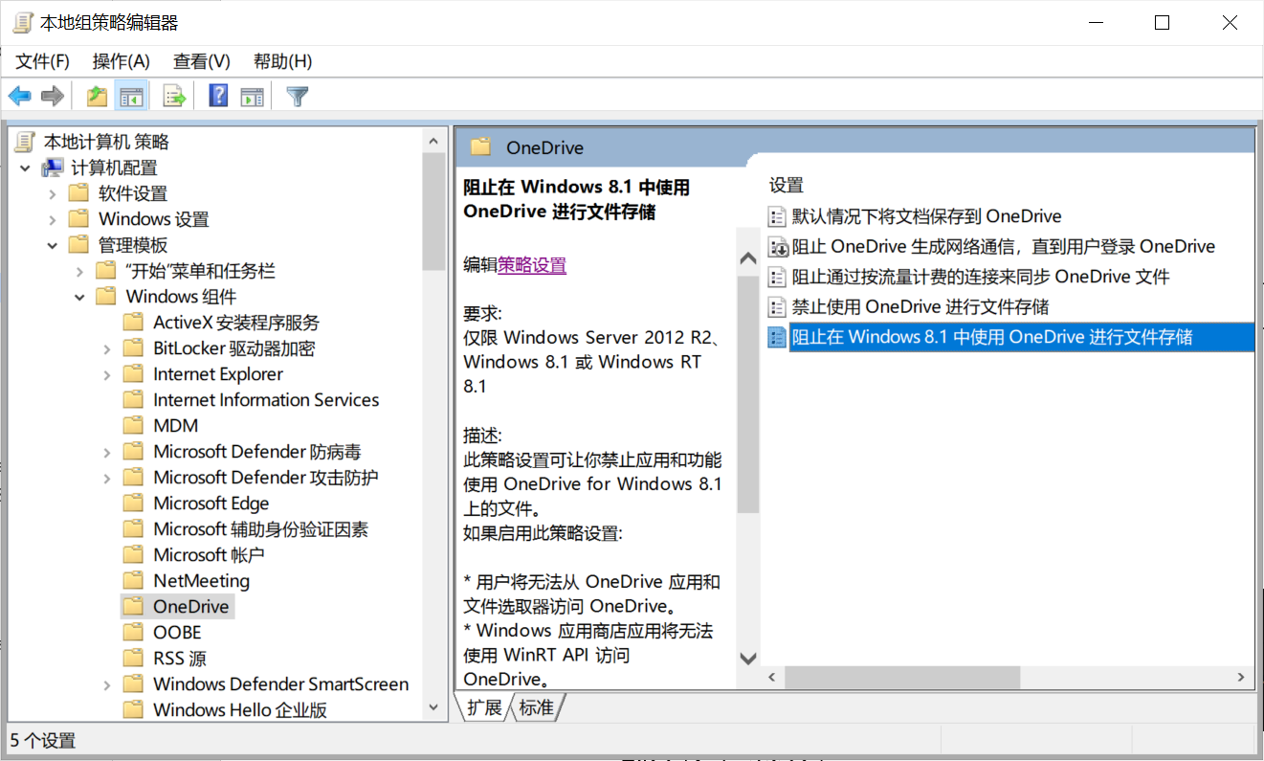

##### 检查语句

select data from registry

where key like

"HKEY_CURRENT_USER\SOFTWARE\Microsoft\Windows\CurrentVersion\Group Policy Objects\%Machine%\Software\Policies\Microsoft\Windows\OneDrive" and name = "DisableFileSync";

##### 检查结果

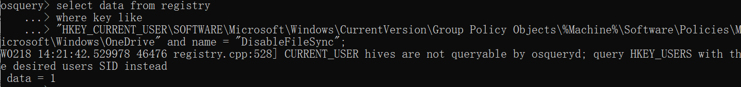

data = 1，则该检查项通过。

#### 468、Disable Windows Hello for Business

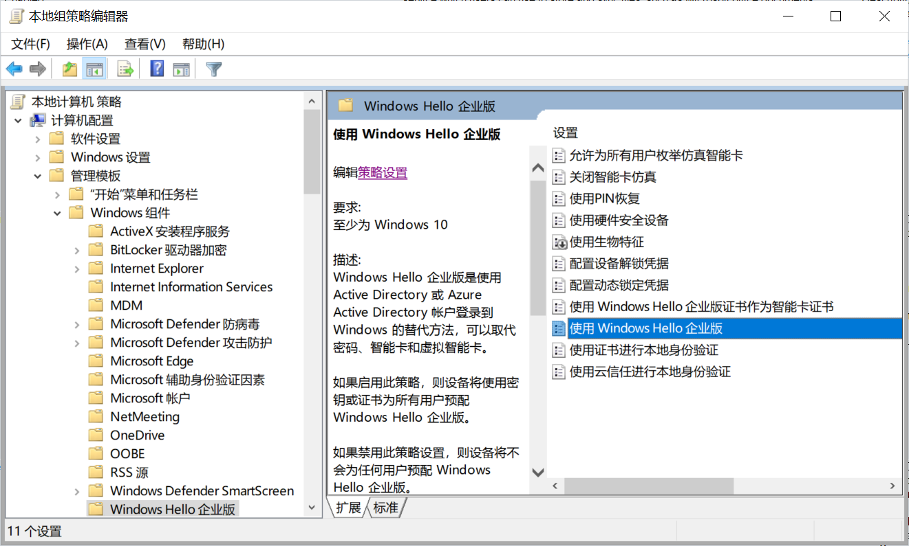

##### 检查语句

select data from registry

where key like

"HKEY_CURRENT_USER\SOFTWARE\Microsoft\Windows\CurrentVersion\Group Policy Objects\%Machine%\Software\Policies\Microsoft\PassportForWork" and name = "Enabled";

##### 检查结果

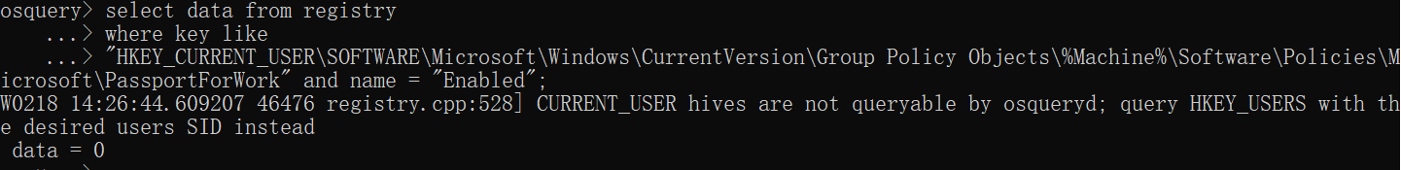

data = 0，则该检查项通过。

#### 464-441（除446、444）、434-424

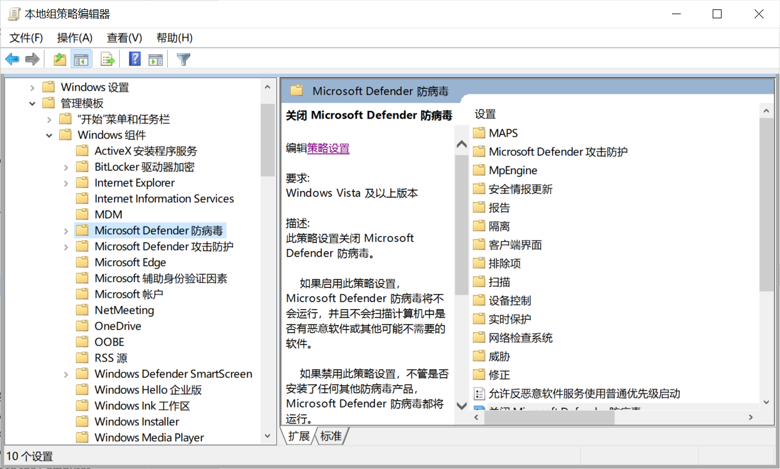

**464、Ensure 'Configure the 'Block at First Sight' feature' is set to 'Enabled'**

**检查语句**

select data from registry

where key like

"HKEY_CURRENT_USER\SOFTWARE\Microsoft\Windows\CurrentVersion\Group Policy Objects\%Machine%\Software\Policies\Microsoft\Windows Defender\Spynet" and name = "DisableBlockAtFirstSeen";

**检查结果**

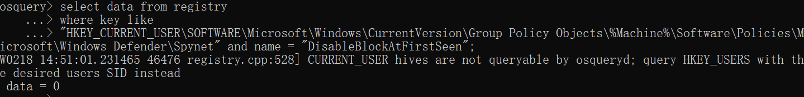

data = 0，则该检查项通过。

**463、Ensure 'Specify the day of the week to run a scheduled full scan to complete remediation' is set to 'Enabled: Every Day'**

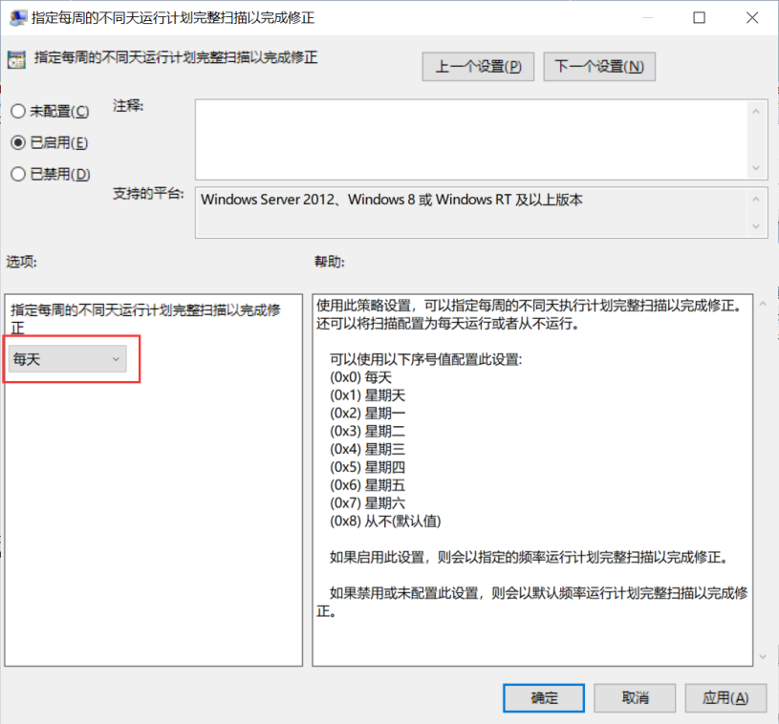

**检查语句**

select data from registry

where key like

"HKEY_CURRENT_USER\SOFTWARE\Microsoft\Windows\CurrentVersion\Group Policy Objects\%Machine%\Software\Policies\Microsoft\Windows Defender\Remediation" and name = "Scan_ScheduleDay";

**检查结果**

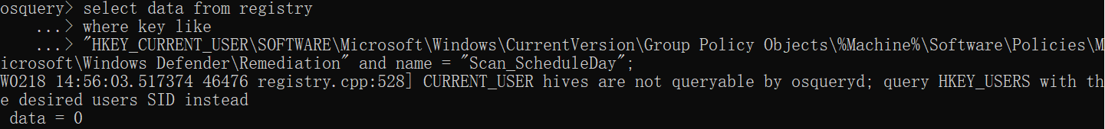

data = 0，则该检查项通过。

**462、Ensure 'Configure local setting override for monitoring file and program activity on your computer' is set to 'Disabled'**

**检查语句**

select data from registry

where key like

"HKEY_CURRENT_USER\SOFTWARE\Microsoft\Windows\CurrentVersion\Group Policy Objects\%Machine%\Software\Policies\Microsoft\Windows Defender\Real-Time Protection" and name = "LocalSettingOverrideDisableOnAccessProtection";

**检查结果**

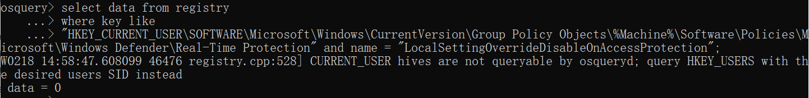

data = 0，则该检查项通过。

**461、Ensure 'Configure local setting override for monitoring for incoming and outgoing file activity' is set to 'Disabled'**

**检查语句**

select data from registry

where key like

"HKEY_CURRENT_USER\SOFTWARE\Microsoft\Windows\CurrentVersion\Group Policy Objects\%Machine%\Software\Policies\Microsoft\Windows Defender\Real-Time Protection" and name = "LocalSettingOverrideRealtimeScanDirection";

**检查结果**

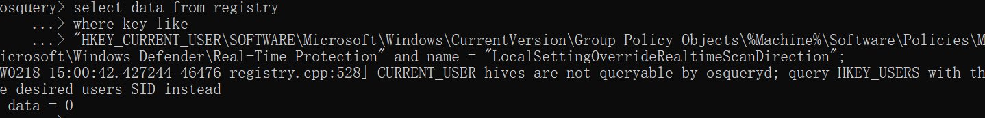

data = 0，则该检查项通过。

**460、Ensure 'Configure local setting override for turn on behavior monitoring' is set to 'Disabled'**

**检查语句**

select data from registry

where key like

"HKEY_CURRENT_USER\SOFTWARE\Microsoft\Windows\CurrentVersion\Group Policy Objects\%Machine%\Software\Policies\Microsoft\Windows Defender\Real-Time Protection" and name = "LocalSettingOverrideDisableBehaviorMonitoring";

**检查结果**

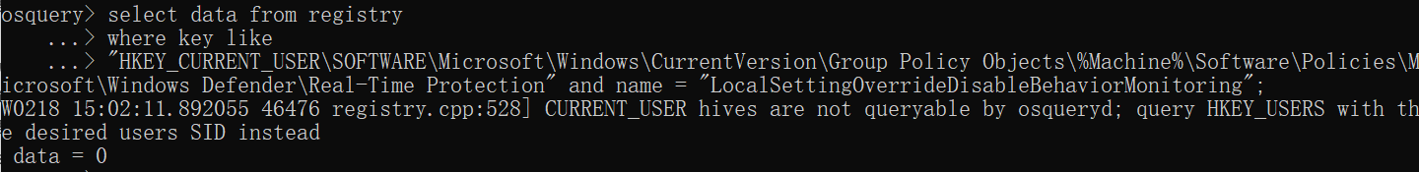

data = 0，则该检查项通过。

**459、Ensure 'Configure local setting override to turn on real-time protection' is set to 'Disabled'**

**检查语句**

select data from registry

where key like

"HKEY_CURRENT_USER\SOFTWARE\Microsoft\Windows\CurrentVersion\Group Policy Objects\%Machine%\Software\Policies\Microsoft\Windows Defender\Real-Time Protection" and name = "LocalSettingOverrideDisableRealtimeMonitoring";

**检查结果**

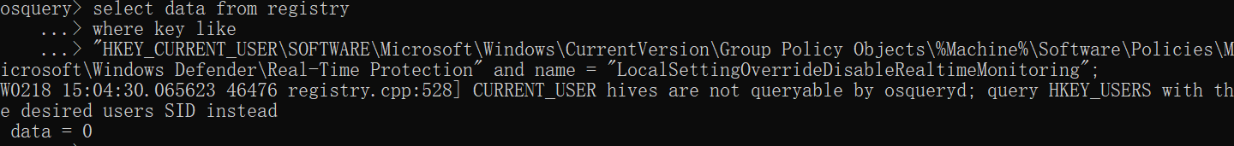

data = 0，则该检查项通过。

**458、Ensure 'Configure monitoring for incoming and outgoing file and program activity' is set to 'Enabled: bi-directional (full on-access)'**

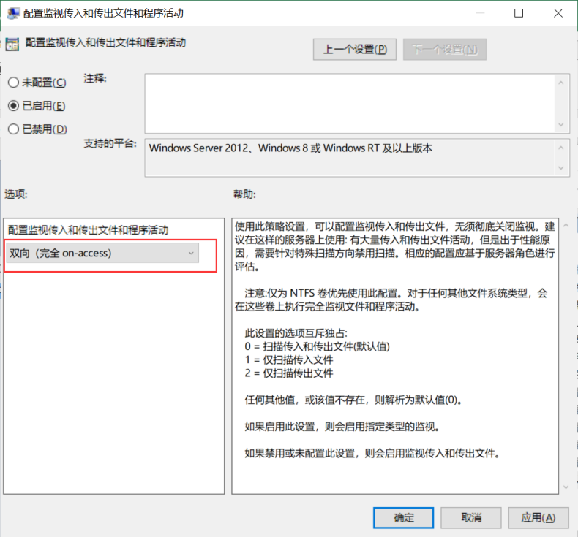

**检查语句**

select data from registry

where key like

"HKEY_CURRENT_USER\SOFTWARE\Microsoft\Windows\CurrentVersion\Group Policy Objects\%Machine%\Software\Policies\Microsoft\Windows Defender\Real-Time Protection" and name = "RealtimeScanDirection";

**检查结果**

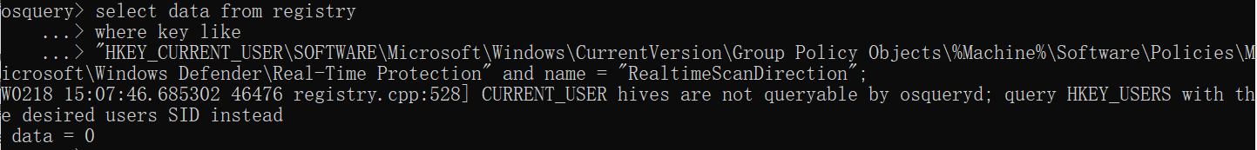

data = 0，则该检查项通过。

**457、Ensure 'Monitor file and program activity on your computer' is set to 'Enabled'**

**检查语句**

select data from registry

where key like

"HKEY_CURRENT_USER\SOFTWARE\Microsoft\Windows\CurrentVersion\Group Policy Objects\%Machine%\Software\Policies\Microsoft\Windows Defender\Real-Time Protection" and name = "DisableOnAccessProtection";

**检查结果**

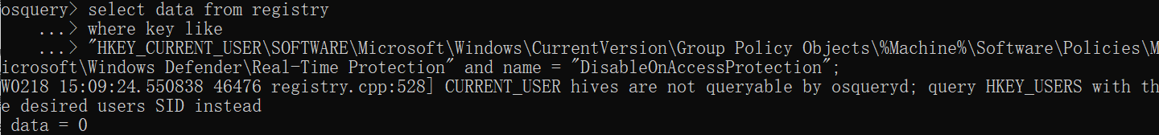

data = 0，则该检查项通过。

**456、Ensure 'Turn on raw volume write notifications' is set to 'Enabled'**

**检查语句**

select data from registry

where key like

"HKEY_CURRENT_USER\SOFTWARE\Microsoft\Windows\CurrentVersion\Group Policy Objects\%Machine%\Software\Policies\Microsoft\Windows Defender\Real-Time Protection" and name = "DisableRawWriteNotification";

**检查结果**

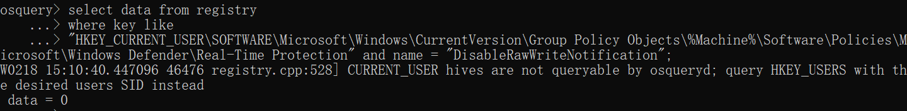

data = 0，则该检查项通过。

**455、Ensure 'Turn on process scanning whenever real-time protection is enabled' is set to 'Enabled'**

**检查语句**

select data from registry

where key like

"HKEY_CURRENT_USER\SOFTWARE\Microsoft\Windows\CurrentVersion\Group Policy Objects\%Machine%\Software\Policies\Microsoft\Windows Defender\Real-Time Protection" and name = "DisableScanOnRealtimeEnable";

**检查结果**

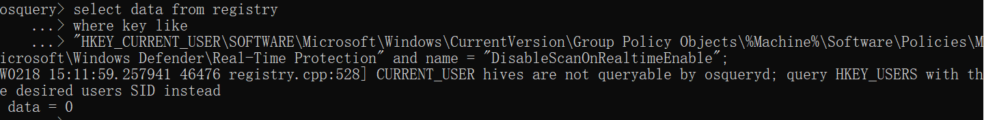

data = 0，则该检查项通过。

**454、Ensure 'Select cloud protection level' is set to 'Enabled: High blocking level'**

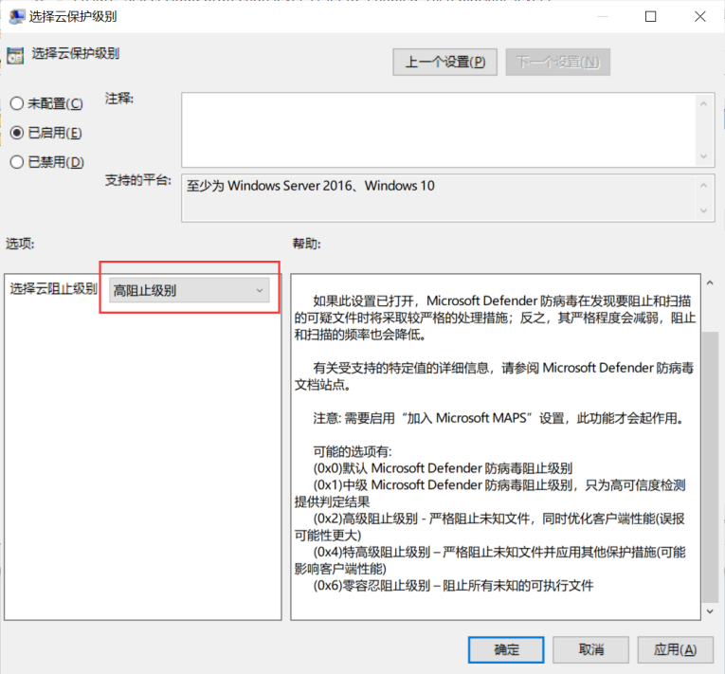

**检查语句**

select data from registry

where key like

"HKEY_CURRENT_USER\SOFTWARE\Microsoft\Windows\CurrentVersion\Group Policy Objects\%Machine%\Software\Policies\Microsoft\Windows Defender\MpEngine" and name = "MpCloudBlockLevel";

**检查结果**

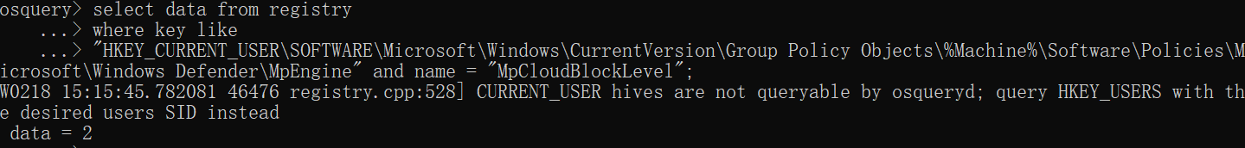

data = 2，则该检查项通过。

**453、Ensure 'Turn on protocol recognition' is set to 'Enabled'**

**检查语句**

select data from registry

where key like

"HKEY_CURRENT_USER\SOFTWARE\Microsoft\Windows\CurrentVersion\Group Policy Objects\%Machine%\Software\Policies\Microsoft\Windows Defender\NIS" and name = "DisableProtocolRecognition";

**检查结果**

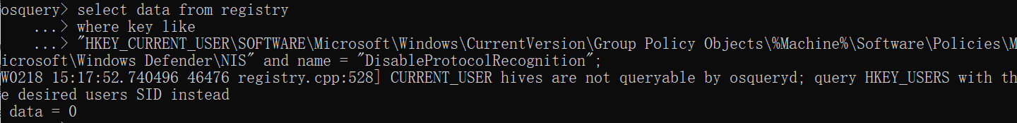

data = 0，则该检查项通过。

**452、Ensure 'Turn on heuristics' is set to 'Enabled'**

**检查语句**

select data from registry

where key like

"HKEY_CURRENT_USER\SOFTWARE\Microsoft\Windows\CurrentVersion\Group Policy Objects\%Machine%\Software\Policies\Microsoft\Windows Defender\Scan" and name = "DisableHeuristics";

**检查结果**

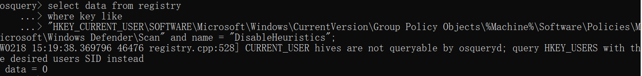

data = 0，则该检查项通过。

**451、Ensure 'Scan packed executables' is set to 'Enabled'**

**检查语句**

select data from registry

where key like

"HKEY_CURRENT_USER\SOFTWARE\Microsoft\Windows\CurrentVersion\Group Policy Objects\%Machine%\Software\Policies\Microsoft\Windows Defender\Scan" and name = "DisablePackedExeScanning";

**检查结果**

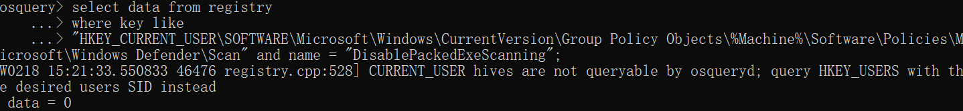

data = 0，则该检查项通过。

**450、Ensure 'Initiate security intelligence update on startup' is set to 'Enabled'**

**检查语句**

select data from registry

where key like

"HKEY_CURRENT_USER\SOFTWARE\Microsoft\Windows\CurrentVersion\Group Policy Objects\%Machine%\Software\Policies\Microsoft\Windows Defender\Signature Updates" and name = "DisableUpdateOnStartupWithoutEngine";

**检查结果**

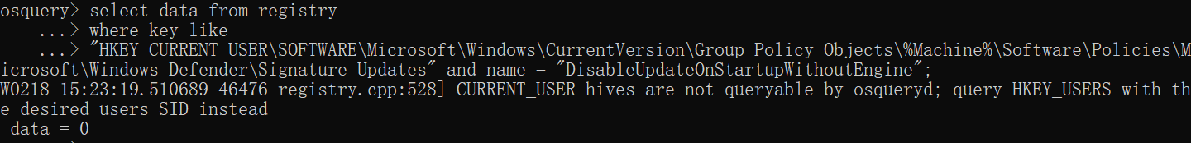

data = 0，则该检查项通过。

**449、Ensure 'Define the number of days before virus security intelligence is considered out of date' is set to 'Enabled: 3' Days or less**

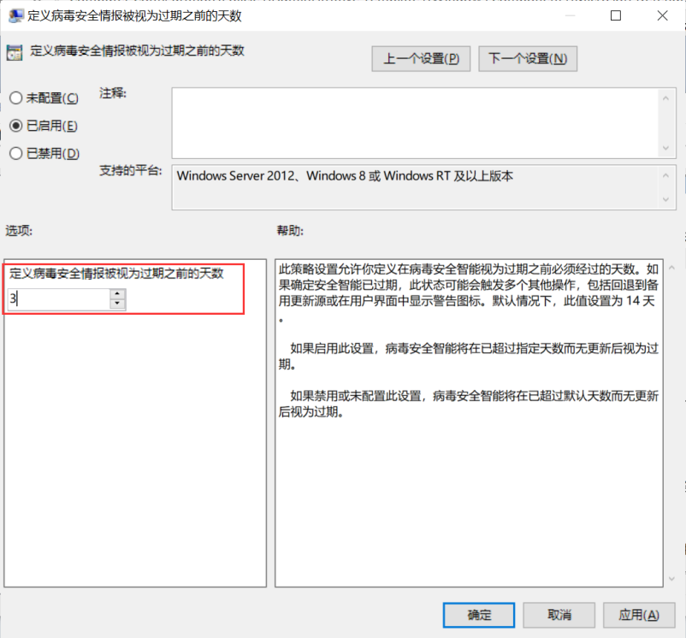

**检查语句**

select data from registry

where key like

"HKEY_CURRENT_USER\SOFTWARE\Microsoft\Windows\CurrentVersion\Group Policy Objects\%Machine%\Software\Policies\Microsoft\Windows Defender\Signature Updates" and name = "AVSignatureDue";

**检查结果**

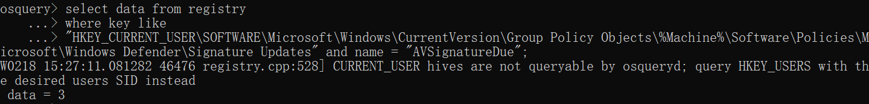

data <= 3，则该检查项通过。

**448、Ensure 'Define the number of days before spyware security intelligence is considered out of date' is set to 'Enabled: 3' Days or less**

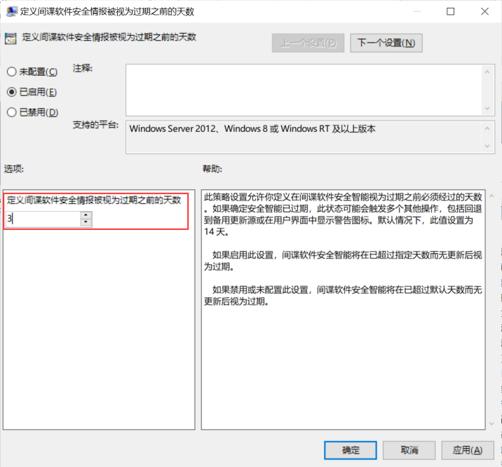

**检查语句**

select data from registry

where key like

"HKEY_CURRENT_USER\SOFTWARE\Microsoft\Windows\CurrentVersion\Group Policy Objects\%Machine%\Software\Policies\Microsoft\Windows Defender\Signature Updates" and name = "ASSignatureDue";

**检查结果**

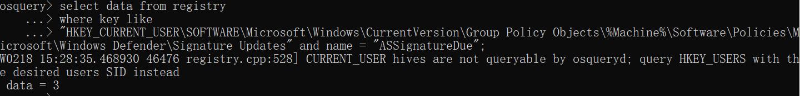

data <= 3，则该检查项通过。

**447、Ensure 'Check for the latest virus and spyware security intelligence on startup' is set to 'Enabled'**

**检查语句**

select data from registry

where key like

"HKEY_CURRENT_USER\SOFTWARE\Microsoft\Windows\CurrentVersion\Group Policy Objects\%Machine%\Software\Policies\Microsoft\Windows Defender\Signature Updates" and name = "UpdateOnStartUp";

**检查结果**

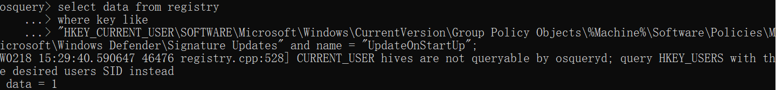

data = 1，则该检查项通过。

**445、Ensure 'Configure local setting override for scanning all downloaded files and attachments' is set to 'Disabled'**

**检查语句**

select data from registry

where key like

"HKEY_CURRENT_USER\SOFTWARE\Microsoft\Windows\CurrentVersion\Group Policy Objects\%Machine%\Software\Policies\Microsoft\Windows Defender\Real-Time Protection" and name = "LocalSettingOverrideDisableIOAVProtection";

**检查结果**

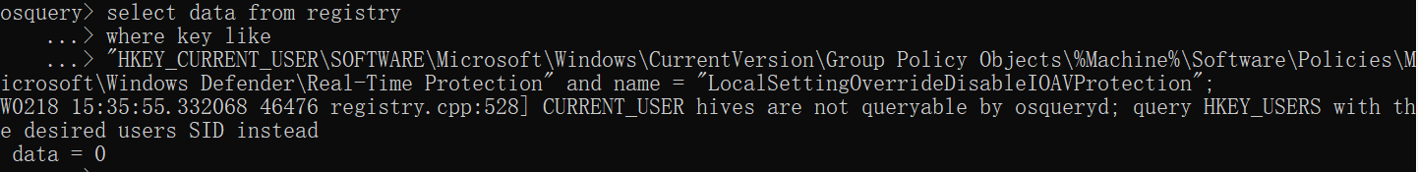

data = 0，则该检查项通过。

**443、Ensure 'Turn off real-time protection' is set to 'Disabled'**

**检查语句**

select data from registry

where key like

"HKEY_CURRENT_USER\SOFTWARE\Microsoft\Windows\CurrentVersion\Group Policy Objects\%Machine%\Software\Policies\Microsoft\Windows Defender\Real-Time Protection" and name = "DisableRealtimeMonitoring";

**检查结果**

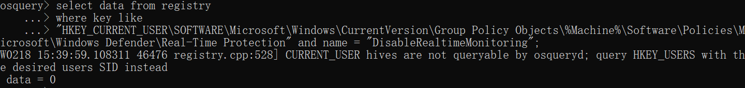

data = 0，则该检查项通过。

**442、Ensure 'Configure local setting override for reporting to Microsoft MAPS' is set to 'Disabled'**

**检查语句**

select data from registry

where key like

"HKEY_CURRENT_USER\SOFTWARE\Microsoft\Windows\CurrentVersion\Group Policy Objects\%Machine%\Software\Policies\Microsoft\Windows Defender\Spynet" and name = "LocalSettingOverrideSpynetReporting";

**检查结果**

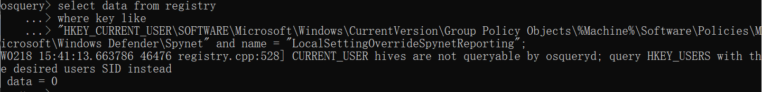

data = 0，则该检查项通过。

**441、Ensure 'Configure detection for potentially unwanted applications' is set to 'Audit'**

**检查语句**

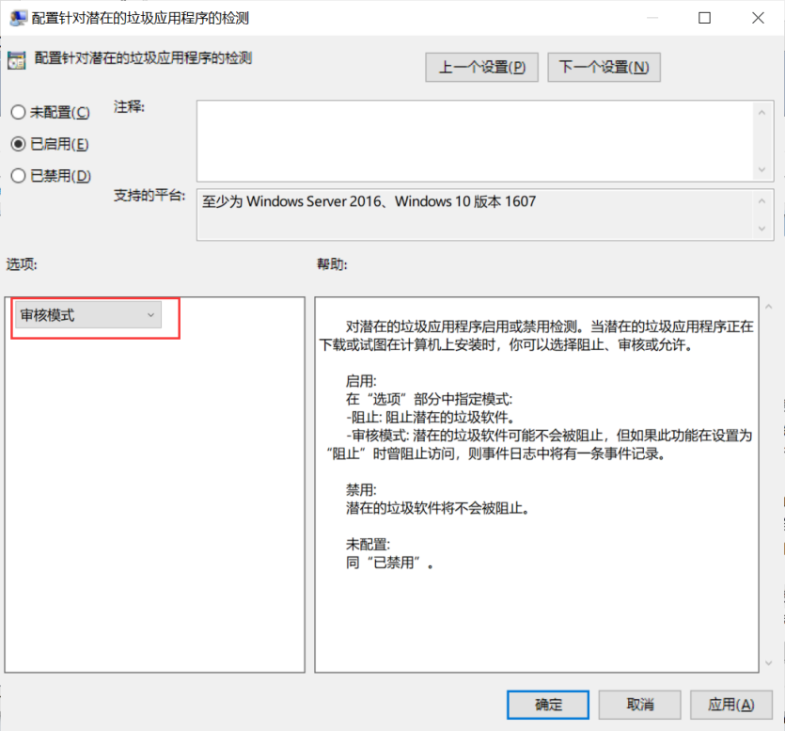

select data from registry

where key like

"HKEY_CURRENT_USER\SOFTWARE\Microsoft\Windows\CurrentVersion\Group Policy Objects\%Machine%\Software\Policies\Microsoft\Windows Defender" and name = "PUAProtection";

**检查结果**

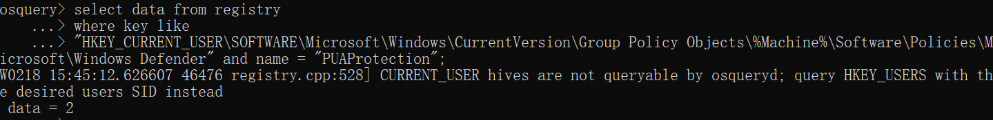

data = 2，则该检查项通过。

**434、Configure Dangerous Websites Protection**

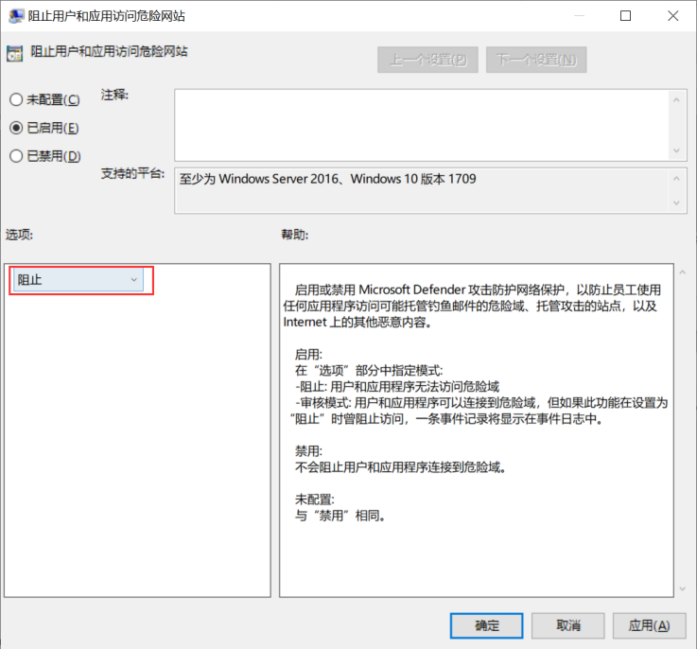

**检查语句**

select data from registry

where key like

"HKEY_CURRENT_USER\SOFTWARE\Microsoft\Windows\CurrentVersion\Group Policy Objects\%Machine%\Software\Policies\Microsoft\Windows Defender\Windows Defender Exploit Guard\Network Protection" and name = "EnableNetworkProtection";

**检查结果**

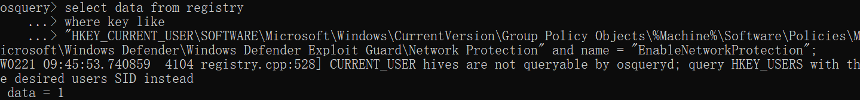

data = 1，则该检查项通过。

**433、Enable Pattern Update Check before Scans**

**检查语句**

select data from registry

where key like

"HKEY_CURRENT_USER\SOFTWARE\Microsoft\Windows\CurrentVersion\Group Policy Objects\%Machine%\Software\Policies\Microsoft\Windows Defender\Scan" and name = "CheckForSignaturesBeforeRunningScan";

**检查结果**

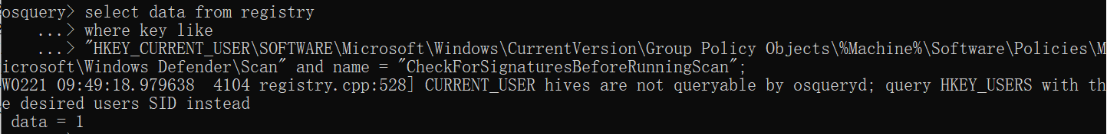

data = 1，则该检查项通过。

**432、Configure Update Interval for Security Intelligence**

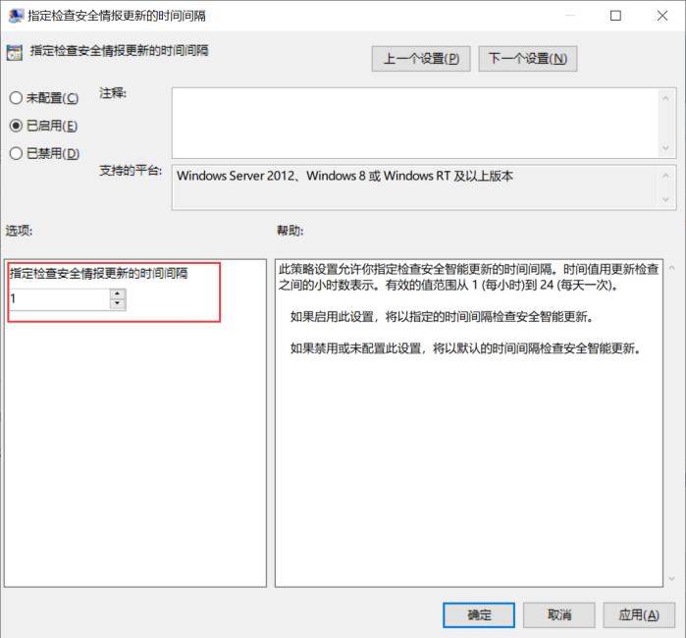

**检查语句**

select data from registry

where key like

"HKEY_CURRENT_USER\SOFTWARE\Microsoft\Windows\CurrentVersion\Group Policy Objects\%Machine%\Software\Policies\Microsoft\Windows Defender\Signature Updates" and name = "SignatureUpdateInterval";

**检查结果**

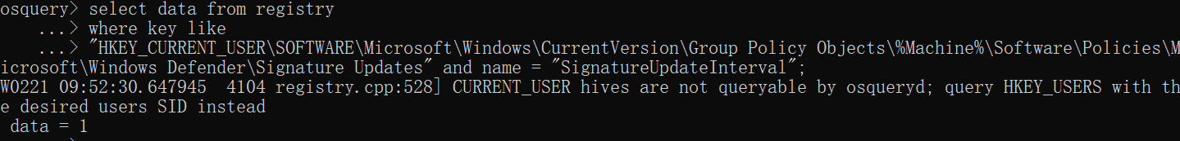

data = 1，则该检查项通过。

**431、Enable Scanning of E-mail**

**检查语句**

select data from registry

where key like

"HKEY_CURRENT_USER\SOFTWARE\Microsoft\Windows\CurrentVersion\Group Policy Objects\%Machine%\Software\Policies\Microsoft\Windows Defender\Scan" and name = "DisableEmailScanning";

**检查结果**

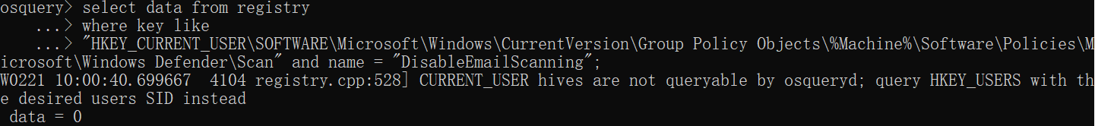

data = 0，则该检查项通过。

**430、Enable Scanning of Removable Drives**

**检查语句**

select data from registry

where key like

"HKEY_CURRENT_USER\SOFTWARE\Microsoft\Windows\CurrentVersion\Group Policy Objects\%Machine%\Software\Policies\Microsoft\Windows Defender\Scan" and name = "DisableRemovableDriveScanning";

**检查结果**

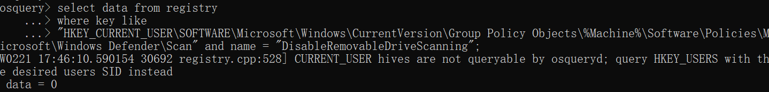

data = 0，则该检查项通过。

**429、Enable Scanning of Archives**

**检查语句**

select data from registry

where key like

"HKEY_CURRENT_USER\SOFTWARE\Microsoft\Windows\CurrentVersion\Group Policy Objects\%Machine%\Software\Policies\Microsoft\Windows Defender\Scan" and name = "DisableArchiveScanning";

**检查结果**

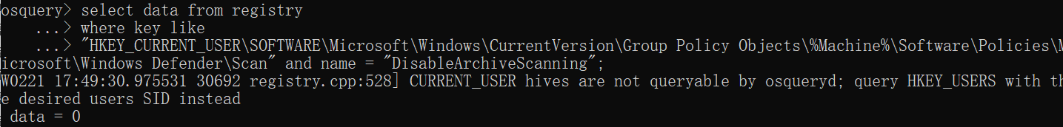

data = 0，则该检查项通过。

**428、Enable Behavior Monitoring**

**检查语句**

select data from registry

where key like

"HKEY_CURRENT_USER\SOFTWARE\Microsoft\Windows\CurrentVersion\Group Policy Objects\%Machine%\Software\Policies\Microsoft\Windows Defender\Real-Time Protection" and name = "DisableBehaviorMonitoring";

**检查结果**

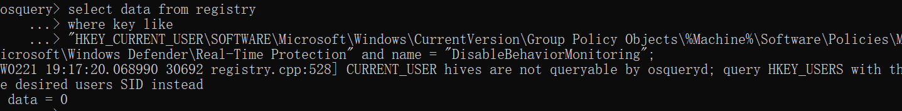

data = 0，则该检查项通过。

**427、Enable 'Scan all Downloads and Attachments'**

**检查语句**

select data from registry

where key like

"HKEY_CURRENT_USER\SOFTWARE\Microsoft\Windows\CurrentVersion\Group Policy Objects\%Machine%\Software\Policies\Microsoft\Windows Defender\Real-Time Protection" and name = "DisableIOAVProtection";

**检查结果**

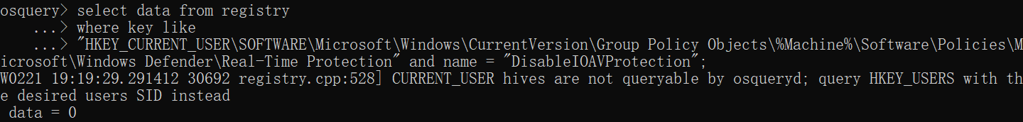

data = 0，则该检查项通过。

**426、Disable Watson Events**

**检查语句**

select data from registry

where key like

"HKEY_CURRENT_USER\SOFTWARE\Microsoft\Windows\CurrentVersion\Group Policy Objects\%Machine%\Software\Policies\Microsoft\Windows Defender\Reporting" and name = "DisableGenericRePorts";

**检查结果**

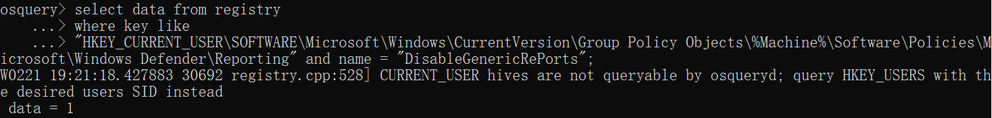

data = 1，则该检查项通过。

**425、Disable Joining Microsoft MAPS**

**检查语句**

select data from registry

where key like

"HKEY_CURRENT_USER\SOFTWARE\Microsoft\Windows\CurrentVersion\Group Policy Objects\%Machine%\Software\Policies\Microsoft\Windows Defender\Spynet";

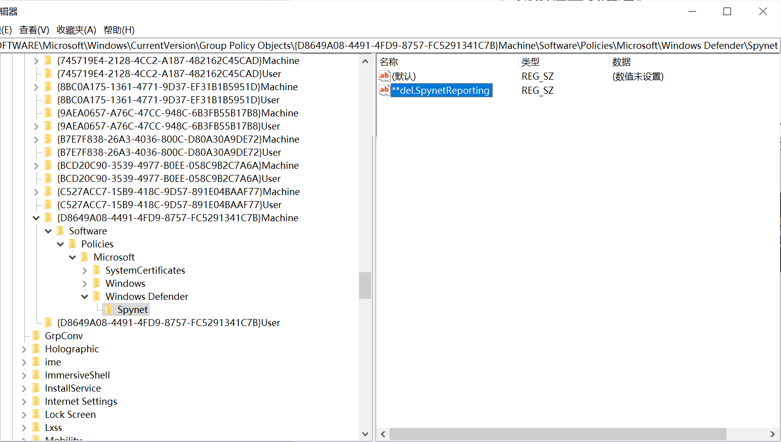

**检查结果**

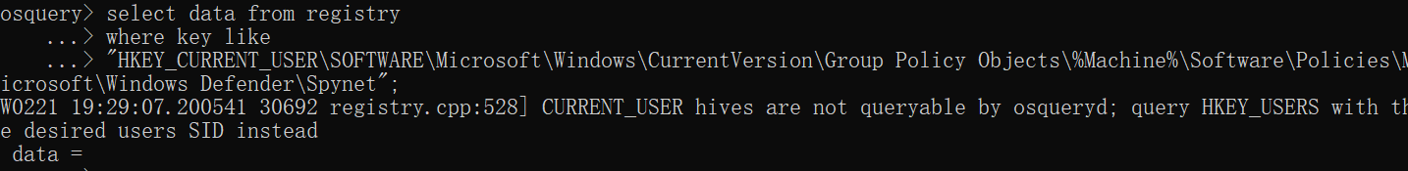

data = ，则该检查项通过。

**424、Configure Microsoft Defender AntiVirus**

**检查语句**

select data from registry

where key like

"HKEY_CURRENT_USER\SOFTWARE\Microsoft\Windows\CurrentVersion\Group Policy Objects\%Machine%\Software\Policies\Microsoft\Windows Defender" and name = "DisableAntiSpyware";

**检查结果**

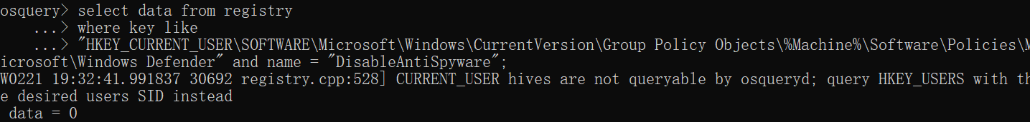

data = 0，则该检查项通过。

#### 444、438

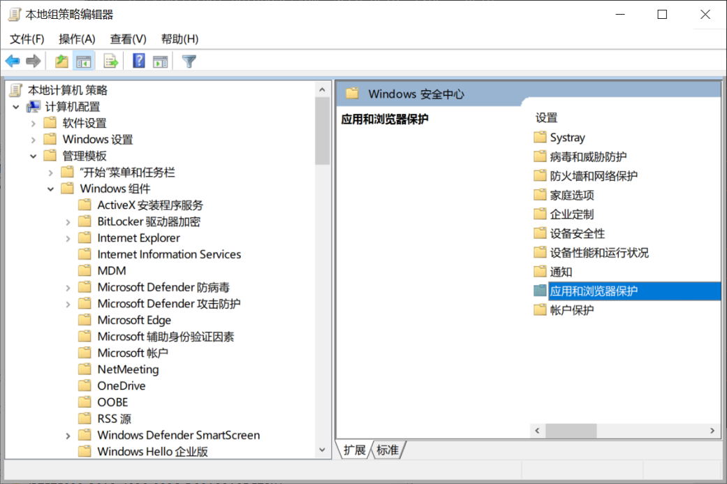

**444、Ensure 'Prevent users from modifying settings' is set to 'Enabled'**

**检查语句**

select data from registry

where key like

"HKEY_CURRENT_USER\SOFTWARE\Microsoft\Windows\CurrentVersion\Group Policy Objects\%Machine%\Software\Policies\Microsoft\Windows Defender Security Center\App and Browser protection" and name = "DisallowExploitProtectionOverride";

**检查结果**

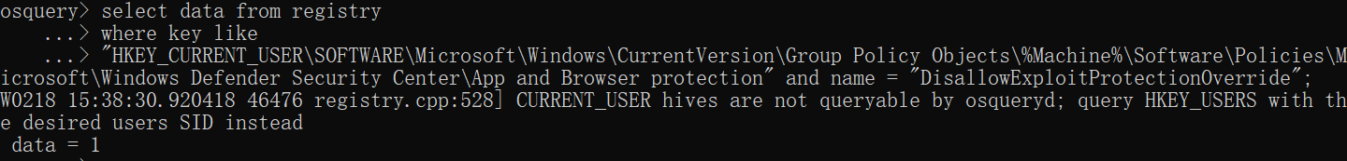

data = 1，则该检查项通过。

**438、Lock Exploit Protection Settings (Windows 10, version 1803 and lower)**

**检查语句**

select data from registry

where key like

"HKEY_CURRENT_USER\SOFTWARE\Microsoft\Windows\CurrentVersion\Group Policy Objects\%Machine%\Software\Policies\Microsoft\Windows Defender Security Center\App and Browser protection" and name = "DisallowExploitProtectionOverride";

**检查结果**

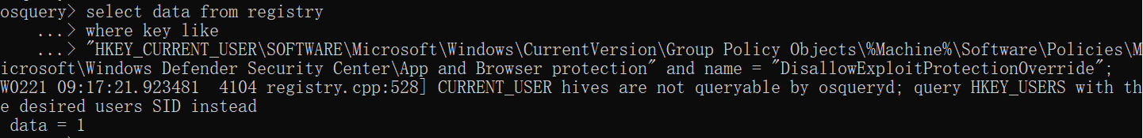

data = 1，则该检查项通过。

#### 436、Ensure 'Configure Windows Defender SmartScreen' is set to 'Disabled'

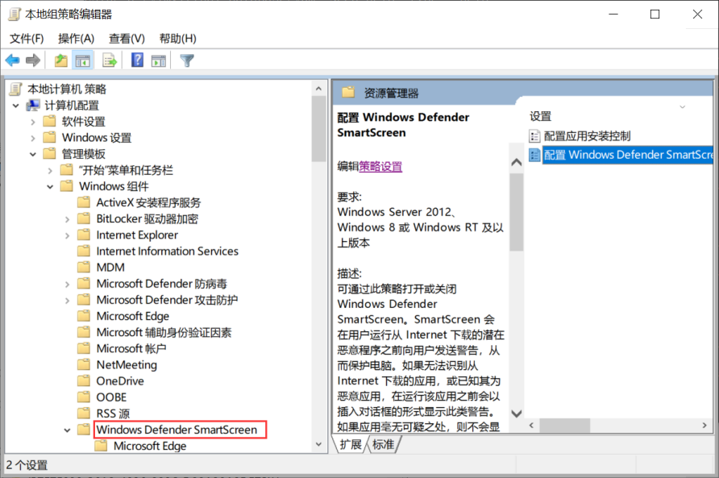

**检查语句**

select data from registry

where key like

"HKEY_CURRENT_USER\SOFTWARE\Microsoft\Windows\CurrentVersion\Group Policy Objects\%Machine%\Software\Policies\Microsoft\Windows\System" and name = "EnableSmartScreen";

**检查结果**

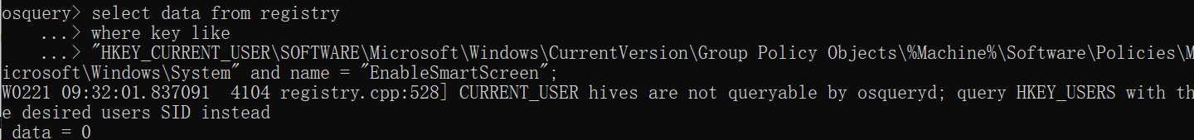

data = 0，则该检查项通过。

#### 422-388（除401）、383-305（除374）

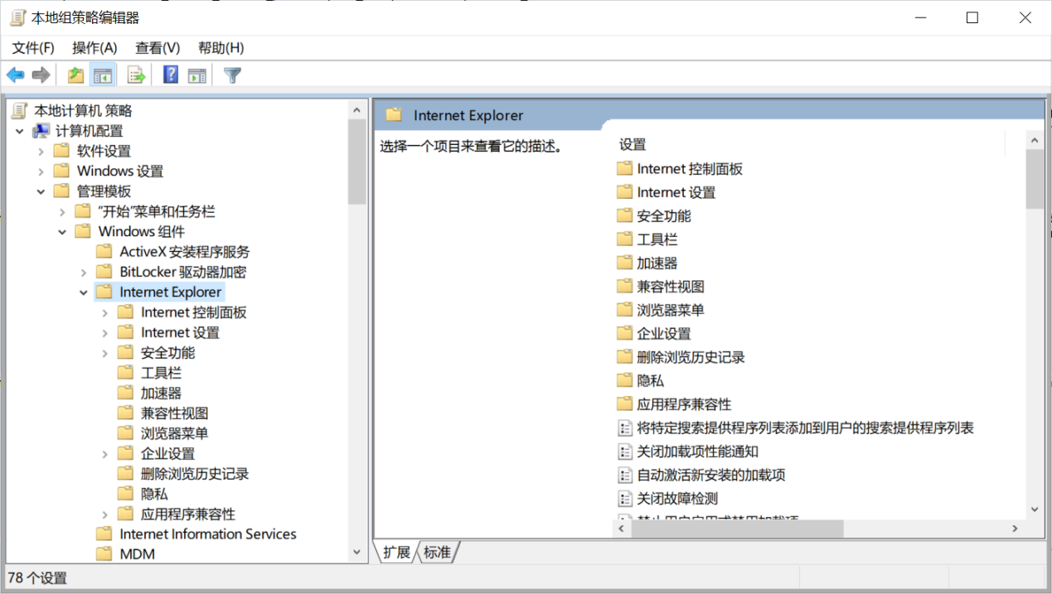

**422、Configure 'Allow installation of desktop items' for the intranet zone**

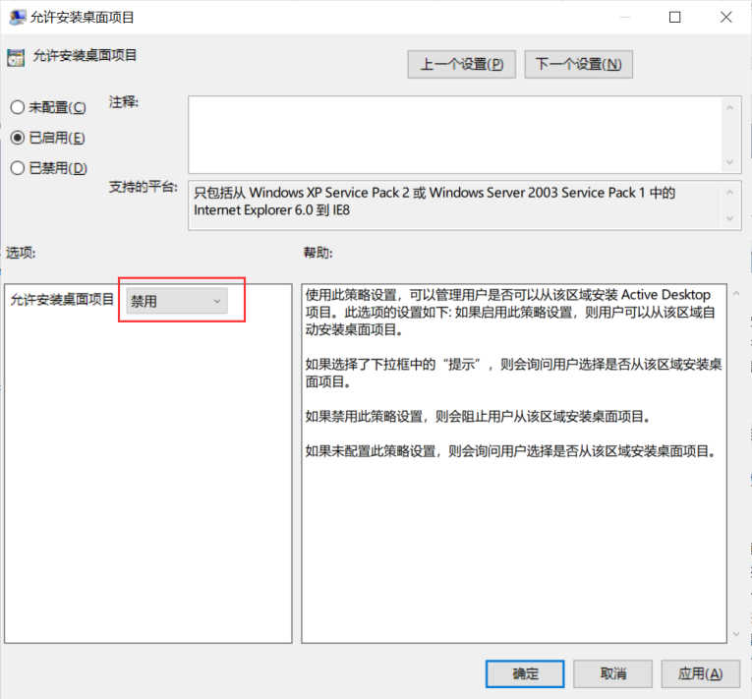

**检查语句**

select data from registry

where key like

"HKEY_CURRENT_USER\SOFTWARE\Microsoft\Windows\CurrentVersion\Group Policy Objects\%Machine%\Software\Policies\Microsoft\Windows\CurrentVersion\Internet Settings\Zones\1" and name = "1800";

**检查结果**

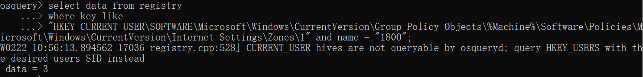

data = 3，则该检查项通过。

**421、Configure 'Navigate windows and frames across different domains' for the internet zone**

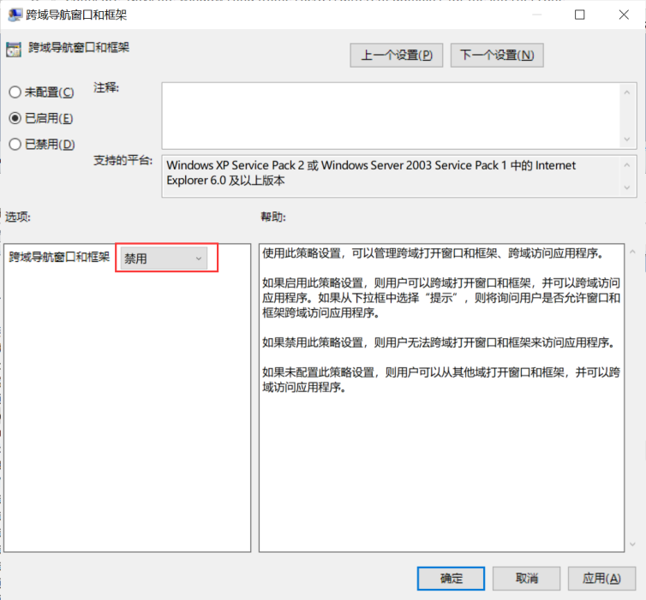

**检查语句**

select data from registry

where key like

"HKEY_CURRENT_USER\SOFTWARE\Microsoft\Windows\CurrentVersion\Group Policy Objects\%Machine%\Software\Policies\Microsoft\Windows\CurrentVersion\Internet Settings\Zones\3" and name = "1607";

**检查结果**

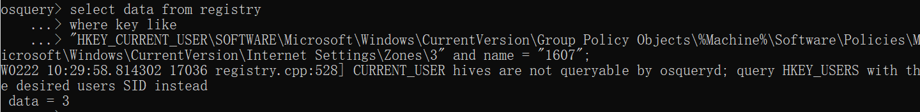

data = 3，则该检查项通过。

**420、Configure 'Launching applications and files in an IFRAME' for the internet zone**

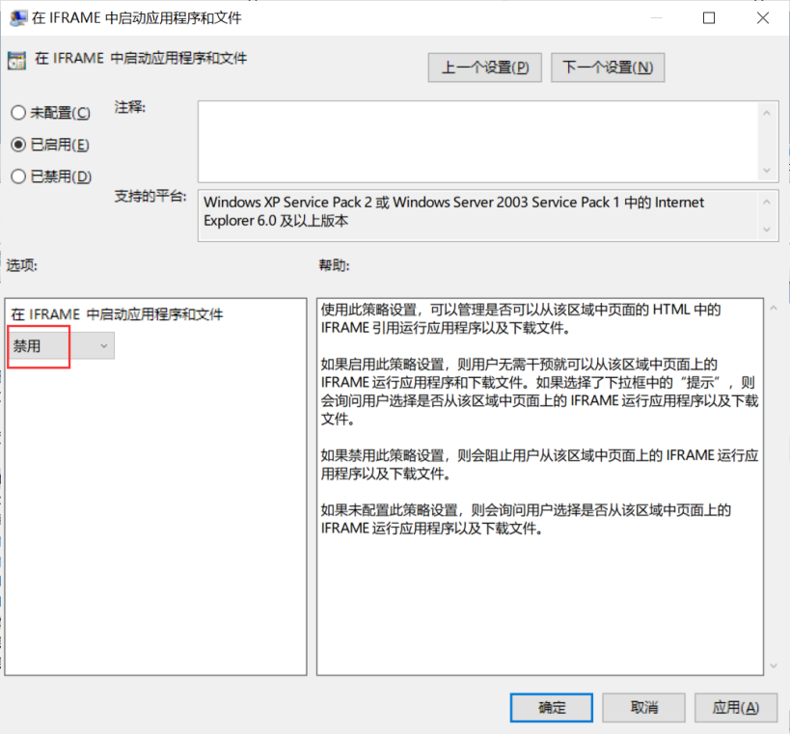

**检查语句**

select data from registry

where key like

"HKEY_CURRENT_USER\SOFTWARE\Microsoft\Windows\CurrentVersion\Group Policy Objects\%Machine%\Software\Policies\Microsoft\Windows\CurrentVersion\Internet Settings\Zones\3" and name = "1804";

**检查结果**

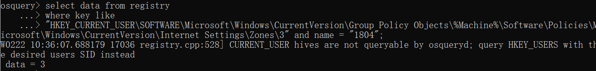

data = 3，则该检查项通过。

**419、Configure 'Include local path when user is uploading files to a server' for the internet zone**

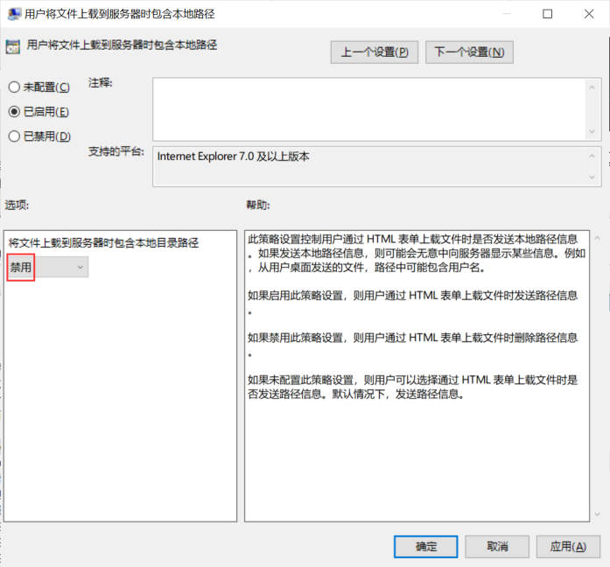

**检查语句**

select data from registry

where key like

"HKEY_CURRENT_USER\SOFTWARE\Microsoft\Windows\CurrentVersion\Group Policy Objects\%Machine%\Software\Policies\Microsoft\Windows\CurrentVersion\Internet Settings\Zones\3" and name = "160A";

**检查结果**

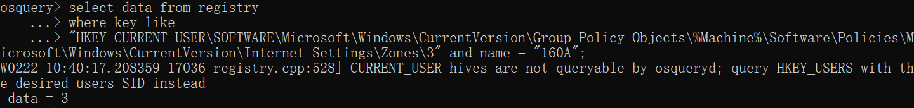

data = 3，则该检查项通过。

**418、Configure 'Enable dragging of content from different domains within a window' for the internet zone**

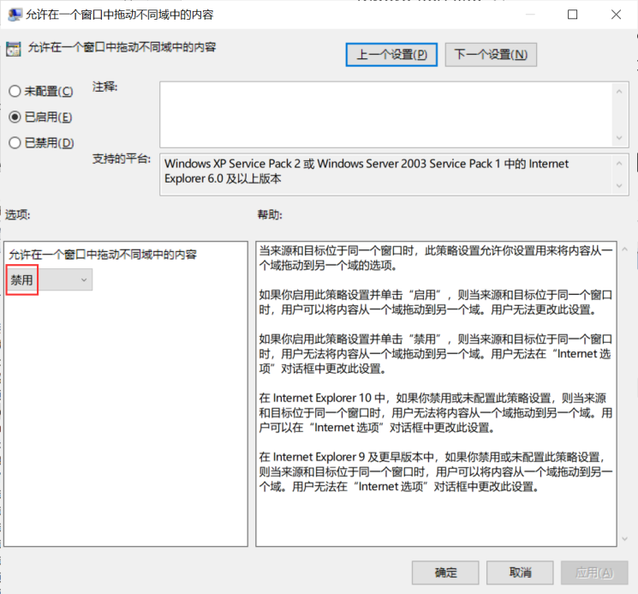

**检查语句**

select data from registry

where key like

"HKEY_CURRENT_USER\SOFTWARE\Microsoft\Windows\CurrentVersion\Group Policy Objects\%Machine%\Software\Policies\Microsoft\Windows\CurrentVersion\Internet Settings\Zones\3" and name = "2708";

**检查结果**

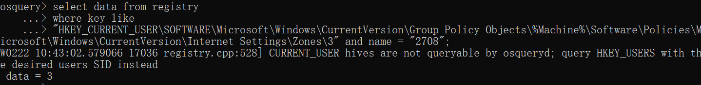

data = 3，则该检查项通过。

**417、Configure 'Enable dragging of content from different domains across windows' for the internet zone**

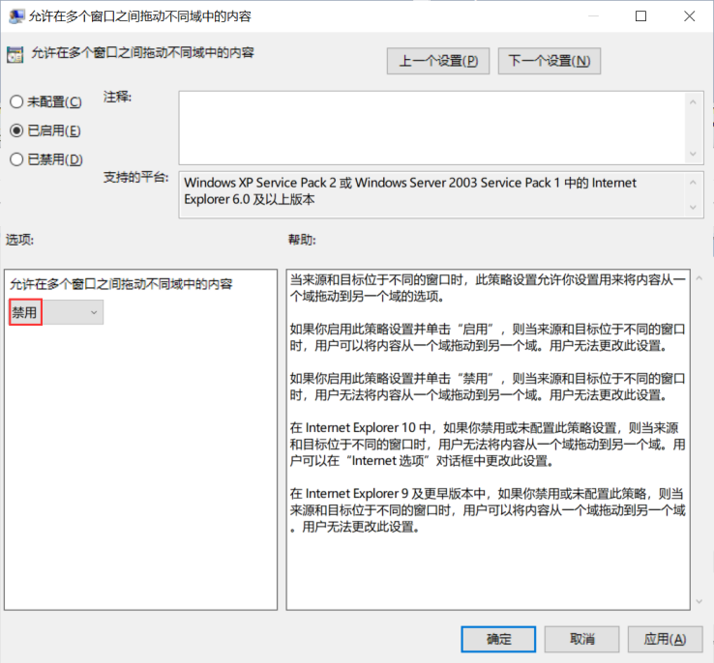

**检查语句**

select data from registry

where key like

"HKEY_CURRENT_USER\SOFTWARE\Microsoft\Windows\CurrentVersion\Group Policy Objects\%Machine%\Software\Policies\Microsoft\Windows\CurrentVersion\Internet Settings\Zones\3" and name = "2709";

**检查结果**

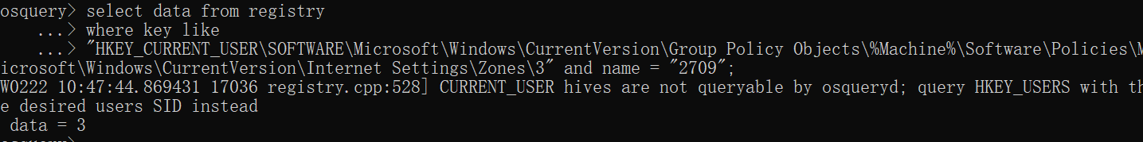

data = 3，则该检查项通过。

**416、Configure 'Allow websites to open windows without status bar or Address bar' for the internet zone**

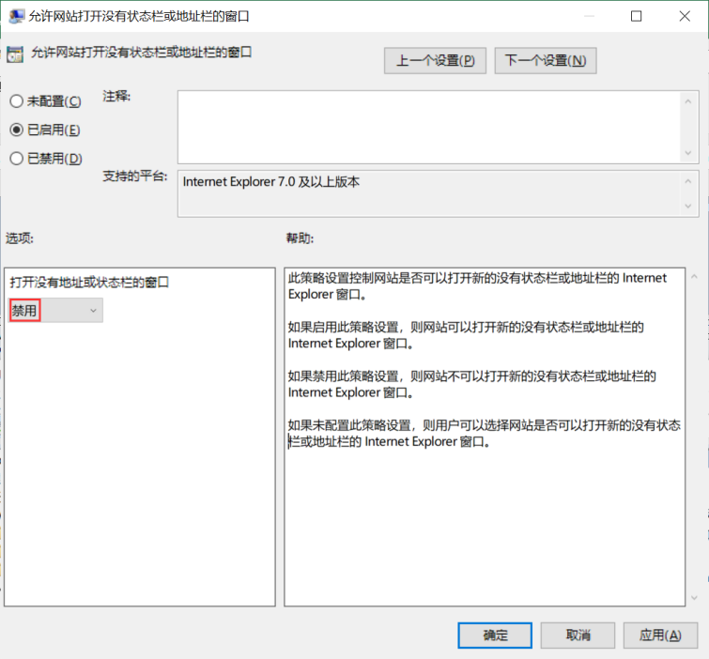

**检查语句**

select data from registry

where key like

"HKEY_CURRENT_USER\SOFTWARE\Microsoft\Windows\CurrentVersion\Group Policy Objects\%Machine%\Software\Policies\Microsoft\Windows\CurrentVersion\Internet Settings\Zones\3" and name = "2104";

**检查结果**

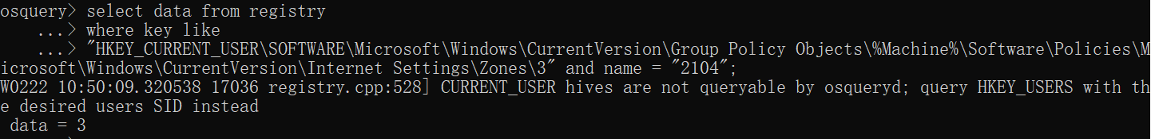

data = 3，则该检查项通过。

**415、Configure 'Allow installation of desktop items' for the internet zone**

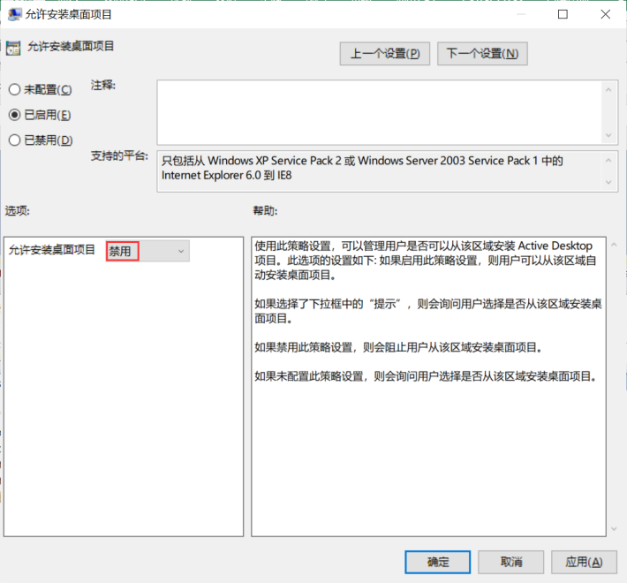

**检查语句**

select data from registry

where key like

"HKEY_CURRENT_USER\SOFTWARE\Microsoft\Windows\CurrentVersion\Group Policy Objects\%Machine%\Software\Policies\Microsoft\Windows\CurrentVersion\Internet Settings\Zones\3" and name = "1800";

**检查结果**

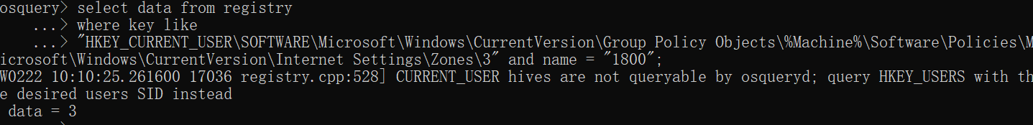

data = 3，则该检查项通过。

**414、Configure 'Access data sources across domains' for the internet zone**

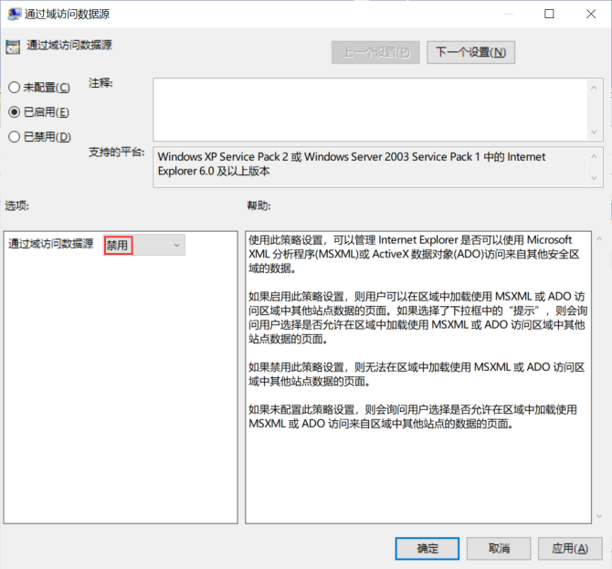

**检查语句**

select data from registry

where key like

"HKEY_CURRENT_USER\SOFTWARE\Microsoft\Windows\CurrentVersion\Group Policy Objects\%Machine%\Software\Policies\Microsoft\Windows\CurrentVersion\Internet Settings\Zones\3" and name = "1406";

**检查结果**

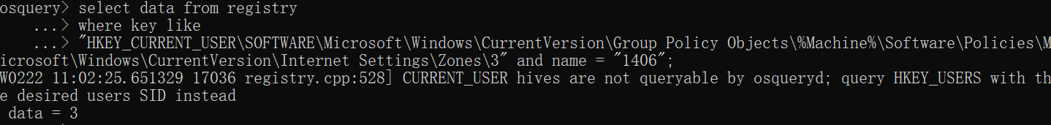

data = 3，则该检查项通过。

**413、Configure 'Show security warning for potentially unsafe files' for the restricted sites zone**

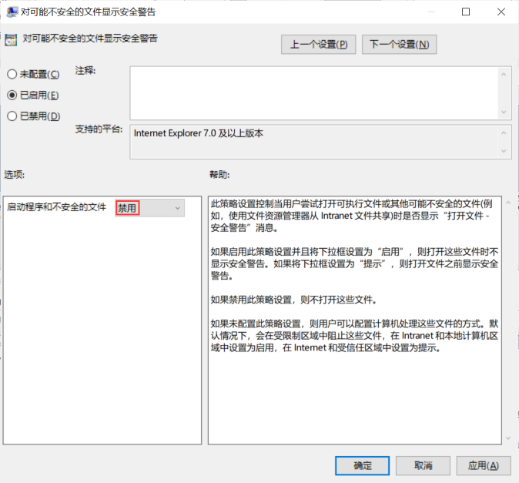

**检查语句**

select data from registry

where key like

"HKEY_CURRENT_USER\SOFTWARE\Microsoft\Windows\CurrentVersion\Group Policy Objects\%Machine%\Software\Policies\Microsoft\Windows\CurrentVersion\Internet Settings\Zones\4" and name = "1806";

**检查结果**

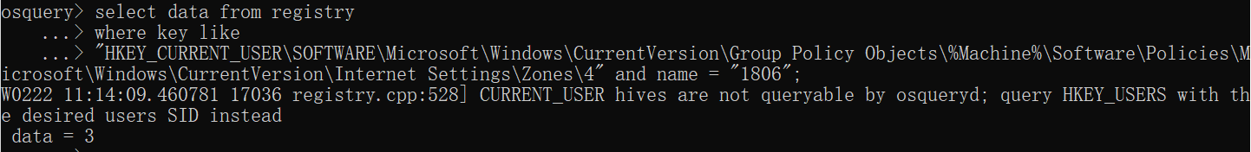

data = 3，则该检查项通过。

**412、Configure 'Navigate windows and frames across different domains' for the restricted sites zone**

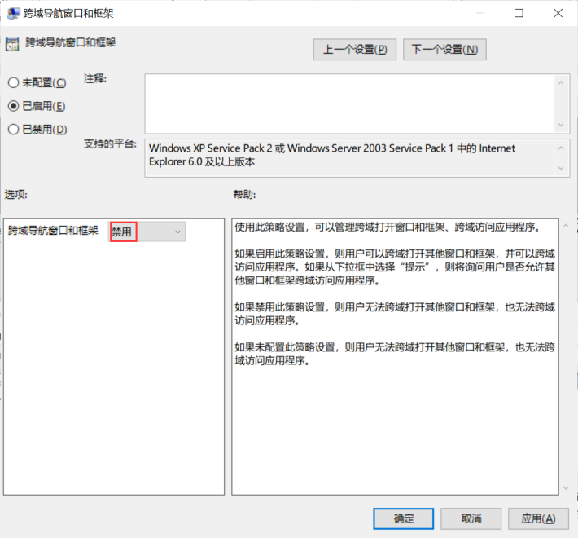

**检查语句**

select data from registry

where key like

"HKEY_CURRENT_USER\SOFTWARE\Microsoft\Windows\CurrentVersion\Group Policy Objects\%Machine%\Software\Policies\Microsoft\Windows\CurrentVersion\Internet Settings\Zones\4" and name = "1607";

**检查结果**

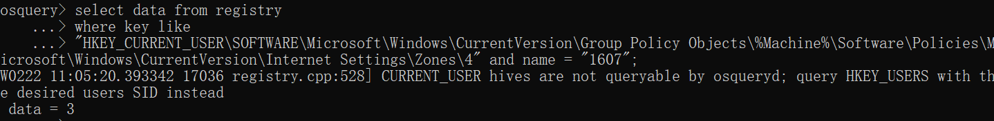

data = 3，则该检查项通过。

**411、Configure 'Launching applications and files in an IFRAME' for the restricted sites zone**

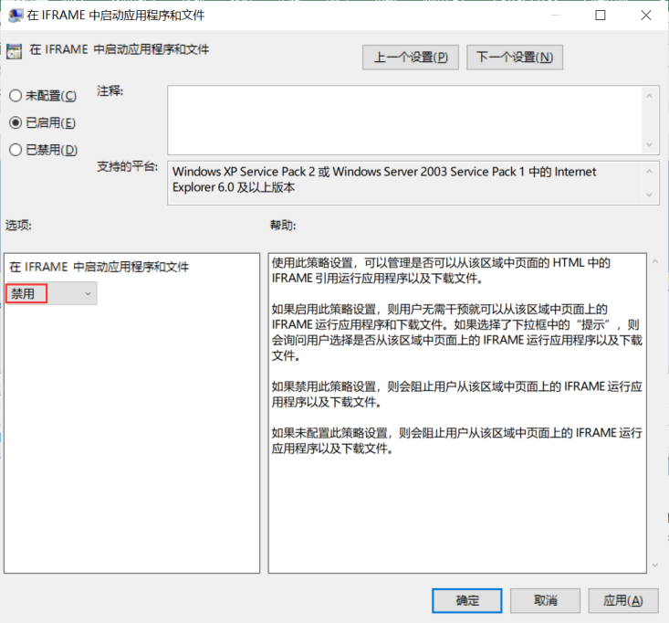

**检查语句**

select data from registry

where key like

"HKEY_CURRENT_USER\SOFTWARE\Microsoft\Windows\CurrentVersion\Group Policy Objects\%Machine%\Software\Policies\Microsoft\Windows\CurrentVersion\Internet Settings\Zones\4" and name = "1804";

**检查结果**

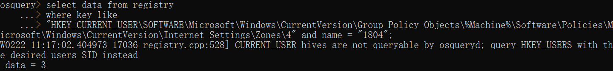

data = 3，则该检查项通过。

**410、Configure 'Include local path when user is uploading files to a server' for the restricted sites zone**

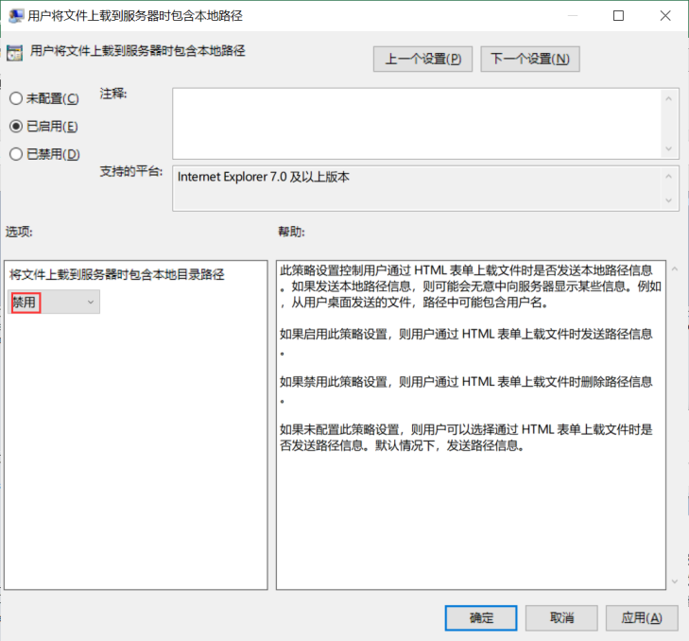

**检查语句**

select data from registry

where key like

"HKEY_CURRENT_USER\SOFTWARE\Microsoft\Windows\CurrentVersion\Group Policy Objects\%Machine%\Software\Policies\Microsoft\Windows\CurrentVersion\Internet Settings\Zones\4" and name = "160A";

**检查结果**

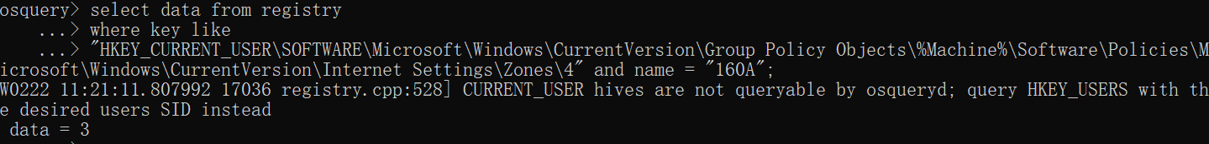

data = 3，则该检查项通过。

**409、Configure 'Enable dragging of content from different domains within a window' for the restricted sites zone**

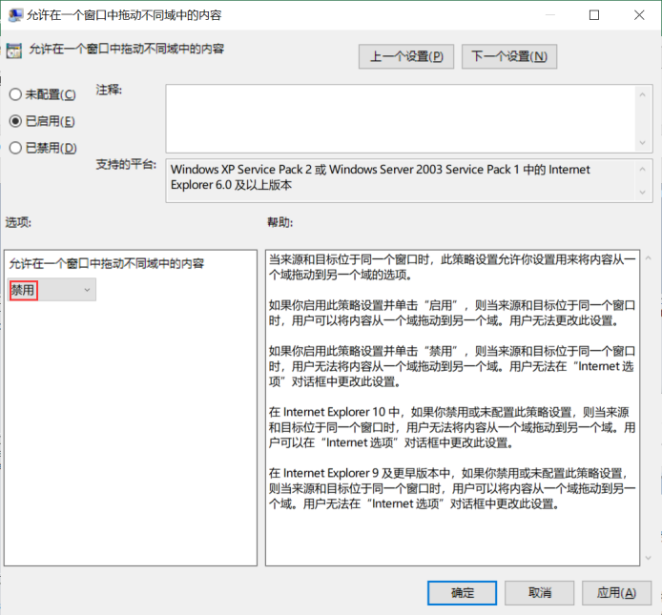

**检查语句**

select data from registry

where key like

"HKEY_CURRENT_USER\SOFTWARE\Microsoft\Windows\CurrentVersion\Group Policy Objects\%Machine%\Software\Policies\Microsoft\Windows\CurrentVersion\Internet Settings\Zones\4" and name = "2708";

**检查结果**

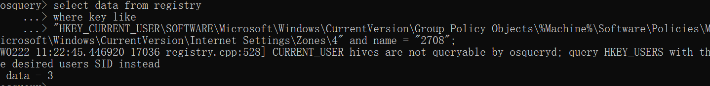

data = 3，则该检查项通过。

**408、Configure 'Enable dragging of content from different domains across windows' for the restricted sites zone**

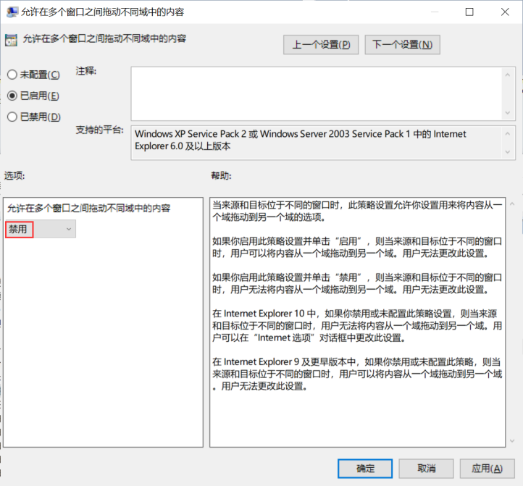

**检查语句**

select data from registry

where key like

"HKEY_CURRENT_USER\SOFTWARE\Microsoft\Windows\CurrentVersion\Group Policy Objects\%Machine%\Software\Policies\Microsoft\Windows\CurrentVersion\Internet Settings\Zones\4" and name = "2709";

**检查结果**

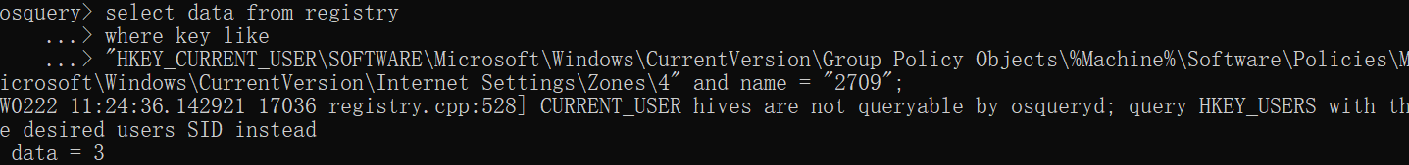

data = 3，则该检查项通过。

**407、Configure 'Allow websites to open windows without status bar or Address bar' for the restricted sites zone**

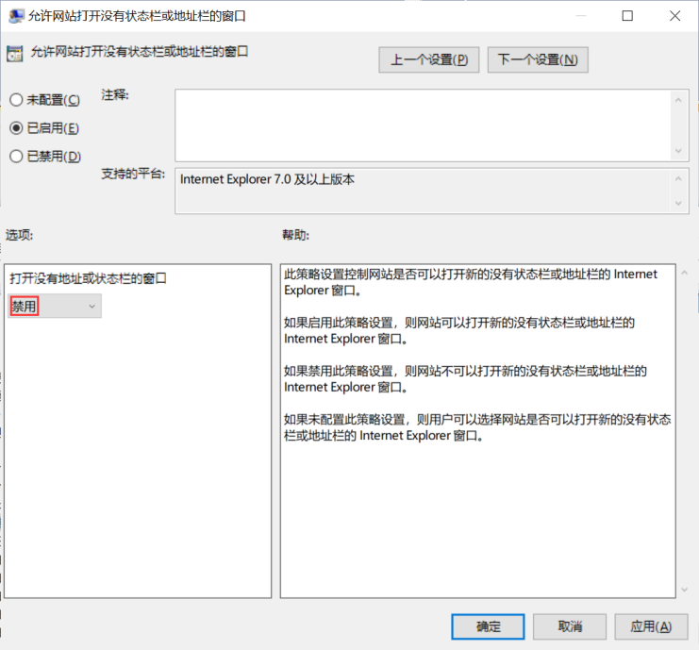

**检查语句**

select data from registry

where key like

"HKEY_CURRENT_USER\SOFTWARE\Microsoft\Windows\CurrentVersion\Group Policy Objects\%Machine%\Software\Policies\Microsoft\Windows\CurrentVersion\Internet Settings\Zones\4" and name = "2104";

**检查结果**

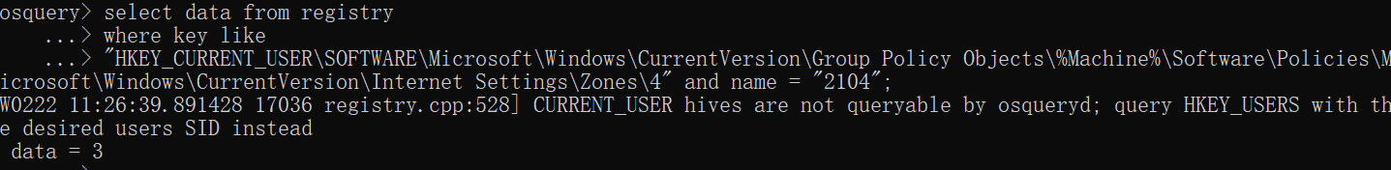

data = 3，则该检查项通过。

**406、Configure 'Allow META REFRESH' for the restricted sites zone**

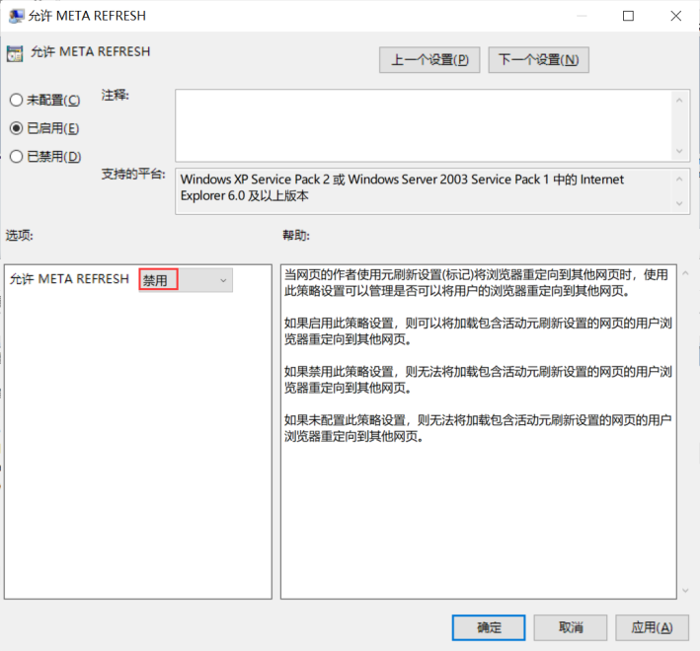

**检查语句**

select data from registry

where key like

"HKEY_CURRENT_USER\SOFTWARE\Microsoft\Windows\CurrentVersion\Group Policy Objects\%Machine%\Software\Policies\Microsoft\Windows\CurrentVersion\Internet Settings\Zones\4" and name = "1608";

**检查结果**

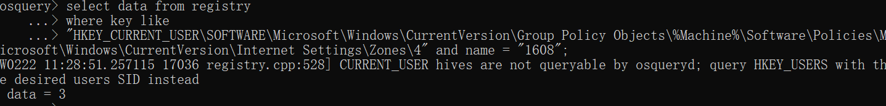

data = 3，则该检查项通过。

**405、Configure 'Allow installation of desktop items' for the restricted sites zone**

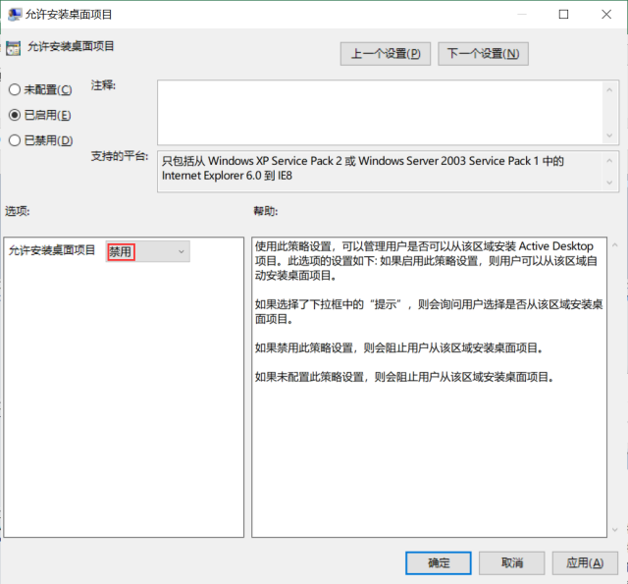

**检查语句**

select data from registry

where key like

"HKEY_CURRENT_USER\SOFTWARE\Microsoft\Windows\CurrentVersion\Group Policy Objects\%Machine%\Software\Policies\Microsoft\Windows\CurrentVersion\Internet Settings\Zones\4" and name = "1800";

**检查结果**

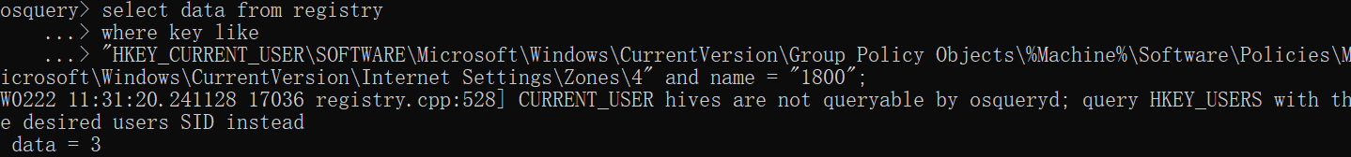

data = 3，则该检查项通过。

**404、Configure 'Allow drag and drop or copy and paste files' for the restricted sites zone**

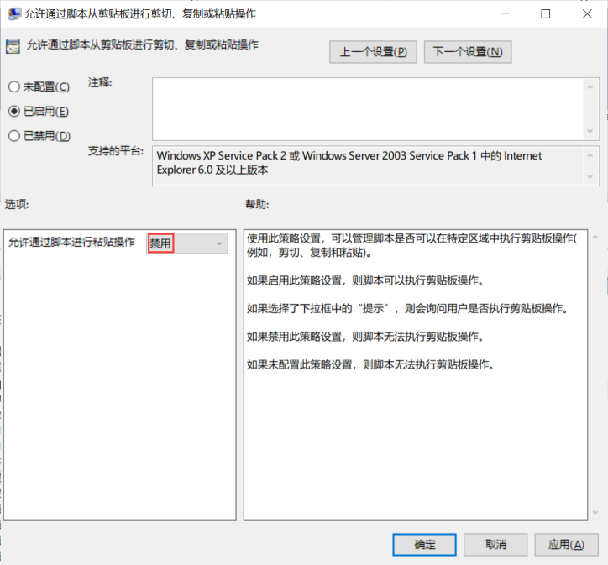

**检查语句**

select data from registry

where key like

"HKEY_CURRENT_USER\SOFTWARE\Microsoft\Windows\CurrentVersion\Group Policy Objects\%Machine%\Software\Policies\Microsoft\Windows\CurrentVersion\Internet Settings\Zones\4" and name = "1407";

**检查结果**

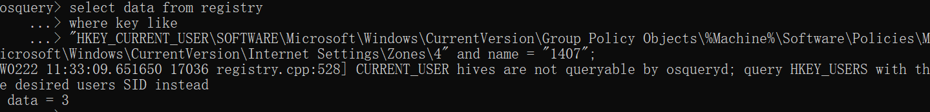

data = 3，则该检查项通过。

**403、Configure 'Allow active content over restricted protocols to access my computer' for the restricted sites zone**

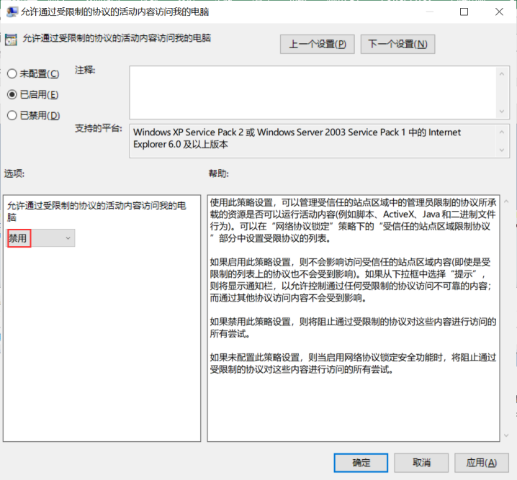

**检查语句**

select data from registry

where key like

"HKEY_CURRENT_USER\SOFTWARE\Microsoft\Windows\CurrentVersion\Group Policy Objects\%Machine%\Software\Policies\Microsoft\Windows\CurrentVersion\Internet Settings\Zones\4" and name = "2300";

**检查结果**

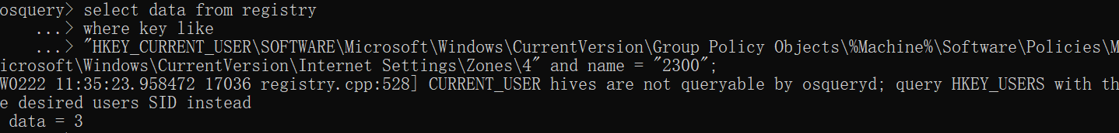

data = 3，则该检查项通过。

**402、Configure 'Access data sources across domains' for the restricted sites zone**

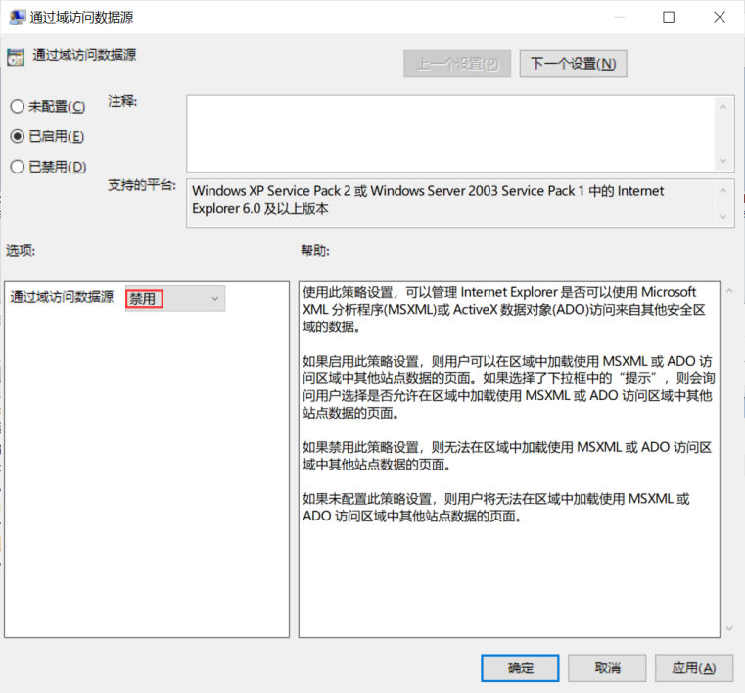

**检查语句**

select data from registry

where key like

"HKEY_CURRENT_USER\SOFTWARE\Microsoft\Windows\CurrentVersion\Group Policy Objects\%Machine%\Software\Policies\Microsoft\Windows\CurrentVersion\Internet Settings\Zones\4" and name = "1406";

**检查结果**

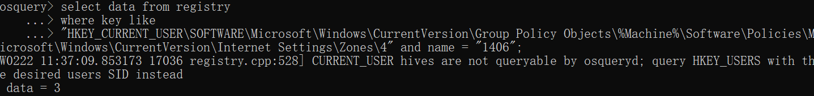

data = 3，则该检查项通过。

**400、Configure 'Logon options' for the internet zone**

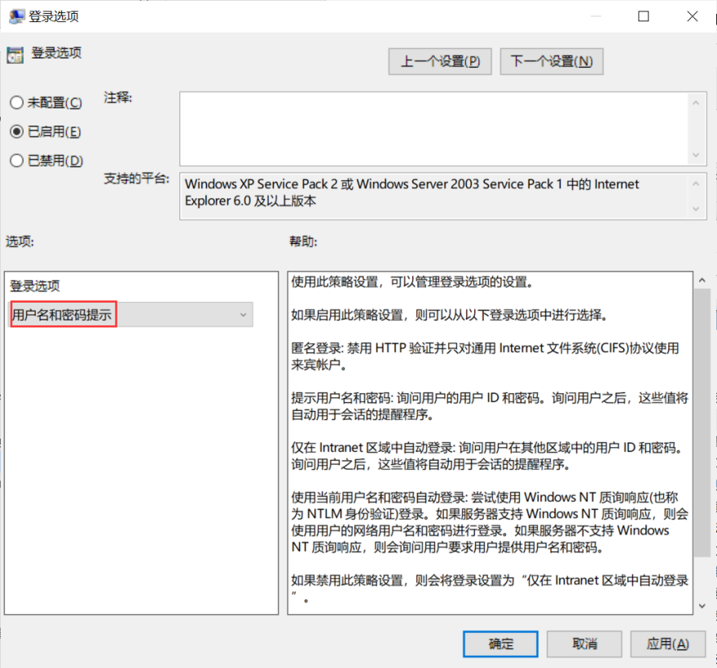

**检查语句**

select data from registry

where key like

"HKEY_CURRENT_USER\SOFTWARE\Microsoft\Windows\CurrentVersion\Group Policy Objects\%Machine%\Software\Policies\Microsoft\Windows\CurrentVersion\Internet Settings\Zones\3" and name = "1A00";

**检查结果**

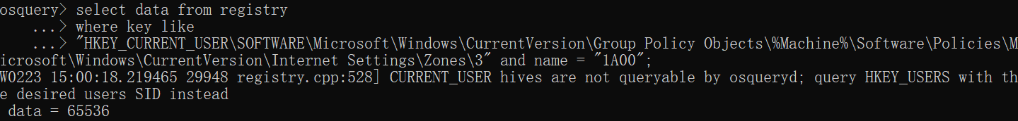

data = 65536，则该检查项通过。

**399、Configure 'Logon options' for the restricted sites zone**

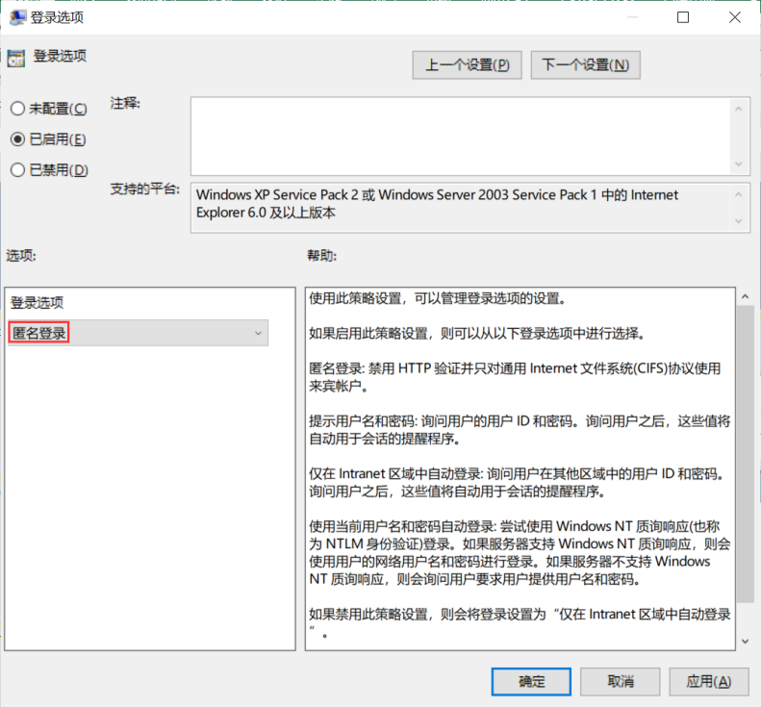

**检查语句**

select data from registry

where key like

"HKEY_CURRENT_USER\SOFTWARE\Microsoft\Windows\CurrentVersion\Group Policy Objects\%Machine%\Software\Policies\Microsoft\Windows\CurrentVersion\Internet Settings\Zones\4" and name = "1A00";

**检查结果**

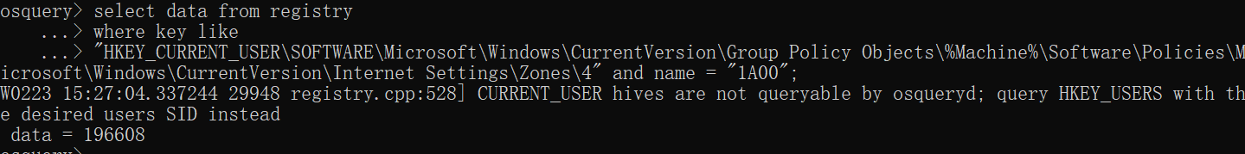

data = 196608，则该检查项通过。

**398、Configure 'Turn on Protected Mode' for the internet zone**

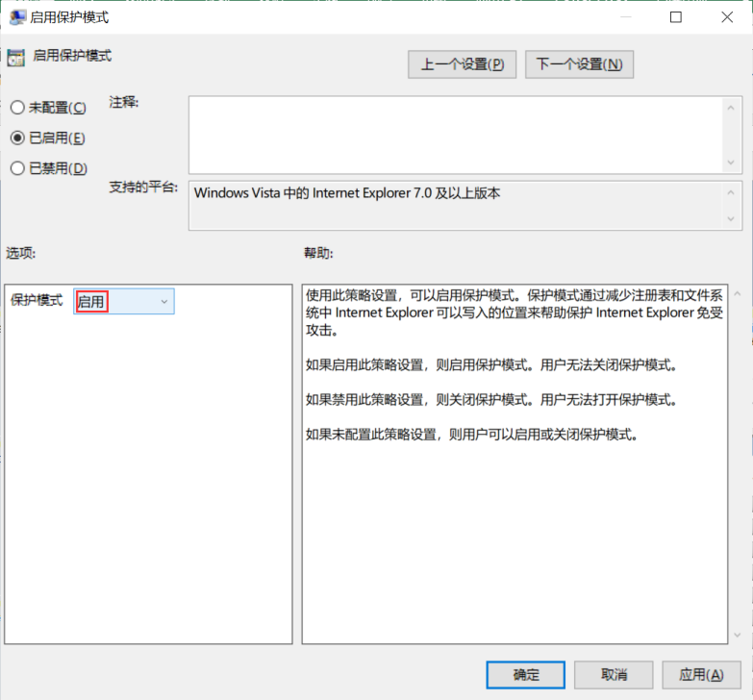

**检查语句**

select data from registry

where key like

"HKEY_CURRENT_USER\SOFTWARE\Microsoft\Windows\CurrentVersion\Group Policy Objects\%Machine%\Software\Policies\Microsoft\Windows\CurrentVersion\Internet Settings\Zones\3" and name = "2500";

**检查结果**

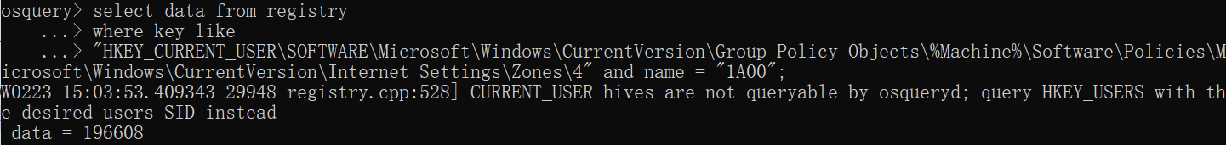

data = 0，则该检查项通过。

**397、Configure 'Turn on Protected Mode' for the restricted sites zone**

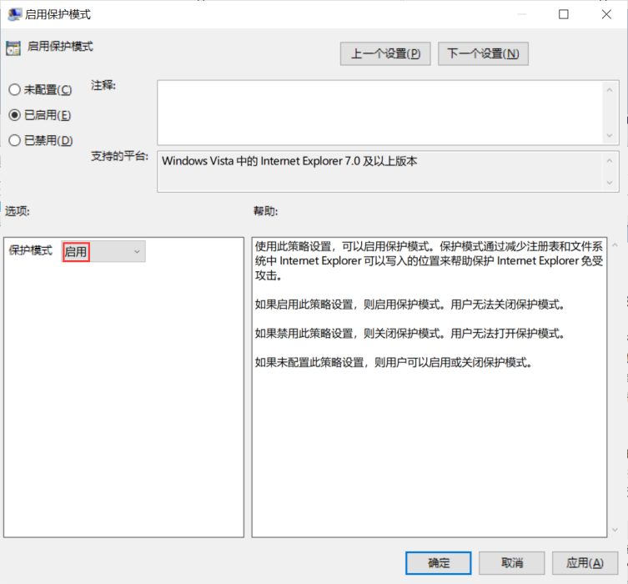

**检查语句**

select data from registry

where key like

"HKEY_CURRENT_USER\SOFTWARE\Microsoft\Windows\CurrentVersion\Group Policy Objects\%Machine%\Software\Policies\Microsoft\Windows\CurrentVersion\Internet Settings\Zones\4" and name = "2500";

**检查结果**

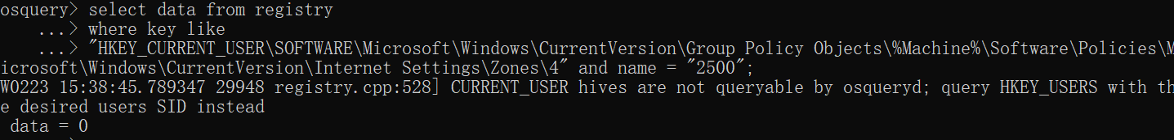

data = 0，则该检查项通过。

**396、Configure 'Do not prompt for client certificate selection when no certificates or only one certificate exists.' for the internet zone**

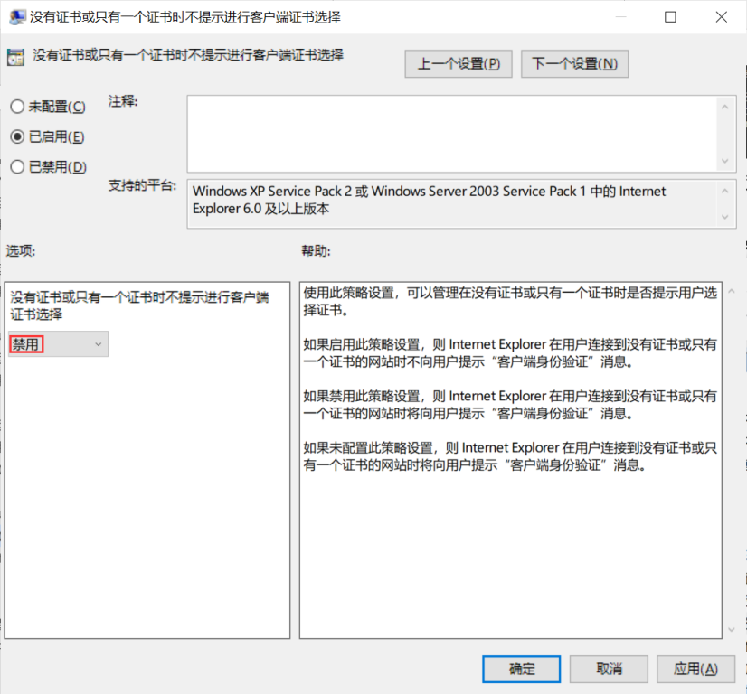

**检查语句**

select data from registry

where key like

"HKEY_CURRENT_USER\SOFTWARE\Microsoft\Windows\CurrentVersion\Group Policy Objects\%Machine%\Software\Policies\Microsoft\Windows\CurrentVersion\Internet Settings\Zones\3" and name = "1A04";

**检查结果**

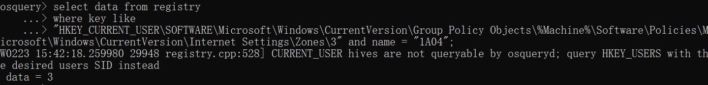

data = 3，则该检查项通过。

**395、Configure 'Display mixed content' for the internet zone**

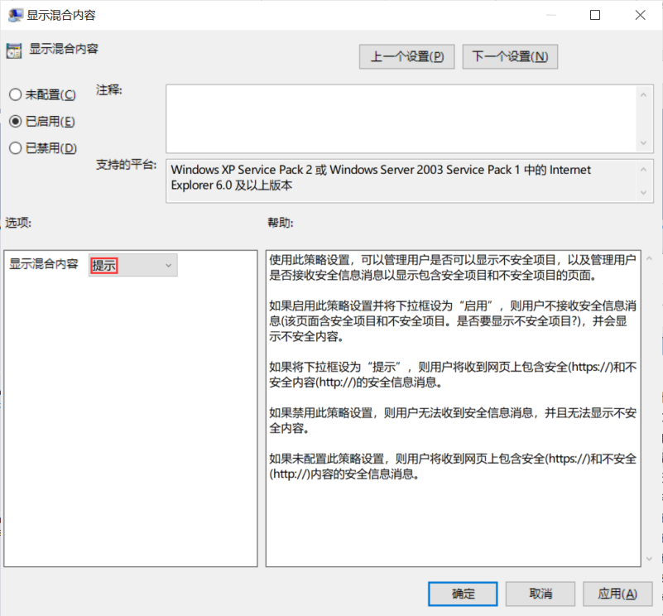

**检查语句**

select data from registry

where key like

"HKEY_CURRENT_USER\SOFTWARE\Microsoft\Windows\CurrentVersion\Group Policy Objects\%Machine%\Software\Policies\Microsoft\Windows\CurrentVersion\Internet Settings\Zones\3" and name = "1609";

**检查结果**

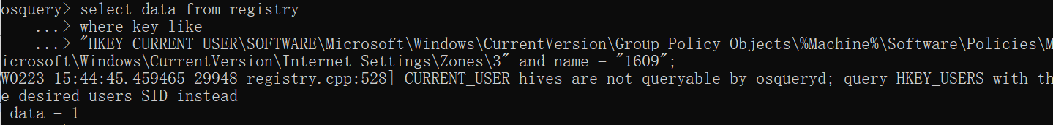

data = 1，则该检查项通过。

**394、Configure 'Submit non-encrypted form data' for the restricted sites zone**

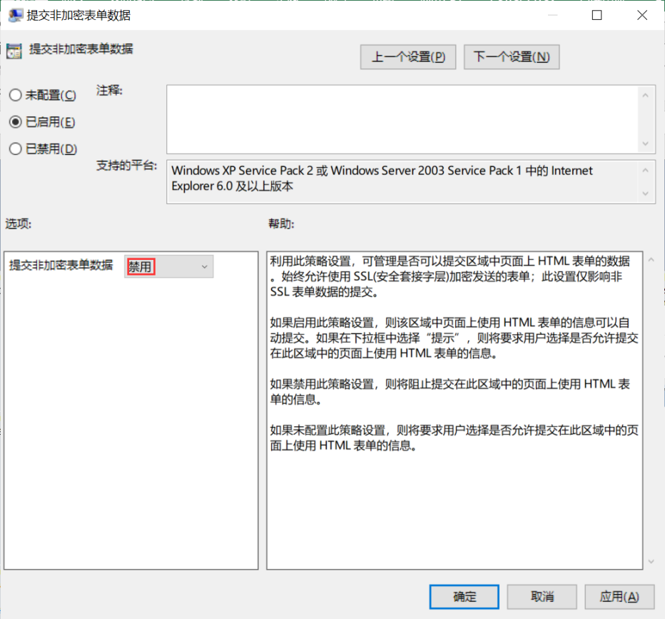

**检查语句**

select data from registry

where key like

"HKEY_CURRENT_USER\SOFTWARE\Microsoft\Windows\CurrentVersion\Group Policy Objects\%Machine%\Software\Policies\Microsoft\Windows\CurrentVersion\Internet Settings\Zones\4" and name = "1601";

**检查结果**

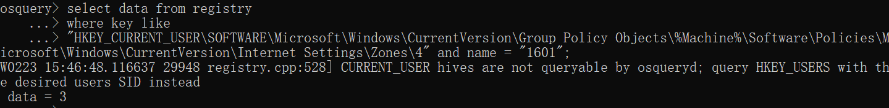

data = 3，则该检查项通过。

**393、Configure 'Do not prompt for client certificate selection when no certificates or only one certificate exists.' for the restricted sites zone**

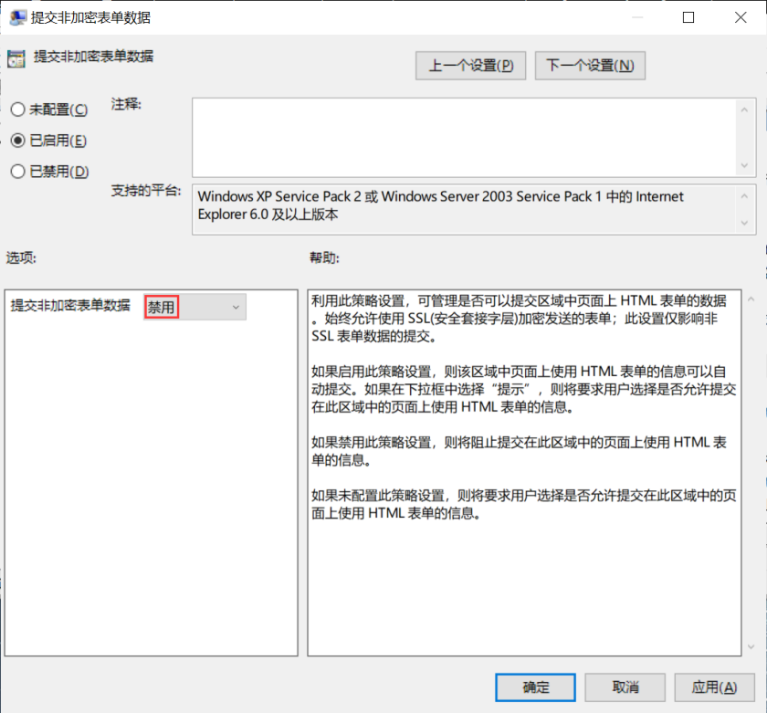

**检查语句**

select data from registry

where key like

"HKEY_CURRENT_USER\SOFTWARE\Microsoft\Windows\CurrentVersion\Group Policy Objects\%Machine%\Software\Policies\Microsoft\Windows\CurrentVersion\Internet Settings\Zones\4" and name = "1601";

**检查结果**



data = 3，则该检查项通过。

**392、Configure 'Display mixed content' for the restricted sites zone**

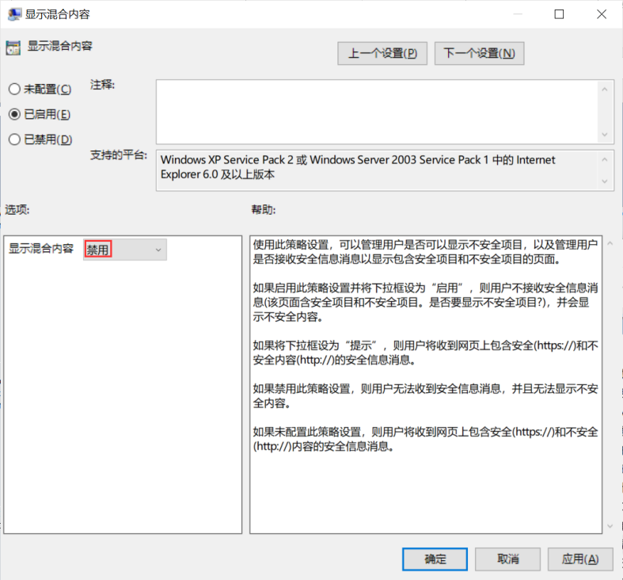

**检查语句**

select data from registry

where key like

"HKEY_CURRENT_USER\SOFTWARE\Microsoft\Windows\CurrentVersion\Group Policy Objects\%Machine%\Software\Policies\Microsoft\Windows\CurrentVersion\Internet Settings\Zones\4" and name = "1609";

**检查结果**

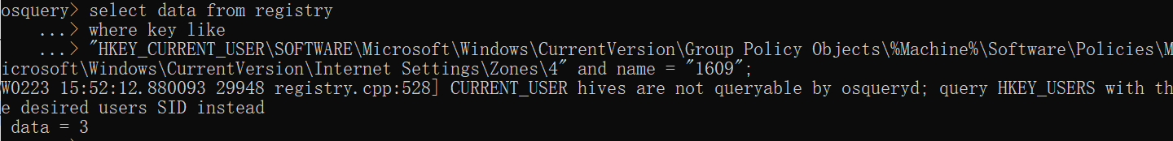

data = 3，则该检查项通过。

**391、Configure 'Turn on certificate address mismatch warning'**

**检查语句**

select data from registry

where key like

"HKEY_CURRENT_USER\SOFTWARE\Microsoft\Windows\CurrentVersion\Group Policy Objects\%Machine%\Software\Policies\Microsoft\Windows\CurrentVersion\Internet Settings" and name = "WarnOnBadCertRecving";

**检查结果**

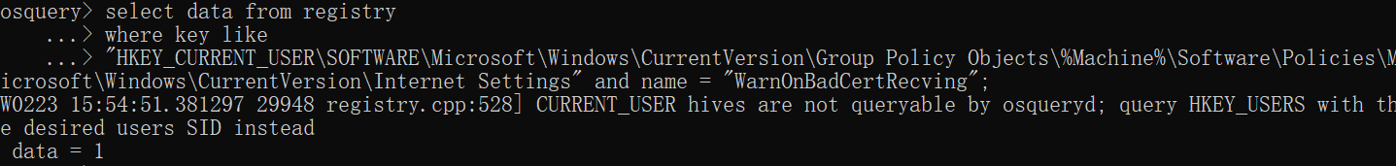

data = 1，则该检查项通过。

**390、Configure 'Turn off encryption support'**

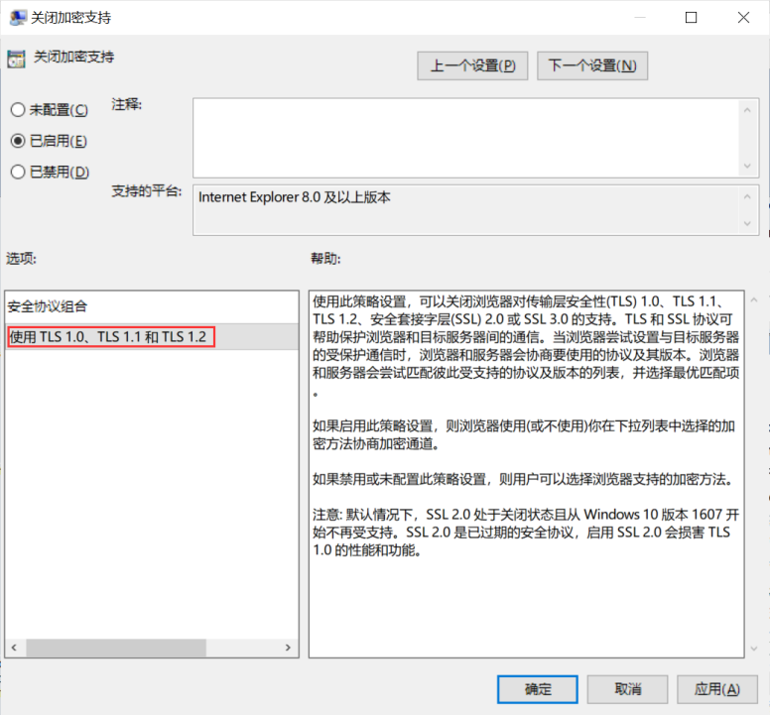

**检查语句**

select data from registry

where key like

"HKEY_CURRENT_USER\SOFTWARE\Microsoft\Windows\CurrentVersion\Group Policy Objects\%Machine%\Software\Policies\Microsoft\Windows\CurrentVersion\Internet Settings" and name = "SecureProtocols";

**检查结果**

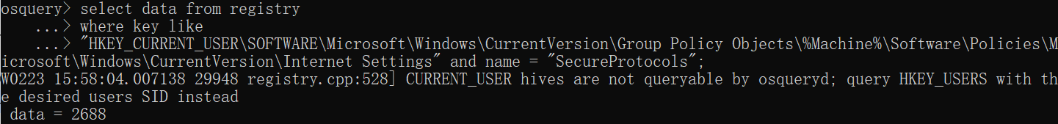

data = 2688，则该检查项通过。

**389、Configure 'Use Pop-up Blocker' for the internet zone**

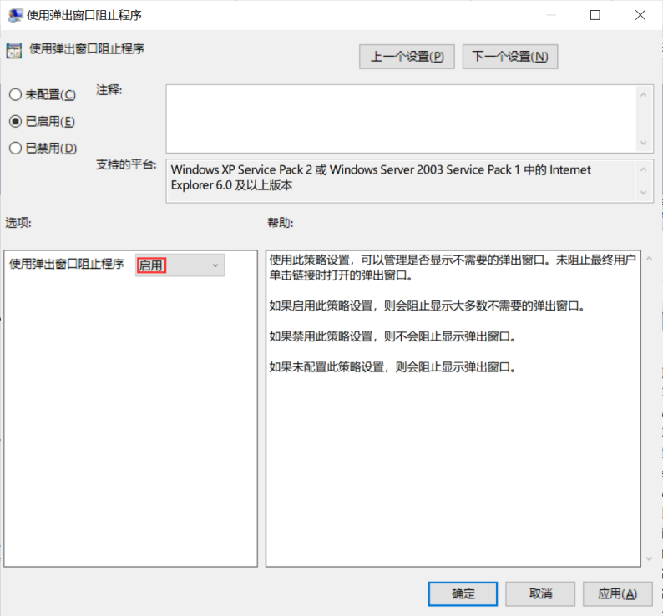

**检查语句**

select data from registry

where key like

"HKEY_CURRENT_USER\SOFTWARE\Microsoft\Windows\CurrentVersion\Group Policy Objects\%Machine%\Software\Policies\Microsoft\Windows\CurrentVersion\Internet Settings\Zones\3" and name = "1809";

**检查结果**

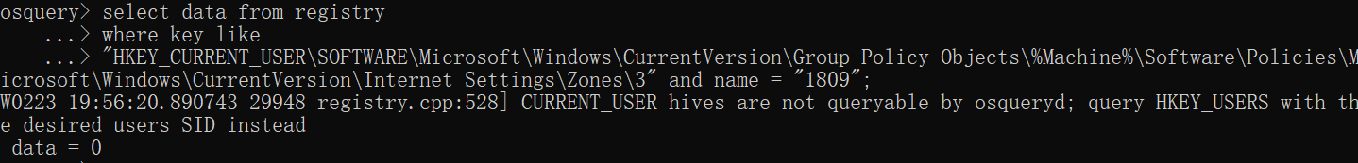

data = 0，则该检查项通过。

**388、Configure 'Use Pop-up Blocker' for the restricted sites zone**

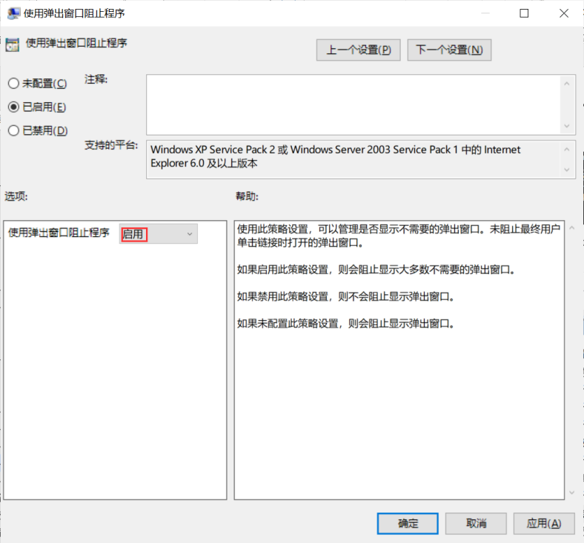

**检查语句**

select data from registry

where key like

"HKEY_CURRENT_USER\SOFTWARE\Microsoft\Windows\CurrentVersion\Group Policy Objects\%Machine%\Software\Policies\Microsoft\Windows\CurrentVersion\Internet Settings\Zones\4" and name = "1809";

**检查结果**

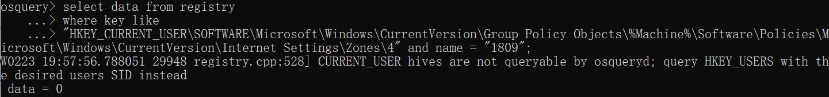

data = 0，则该检查项通过。

**383、Configure 'Turn off the Security Settings Check feature'**

**检查语句**

select data from registry

where key like

"HKEY_CURRENT_USER\SOFTWARE\Microsoft\Windows\CurrentVersion\Group Policy Objects\%Machine%\Software\Policies\Microsoft\Internet Explorer\Security" and name = "DisableSecuritySettingsCheck";

**检查结果**

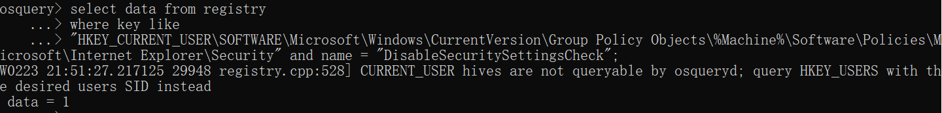

data = 1，则该检查项通过。

**382、Configure 'Turn off Managing SmartScreen Filter for Internet Explorer 8'**

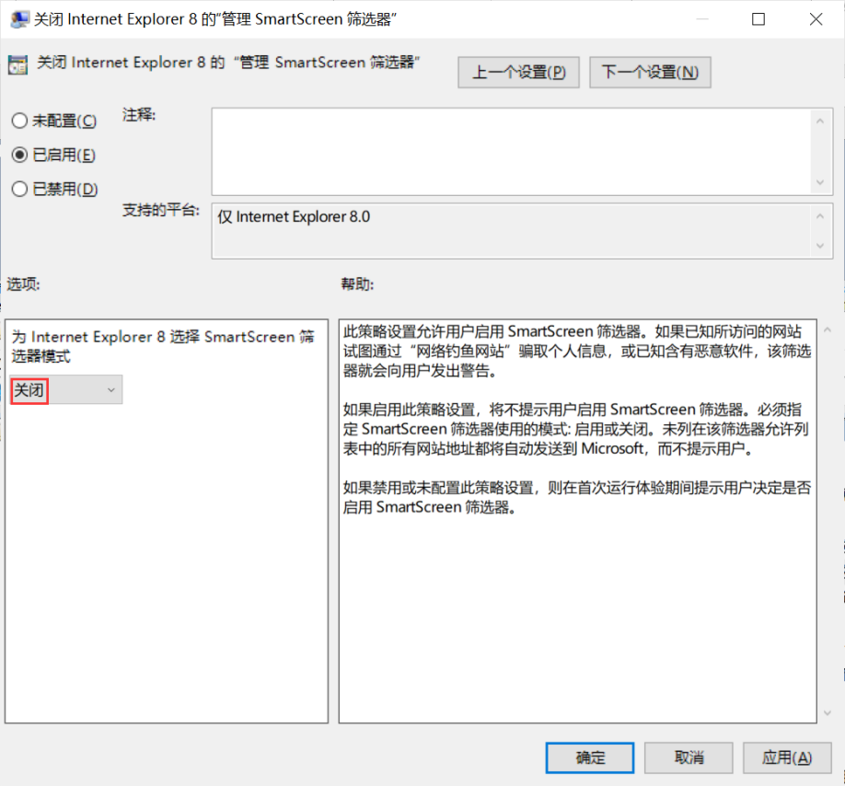

**检查语句**

select data from registry

where key like

"HKEY_CURRENT_USER\SOFTWARE\Microsoft\Windows\CurrentVersion\Group Policy Objects\%Machine%\Software\Policies\Microsoft\Internet Explorer\PhishingFilter" and name = "EnabledV8";

**检查结果**

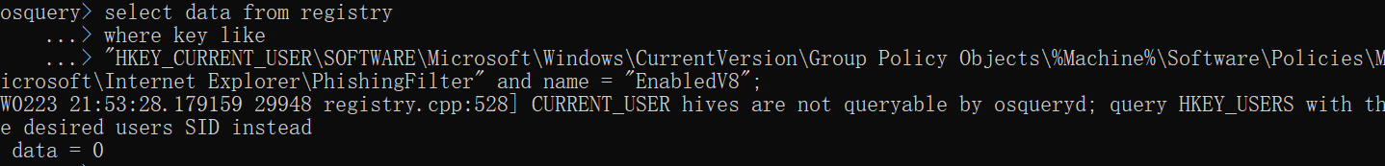

data = 0，则该检查项通过。

**381、Configure 'Prevent running First Run wizard'**

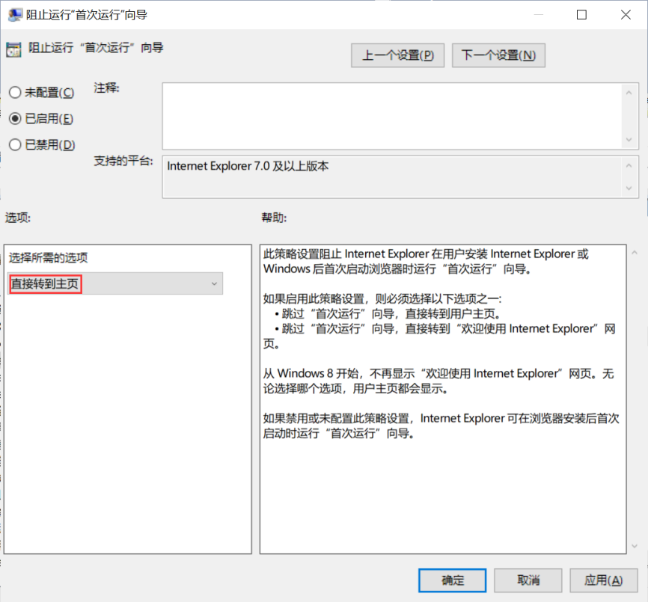

**检查语句**

select data from registry

where key like

"HKEY_CURRENT_USER\SOFTWARE\Microsoft\Windows\CurrentVersion\Group Policy Objects\%Machine%\Software\Policies\Microsoft\Internet Explorer\Main" and name = "DisableFirstRunCustomize";

**检查结果**

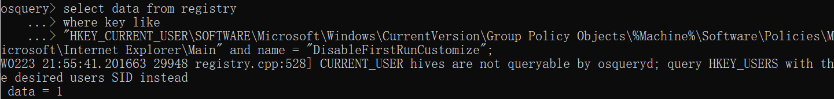

data = 1，则该检查项通过。

**380、Configure 'Prevent managing SmartScreen Filter'**

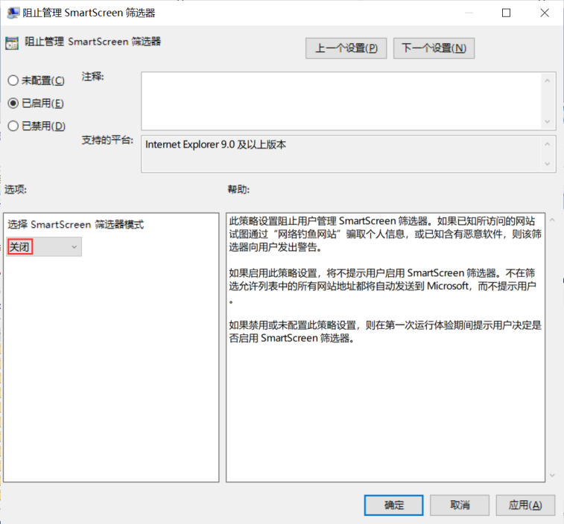

**检查语句**

select data from registry

where key like

"HKEY_CURRENT_USER\SOFTWARE\Microsoft\Windows\CurrentVersion\Group Policy Objects\%Machine%\Software\Policies\Microsoft\Internet Explorer\PhishingFilter" and name = "EnabledV9";

**检查结果**

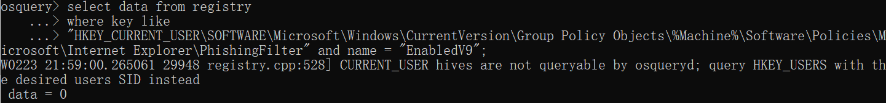

data = 0，则该检查项通过。

**379、Configure 'Turn on SmartScreen Filter scan' for the trusted sites zone**

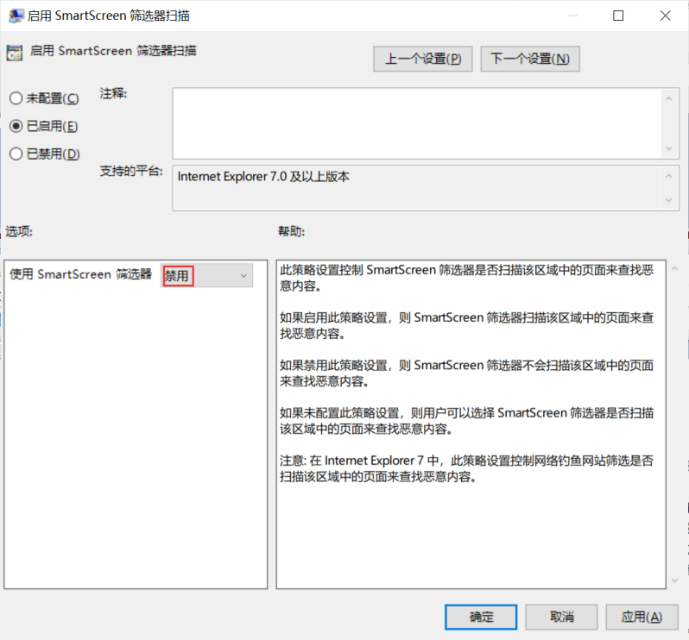

**检查语句**

select data from registry

where key like

"HKEY_CURRENT_USER\SOFTWARE\Microsoft\Windows\CurrentVersion\Group Policy Objects\%Machine%\Software\Policies\Microsoft\Windows\CurrentVersion\Internet Settings\Zones\2" and name = "2301";

**检查结果**

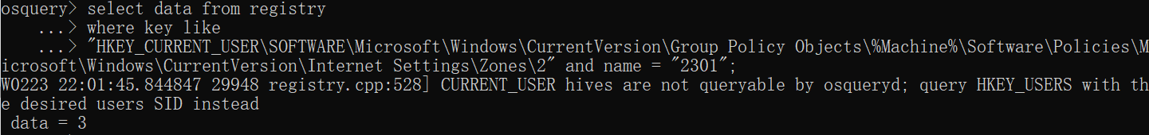

data = 3，则该检查项通过。

**378、Configure 'Turn on SmartScreen Filter scan' for the intranet zone**

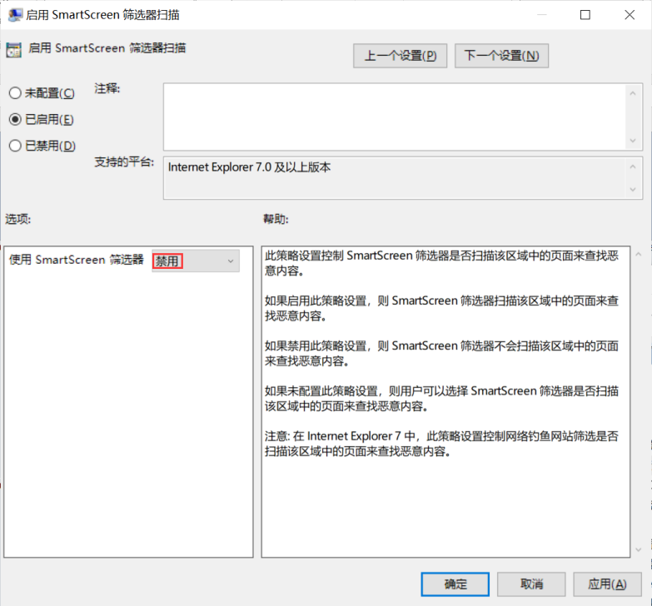

**检查语句**

select data from registry

where key like

"HKEY_CURRENT_USER\SOFTWARE\Microsoft\Windows\CurrentVersion\Group Policy Objects\%Machine%\Software\Policies\Microsoft\Windows\CurrentVersion\Internet Settings\Zones\1" and name = "2301";

**检查结果**

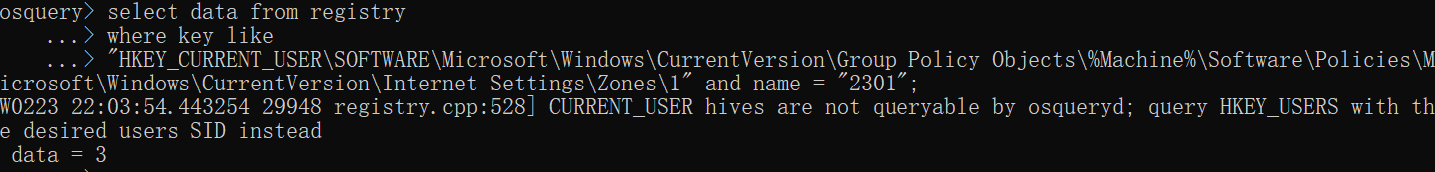

data = 3，则该检查项通过。

**377、Configure 'Turn on SmartScreen Filter scan' for the internet zone**

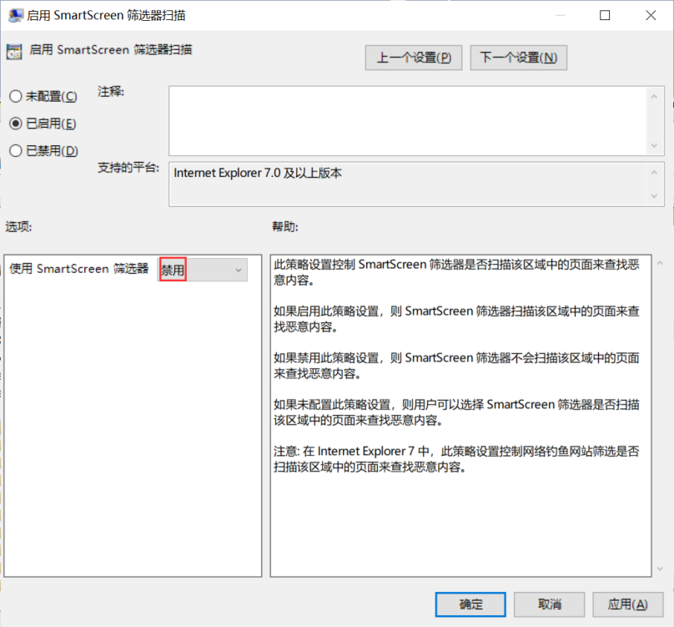

**检查语句**

select data from registry

where key like

"HKEY_CURRENT_USER\SOFTWARE\Microsoft\Windows\CurrentVersion\Group Policy Objects\%Machine%\Software\Policies\Microsoft\Windows\CurrentVersion\Internet Settings\Zones\3" and name = "2301";

**检查结果**

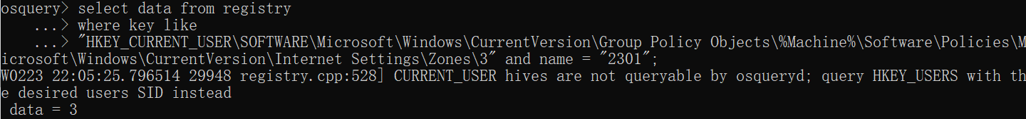

data = 3，则该检查项通过。

**376、Configure 'Turn on SmartScreen Filter scan' for the restricted sites zone**

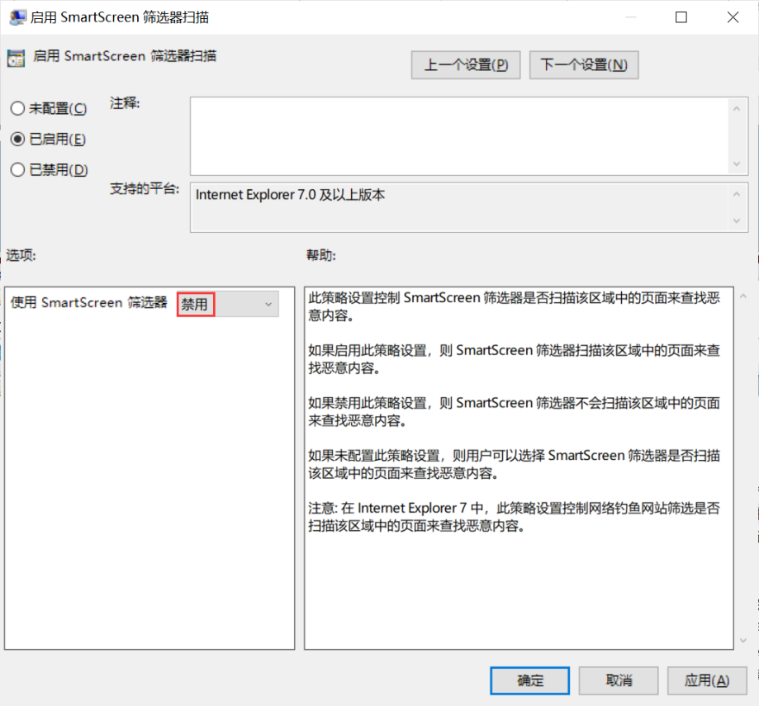

**检查语句**

select data from registry

where key like

"HKEY_CURRENT_USER\SOFTWARE\Microsoft\Windows\CurrentVersion\Group Policy Objects\%Machine%\Software\Policies\Microsoft\Windows\CurrentVersion\Internet Settings\Zones\4" and name = "2301";

**检查结果**

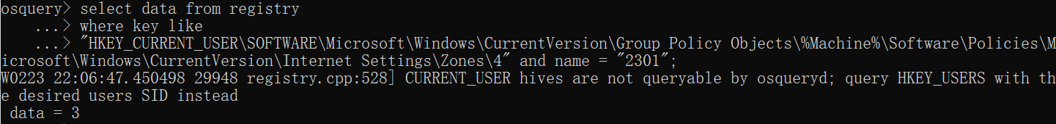

data = 3，则该检查项通过。

**375、Configure 'Turn off the ability to launch report site problems using a menu option'**

**检查语句**

select data from registry

where key like

"HKEY_CURRENT_USER\SOFTWARE\Microsoft\Windows\CurrentVersion\Group Policy Objects\%Machine%\Software\Policies\Microsoft\Internet Explorer\Main" and name = "NoReportSiteProblems";

**检查结果**

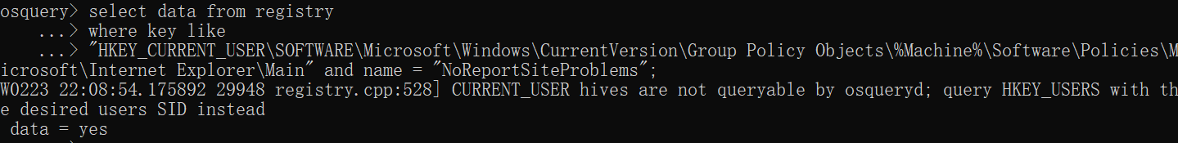

data = yes，则该检查项通过。

**374、Configure 'Help menu: Remove 'Send Feedback' menu option'**

**检查语句**

select data from registry

where key like

"HKEY_CURRENT_USER\SOFTWARE\Microsoft\Windows\CurrentVersion\Group Policy Objects\%Machine%\Software\Policies\Microsoft\Internet Explorer\Main" and name = "NoReportSiteProblems";

**检查结果**



data = yes，则该检查项通过。

**373、Configure 'Turn off Crash Detection'**

**检查语句**

select data from registry

where key like

"HKEY_CURRENT_USER\SOFTWARE\Microsoft\Windows\CurrentVersion\Group Policy Objects\%Machine%\Software\Policies\Microsoft\Internet Explorer\Restrictions" and name = "NoCrashDetection";

**检查结果**

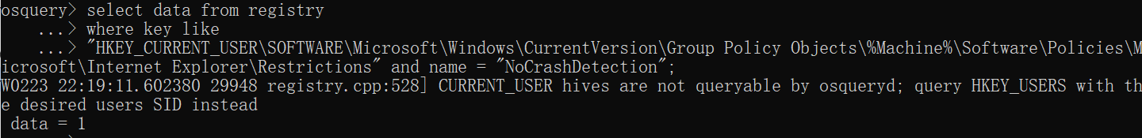

data = 1，则该检查项通过。

**372、Configure 'Turn off Automatic Crash Recovery'**

**检查语句**

select data from registry

where key like

"HKEY_CURRENT_USER\SOFTWARE\Microsoft\Windows\CurrentVersion\Group Policy Objects\%Machine%\Software\Policies\Microsoft\Internet Explorer\Recovery" and name = "AutoRecover";

**检查结果**

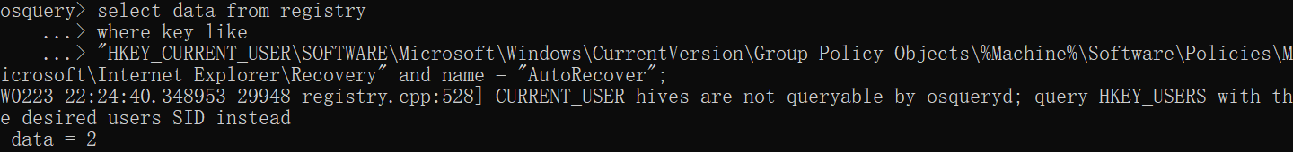

data = 2，则该检查项通过。

**371、Configure 'Prevent participation in the Customer Experience Improvement Program'**

**检查语句**

select data from registry

where key like

"HKEY_CURRENT_USER\SOFTWARE\Microsoft\Windows\CurrentVersion\Group Policy Objects\%Machine%\Software\Policies\Microsoft\Internet Explorer\SQM" and name = "DisableCustomerImprovementProgram";

**检查结果**

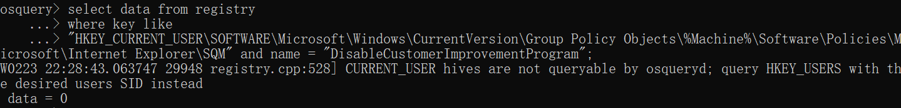

data = 0，则该检查项通过。

**370、Configure 'Turn on Suggested Sites'**

**检查语句**

select data from registry

where key like

"HKEY_CURRENT_USER\SOFTWARE\Microsoft\Windows\CurrentVersion\Group Policy Objects\%Machine%\Software\Policies\Microsoft\Internet Explorer\Suggested Sites" and name = "Enabled";

**检查结果**

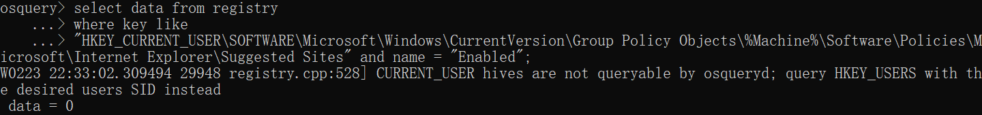

data = 0，则该检查项通过。

**369、Configure 'Allow Microsoft services to provide enhanced suggestions as the user types in the Address bar'**

**检查语句**

select data from registry

where key like

"HKEY_CURRENT_USER\SOFTWARE\Microsoft\Windows\CurrentVersion\Group Policy Objects\%Machine%\Software\Policies\Microsoft\Internet Explorer" and name = "AllowServicePoweredQSA";

**检查结果**

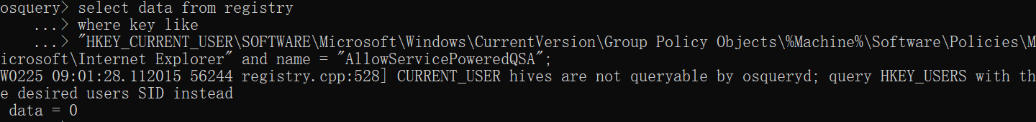

data = 0，则该检查项通过。

**368、Configure 'Turn off the flip ahead with page prediction feature'**

**检查语句**

select data from registry

where key like

"HKEY_CURRENT_USER\SOFTWARE\Microsoft\Windows\CurrentVersion\Group Policy Objects\%Machine%\Software\Policies\Microsoft\Internet Explorer\FlipAhead" and name = "Enabled";

**检查结果**

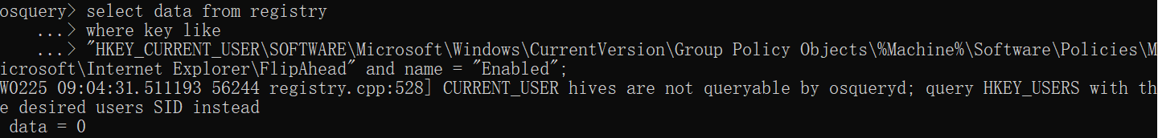

data = 0，则该检查项通过。

**367、Configure 'Turn off Accelerators'**

**检查语句**

select data from registry

where key like

"HKEY_CURRENT_USER\SOFTWARE\Microsoft\Windows\CurrentVersion\Group Policy Objects\%Machine%\Software\Policies\Microsoft\Internet Explorer\Activities" and name = "NoActivities";

**检查结果**

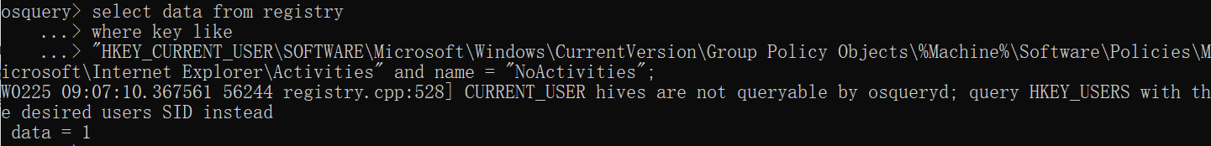

data = 1，则该检查项通过。

**366、Configure 'Allow third-party browser extensions'**

**检查语句**

select data from registry

where key like

"HKEY_CURRENT_USER\SOFTWARE\Microsoft\Windows\CurrentVersion\Group Policy Objects\%Machine%\Software\Policies\Microsoft\Internet Explorer\Main" and name = "Enable Browser Extensions";

**检查结果**

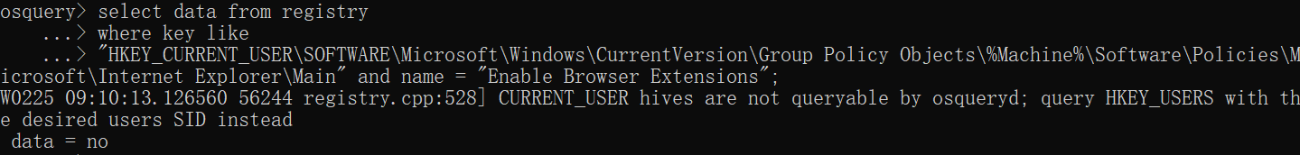

data = no，则该检查项通过。

**365、Configure 'Turn on Cross-Site Scripting Filter' for the trusted sites zone**

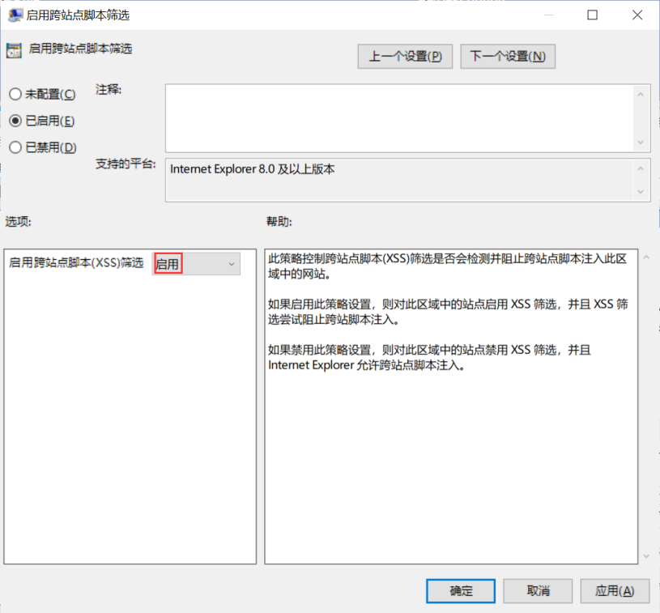

**检查语句**

select data from registry

where key like

"HKEY_CURRENT_USER\SOFTWARE\Microsoft\Windows\CurrentVersion\Group Policy Objects\%Machine%\Software\Policies\Microsoft\Windows\CurrentVersion\Internet Settings\Zones\2" and name = "1409";

**检查结果**

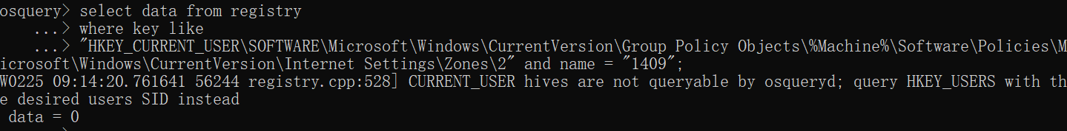

data = 0，则该检查项通过。

**364、Configure 'Turn on Cross-Site Scripting Filter' for the intranet zone**

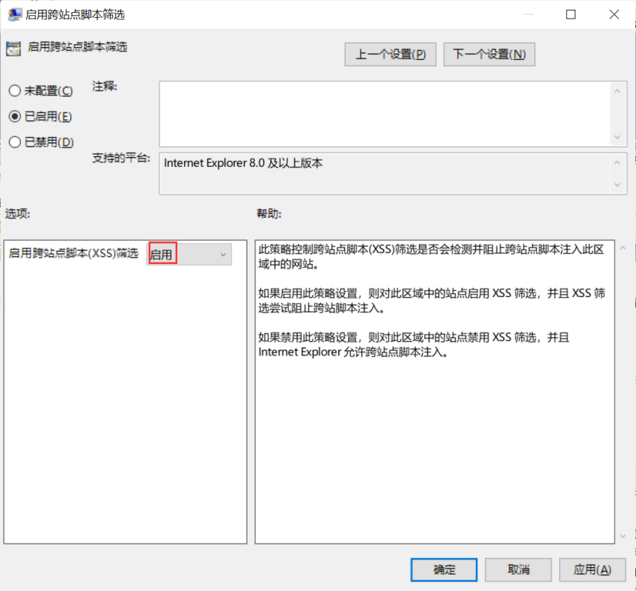

**检查语句**

select data from registry

where key like

"HKEY_CURRENT_USER\SOFTWARE\Microsoft\Windows\CurrentVersion\Group Policy Objects\%Machine%\Software\Policies\Microsoft\Windows\CurrentVersion\Internet Settings\Zones\1" and name = "1409";

**检查结果**

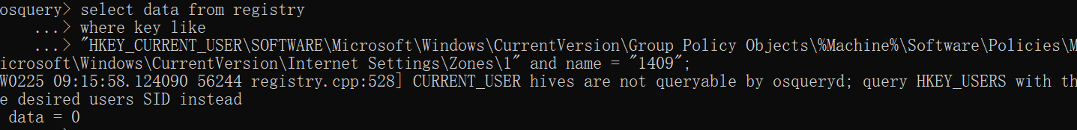

data = 0，则该检查项通过。

**363、Configure 'Turn on Cross-Site Scripting Filter' for the internet zone**

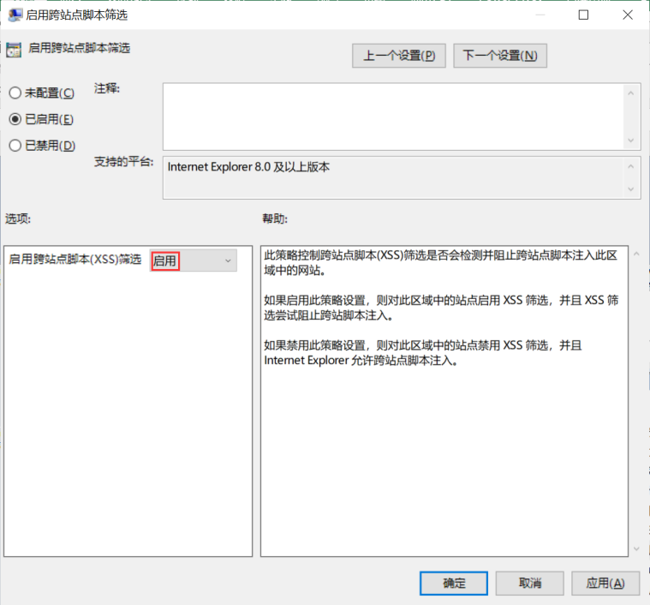

**检查语句**

select data from registry

where key like

"HKEY_CURRENT_USER\SOFTWARE\Microsoft\Windows\CurrentVersion\Group Policy Objects\%Machine%\Software\Policies\Microsoft\Windows\CurrentVersion\Internet Settings\Zones\3" and name = "1409";

**检查结果**

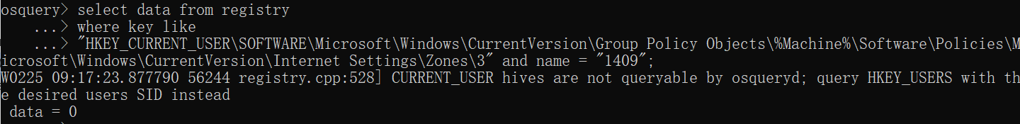

data = 0，则该检查项通过。

**362、Configure 'Allow websites to prompt for information by using scripted windows' for the internet zone**

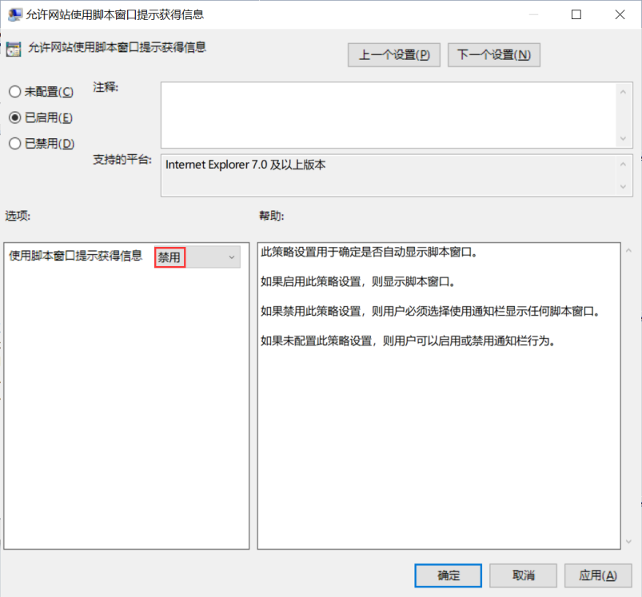

**检查语句**

select data from registry

where key like

"HKEY_CURRENT_USER\SOFTWARE\Microsoft\Windows\CurrentVersion\Group Policy Objects\%Machine%\Software\Policies\Microsoft\Windows\CurrentVersion\Internet Settings\Zones\3" and name = "2105";

**检查结果**

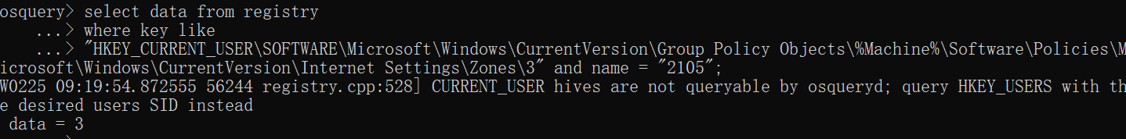

data = 3，则该检查项通过。

**361、Configure 'Allow updates to status bar via script' for the internet zone**

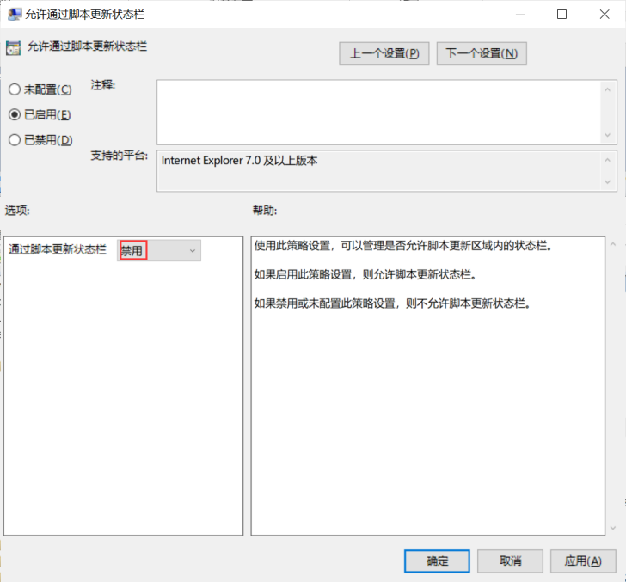

**检查语句**

select data from registry

where key like

"HKEY_CURRENT_USER\SOFTWARE\Microsoft\Windows\CurrentVersion\Group Policy Objects\%Machine%\Software\Policies\Microsoft\Windows\CurrentVersion\Internet Settings\Zones\3" and name = "2103";

**检查结果**

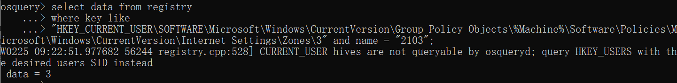

data = 3，则该检查项通过。

**360、Configure 'Allow script-initiated windows without size or position constraints' for the internet zone**

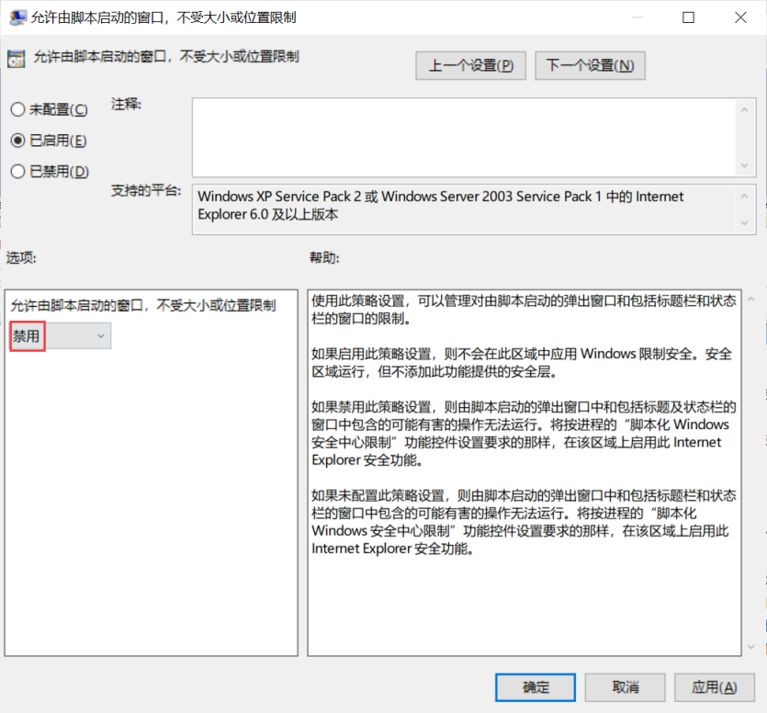

**检查语句**

select data from registry

where key like

"HKEY_CURRENT_USER\SOFTWARE\Microsoft\Windows\CurrentVersion\Group Policy Objects\%Machine%\Software\Policies\Microsoft\Windows\CurrentVersion\Internet Settings\Zones\3" and name = "2102";

**检查结果**

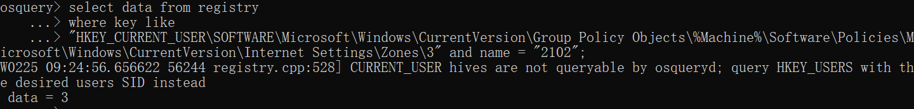

data = 3，则该检查项通过。

**359、Configure 'Allow scripting of Internet Explorer WebBrowser controls' for the internet zone**

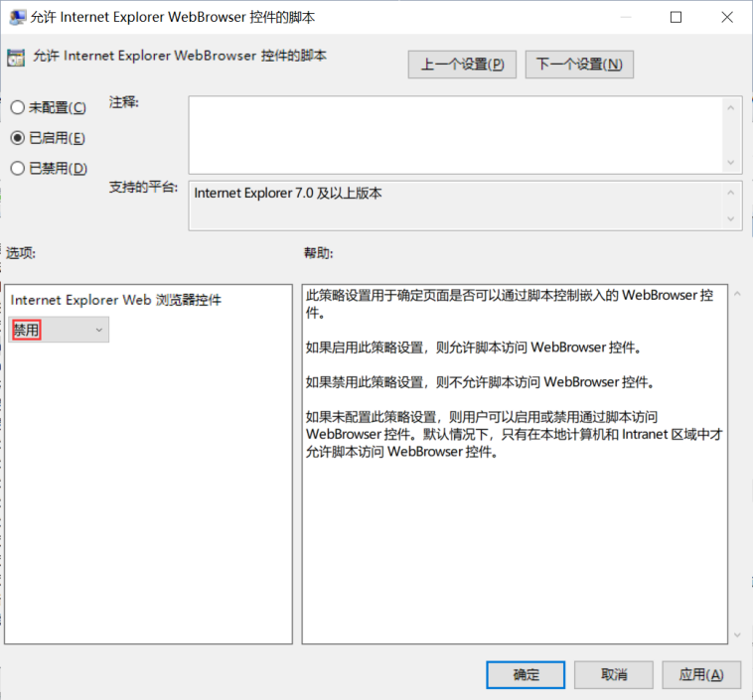

**检查语句**

select data from registry

where key like

"HKEY_CURRENT_USER\SOFTWARE\Microsoft\Windows\CurrentVersion\Group Policy Objects\%Machine%\Software\Policies\Microsoft\Windows\CurrentVersion\Internet Settings\Zones\3" and name = "1206";

**检查结果**

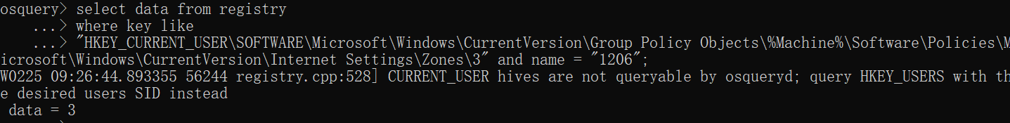

data = 3，则该检查项通过。

**358、Configure 'Allow cut, copy or paste operations from the clipboard via script' for the internet zone**

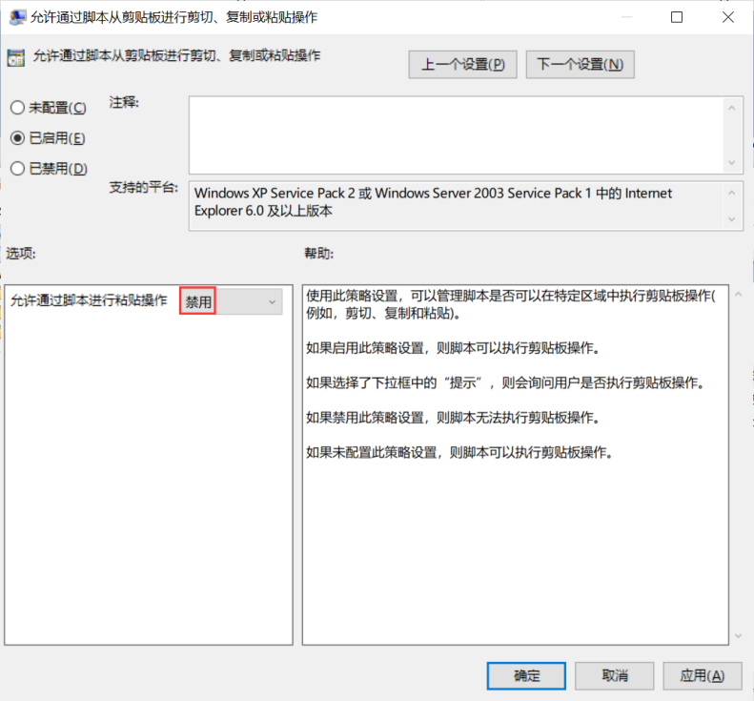

**检查语句**

select data from registry

where key like

"HKEY_CURRENT_USER\SOFTWARE\Microsoft\Windows\CurrentVersion\Group Policy Objects\%Machine%\Software\Policies\Microsoft\Windows\CurrentVersion\Internet Settings\Zones\3" and name = "1407";

**检查结果**

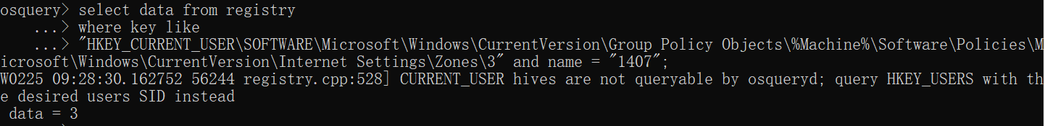

data = 3，则该检查项通过。

**357、Configure 'Allow VBScript to run in Internet Explorer' for the internet zone**

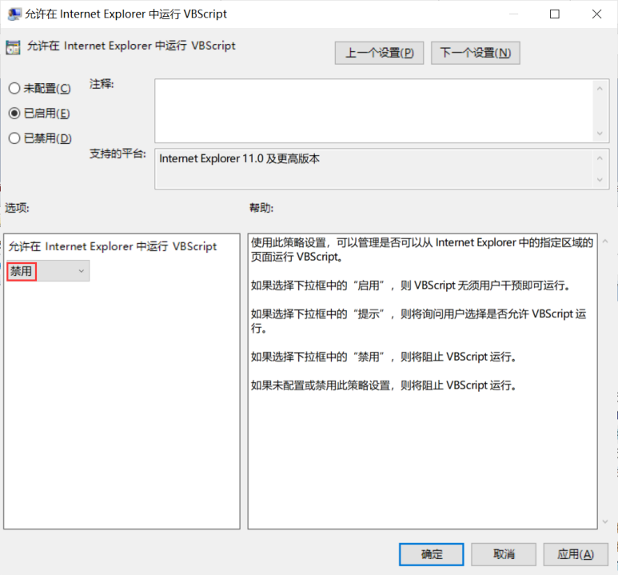

**检查语句**

select data from registry

where key like

"HKEY_CURRENT_USER\SOFTWARE\Microsoft\Windows\CurrentVersion\Group Policy Objects\%Machine%\Software\Policies\Microsoft\Windows\CurrentVersion\Internet Settings\Zones\3" and name = "140C";

**检查结果**

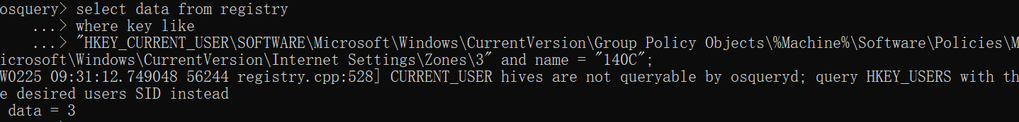

data = 3，则该检查项通过。

**356、Configure 'Turn on Cross-Site Scripting Filter' for the restricted sites zone**

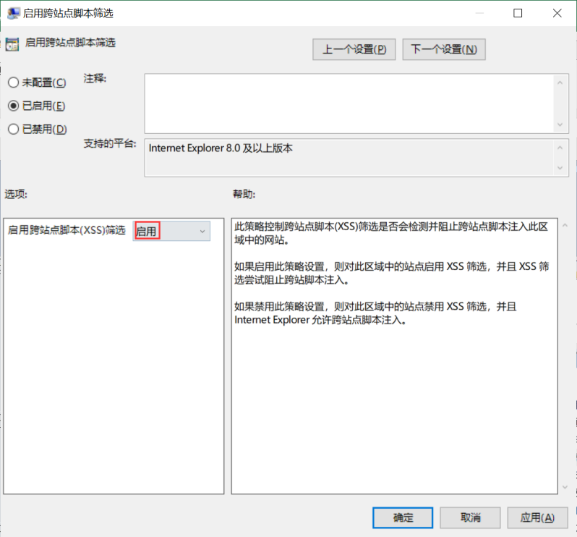

**检查语句**

select data from registry

where key like

"HKEY_CURRENT_USER\SOFTWARE\Microsoft\Windows\CurrentVersion\Group Policy Objects\%Machine%\Software\Policies\Microsoft\Windows\CurrentVersion\Internet Settings\Zones\4" and name = "1409";

**检查结果**

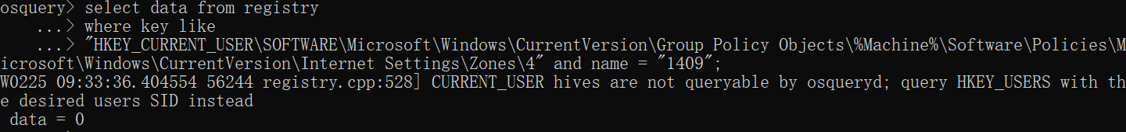

data = 0，则该检查项通过。

**355、Configure 'Scripting of Java applets' for the restricted sites zone**

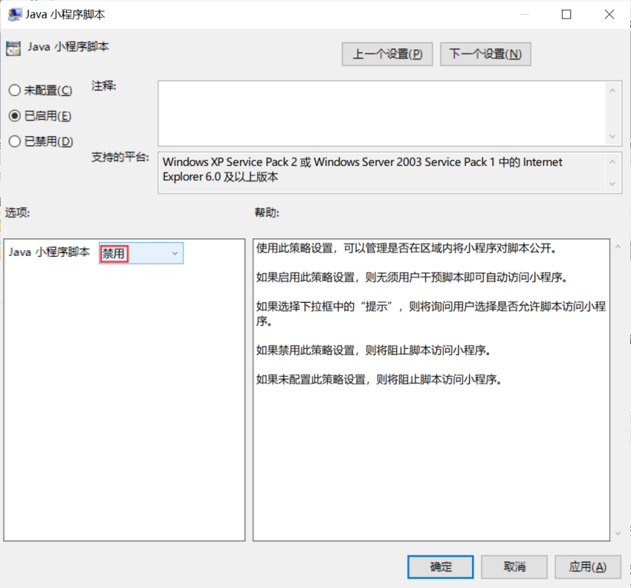

**检查语句**

select data from registry

where key like

"HKEY_CURRENT_USER\SOFTWARE\Microsoft\Windows\CurrentVersion\Group Policy Objects\%Machine%\Software\Policies\Microsoft\Windows\CurrentVersion\Internet Settings\Zones\4" and name = "1402";

**检查结果**

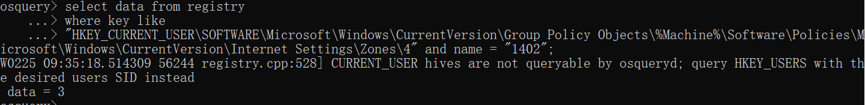

data = 3，则该检查项通过。

**354、Configure 'Allow websites to prompt for information by using scripted windows' for the restricted sites zone**

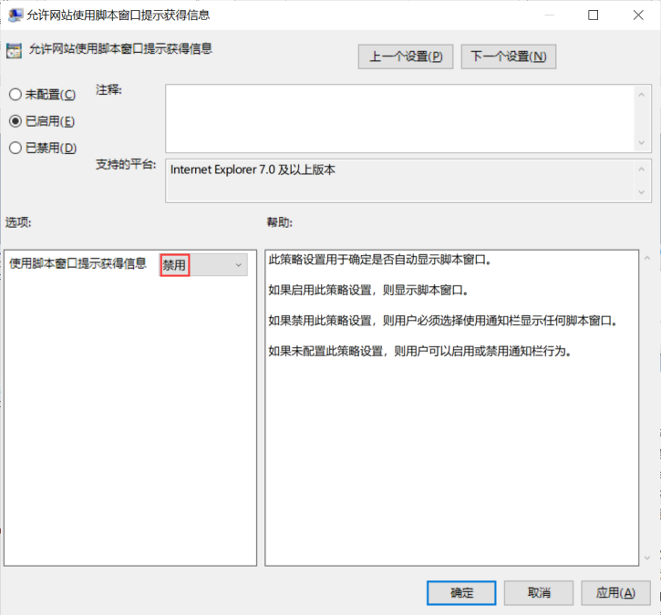

**检查语句**

select data from registry

where key like

"HKEY_CURRENT_USER\SOFTWARE\Microsoft\Windows\CurrentVersion\Group Policy Objects\%Machine%\Software\Policies\Microsoft\Windows\CurrentVersion\Internet Settings\Zones\4" and name = "2105";

**检查结果**

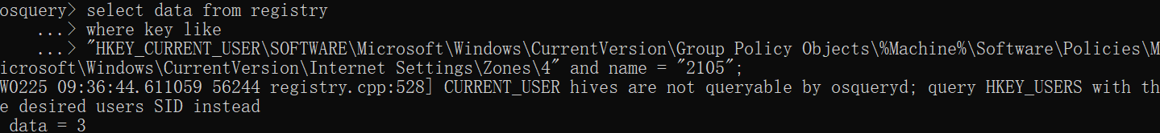

data = 3，则该检查项通过。

**353、Configure 'Allow updates to status bar via script' for the restricted sites zone**

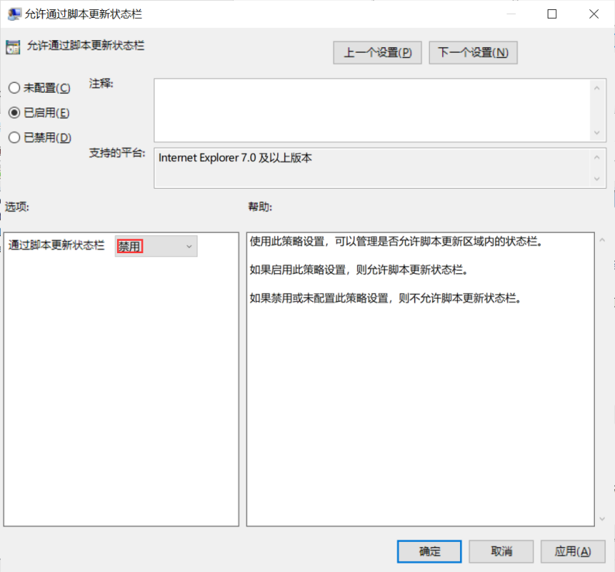

**检查语句**

select data from registry

where key like

"HKEY_CURRENT_USER\SOFTWARE\Microsoft\Windows\CurrentVersion\Group Policy Objects\%Machine%\Software\Policies\Microsoft\Windows\CurrentVersion\Internet Settings\Zones\4" and name = "2103";

**检查结果**

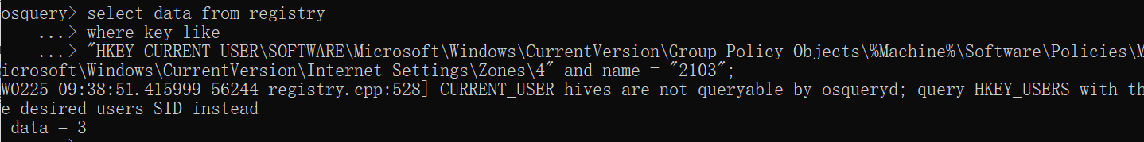

data = 3，则该检查项通过。

**352、Configure 'Allow script-initiated windows without size or position constraints' for the restricted sites zone**

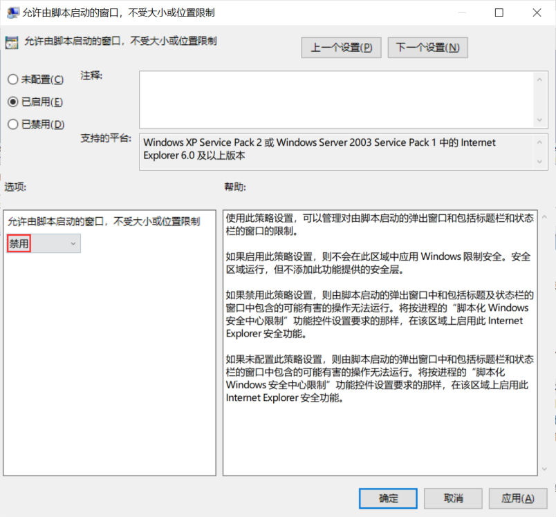

**检查语句**

select data from registry

where key like

"HKEY_CURRENT_USER\SOFTWARE\Microsoft\Windows\CurrentVersion\Group Policy Objects\%Machine%\Software\Policies\Microsoft\Windows\CurrentVersion\Internet Settings\Zones\4" and name = "2102";

**检查结果**

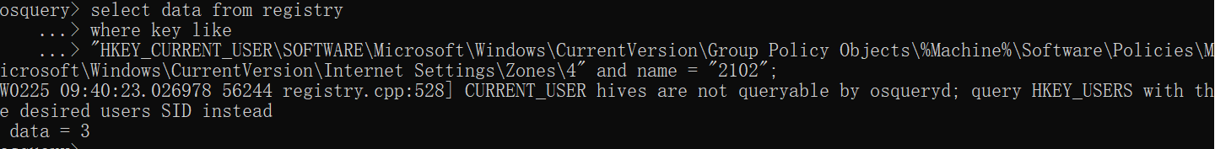

data = 3，则该检查项通过。

**351、Configure 'Allow scripting of Internet Explorer WebBrowser controls' for the restricted sites zone**

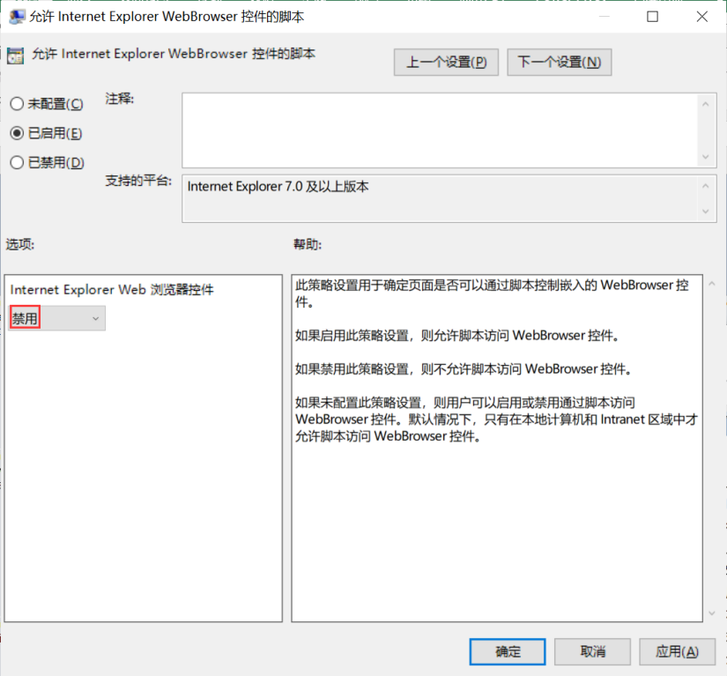

**检查语句**

select data from registry

where key like

"HKEY_CURRENT_USER\SOFTWARE\Microsoft\Windows\CurrentVersion\Group Policy Objects\%Machine%\Software\Policies\Microsoft\Windows\CurrentVersion\Internet Settings\Zones\4" and name = "1206";

**检查结果**

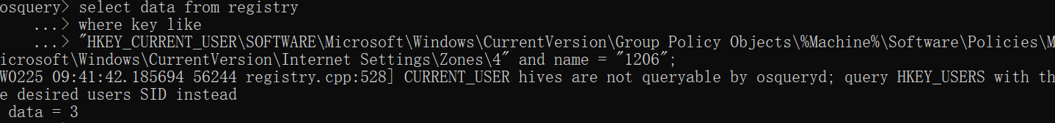

data = 3，则该检查项通过。

**350、Configure 'Allow cut, copy or paste operations from the clipboard via script' for the restricted sites zone**

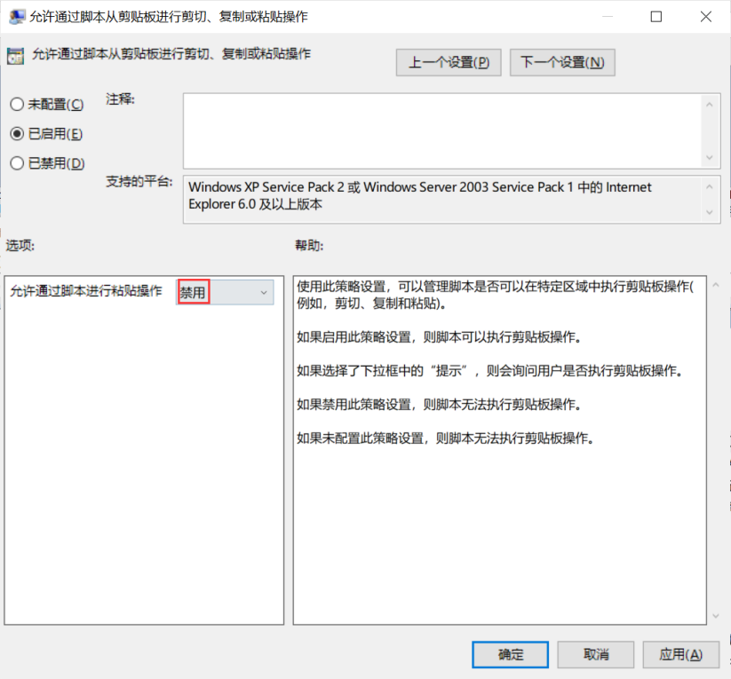

**检查语句**

select data from registry

where key like

"HKEY_CURRENT_USER\SOFTWARE\Microsoft\Windows\CurrentVersion\Group Policy Objects\%Machine%\Software\Policies\Microsoft\Windows\CurrentVersion\Internet Settings\Zones\4" and name = "1407";

**检查结果**

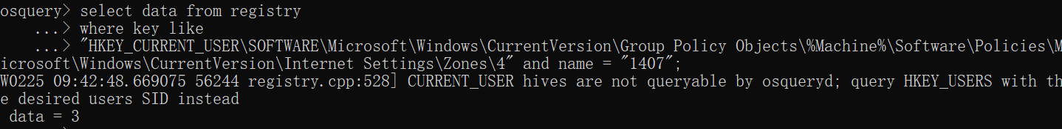

data = 3，则该检查项通过。

**349、Configure 'Allow VBScript to run in Internet Explorer' for the restricted sites zone**

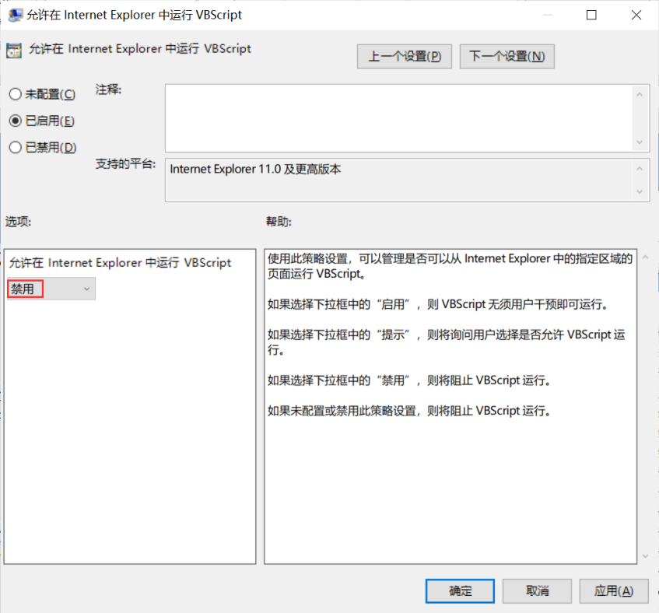

**检查语句**

select data from registry

where key like

"HKEY_CURRENT_USER\SOFTWARE\Microsoft\Windows\CurrentVersion\Group Policy Objects\%Machine%\Software\Policies\Microsoft\Windows\CurrentVersion\Internet Settings\Zones\4" and name = "140C";

**检查结果**

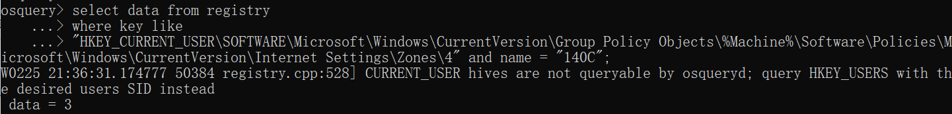

data = 3，则该检查项通过。

**348、Configure 'Allow active scripting' for the restricted sites zone**

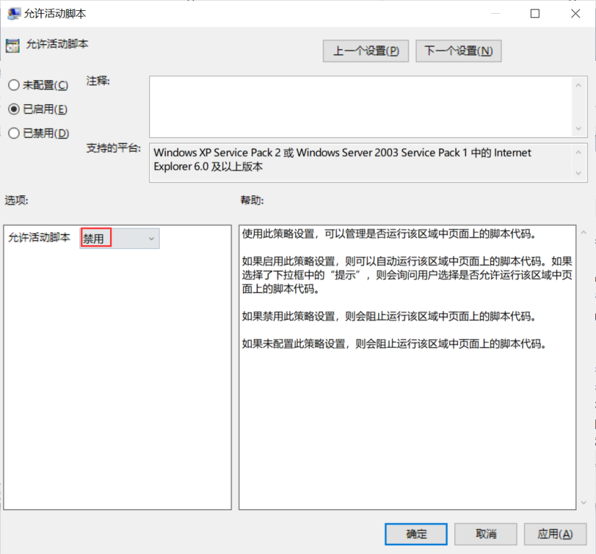

**检查语句**

select data from registry

where key like

"HKEY_CURRENT_USER\SOFTWARE\Microsoft\Windows\CurrentVersion\Group Policy Objects\%Machine%\Software\Policies\Microsoft\Windows\CurrentVersion\Internet Settings\Zones\4" and name = "1400";

**检查结果**

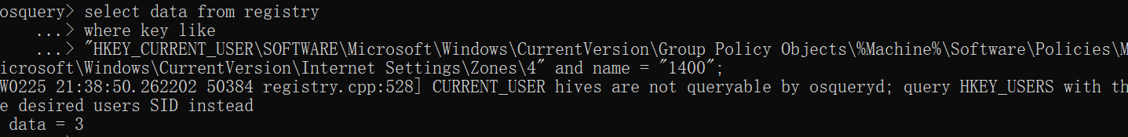

data = 3，则该检查项通过。

**347、Configure 'Automatic prompting for file downloads' for the internet zone**

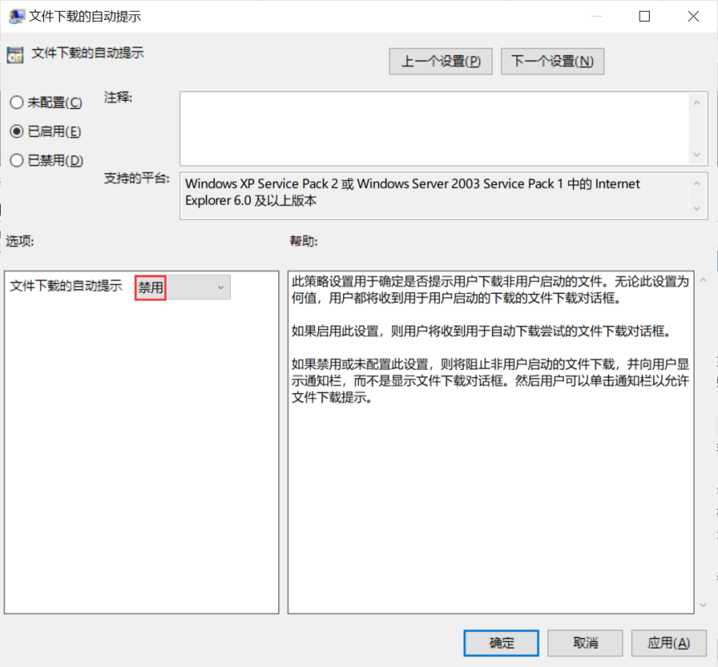

**检查语句**

select data from registry

where key like

"HKEY_CURRENT_USER\SOFTWARE\Microsoft\Windows\CurrentVersion\Group Policy Objects\%Machine%\Software\Policies\Microsoft\Windows\CurrentVersion\Internet Settings\Zones\3" and name = "2200";

**检查结果**

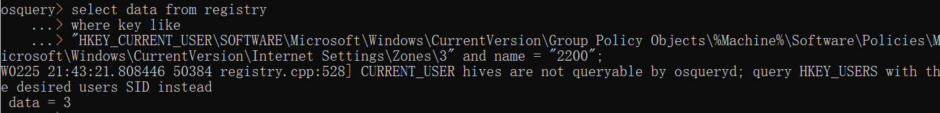

data = 3，则该检查项通过。

**346、Configure 'Automatic prompting for file downloads' for the restricted sites zone**

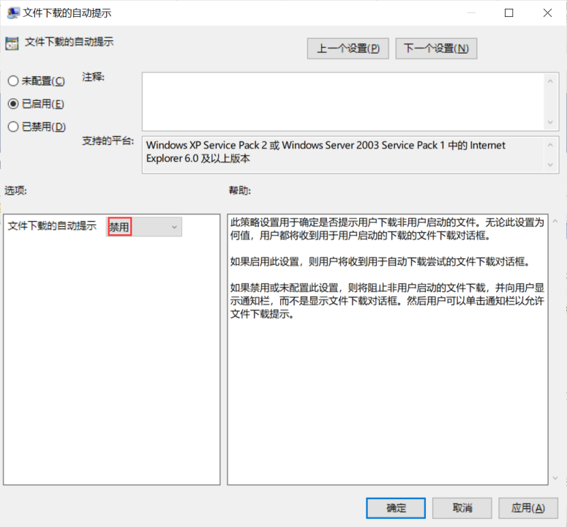

**检查语句**

select data from registry

where key like

"HKEY_CURRENT_USER\SOFTWARE\Microsoft\Windows\CurrentVersion\Group Policy Objects\%Machine%\Software\Policies\Microsoft\Windows\CurrentVersion\Internet Settings\Zones\4" and name = "2200";

**检查结果**

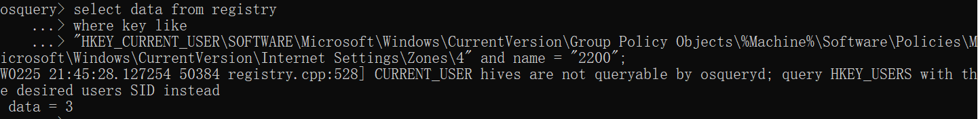

data = 3，则该检查项通过。

**345、Configure 'Allow font downloads' for the restricted sites zone**

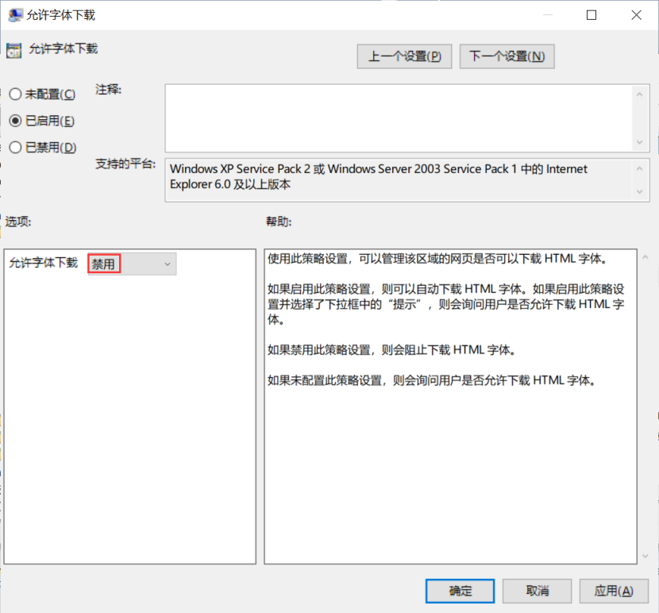

**检查语句**

select data from registry

where key like

"HKEY_CURRENT_USER\SOFTWARE\Microsoft\Windows\CurrentVersion\Group Policy Objects\%Machine%\Software\Policies\Microsoft\Windows\CurrentVersion\Internet Settings\Zones\4" and name = "1604";

**检查结果**

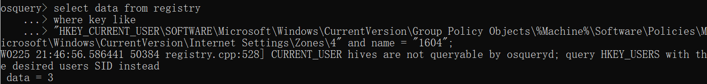

data = 3，则该检查项通过。

**344、Configure 'Allow file downloads' for the restricted sites zone**

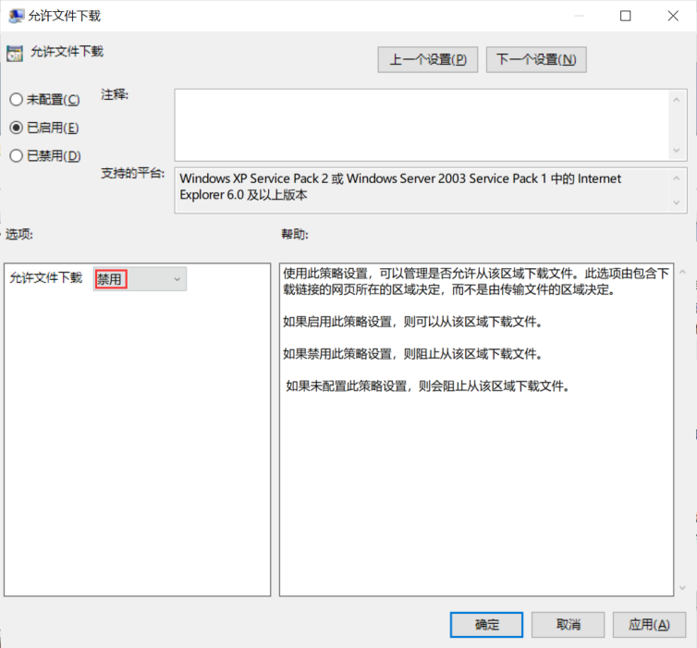

**检查语句**

select data from registry

where key like

"HKEY_CURRENT_USER\SOFTWARE\Microsoft\Windows\CurrentVersion\Group Policy Objects\%Machine%\Software\Policies\Microsoft\Windows\CurrentVersion\Internet Settings\Zones\4" and name = "1803";

**检查结果**

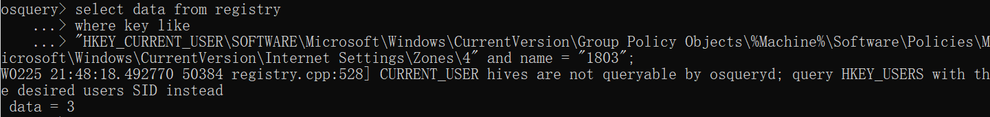

data = 3，则该检查项通过。

**343、Configure 'Allow video and animation on a webpage that uses an older media player' for the trusted sites zone**

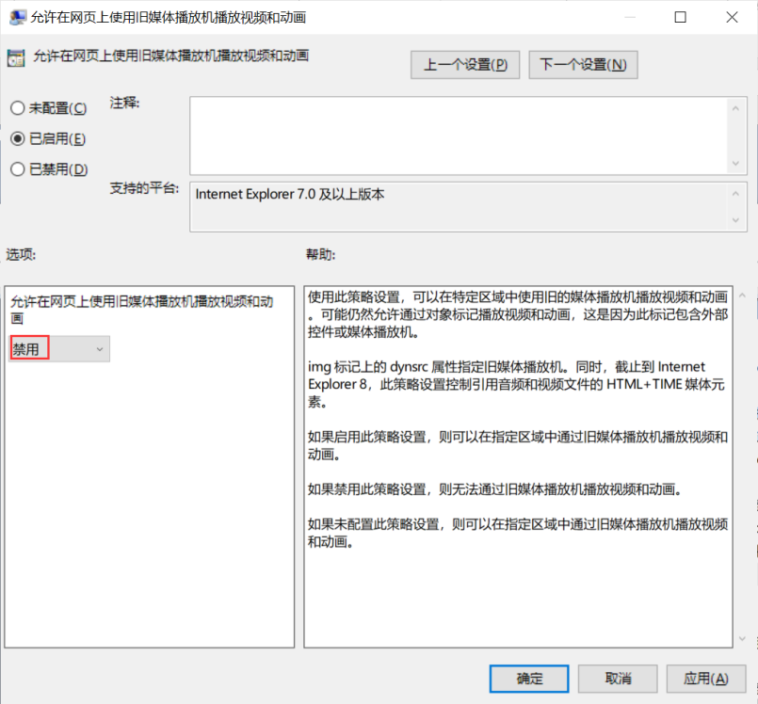

**检查语句**

select data from registry

where key like

"HKEY_CURRENT_USER\SOFTWARE\Microsoft\Windows\CurrentVersion\Group Policy Objects\%Machine%\Software\Policies\Microsoft\Windows\CurrentVersion\Internet Settings\Zones\2" and name = "120A";

**检查结果**

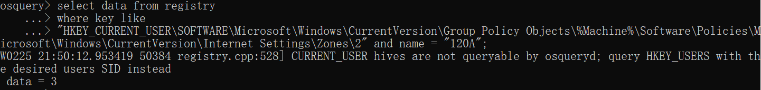

data = 3，则该检查项通过。

**342、Configure 'Allow video and animation on a webpage that uses an older media player' for the intranet zone**

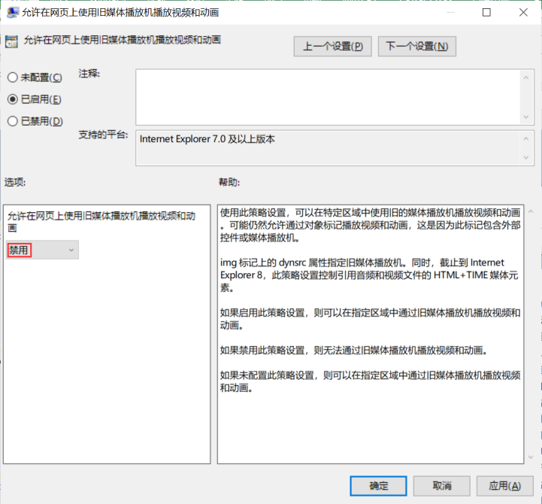

**检查语句**

select data from registry

where key like

"HKEY_CURRENT_USER\SOFTWARE\Microsoft\Windows\CurrentVersion\Group Policy Objects\%Machine%\Software\Policies\Microsoft\Windows\CurrentVersion\Internet Settings\Zones\1" and name = "120A";

**检查结果**

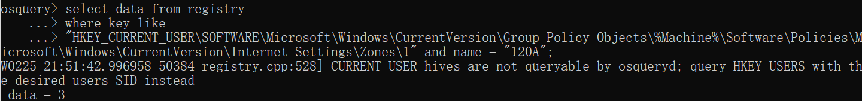

data = 3，则该检查项通过。

**341、Configure 'Allow scriptlets' for the intranet zone**

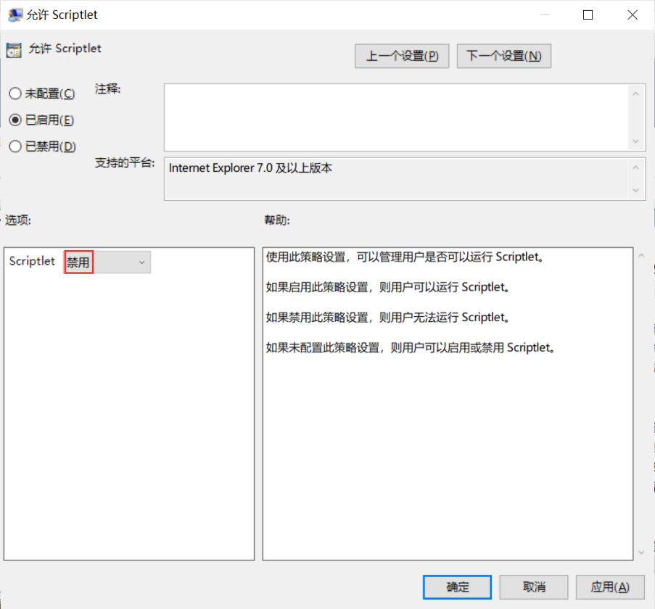

**检查语句**

select data from registry

where key like

"HKEY_CURRENT_USER\SOFTWARE\Microsoft\Windows\CurrentVersion\Group Policy Objects\%Machine%\Software\Policies\Microsoft\Windows\CurrentVersion\Internet Settings\Zones\1" and name = "1209";

**检查结果**

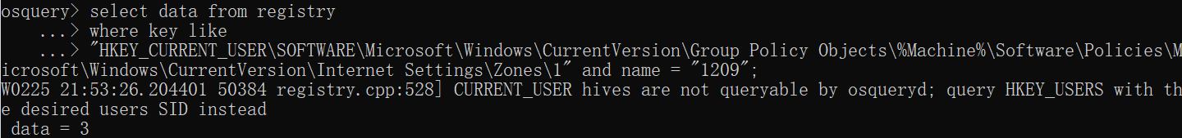

data = 3，则该检查项通过。

**340、Configure 'Allow video and animation on a webpage that uses an older media player' for the internet zone**

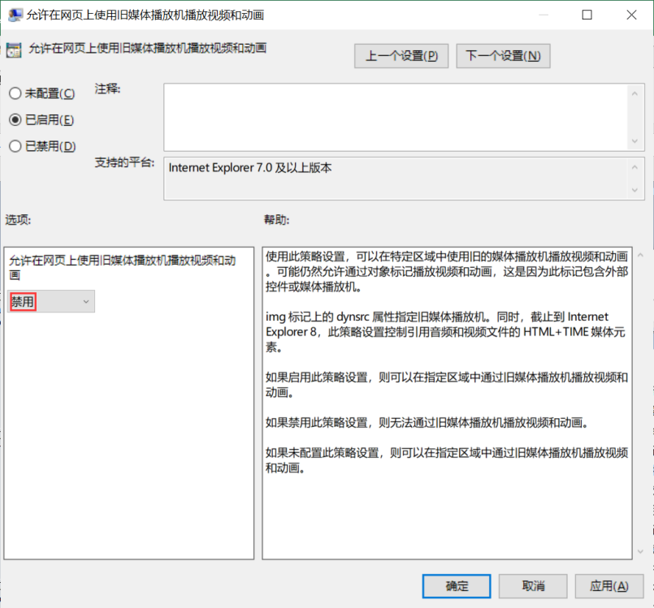

**检查语句**

select data from registry

where key like

"HKEY_CURRENT_USER\SOFTWARE\Microsoft\Windows\CurrentVersion\Group Policy Objects\%Machine%\Software\Policies\Microsoft\Windows\CurrentVersion\Internet Settings\Zones\3" and name = "120A";

**检查结果**

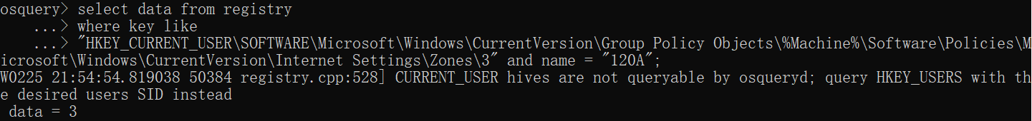

data = 3，则该检查项通过。

**339、Configure 'Allow scriptlets' for the internet zone**

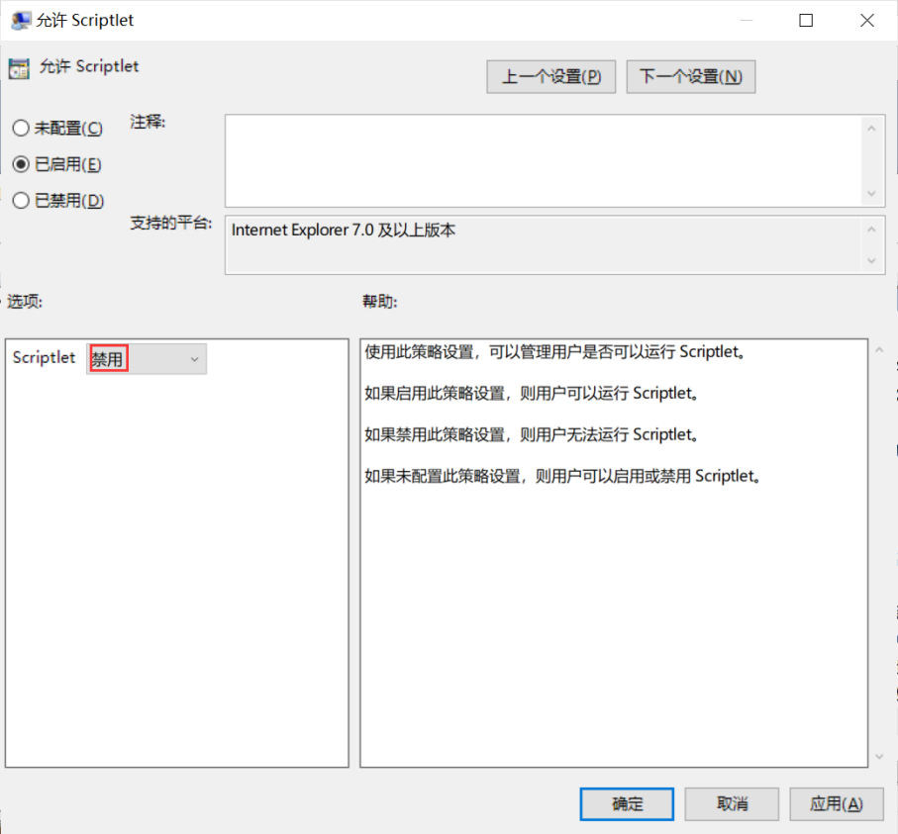

**检查语句**

select data from registry

where key like

"HKEY_CURRENT_USER\SOFTWARE\Microsoft\Windows\CurrentVersion\Group Policy Objects\%Machine%\Software\Policies\Microsoft\Windows\CurrentVersion\Internet Settings\Zones\3" and name = "1209";

**检查结果**

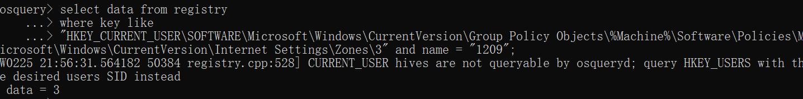

data = 3，则该检查项通过。

**338、Configure 'Allow video and animation on a webpage that uses an older media player' for the restricted sites zone**

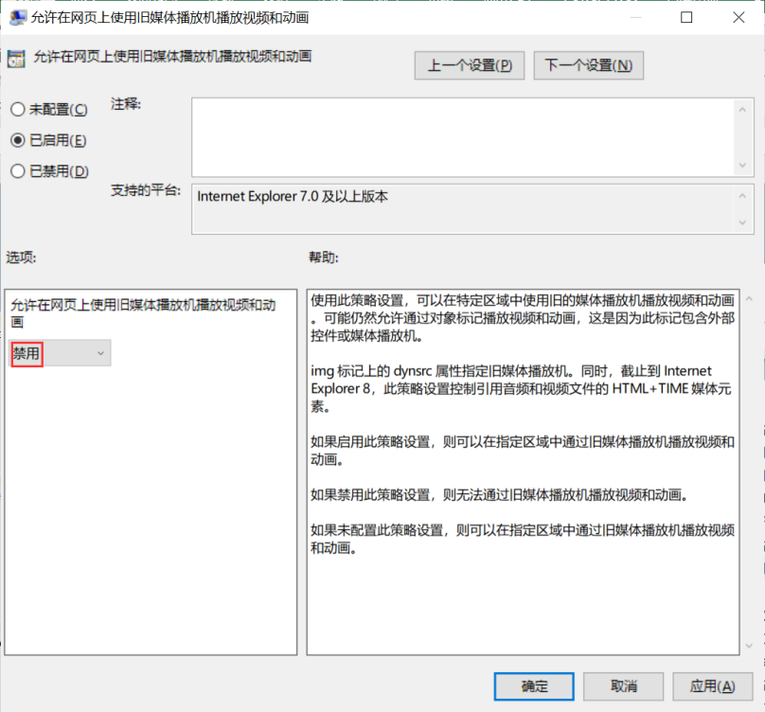

**检查语句**

select data from registry

where key like

"HKEY_CURRENT_USER\SOFTWARE\Microsoft\Windows\CurrentVersion\Group Policy Objects\%Machine%\Software\Policies\Microsoft\Windows\CurrentVersion\Internet Settings\Zones\4" and name = "120A";

**检查结果**

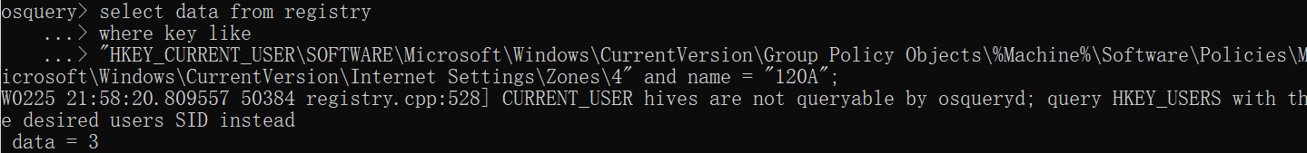

data = 3，则该检查项通过。

**337、Configure 'Allow scriptlets' for the restricted sites zone**

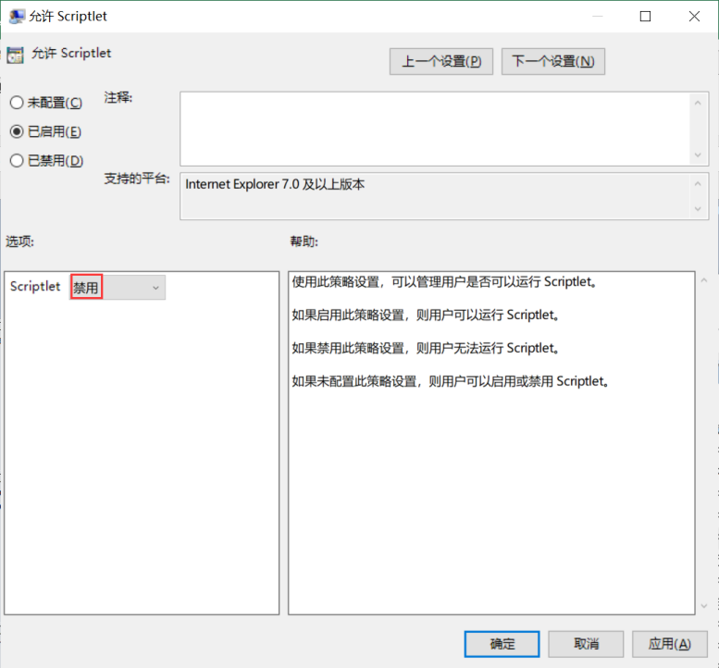

**检查语句**

select data from registry

where key like

"HKEY_CURRENT_USER\SOFTWARE\Microsoft\Windows\CurrentVersion\Group Policy Objects\%Machine%\Software\Policies\Microsoft\Windows\CurrentVersion\Internet Settings\Zones\4" and name = "1209";

**检查结果**

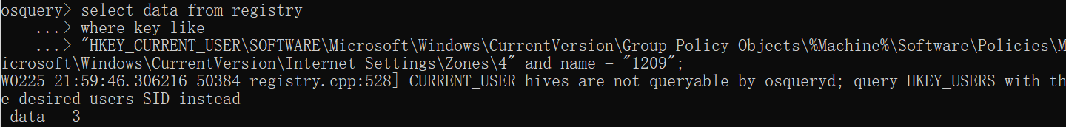

data = 3，则该检查项通过。

**336、Configure 'Allow binary and script behaviors' for the restricted sites zone**

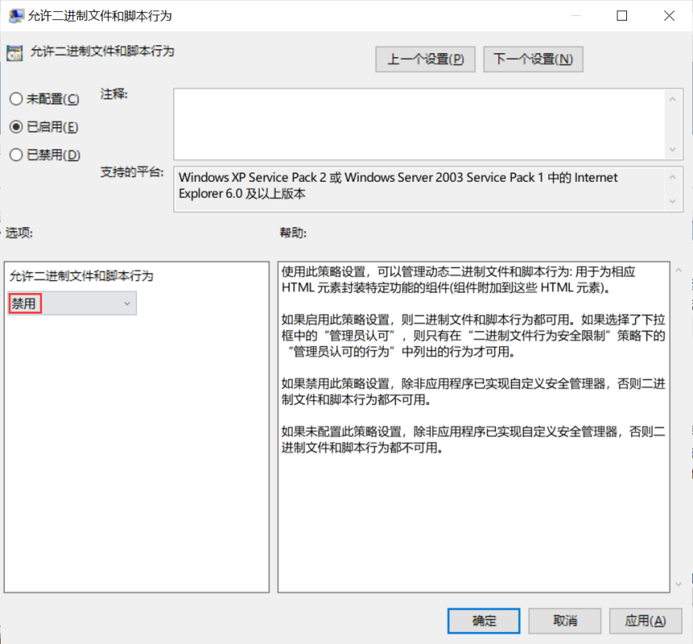

**检查语句**

select data from registry

where key like

"HKEY_CURRENT_USER\SOFTWARE\Microsoft\Windows\CurrentVersion\Group Policy Objects\%Machine%\Software\Policies\Microsoft\Windows\CurrentVersion\Internet Settings\Zones\4" and name = "2000";

**检查结果**

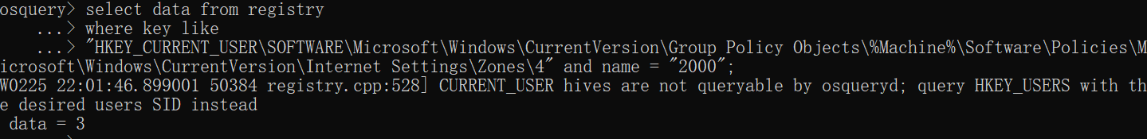

data = 3，则该检查项通过。

**335、Configure 'Don't run antimalware programs against ActiveX controls' for the trusted sites zone**

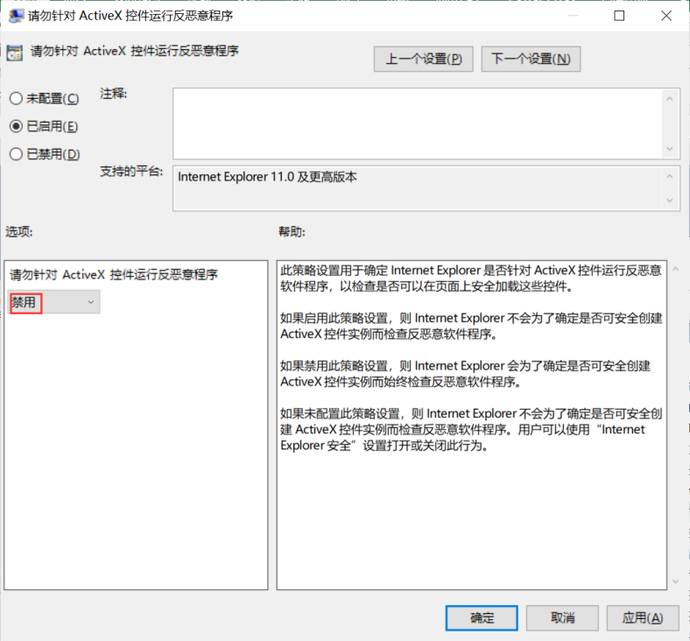

**检查语句**

select data from registry

where key like

"HKEY_CURRENT_USER\SOFTWARE\Microsoft\Windows\CurrentVersion\Group Policy Objects\%Machine%\Software\Policies\Microsoft\Windows\CurrentVersion\Internet Settings\Zones\2" and name = "270C";

**检查结果**

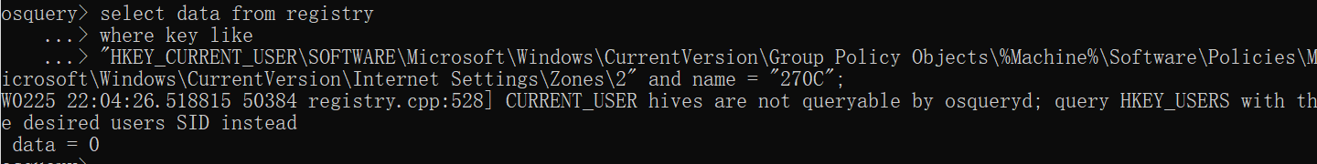

data = 0，则该检查项通过。

**334、Configure 'Initialize and script ActiveX controls not marked as safe' for the intranet zone**

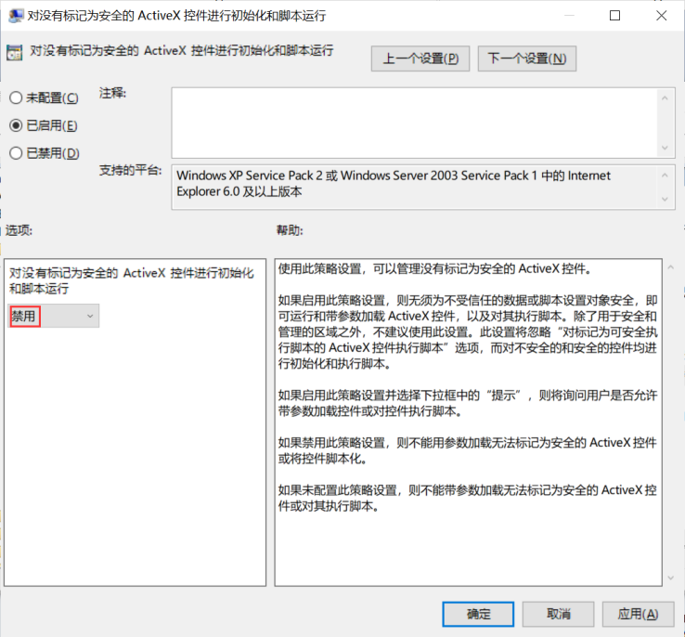

**检查语句**

select data from registry

where key like

"HKEY_CURRENT_USER\SOFTWARE\Microsoft\Windows\CurrentVersion\Group Policy Objects\%Machine%\Software\Policies\Microsoft\Windows\CurrentVersion\Internet Settings\Zones\1" and name = "1201";

**检查结果**

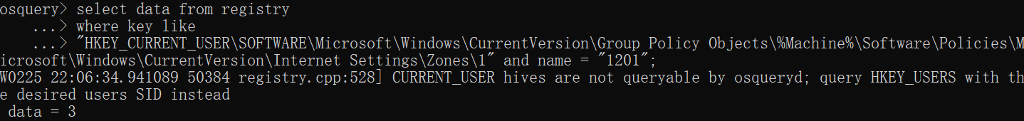

data = 3，则该检查项通过。

**333、Configure 'Download unsigned ActiveX controls' for the intranet zone**

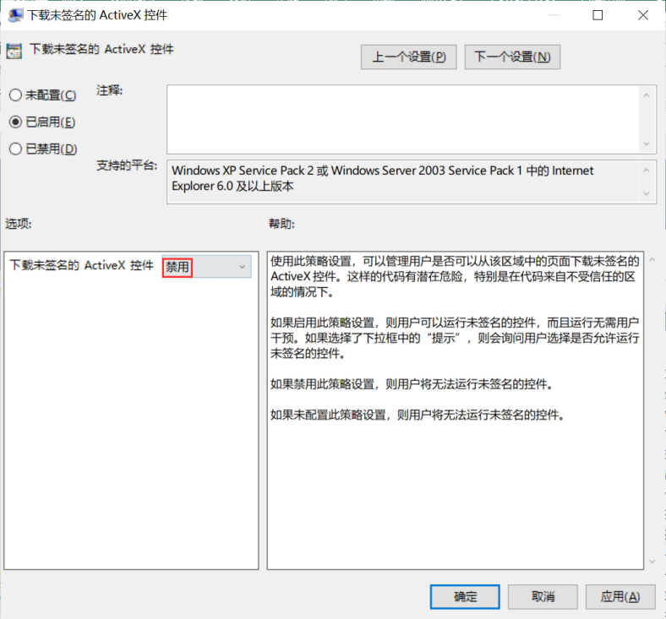

**检查语句**

select data from registry

where key like

"HKEY_CURRENT_USER\SOFTWARE\Microsoft\Windows\CurrentVersion\Group Policy Objects\%Machine%\Software\Policies\Microsoft\Windows\CurrentVersion\Internet Settings\Zones\1" and name = "1004";

**检查结果**

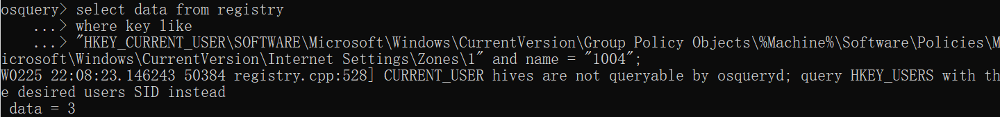

data = 3，则该检查项通过。

**332、Configure 'Don't run antimalware programs against ActiveX controls' for the intranet zone**

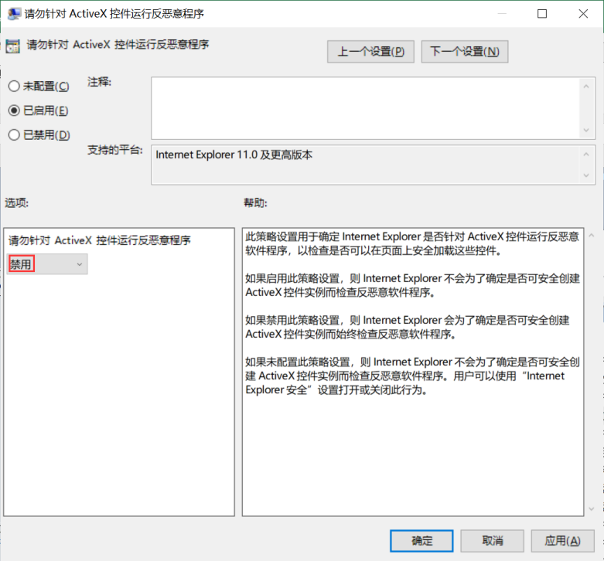

**检查语句**

select data from registry

where key like

"HKEY_CURRENT_USER\SOFTWARE\Microsoft\Windows\CurrentVersion\Group Policy Objects\%Machine%\Software\Policies\Microsoft\Windows\CurrentVersion\Internet Settings\Zones\1" and name = "270C";

**检查结果**

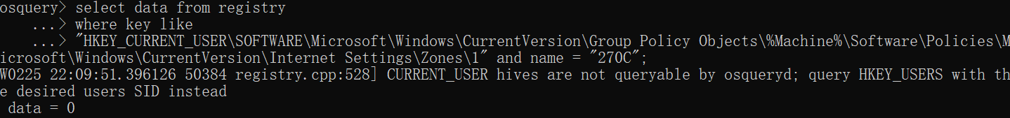

data = 0，则该检查项通过。

**331、Configure 'Initialize and script ActiveX controls not marked as safe' for the internet zone**

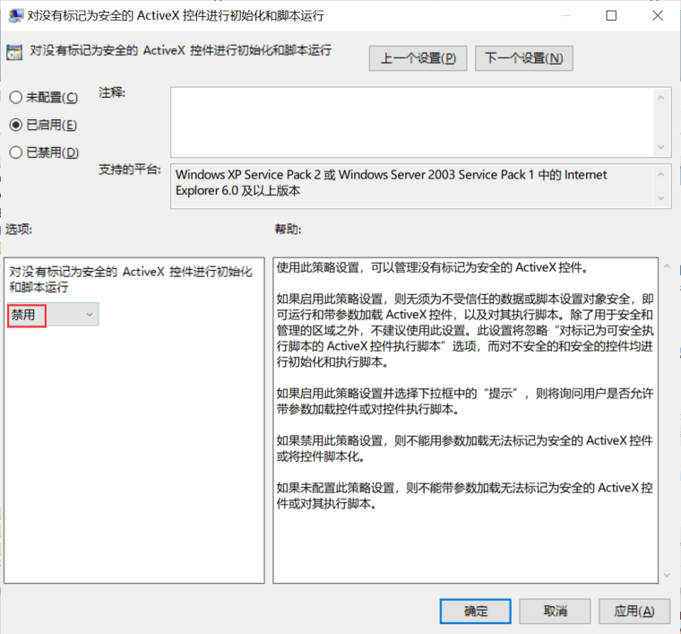

**检查语句**

select data from registry

where key like

"HKEY_CURRENT_USER\SOFTWARE\Microsoft\Windows\CurrentVersion\Group Policy Objects\%Machine%\Software\Policies\Microsoft\Windows\CurrentVersion\Internet Settings\Zones\3" and name = "1201";

**检查结果**

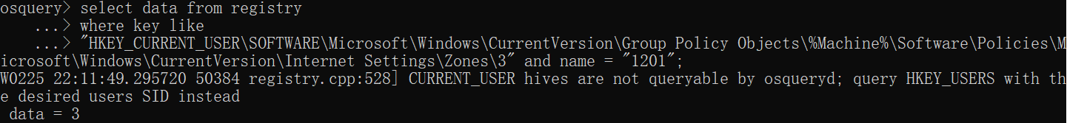

data = 3，则该检查项通过。

**330、Configure 'Download unsigned ActiveX controls' for the internet zone**

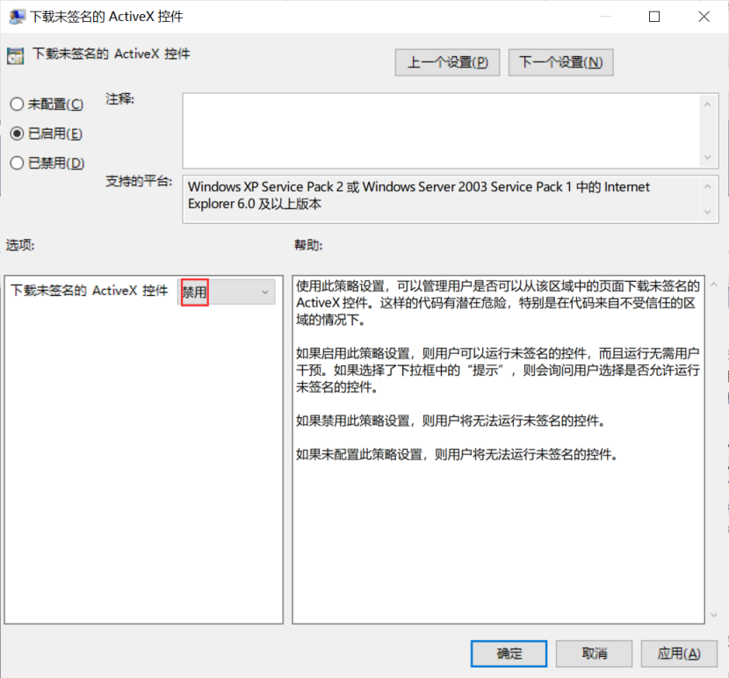

**检查语句**

select data from registry

where key like

"HKEY_CURRENT_USER\SOFTWARE\Microsoft\Windows\CurrentVersion\Group Policy Objects\%Machine%\Software\Policies\Microsoft\Windows\CurrentVersion\Internet Settings\Zones\3" and name = "1004";

**检查结果**

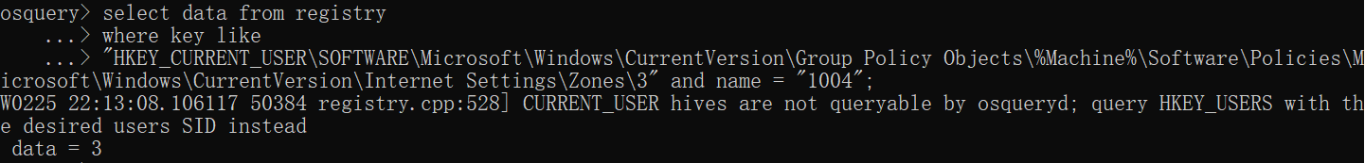

data = 3，则该检查项通过。

**329、Configure 'Download signed ActiveX controls' for the internet zone**

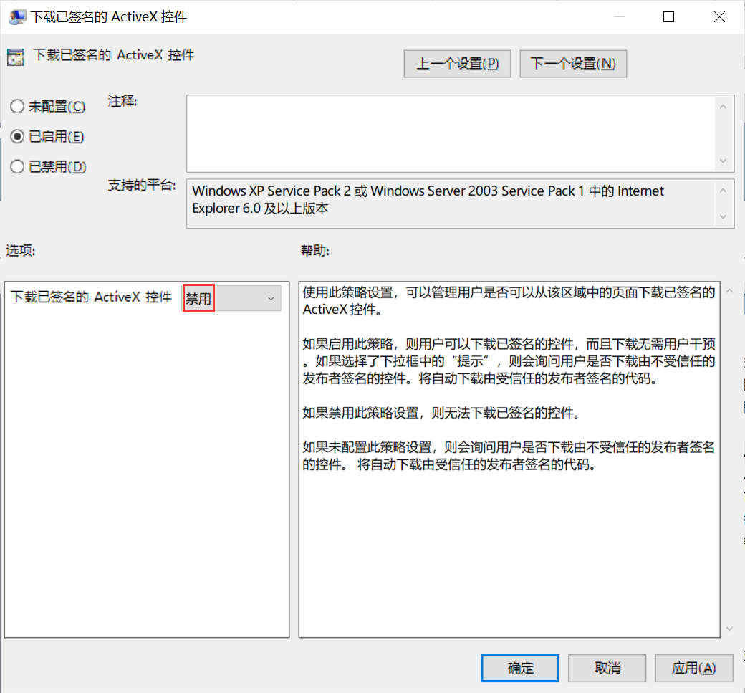

**检查语句**

select data from registry

where key like

"HKEY_CURRENT_USER\SOFTWARE\Microsoft\Windows\CurrentVersion\Group Policy Objects\%Machine%\Software\Policies\Microsoft\Windows\CurrentVersion\Internet Settings\Zones\3" and name = "1001";

**检查结果**

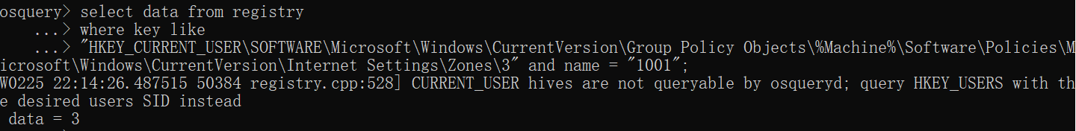

data = 3，则该检查项通过。

**328、Configure 'Don't run antimalware programs against ActiveX controls' for the internet zone**

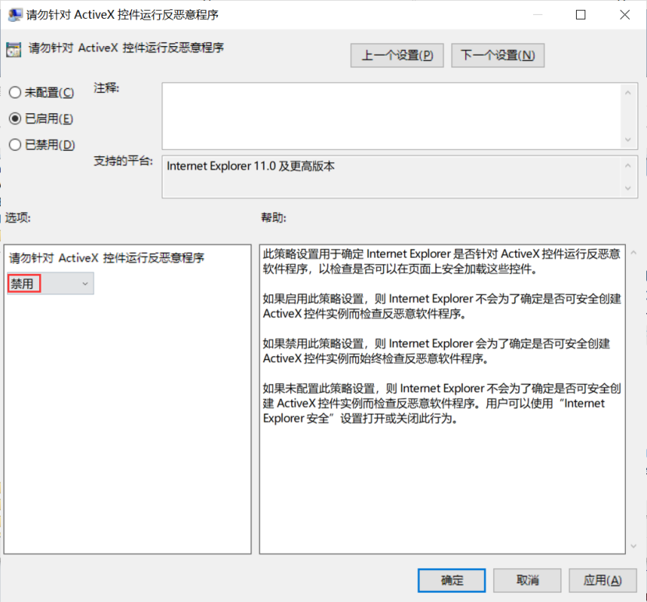

**检查语句**

select data from registry

where key like

"HKEY_CURRENT_USER\SOFTWARE\Microsoft\Windows\CurrentVersion\Group Policy Objects\%Machine%\Software\Policies\Microsoft\Windows\CurrentVersion\Internet Settings\Zones\3" and name = "270C";

**检查结果**

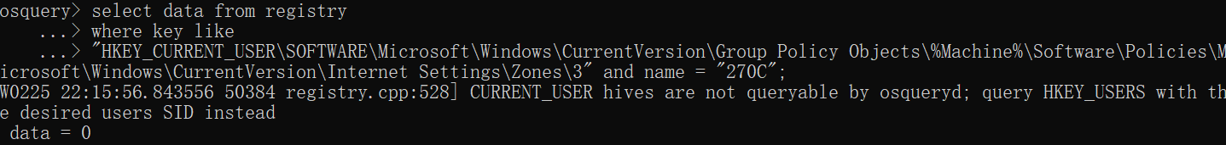

data = 0，则该检查项通过。

**327、Configure 'Automatic prompting for ActiveX controls' for the internet zone**

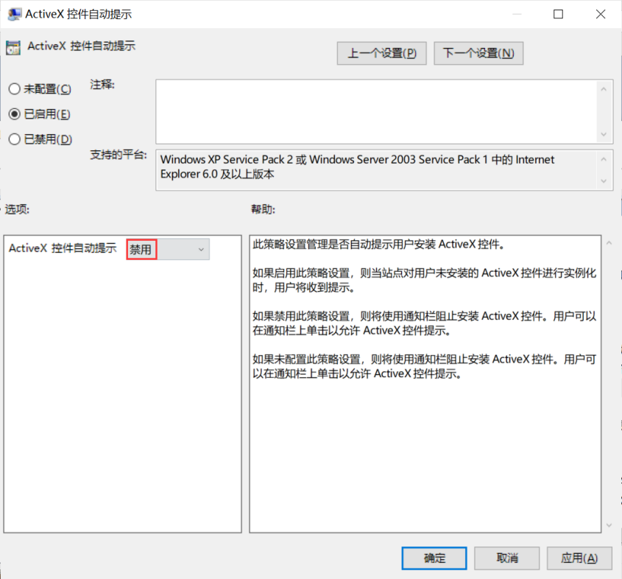

**检查语句**

select data from registry

where key like

"HKEY_CURRENT_USER\SOFTWARE\Microsoft\Windows\CurrentVersion\Group Policy Objects\%Machine%\Software\Policies\Microsoft\Windows\CurrentVersion\Internet Settings\Zones\3" and name = "2201";

**检查结果**

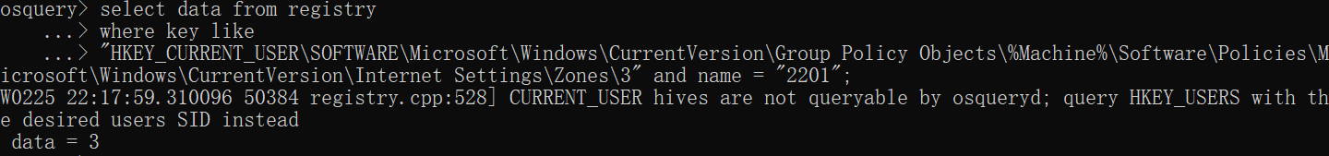

data = 3，则该检查项通过。

**326、Configure 'Allow only approved domains to use the TDC ActiveX control' for the internet zone**

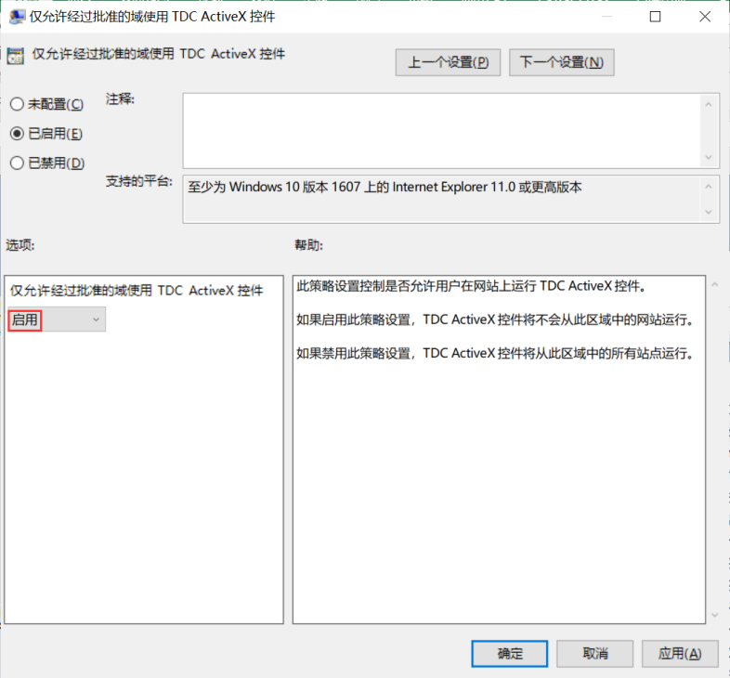

**检查语句**

select data from registry

where key like

"HKEY_CURRENT_USER\SOFTWARE\Microsoft\Windows\CurrentVersion\Group Policy Objects\%Machine%\Software\Policies\Microsoft\Windows\CurrentVersion\Internet Settings\Zones\3" and name = "120c";

**检查结果**

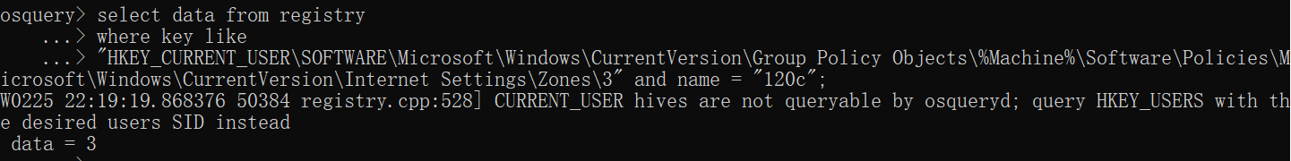

data = 3，则该检查项通过。

**325、Configure 'Allow only approved domains to use ActiveX controls without prompt' for the internet zone**

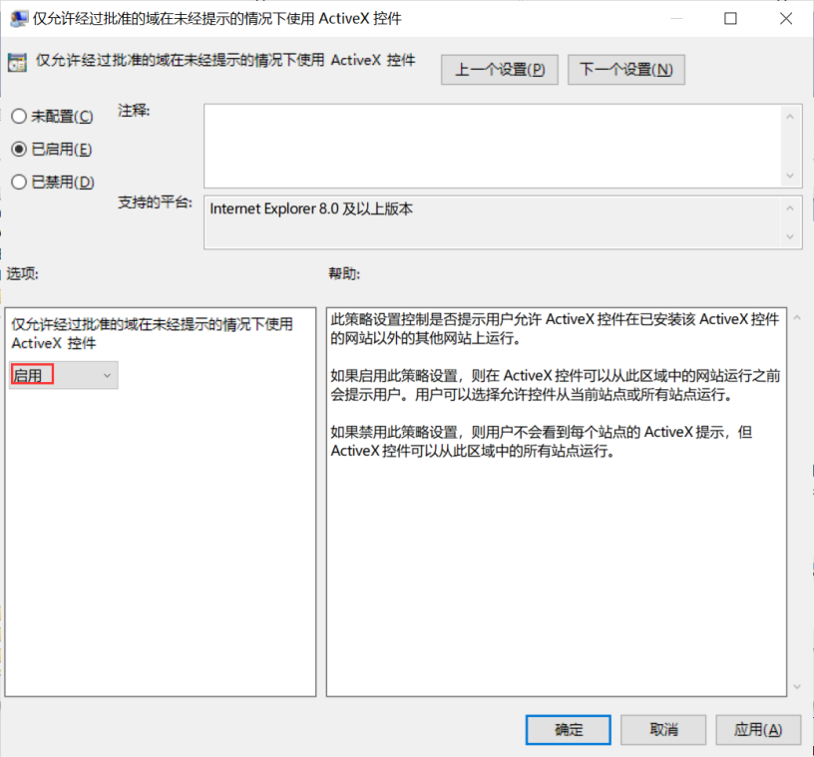

**检查语句**

select data from registry

where key like

"HKEY_CURRENT_USER\SOFTWARE\Microsoft\Windows\CurrentVersion\Group Policy Objects\%Machine%\Software\Policies\Microsoft\Windows\CurrentVersion\Internet Settings\Zones\3" and name = "120b";

**检查结果**

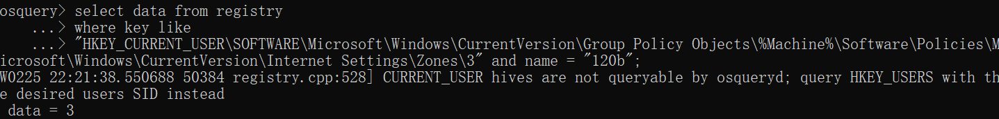

data = 3，则该检查项通过。

**324、Configure 'Script ActiveX controls marked safe for scripting' for the restricted sites zone**

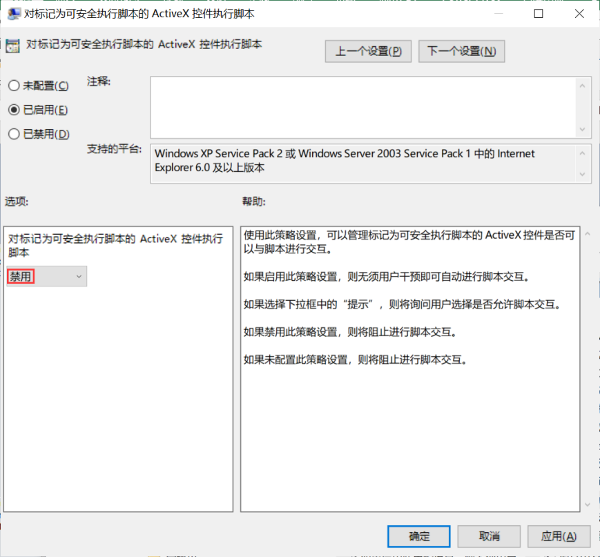

**检查语句**

select data from registry

where key like

"HKEY_CURRENT_USER\SOFTWARE\Microsoft\Windows\CurrentVersion\Group Policy Objects\%Machine%\Software\Policies\Microsoft\Windows\CurrentVersion\Internet Settings\Zones\4" and name = "1405";

**检查结果**

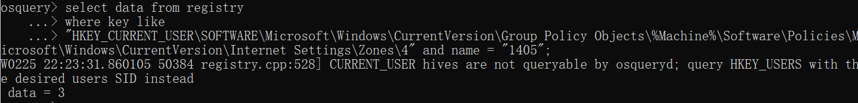

data = 3，则该检查项通过。

**323、Configure 'Run ActiveX controls and plugins' for the restricted sites zone**

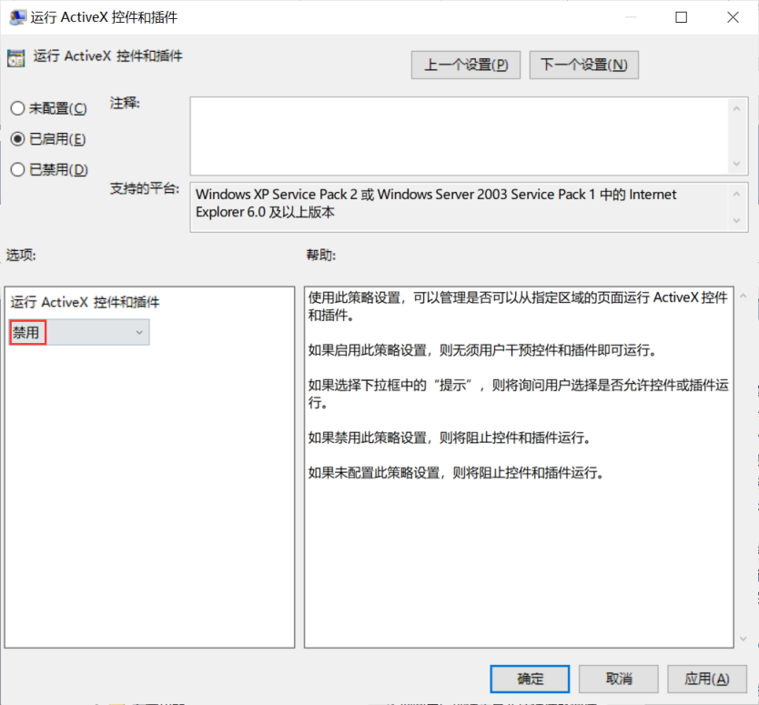

**检查语句**

select data from registry

where key like

"HKEY_CURRENT_USER\SOFTWARE\Microsoft\Windows\CurrentVersion\Group Policy Objects\%Machine%\Software\Policies\Microsoft\Windows\CurrentVersion\Internet Settings\Zones\4" and name = "1200";

**检查结果**

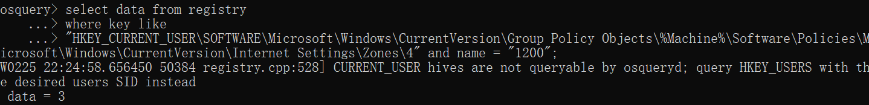

data = 3，则该检查项通过。

**322、Configure 'Initialize and script ActiveX controls not marked as safe' for the restricted sites zone**

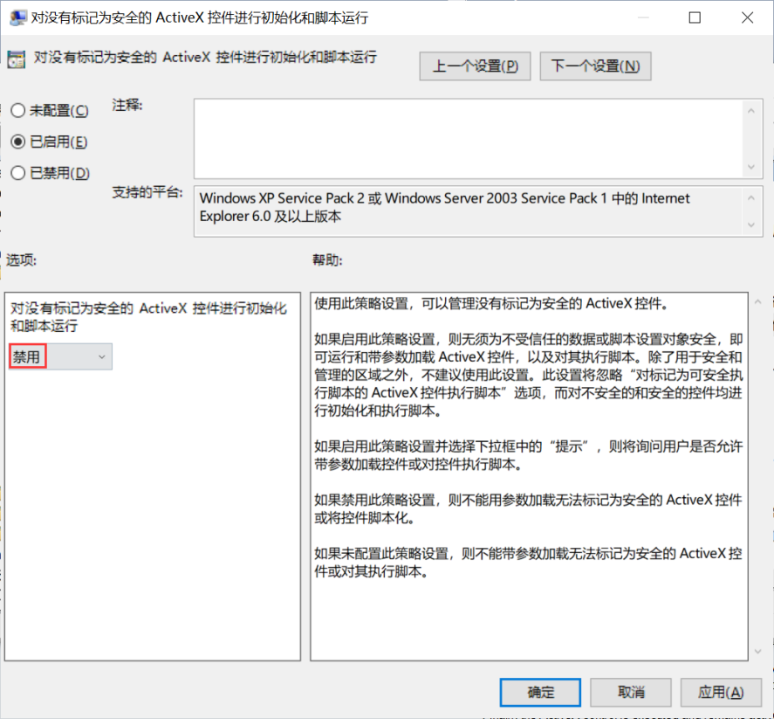

**检查语句**

select data from registry

where key like

"HKEY_CURRENT_USER\SOFTWARE\Microsoft\Windows\CurrentVersion\Group Policy Objects\%Machine%\Software\Policies\Microsoft\Windows\CurrentVersion\Internet Settings\Zones\4" and name = "1201";

**检查结果**

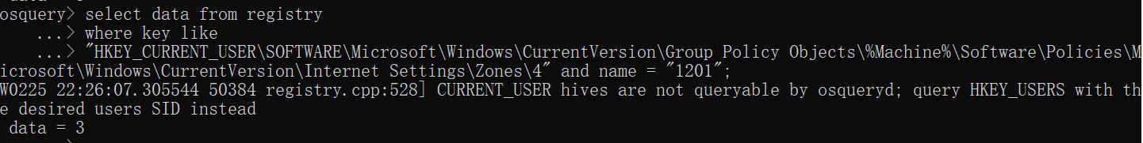

data = 3，则该检查项通过。

**321、Configure 'Download unsigned ActiveX controls' for the restricted sites zone**

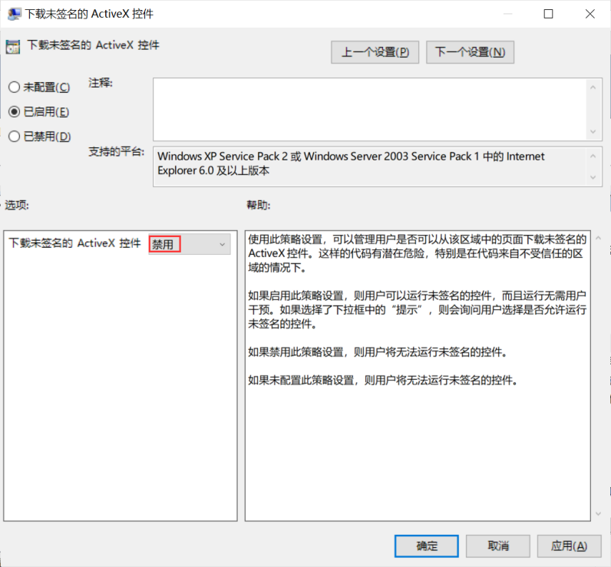

**检查语句**

select data from registry

where key like

"HKEY_CURRENT_USER\SOFTWARE\Microsoft\Windows\CurrentVersion\Group Policy Objects\%Machine%\Software\Policies\Microsoft\Windows\CurrentVersion\Internet Settings\Zones\4" and name = "1004";

**检查结果**

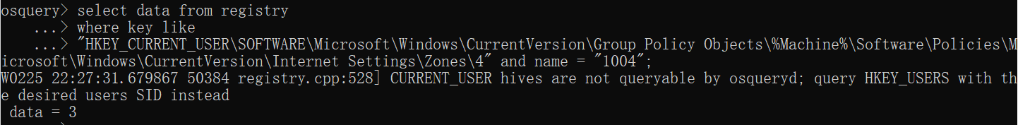

data = 3，则该检查项通过。

**320、Configure 'Download signed ActiveX controls' for the restricted sites zone**

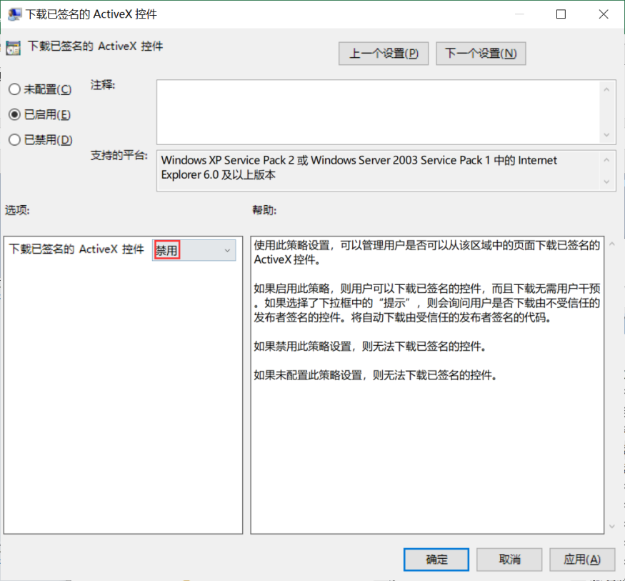

**检查语句**

select data from registry

where key like

"HKEY_CURRENT_USER\SOFTWARE\Microsoft\Windows\CurrentVersion\Group Policy Objects\%Machine%\Software\Policies\Microsoft\Windows\CurrentVersion\Internet Settings\Zones\4" and name = "1001";

**检查结果**

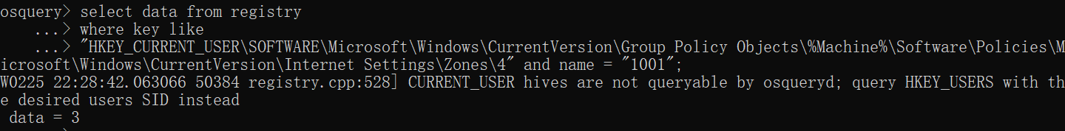

data = 3，则该检查项通过。

**319、Configure 'Don't run antimalware programs against ActiveX controls' for the restricted sites zone**

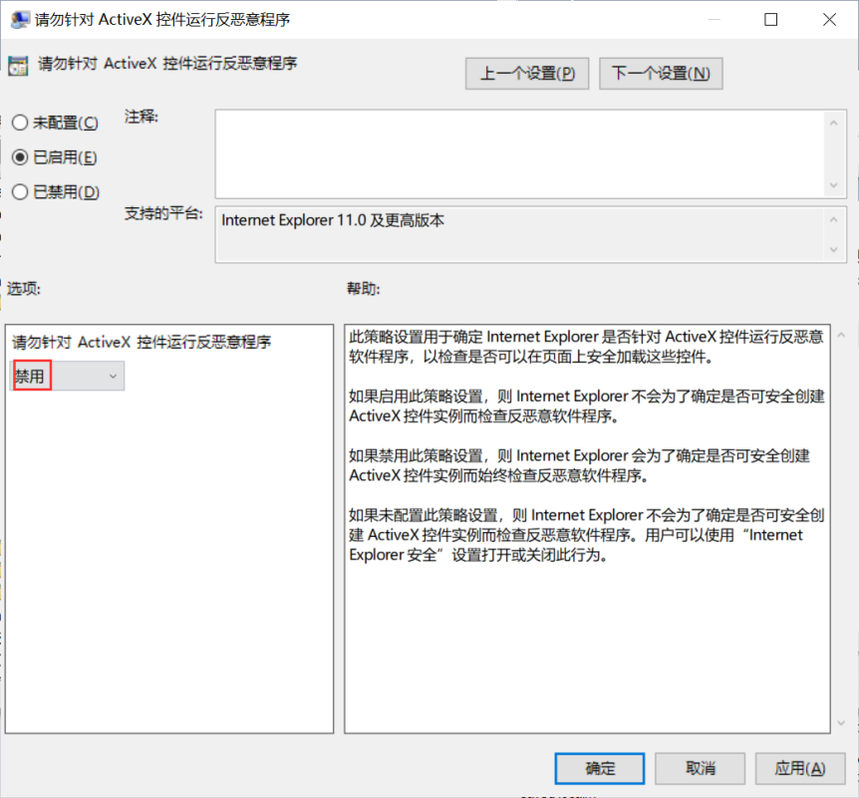

**检查语句**

select data from registry

where key like

"HKEY_CURRENT_USER\SOFTWARE\Microsoft\Windows\CurrentVersion\Group Policy Objects\%Machine%\Software\Policies\Microsoft\Windows\CurrentVersion\Internet Settings\Zones\4" and name = "270C";

**检查结果**

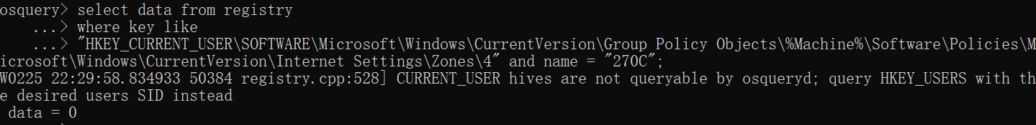

data = 0，则该检查项通过。

**318、Configure 'Automatic prompting for ActiveX controls' for the restricted sites zone**

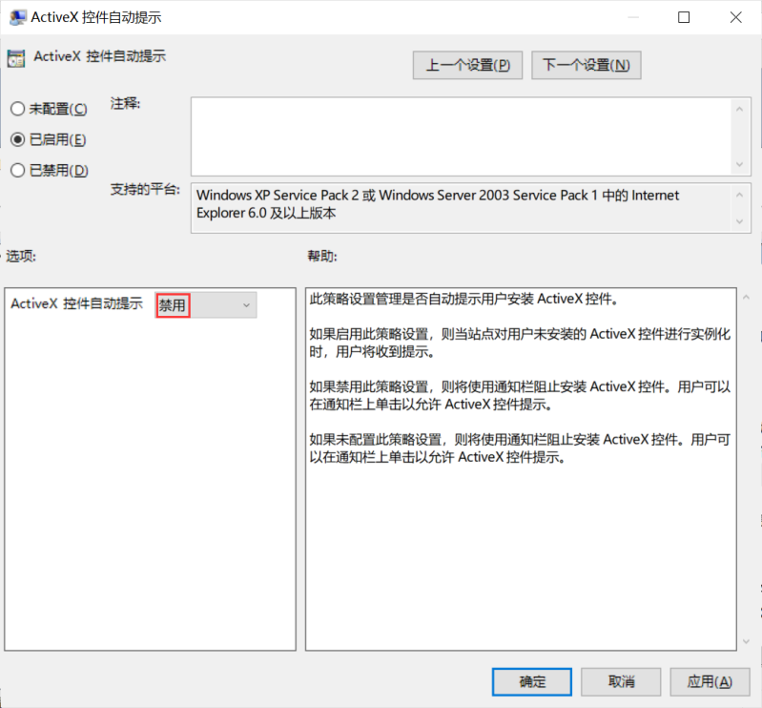

**检查语句**

select data from registry

where key like

"HKEY_CURRENT_USER\SOFTWARE\Microsoft\Windows\CurrentVersion\Group Policy Objects\%Machine%\Software\Policies\Microsoft\Windows\CurrentVersion\Internet Settings\Zones\4" and name = "2201";

**检查结果**

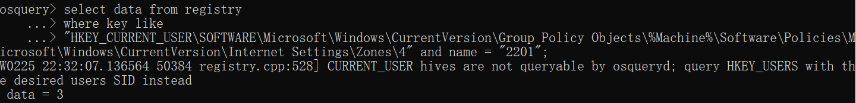

data = 3，则该检查项通过。

**317、Configure 'Allow only approved domains to use the TDC ActiveX control' for the restricted sites zone**

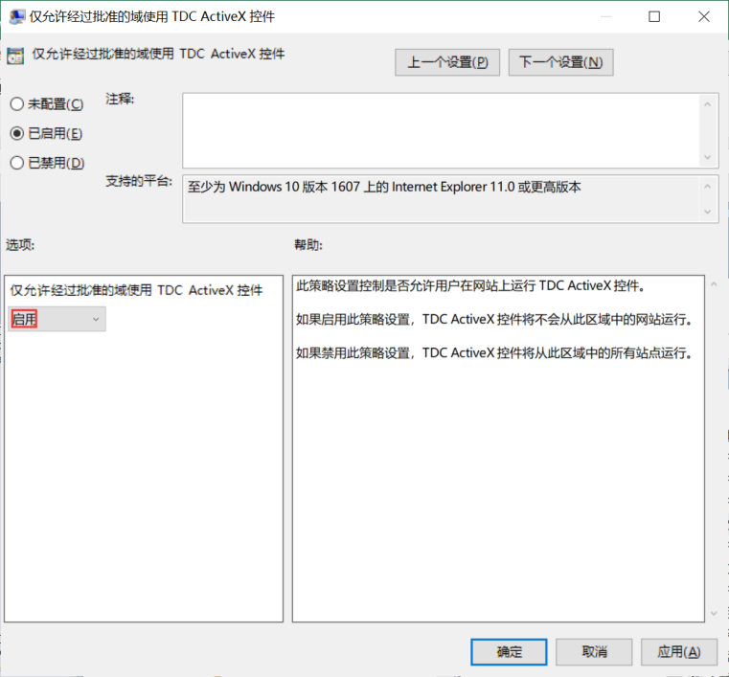

**检查语句**

select data from registry

where key like

"HKEY_CURRENT_USER\SOFTWARE\Microsoft\Windows\CurrentVersion\Group Policy Objects\%Machine%\Software\Policies\Microsoft\Windows\CurrentVersion\Internet Settings\Zones\4" and name = "120c";

**检查结果**

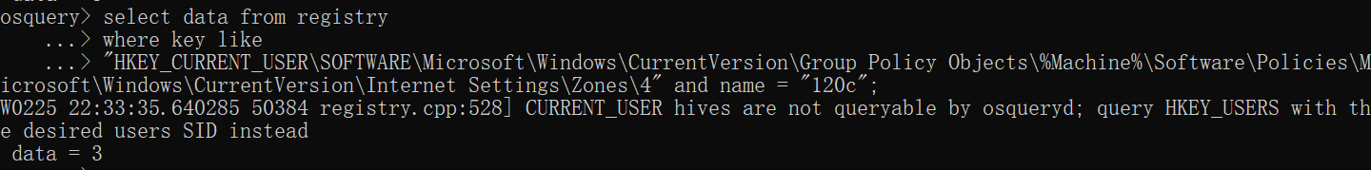

data = 3，则该检查项通过。

**316、Configure 'Allow only approved domains to use ActiveX controls without prompt' for the restricted sites zone**

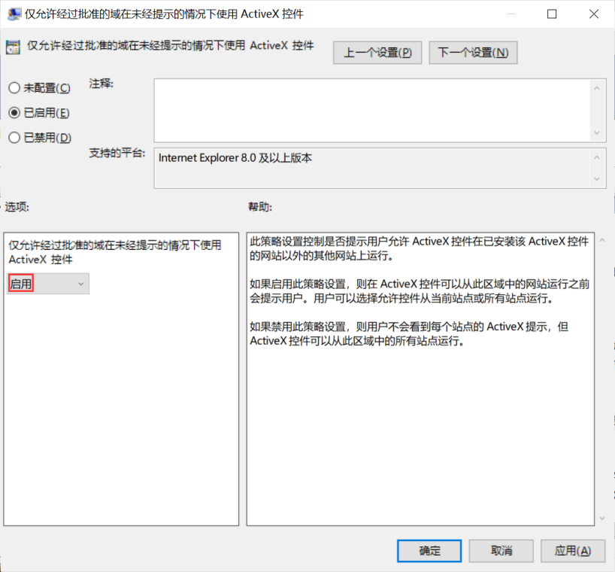

**检查语句**

select data from registry

where key like

"HKEY_CURRENT_USER\SOFTWARE\Microsoft\Windows\CurrentVersion\Group Policy Objects\%Machine%\Software\Policies\Microsoft\Windows\CurrentVersion\Internet Settings\Zones\4" and name = "120b";

**检查结果**

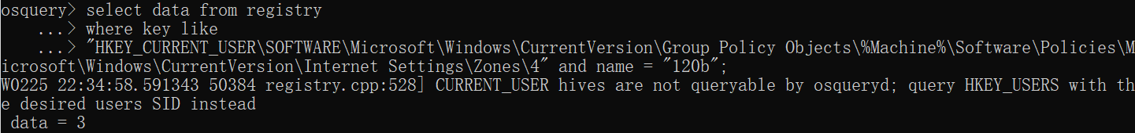

data = 3，则该检查项通过。

**315、Configure 'Turn off .NET Framework Setup' for the trusted sites zone**

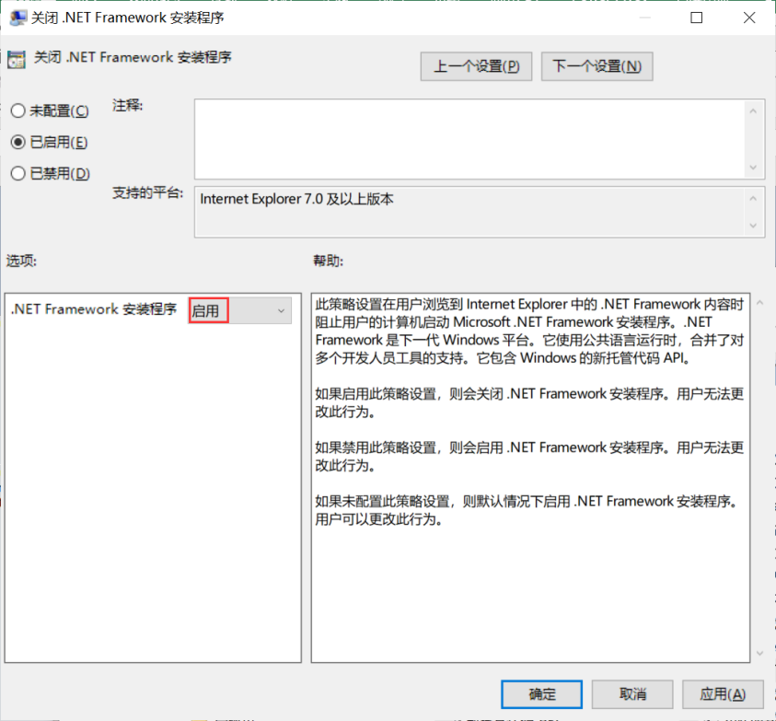

**检查语句**

select data from registry

where key like

"HKEY_CURRENT_USER\SOFTWARE\Microsoft\Windows\CurrentVersion\Group Policy Objects\%Machine%\Software\Policies\Microsoft\Windows\CurrentVersion\Internet Settings\Zones\2" and name = "2600";

**检查结果**

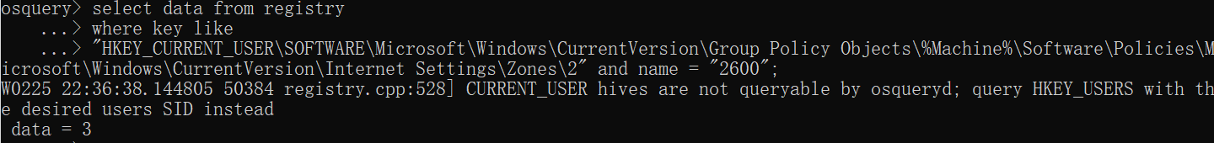

data = 3，则该检查项通过。

**314、Configure 'Turn off .NET Framework Setup' for the intranet zone**

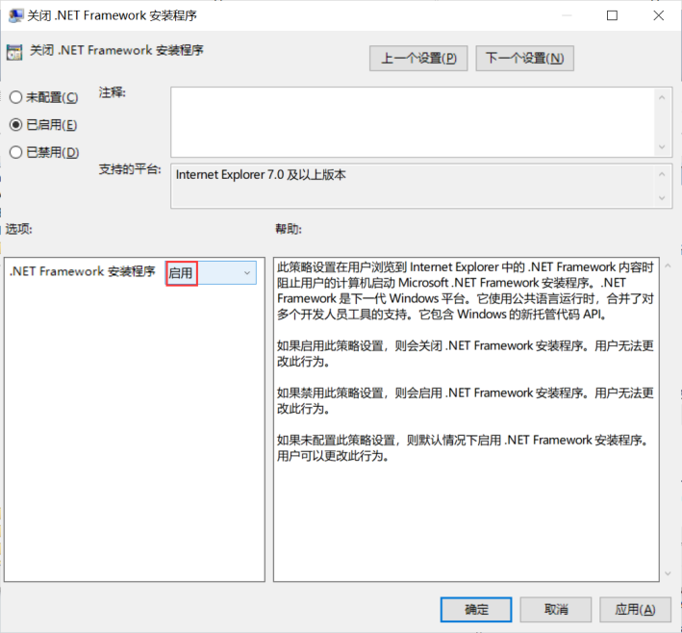

**检查语句**

select data from registry

where key like

"HKEY_CURRENT_USER\SOFTWARE\Microsoft\Windows\CurrentVersion\Group Policy Objects\%Machine%\Software\Policies\Microsoft\Windows\CurrentVersion\Internet Settings\Zones\1" and name = "2600";

**检查结果**

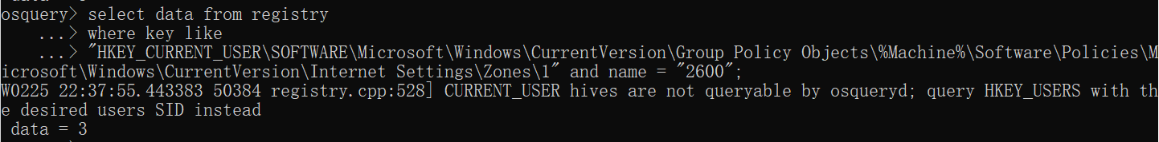

data = 3，则该检查项通过。

**313、Configure 'Turn off .NET Framework Setup' for the internet zone**

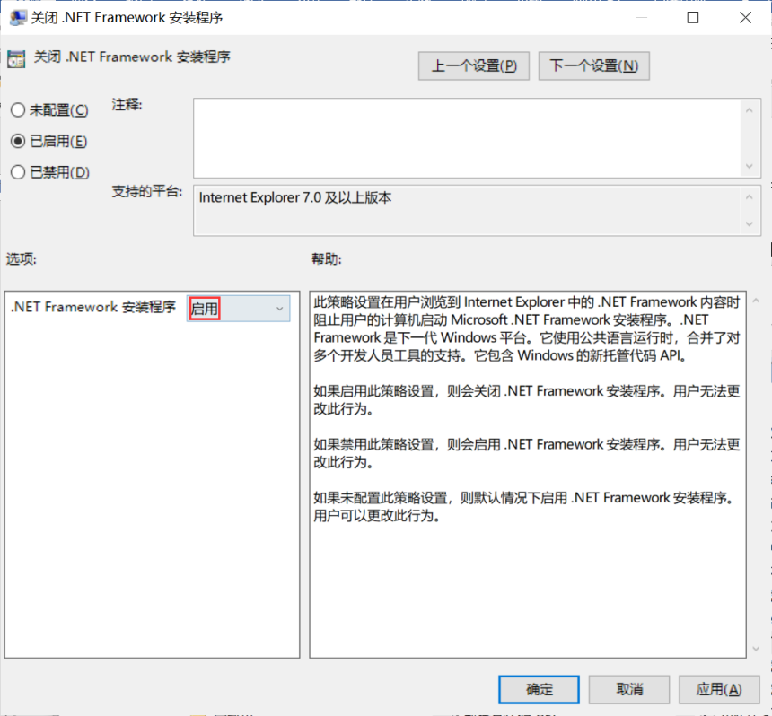

**检查语句**

select data from registry

where key like

"HKEY_CURRENT_USER\SOFTWARE\Microsoft\Windows\CurrentVersion\Group Policy Objects\%Machine%\Software\Policies\Microsoft\Windows\CurrentVersion\Internet Settings\Zones\3" and name = "2600";

**检查结果**

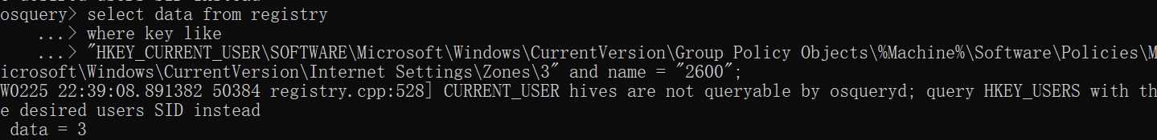

data = 3，则该检查项通过。

**312、Configure 'Run .NET Framework-reliant components signed with Authenticode' for the internet zone**

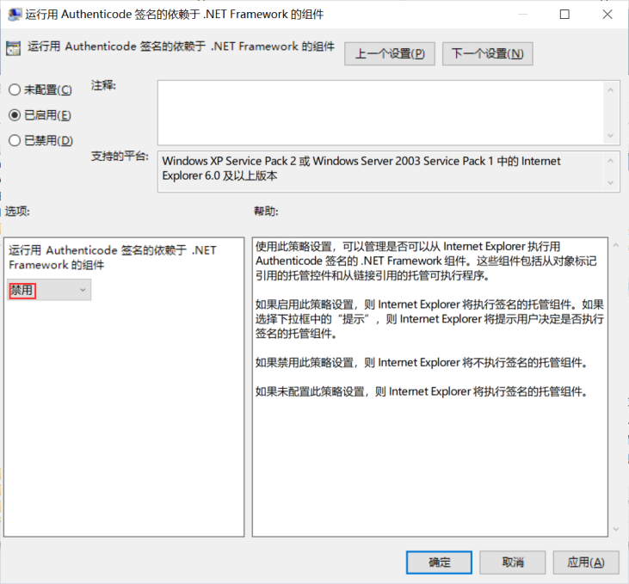

**检查语句**

select data from registry

where key like

"HKEY_CURRENT_USER\SOFTWARE\Microsoft\Windows\CurrentVersion\Group Policy Objects\%Machine%\Software\Policies\Microsoft\Windows\CurrentVersion\Internet Settings\Zones\3" and name = "2001";

**检查结果**

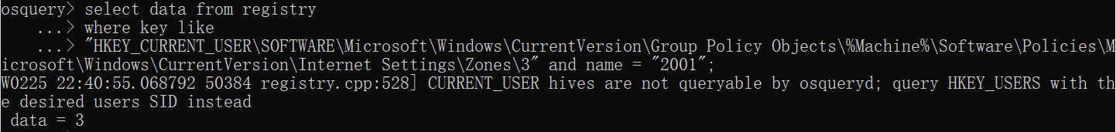

data = 3，则该检查项通过。

**311、Configure 'Run .NET Framework-reliant components not signed with Authenticode' for the internet zone**

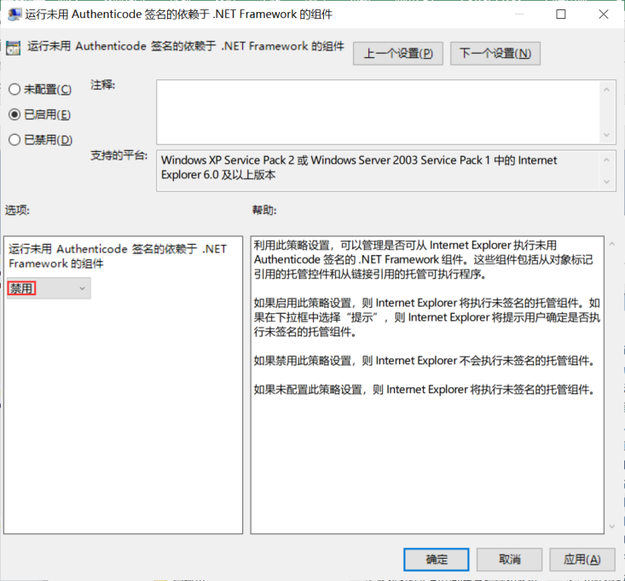

**检查语句**

select data from registry

where key like

"HKEY_CURRENT_USER\SOFTWARE\Microsoft\Windows\CurrentVersion\Group Policy Objects\%Machine%\Software\Policies\Microsoft\Windows\CurrentVersion\Internet Settings\Zones\3" and name = "2004";

**检查结果**

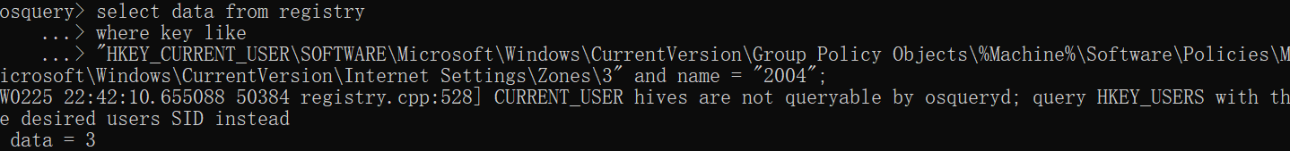

data = 3，则该检查项通过。

**310、Configure 'Turn off .NET Framework Setup' for the restricted sites zone**

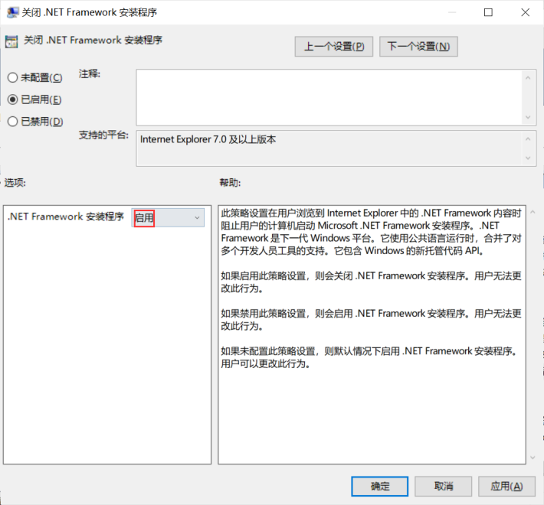

**检查语句**

select data from registry

where key like

"HKEY_CURRENT_USER\SOFTWARE\Microsoft\Windows\CurrentVersion\Group Policy Objects\%Machine%\Software\Policies\Microsoft\Windows\CurrentVersion\Internet Settings\Zones\4" and name = "2600";

**检查结果**

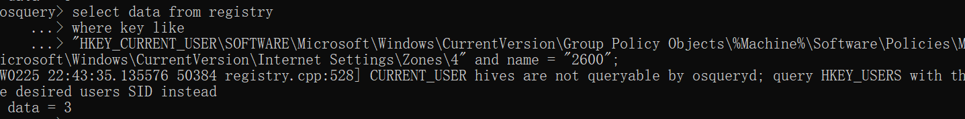

data = 3，则该检查项通过。

**309、Configure 'Run .NET Framework-reliant components signed with Authenticode' for the restricted sites zone**

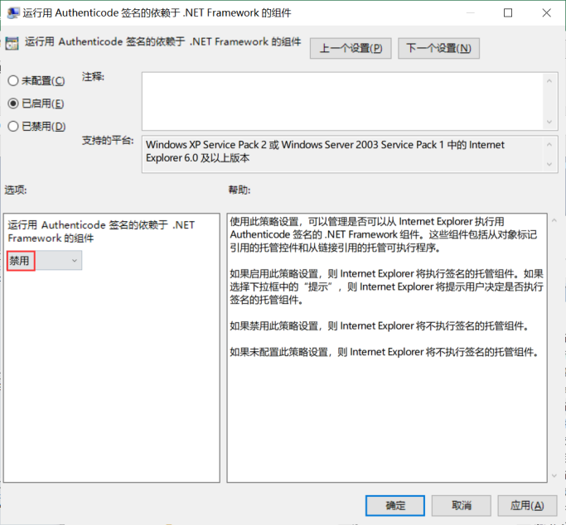

**检查语句**

select data from registry

where key like

"HKEY_CURRENT_USER\SOFTWARE\Microsoft\Windows\CurrentVersion\Group Policy Objects\%Machine%\Software\Policies\Microsoft\Windows\CurrentVersion\Internet Settings\Zones\4" and name = "2001";

**检查结果**

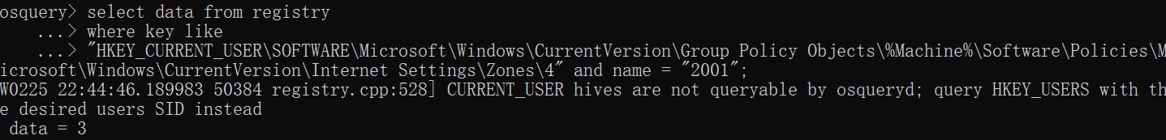

data = 3，则该检查项通过。

**308、Configure 'Run .NET Framework-reliant components not signed with Authenticode' for the restricted sites zone**

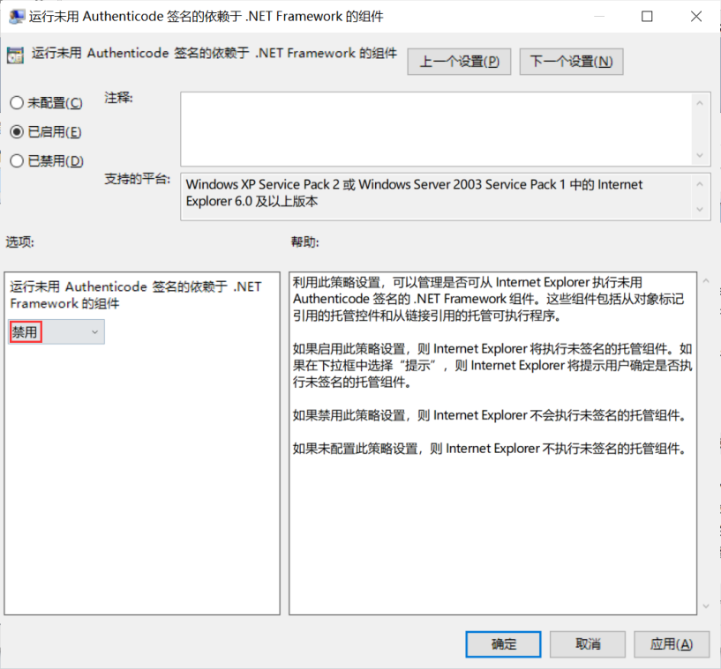

**检查语句**

select data from registry

where key like

"HKEY_CURRENT_USER\SOFTWARE\Microsoft\Windows\CurrentVersion\Group Policy Objects\%Machine%\Software\Policies\Microsoft\Windows\CurrentVersion\Internet Settings\Zones\4" and name = "2004";

**检查结果**

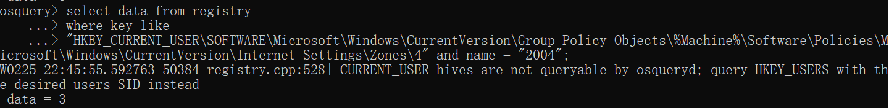

data = 3，则该检查项通过。

**307、Configure 'Allow loading of XPS files' for the restricted sites zone**

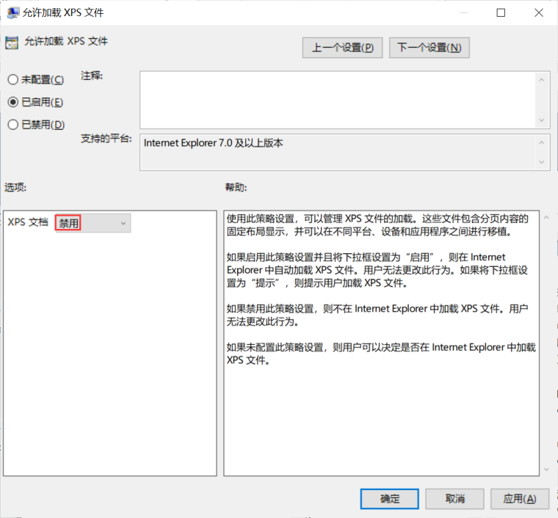

**检查语句**

select data from registry

where key like

"HKEY_CURRENT_USER\SOFTWARE\Microsoft\Windows\CurrentVersion\Group Policy Objects\%Machine%\Software\Policies\Microsoft\Windows\CurrentVersion\Internet Settings\Zones\4" and name = "2401";

**检查结果**

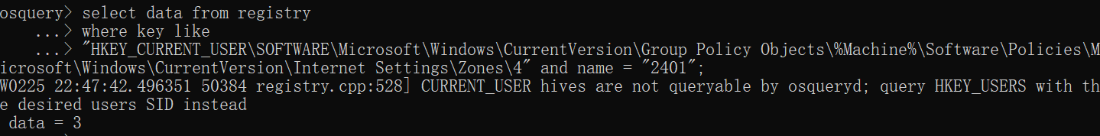

data = 3，则该检查项通过。

**306、Configure 'Allow loading of XAML files' for the restricted sites zone**

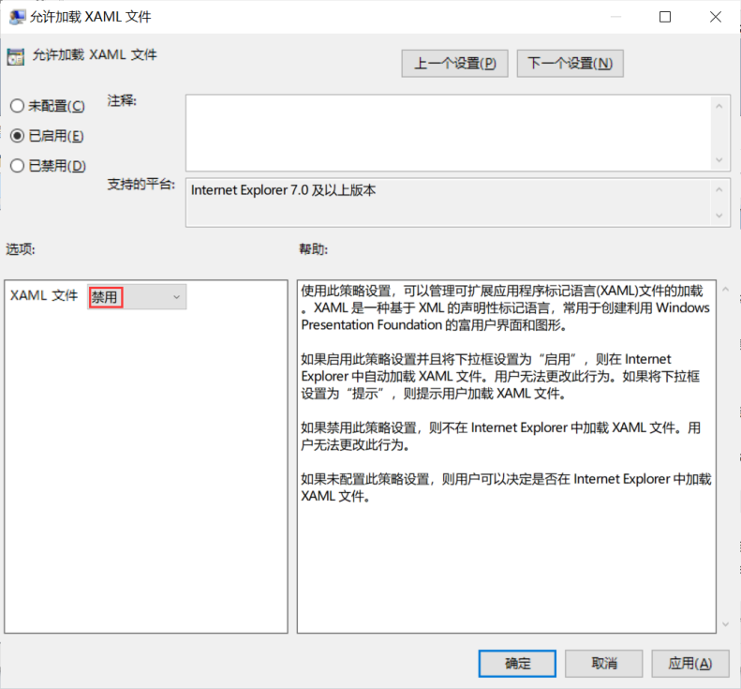

**检查语句**

select data from registry

where key like

"HKEY_CURRENT_USER\SOFTWARE\Microsoft\Windows\CurrentVersion\Group Policy Objects\%Machine%\Software\Policies\Microsoft\Windows\CurrentVersion\Internet Settings\Zones\4" and name = "2402";

**检查结果**

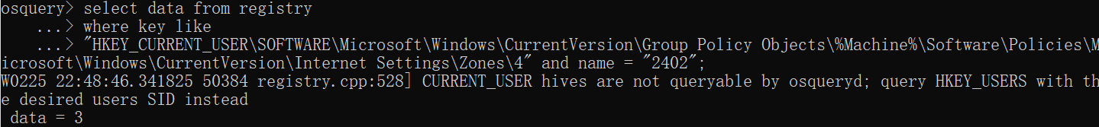

data = 3，则该检查项通过。

**305、Configure 'Allow loading of XAML Browser Applications' for the restricted sites zone**

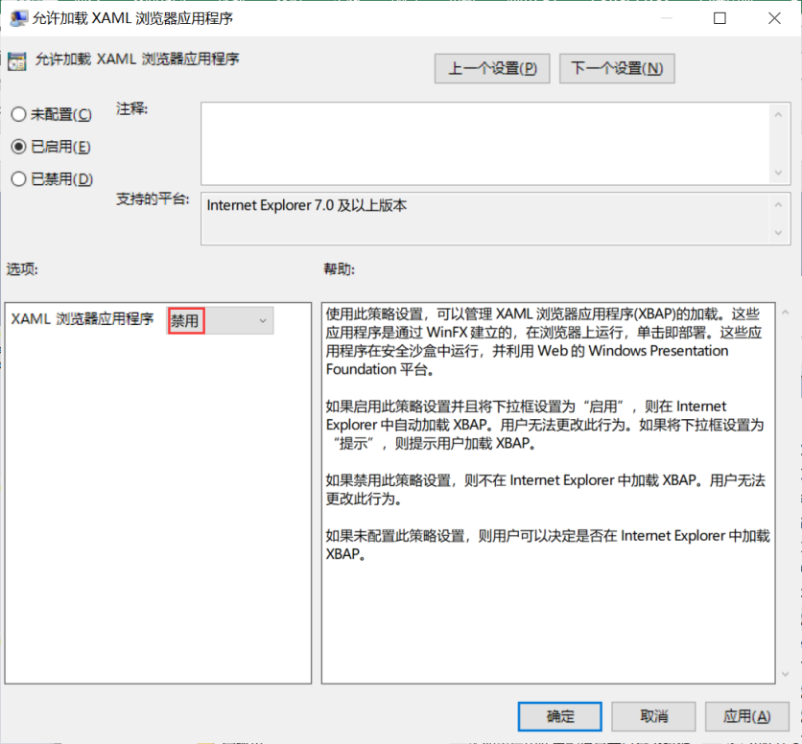

**检查语句**

select data from registry

where key like

"HKEY_CURRENT_USER\SOFTWARE\Microsoft\Windows\CurrentVersion\Group Policy Objects\%Machine%\Software\Policies\Microsoft\Windows\CurrentVersion\Internet Settings\Zones\4" and name = "2400";

**检查结果**

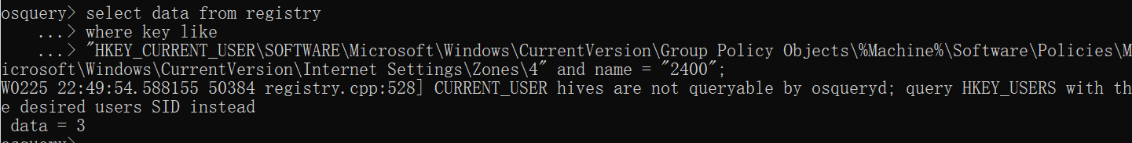

data = 3，则该检查项通过。

#### 401、Configure 'Turn on Basic feed authentication over HTTP'

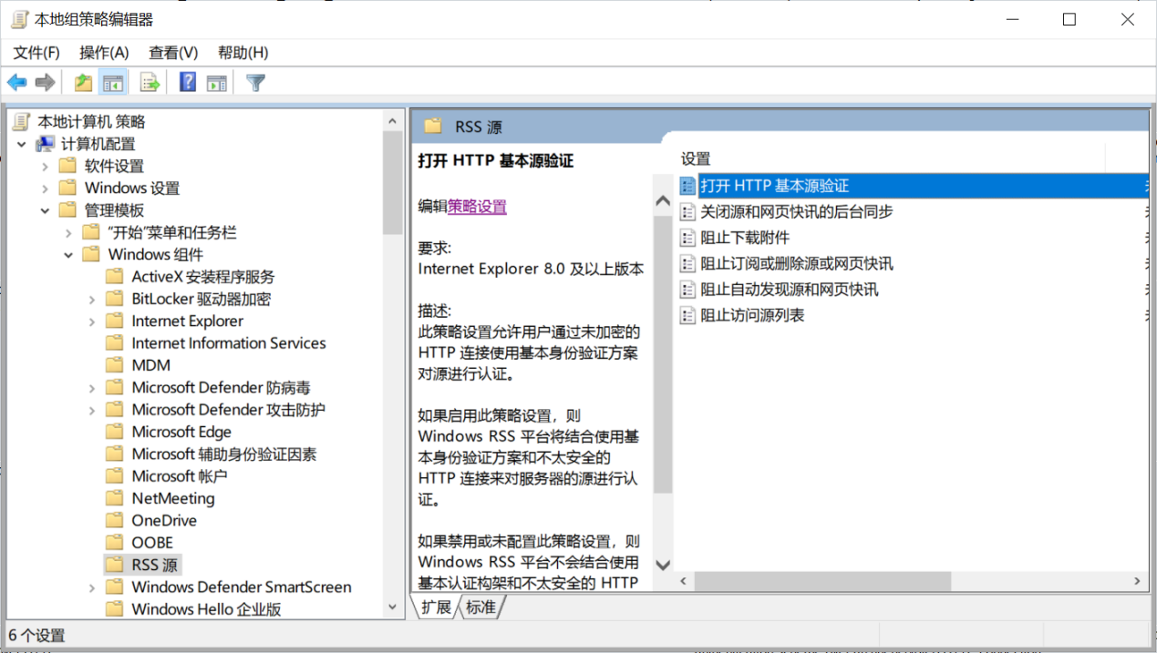

##### 检查语句

select data from registry

where key like

"HKEY_CURRENT_USER\SOFTWARE\Microsoft\Windows\CurrentVersion\Group Policy Objects\%Machine%\Software\Policies\Microsoft\Internet Explorer\Feeds" and name = "AllowBasicAuthInClear";

##### 检查结果

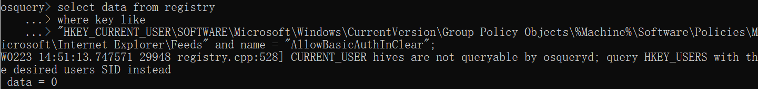

data = 0，则该检查项通过。

#### 387-386

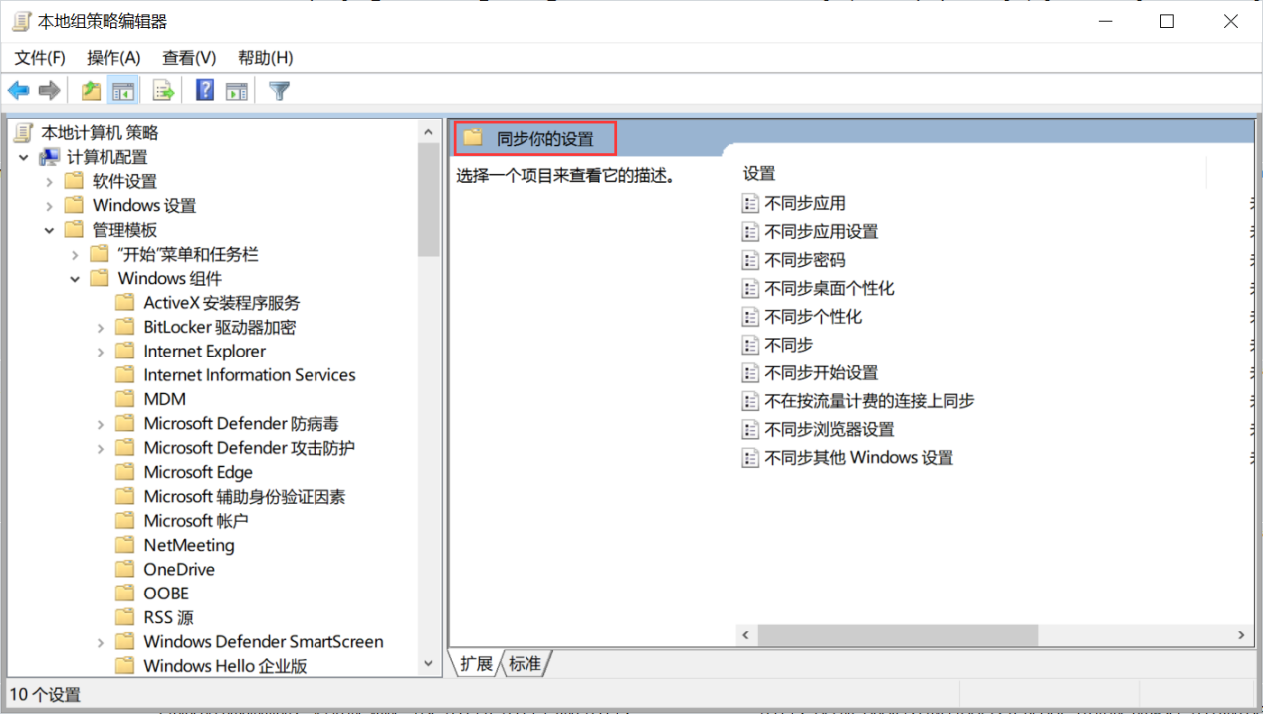

**387、Configure 'Do not sync passwords'**

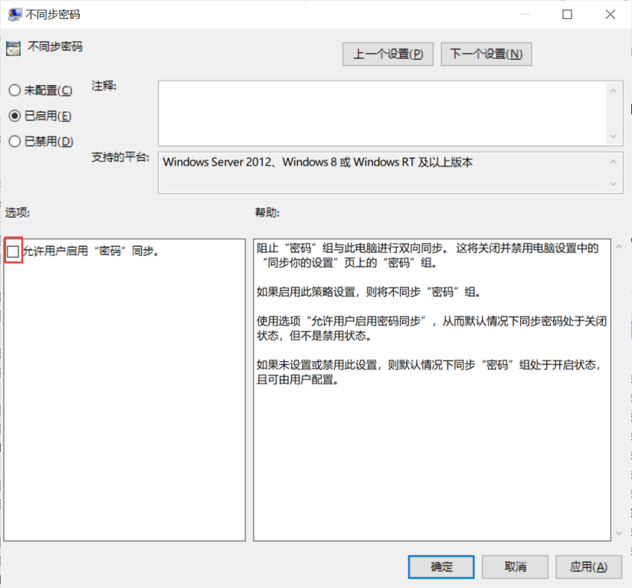

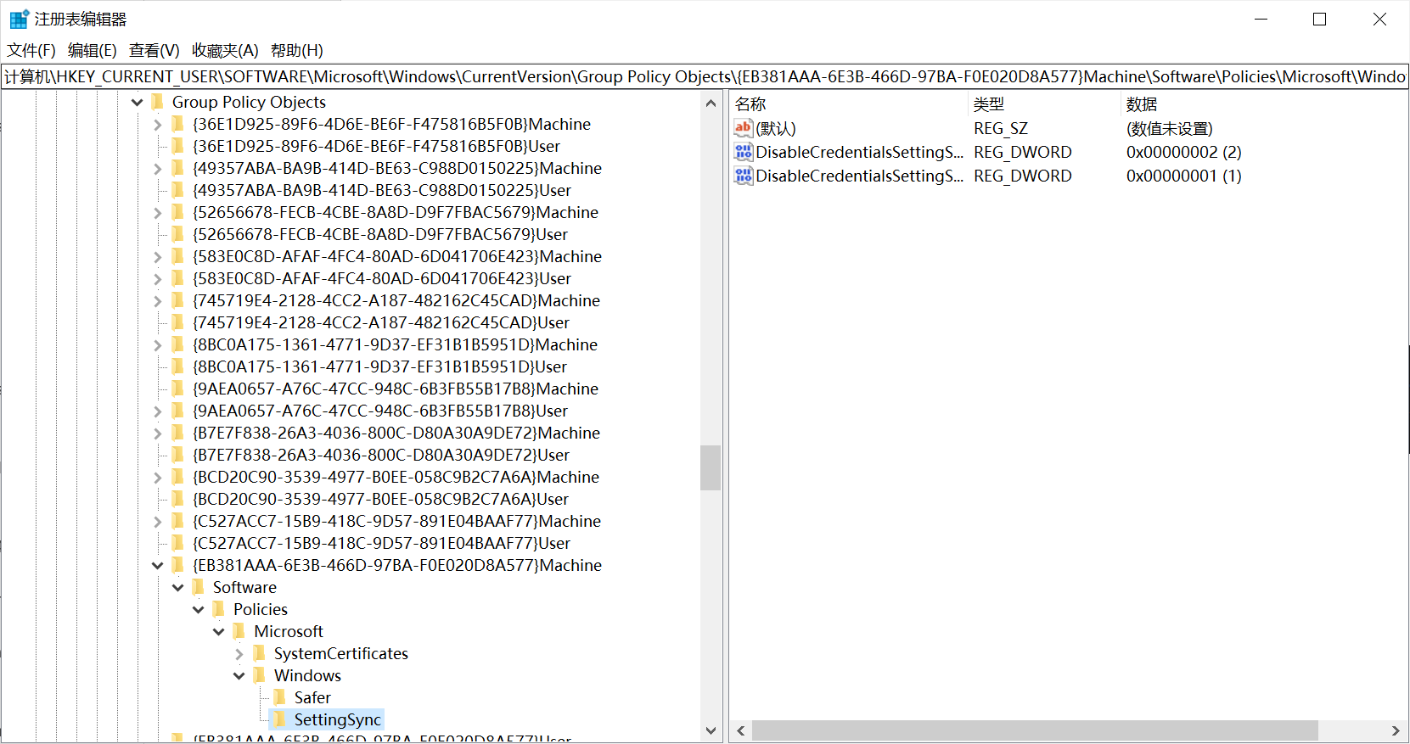

**检查语句**

**（1）**

select data from registry

where key like

"HKEY_CURRENT_USER\SOFTWARE\Microsoft\Windows\CurrentVersion\Group Policy Objects\%Machine%\Software\Policies\Microsoft\Windows\SettingSync" and name = "DisableCredentialsSettingSync";

**（2）**

select data from registry

where key like

"HKEY_CURRENT_USER\SOFTWARE\Microsoft\Windows\CurrentVersion\Group Policy Objects\%Machine%\Software\Policies\Microsoft\Windows\SettingSync" and name = "DisableCredentialsSettingSyncUserOverride";

**检查结果**

**（1）**

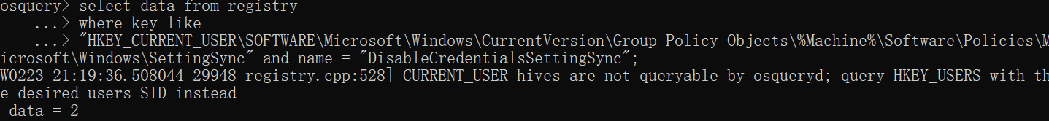

data = 2，则该检查项通过。

**（2）**

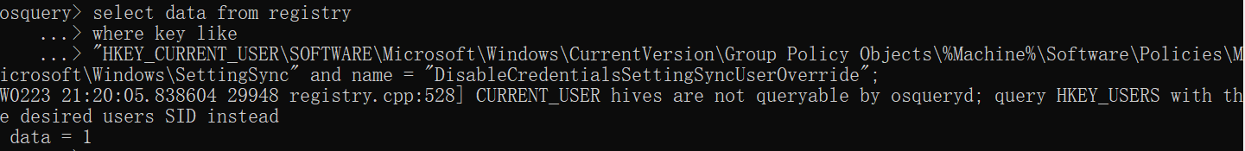

data = 1，则该检查项通过。

**386、Configure 'Do not sync browser settings'**

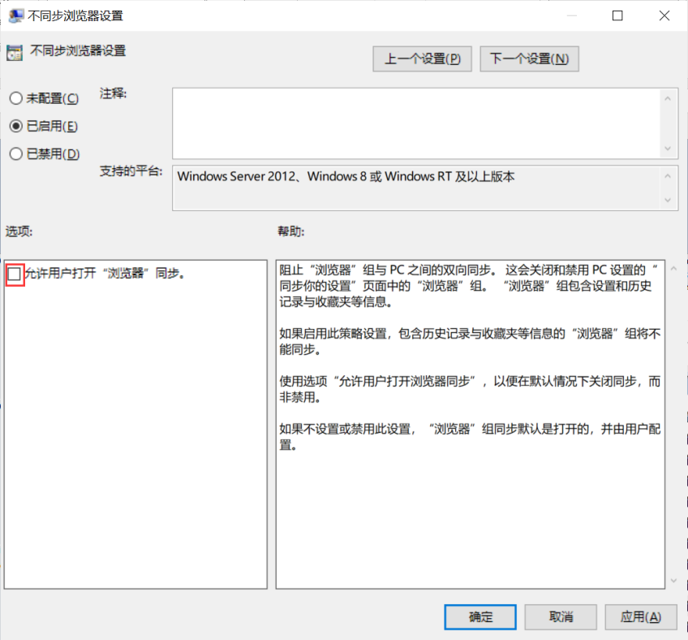

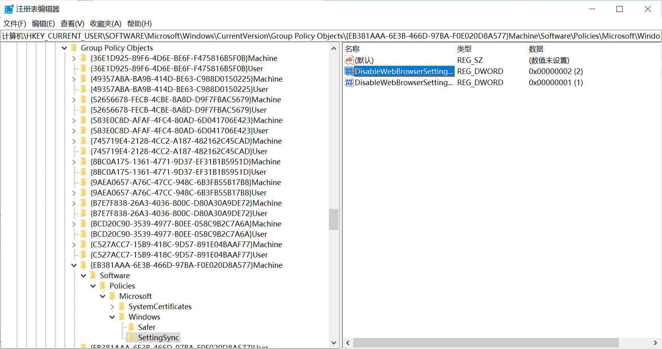

**检查语句**

**（1）**

select data from registry

where key like

"HKEY_CURRENT_USER\SOFTWARE\Microsoft\Windows\CurrentVersion\Group Policy Objects\%Machine%\Software\Policies\Microsoft\Windows\SettingSync" and name = "DisableWebBrowserSettingSync";

**（2）**

select data from registry

where key like

"HKEY_CURRENT_USER\SOFTWARE\Microsoft\Windows\CurrentVersion\Group Policy Objects\%Machine%\Software\Policies\Microsoft\Windows\SettingSync" and name = "DisableWebBrowserSettingSyncUserOverride";

**检查结果**

**（1）**

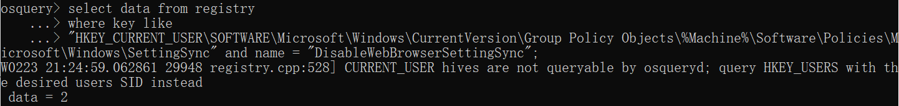

data = 2，则该检查项通过。

**（2）**

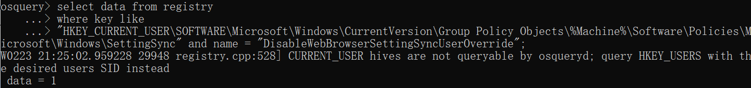

data = 1，则该检查项通过。

#### 304、Ensure 'Prevent non-admin users from installing packaged Windows apps' is set to 'Enabled'

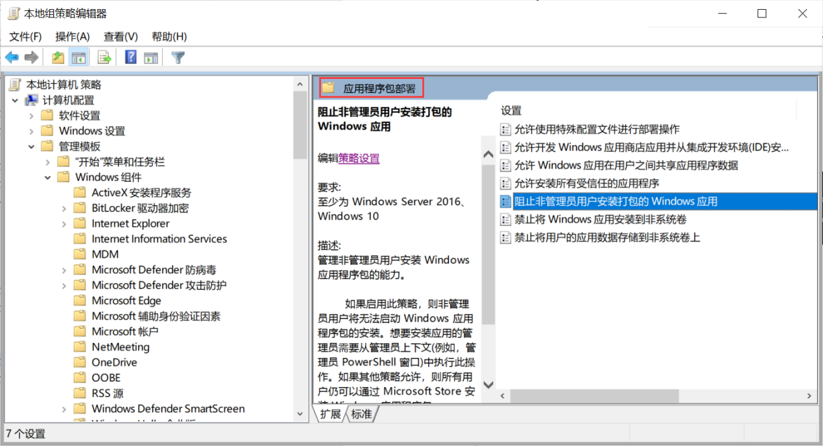

##### 检查语句

select data from registry

where key like

"HKEY_CURRENT_USER\SOFTWARE\Microsoft\Windows\CurrentVersion\Group Policy Objects\%Machine%\Software\Policies\Microsoft\Windows\Appx" and name = "BlockNonAdminUserInstall";

##### 检查结果

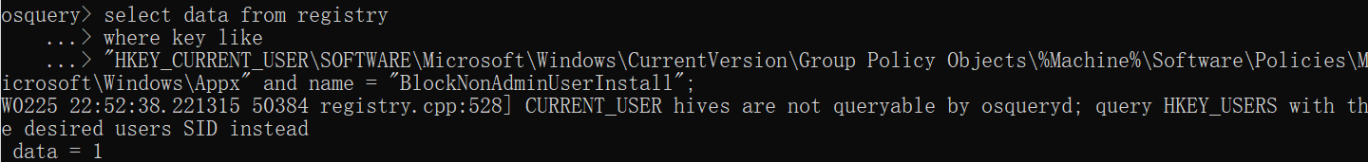

data = 1，则该检查项通过。

#### 301、Disable Message Service Cloud Synchronization

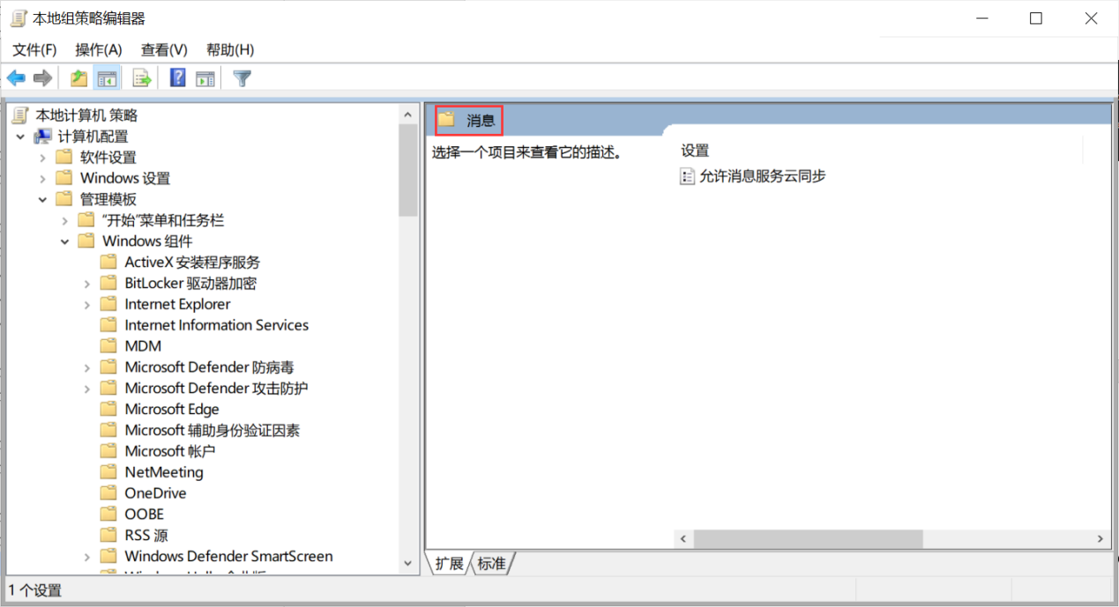

##### 检查语句

select data from registry

where key like

"HKEY_CURRENT_USER\SOFTWARE\Microsoft\Windows\CurrentVersion\Group Policy Objects\%Machine%\Software\Policies\Microsoft\Windows\Messaging" and name = "AllowMessageSync";

##### 检查结果

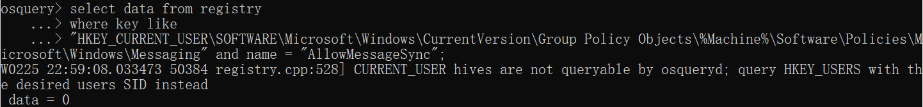

data = 0，则该检查项通过。

### 网络

#### 498-497

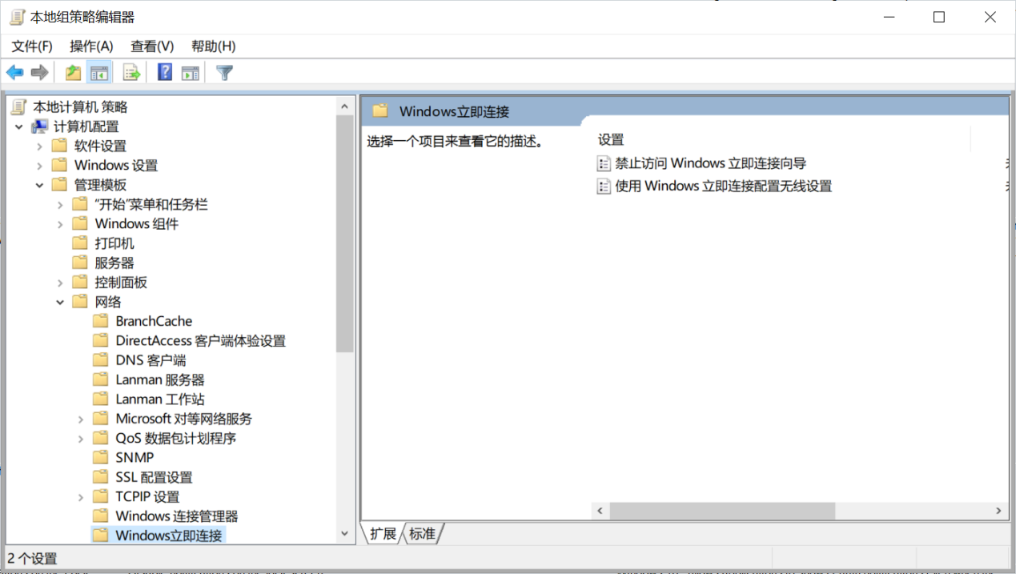

**498、Enable _Prohibit access of the Windows Connect Now wizards_.**

**检查语句**

select data from registry

where key like

"HKEY_CURRENT_USER\SOFTWARE\Microsoft\Windows\CurrentVersion\Group Policy Objects\%Machine%\Software\Policies\Microsoft\Windows\WCN\UI" and name = "DisableWcnUi";

**检查结果**

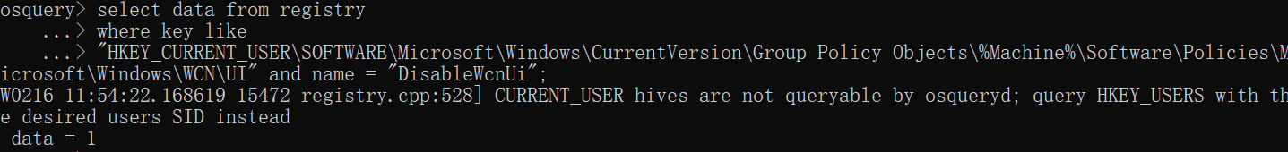

data = 1，则该检查项通过。

**497、Disable _Configuration of wireless settings using Windows Connect Now_.**

**检查语句**

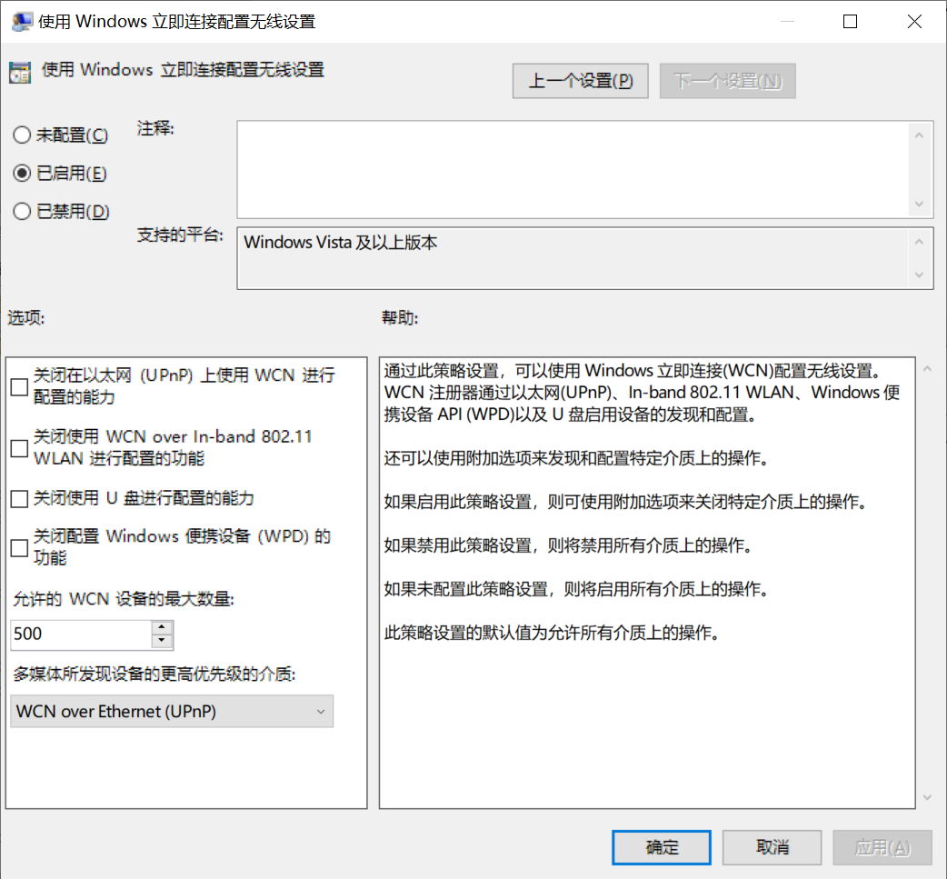

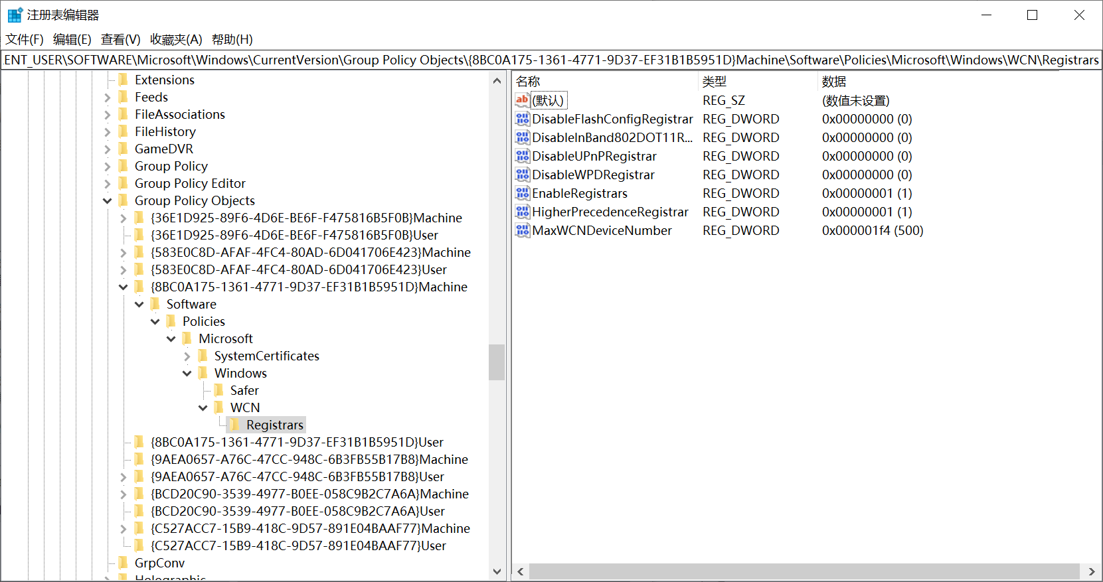

select data from registry

where key like

"HKEY_CURRENT_USER\SOFTWARE\Microsoft\Windows\CurrentVersion\Group Policy Objects\%Machine%\Software\Policies\Microsoft\Windows\WCN\Registrars " and name = "";

**检查结果**

data = 0，则该检查项通过。

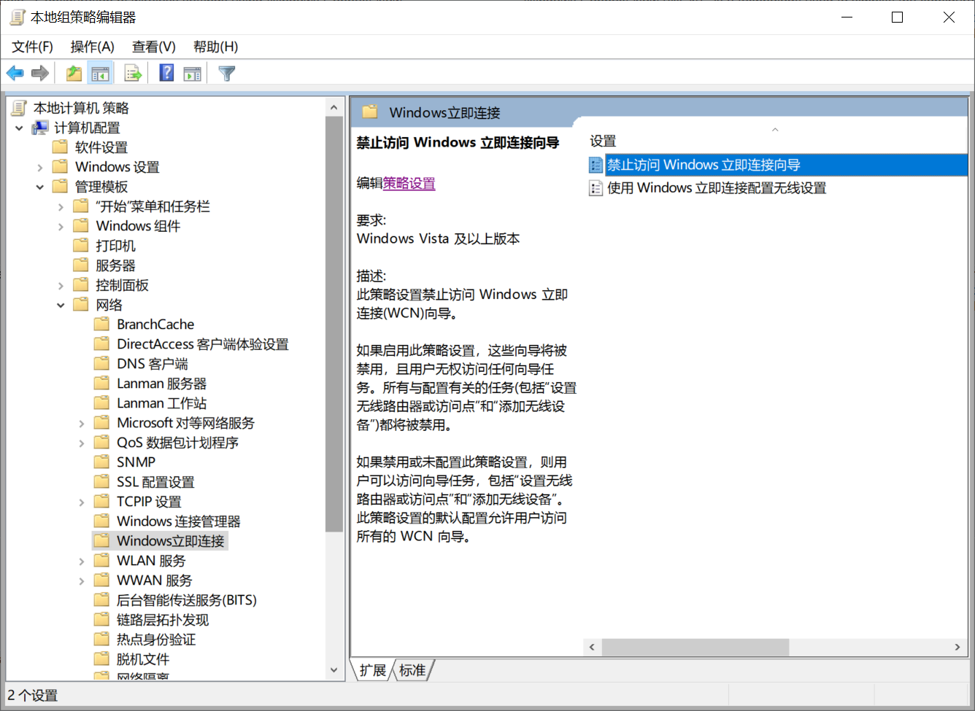

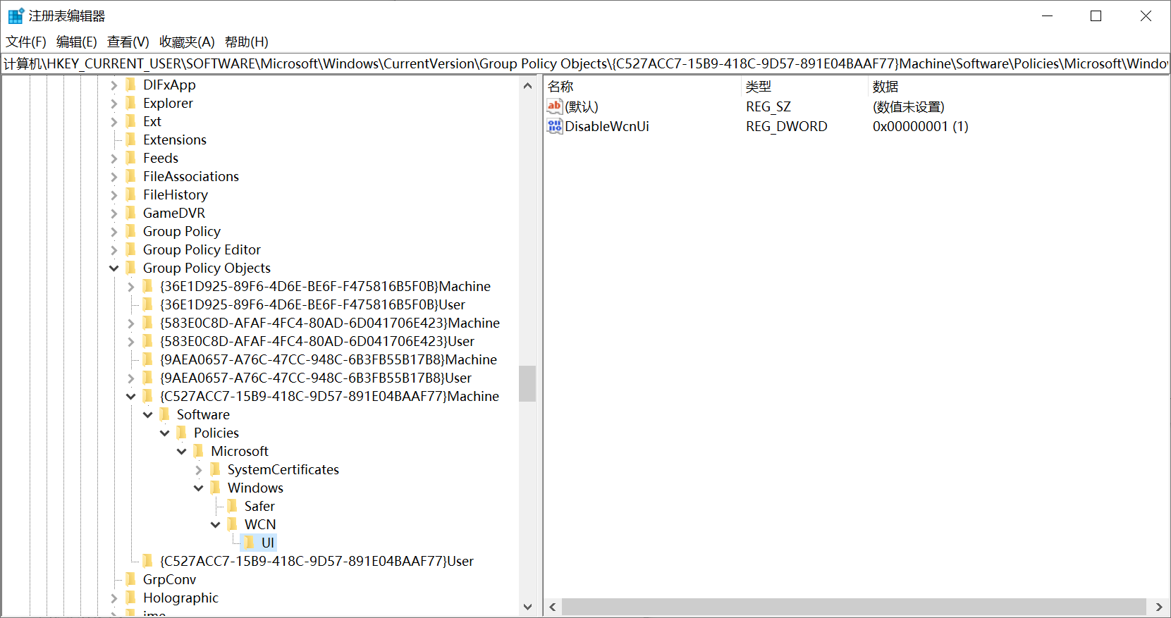

### 系统

#### 525、Enable svchost.exe Mitigation Options

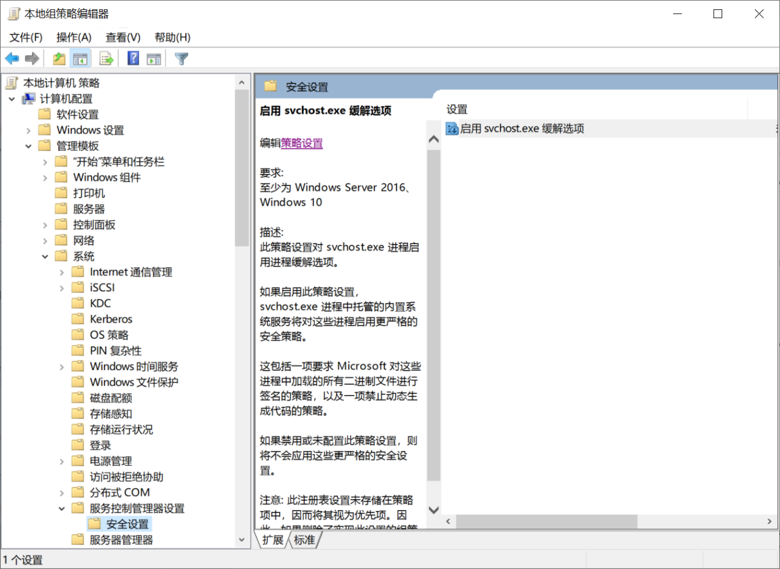

**EnableSvchostMitigationPolicy：启用是1，禁用是0，未配置则不会出现该注册项。**

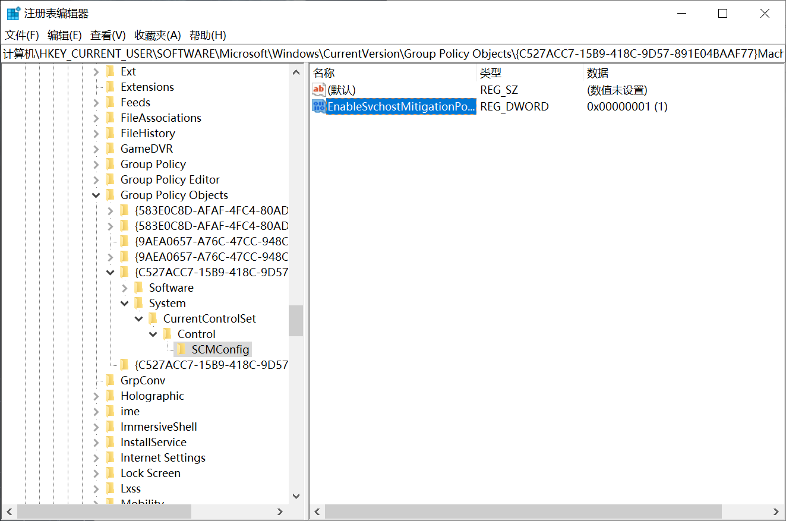

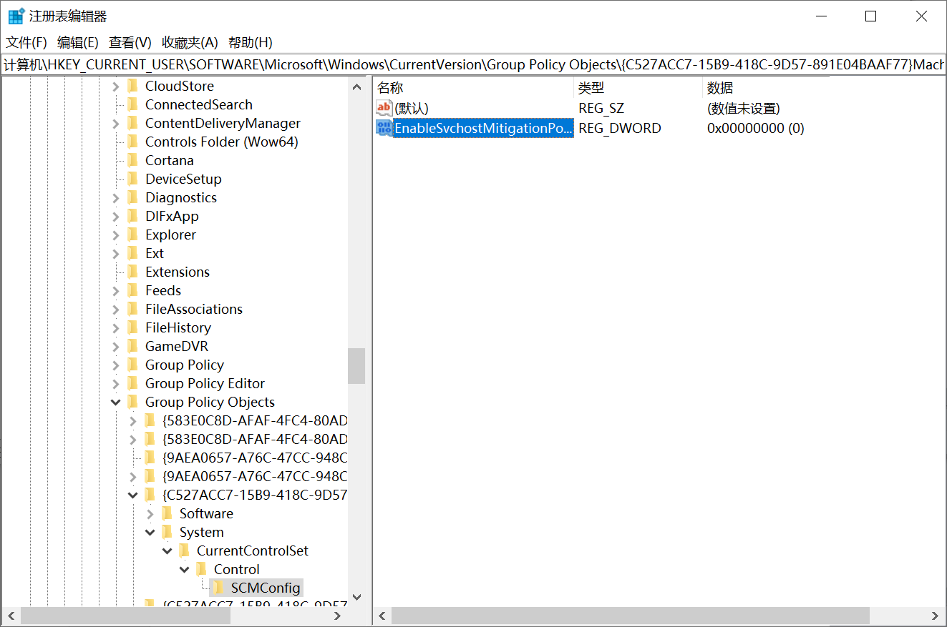

##### 检查语句

select data from registry

where key = "HKEY_CURRENT_USER\SOFTWARE\Microsoft\Windows\CurrentVersion\Group Policy Objects\%Machine%\System\CurrentControlSet\Control\SCMConfig" and name =” EnableSvchostMitigationPolicy”;

##### 检查结果

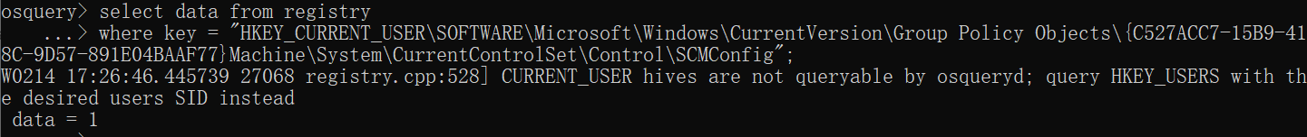

data = 1，则该检查项通过。

#### 500、Disable notifications on the lock screen.

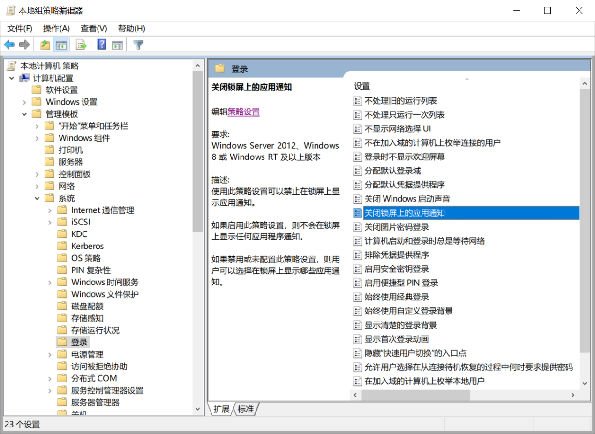

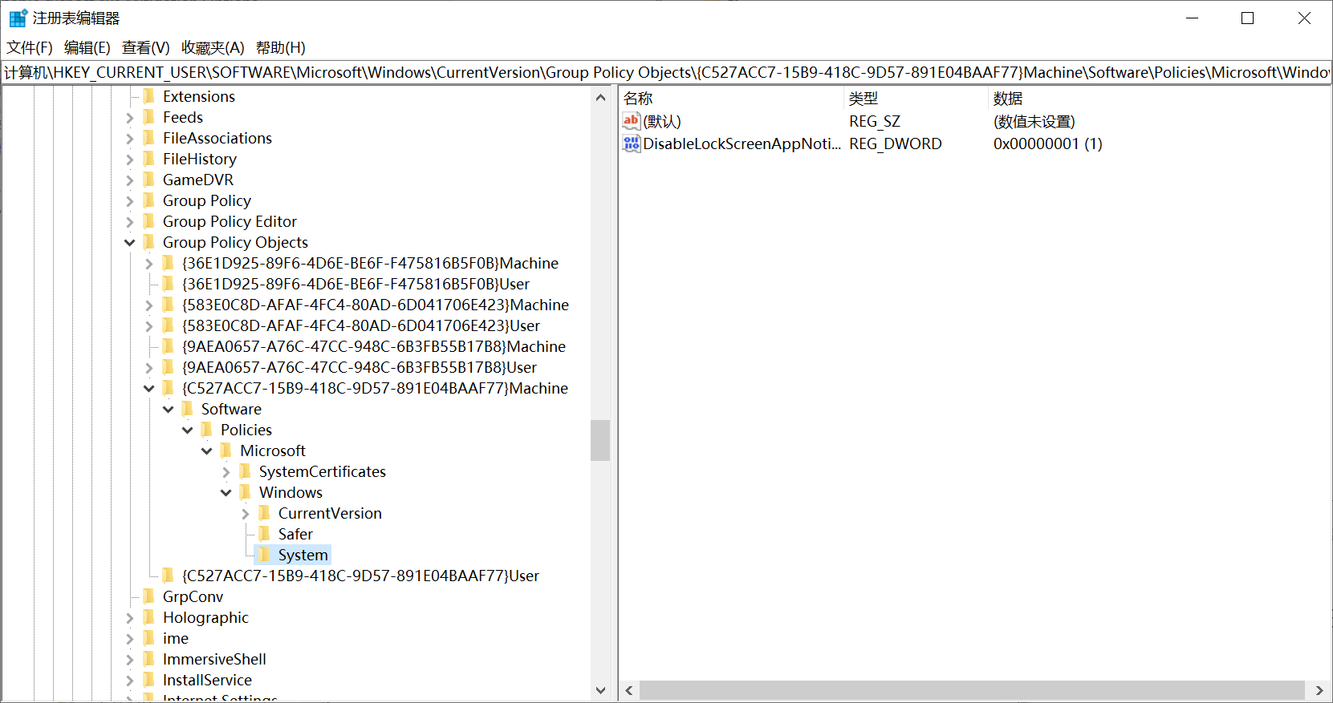

##### 检查语句

select data from registry

where key like

"HKEY_CURRENT_USER\SOFTWARE\Microsoft\Windows\CurrentVersion\Group Policy Objects\%Machine%\Software\Policies\Microsoft\Windows\System" and name = "DisableLockScreenAppNotifications";

##### 检查结果

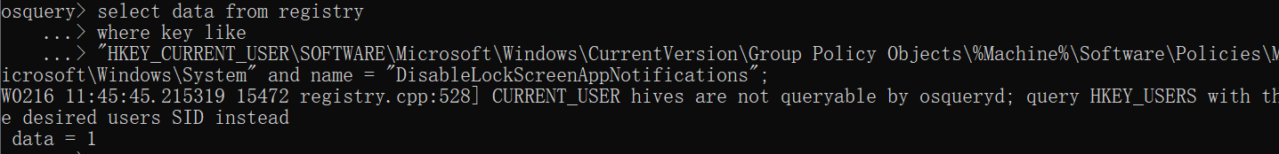

data = 1，则该检查项通过。

#### 496、Disable the _Enables Activity Feed_ setting.

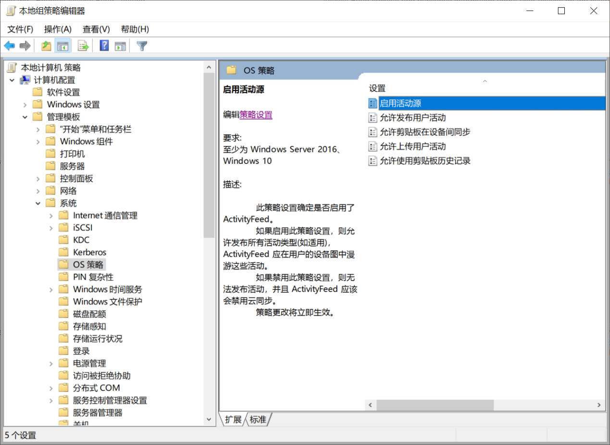

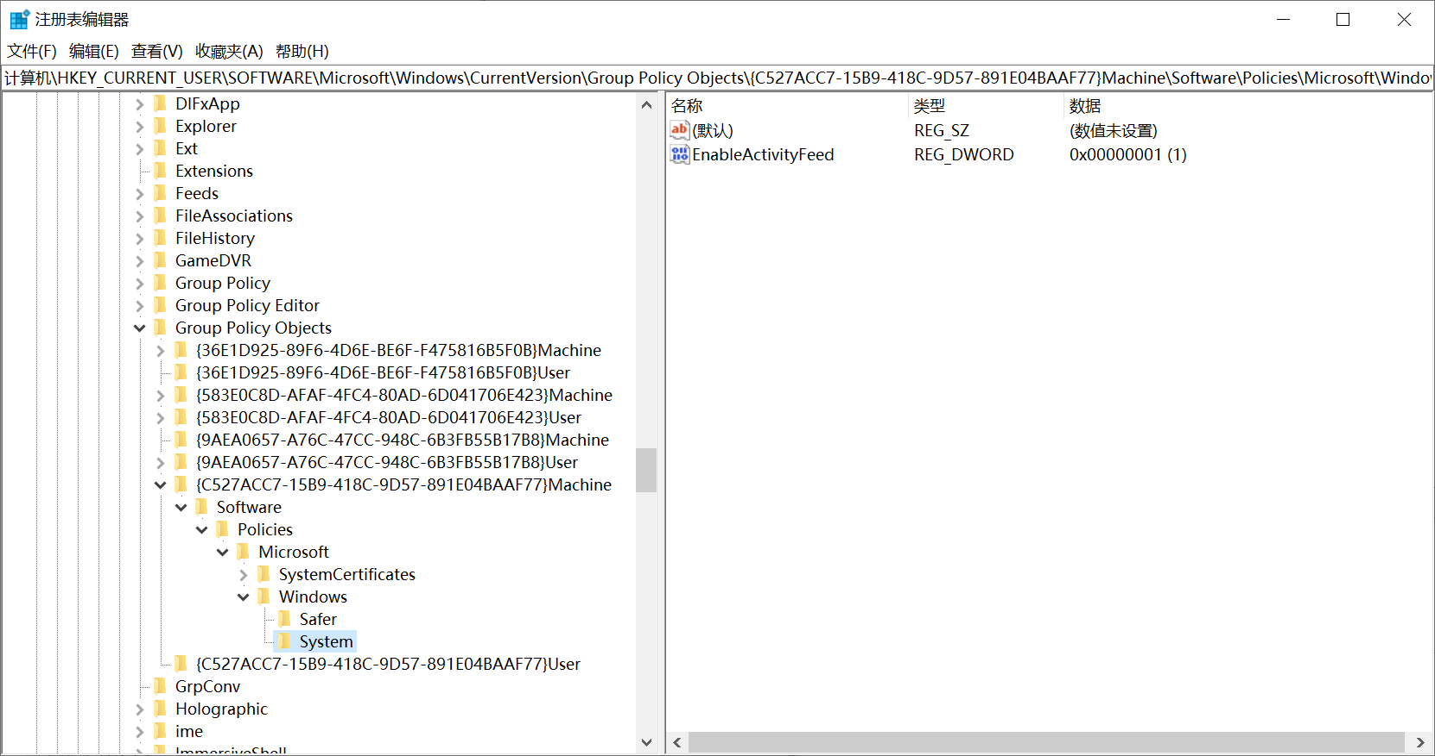

##### 检查语句

select data from registry

where key like

"HKEY_CURRENT_USER\SOFTWARE\Microsoft\Windows\CurrentVersion\Group Policy Objects\%Machine%\Software\Policies\Microsoft\Windows\System" and name = "EnableActivityFeed";

##### 检查结果

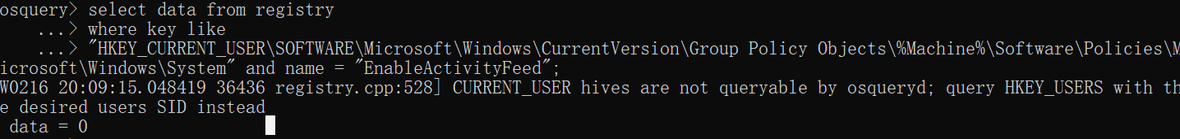

data = 0，则该检查项通过。

#### 494、Disable Cross-Device Experiences

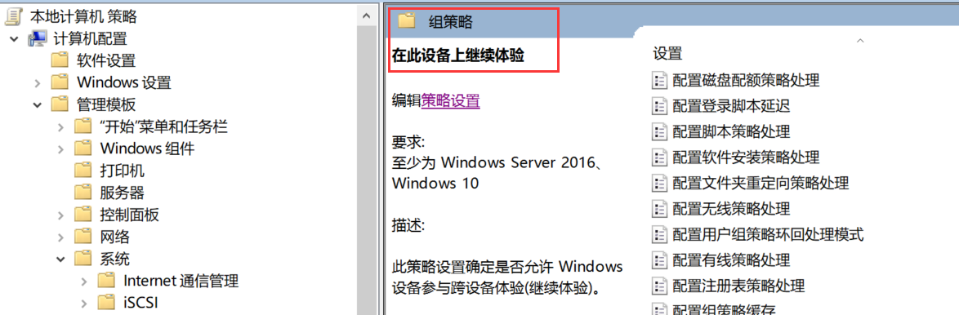

##### 检查语句

select data from registry

where key like

"HKEY_CURRENT_USER\SOFTWARE\Microsoft\Windows\CurrentVersion\Group Policy Objects\%Machine%\Software\Policies\Microsoft\Windows\System" and name = "EnableCdp";

##### 检查结果

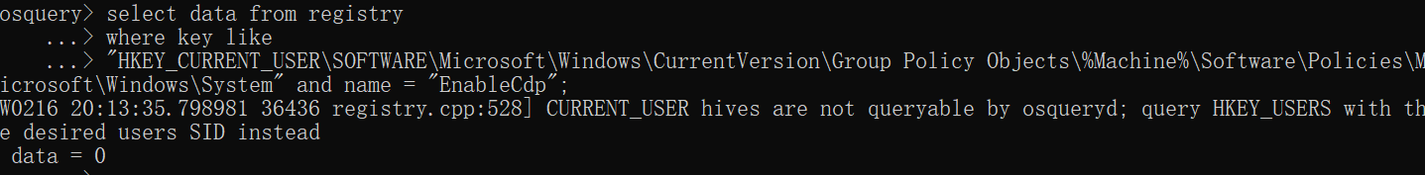

data = 0，则该检查项通过。

#### 483-482

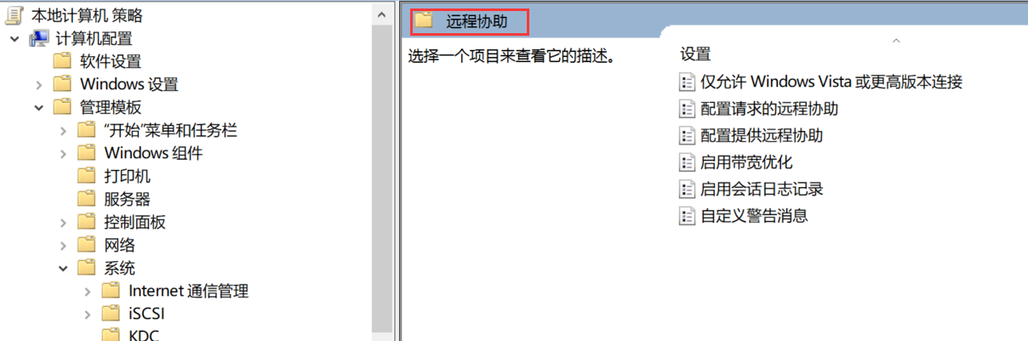

**483、Disable the policy _Configure Offer Remote Assistance_.**

**检查语句**

select data from registry

where key like

"HKEY_CURRENT_USER\SOFTWARE\Microsoft\Windows\CurrentVersion\Group Policy Objects\%Machine%\Software\Policies\Microsoft\Windows NT\Terminal Services" and name = "fAllowUnsolicited";

**检查结果**

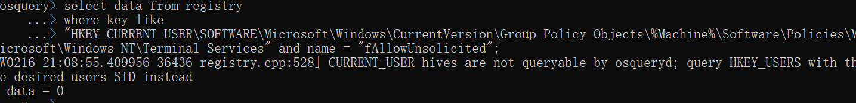

data = 0，则该检查项通过。

**482、Disable the policy _Configure Solicited Remote Assistance_.**

**检查语句**

select data from registry

where key like

"HKEY_CURRENT_USER\SOFTWARE\Microsoft\Windows\CurrentVersion\Group Policy Objects\%Machine%\Software\Policies\Microsoft\Windows NT\Terminal Services" and name = "fAllowToGetHelp";

**检查结果**

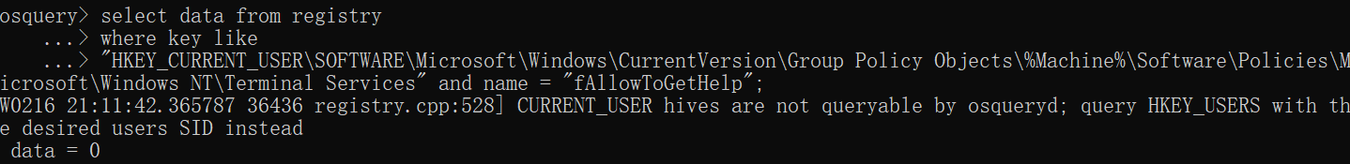

data = 0，则该检查项通过。

#### 480-473

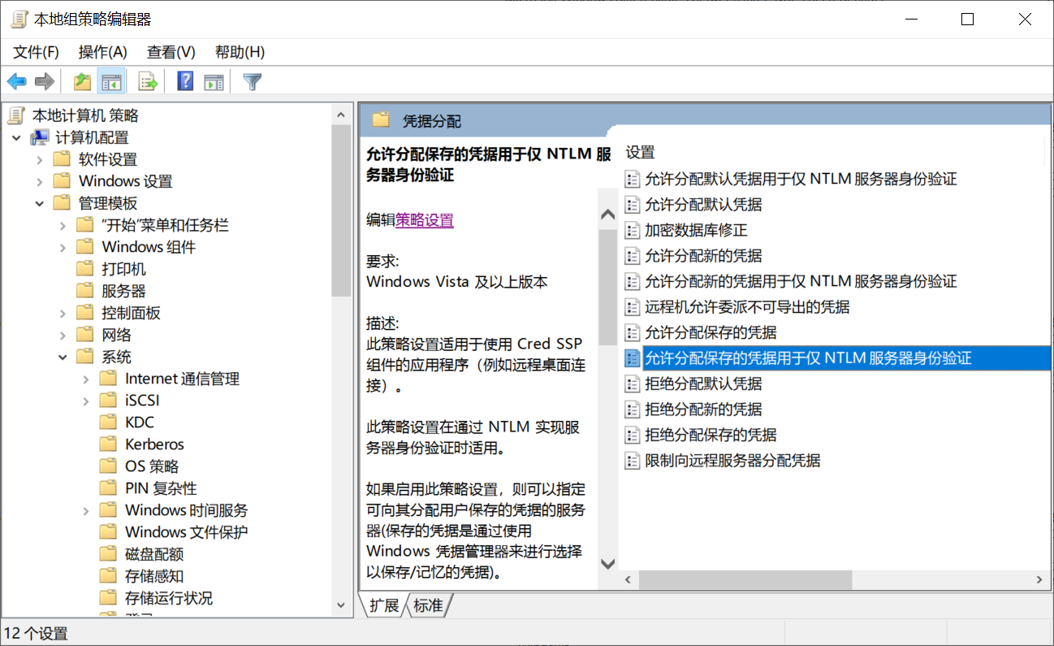

**480、Ensure 'Allow delegating saved credentials with NTLM-only server authentication' is set to 'Disabled'**

**检查语句**

select data from registry

where key like

"HKEY_CURRENT_USER\SOFTWARE\Microsoft\Windows\CurrentVersion\Group Policy Objects\%Machine%\Software\Policies\Microsoft\Windows\CredentialsDelegation" and name = "AllowSavedCredentialsWhenNTLMOnly" and type = "REG_DWORD";

**检查结果**

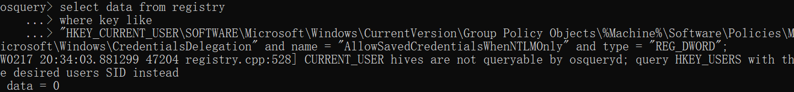

data = 0，则该检查项通过。

**479、Ensure 'Allow delegating saved credentials' is set to 'Disabled'**

**检查语句**

select data from registry

where key like

"HKEY_CURRENT_USER\SOFTWARE\Microsoft\Windows\CurrentVersion\Group Policy Objects\%Machine%\Software\Policies\Microsoft\Windows\CredentialsDelegation" and name = "AllowSavedCredentials" and type = "REG_DWORD";

**检查结果**

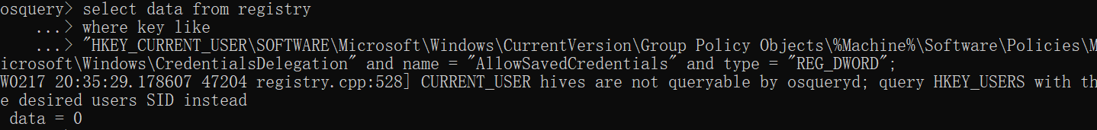

data = 0，则该检查项通过。

**478、Ensure 'Allow delegating fresh credentials with NTLM-only server authentication' is set to 'Disabled'**

**检查语句**

select data from registry

where key like

"HKEY_CURRENT_USER\SOFTWARE\Microsoft\Windows\CurrentVersion\Group Policy Objects\%Machine%\Software\Policies\Microsoft\Windows\CredentialsDelegation" and name = "AllowSavedCredentials" and type = "REG_DWORD";

**检查结果**



data = 0，则该检查项通过。

**477、Ensure 'Allow delegating fresh credentials' is set to 'Disabled'**

**检查语句**

select data from registry

where key like

"HKEY_CURRENT_USER\SOFTWARE\Microsoft\Windows\CurrentVersion\Group Policy Objects\%Machine%\Software\Policies\Microsoft\Windows\CredentialsDelegation" and name = "AllowFreshCredentialsWhenNTLMOnly" and type = "REG_DWORD";

**检查结果**

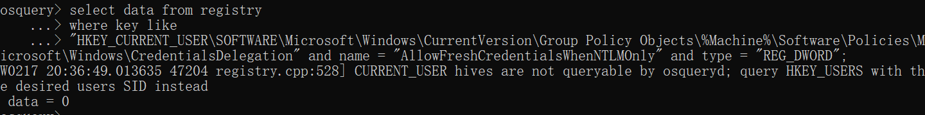

data = 0，则该检查项通过。

**476、Ensure 'Allow delegating default credentials with NTLM-only server authentication' is set to 'Disabled'**

**检查语句**

select data from registry

where key like

"HKEY_CURRENT_USER\SOFTWARE\Microsoft\Windows\CurrentVersion\Group Policy Objects\%Machine%\Software\Policies\Microsoft\Windows\CredentialsDelegation" and name = "AllowDefCredentialsWhenNTLMOnly" and type = "REG_DWORD";

**检查结果**

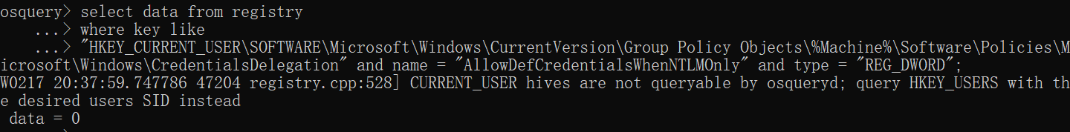

data = 0，则该检查项通过。

**475、Ensure 'Allow delegating default credentials' is set to 'Disabled'**

**检查语句**

select data from registry

where key like

"HKEY_CURRENT_USER\SOFTWARE\Microsoft\Windows\CurrentVersion\Group Policy Objects\%Machine%\Software\Policies\Microsoft\Windows\CredentialsDelegation" and name = "AllowDefaultCredentials" and type = "REG_DWORD";

**检查结果**

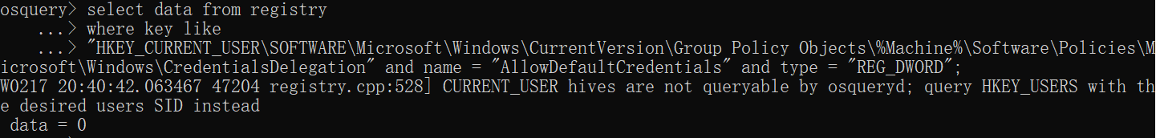

data = 0，则该检查项通过。

**474、Ensure 'Restrict delegation of credentials to remote servers' is set to 'Restrict Credential Delegation'**

**检查语句**

select data from registry

where key like

"HKEY_CURRENT_USER\SOFTWARE\Microsoft\Windows\CurrentVersion\Group Policy Objects\%Machine%\Software\Policies\Microsoft\Windows\CredentialsDelegation" and name = "RestrictedRemoteAdministration" and type = "REG_DWORD";

**检查结果**

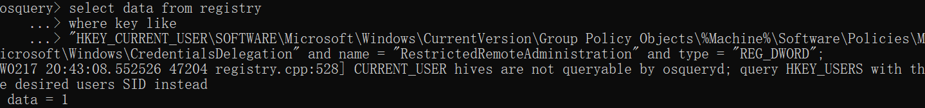

data = 1，则该检查项通过。

**473、Ensure 'Remote host allows delegation of non-exportable credentials' is set to 'Enabled'**

**检查语句**

select data from registry

where key like

"HKEY_CURRENT_USER\SOFTWARE\Microsoft\Windows\CurrentVersion\Group Policy Objects\%Machine%\Software\Policies\Microsoft\Windows\CredentialsDelegation" and name = "AllowProtectedCreds" and type = "REG_DWORD";

**检查结果**

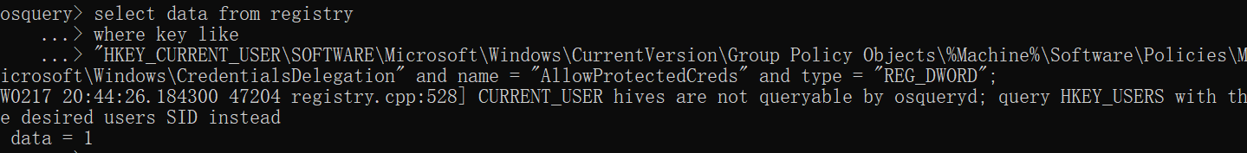

data = 1，则该检查项通过。

#### 472、Ensure 'Allow non-administrators to install drivers for these device setup classes' is set to 'Disabled'

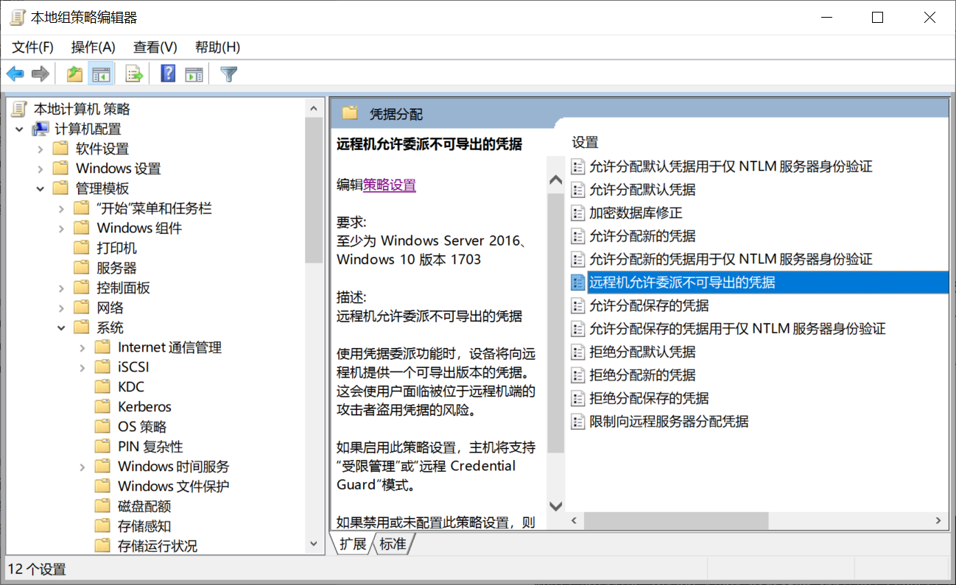

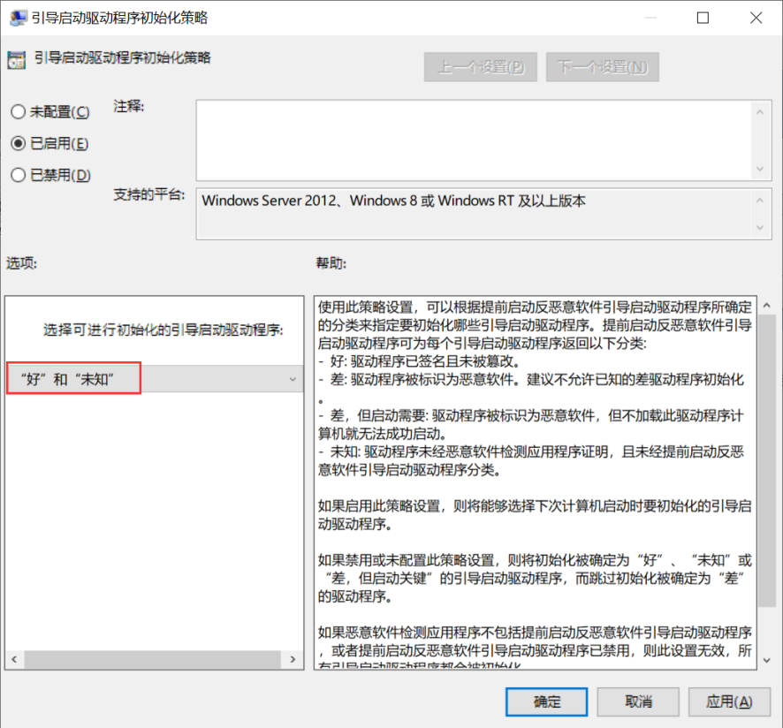

##### 检查语句

select data from registry

where key like

"HKEY_CURRENT_USER\SOFTWARE\Microsoft\Windows\CurrentVersion\Group Policy Objects\%Machine%\System\CurrentControlSet\Policies\EarlyLaunch" and name = "DriverLoadPolicy" and type = "REG_DWORD";

##### 检查结果

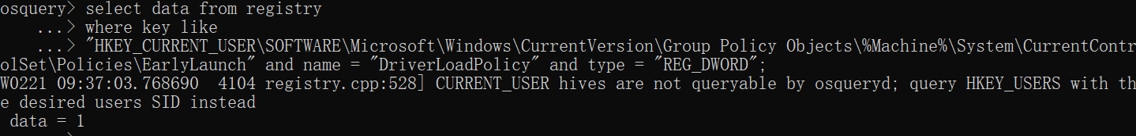

data = 1，则该检查项通过。

#### 435、Enable Early Launch Antimalware

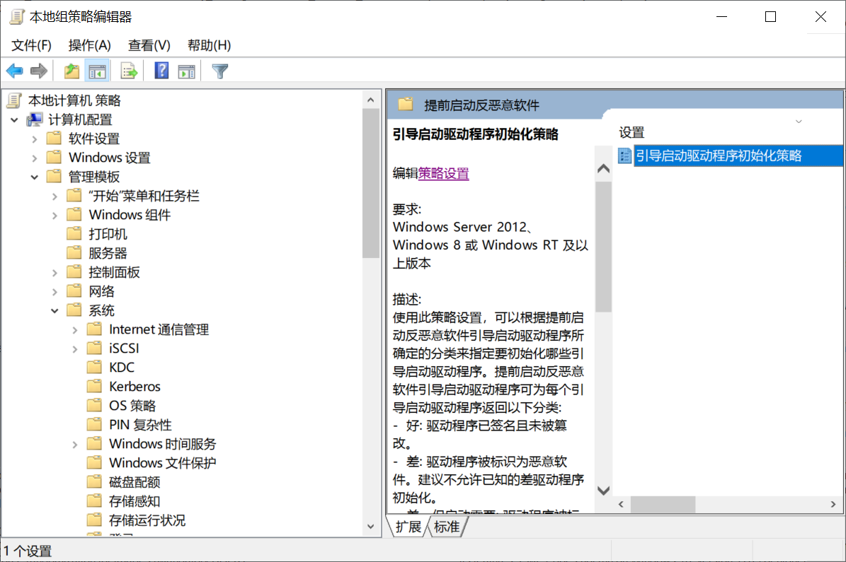

##### 检查语句

select data from registry

where key like

"HKEY_CURRENT_USER\SOFTWARE\Microsoft\Windows\CurrentVersion\Group Policy Objects\%Machine%\Software\Policies\Microsoft\Windows\DriverInstall\Restrictions" and name = "AllowUserDeviceClasses" and type = "REG_DWORD";

##### 检查结果

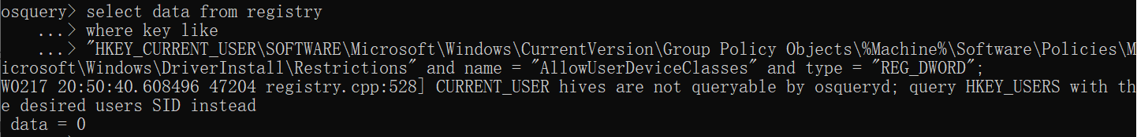

data = 0，则该检查项通过。

#### 302、Disable Storage Sense

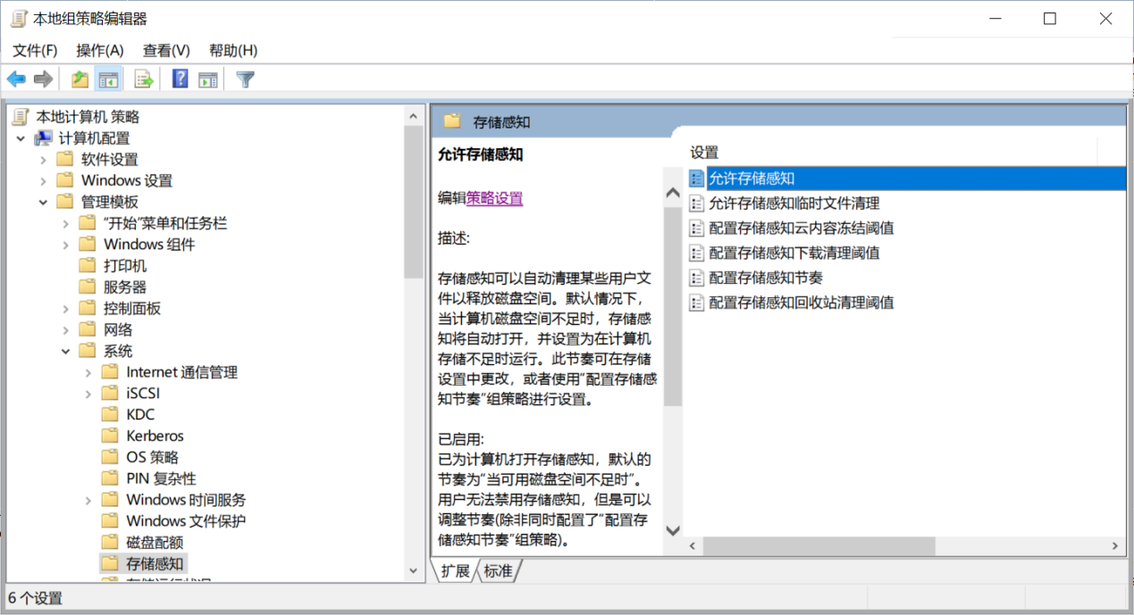

##### 检查语句

select data from registry

where key like

"HKEY_CURRENT_USER\SOFTWARE\Microsoft\Windows\CurrentVersion\Group Policy Objects\%Machine%\Software\Policies\Microsoft\Windows\StorageSense" and name = "AllowStorageSenseGlobal" and type = "REG_DWORD";

##### 检查结果

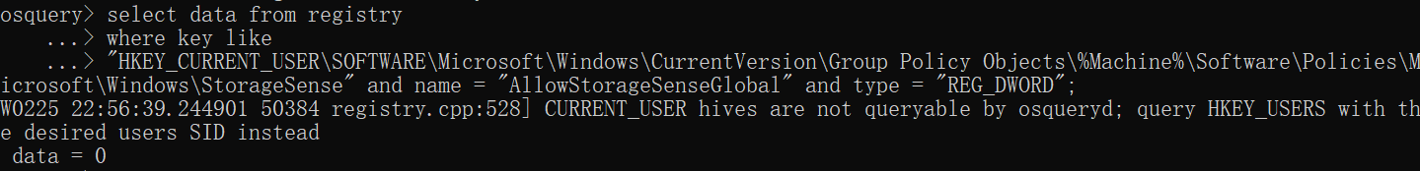

data = 0，则该检查项通过。

#### 300、Disable Clipboard Synchronization Across Devices

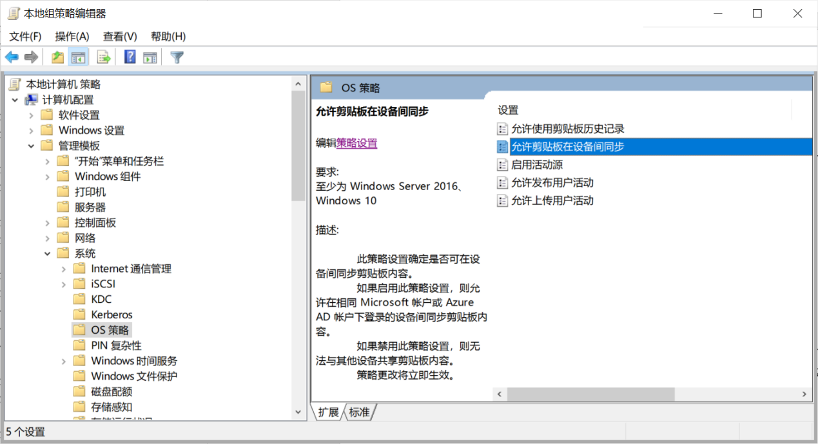

##### 检查语句

select data from registry

where key like

"HKEY_CURRENT_USER\SOFTWARE\Microsoft\Windows\CurrentVersion\Group Policy Objects\%Machine%\Software\Policies\Microsoft\Windows\System" and name = "AllowCrossDeviceClipboard" and type = "REG_DWORD";

##### 检查结果

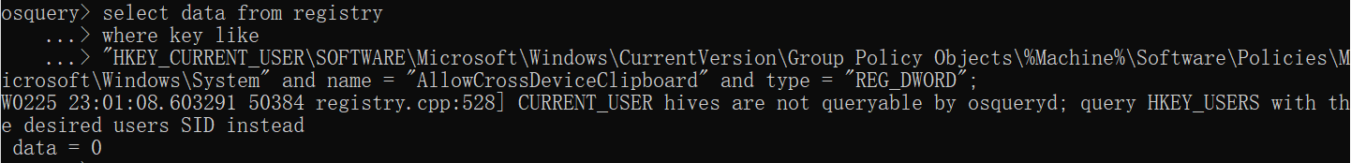

data = 0，则该检查项通过。

## 用户配置（管理模板）

### Windows组件

#### 508-502

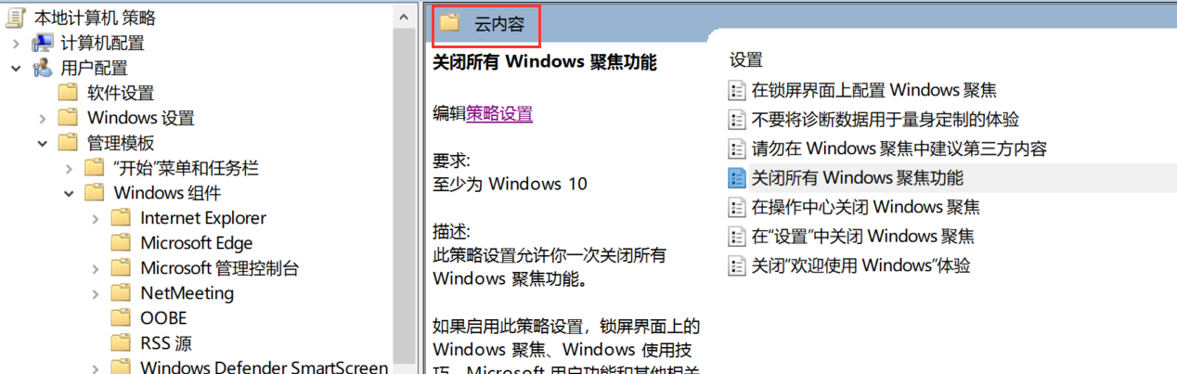

**508、Ensure 'Turn off Windows Spotlight on Settings' is set to 'Enabled'**

**检查语句**

select data from registry

where key like

"HKEY_CURRENT_USER\SOFTWARE\Microsoft\Windows\CurrentVersion\Group Policy Objects\%User%\Software\Policies\Microsoft\Windows\CloudContent" and name = "DisableWindowsSpotlightOnSettings";

**检查结果**

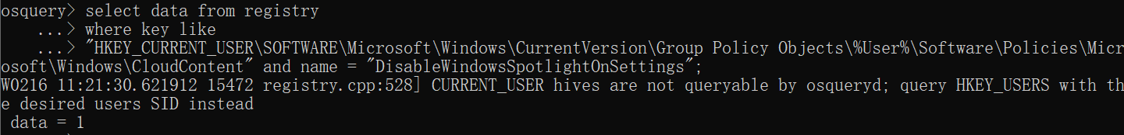

data = 1，则该检查项通过。

**507、Ensure 'Turn off Windows Spotlight on Action Center' is set to 'Enabled'**

**检查语句**

select data from registry

where key like

"HKEY_CURRENT_USER\SOFTWARE\Microsoft\Windows\CurrentVersion\Group Policy Objects\%User%\Software\Policies\Microsoft\Windows\CloudContent" and name = "DisableWindowsSpotlightOnActionCenter";

**检查结果**

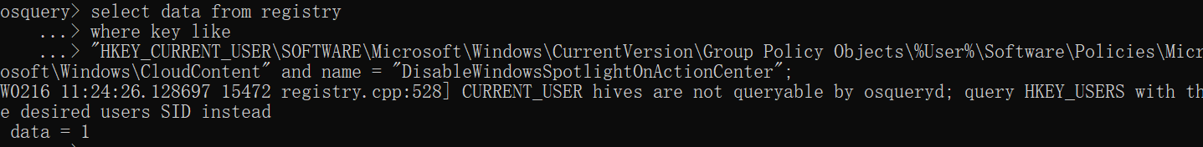

data = 1，则该检查项通过。

**506、Ensure 'Turn off the Windows Welcome Experience' is set to 'Enabled'**

**检查语句**

select data from registry

where key like

"HKEY_CURRENT_USER\SOFTWARE\Microsoft\Windows\CurrentVersion\Group Policy Objects\%User%\Software\Policies\Microsoft\Windows\CloudContent" and name = "DisableWindowsSpotlightWindowsWelcomeExperience";

**检查结果**

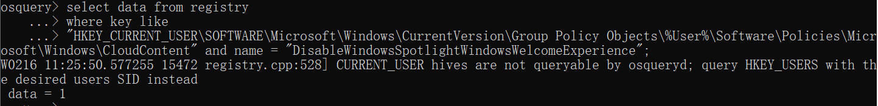

data = 1，则该检查项通过。

**505、Ensure 'Turn off all Windows spotlight features' is set to 'Enabled'**

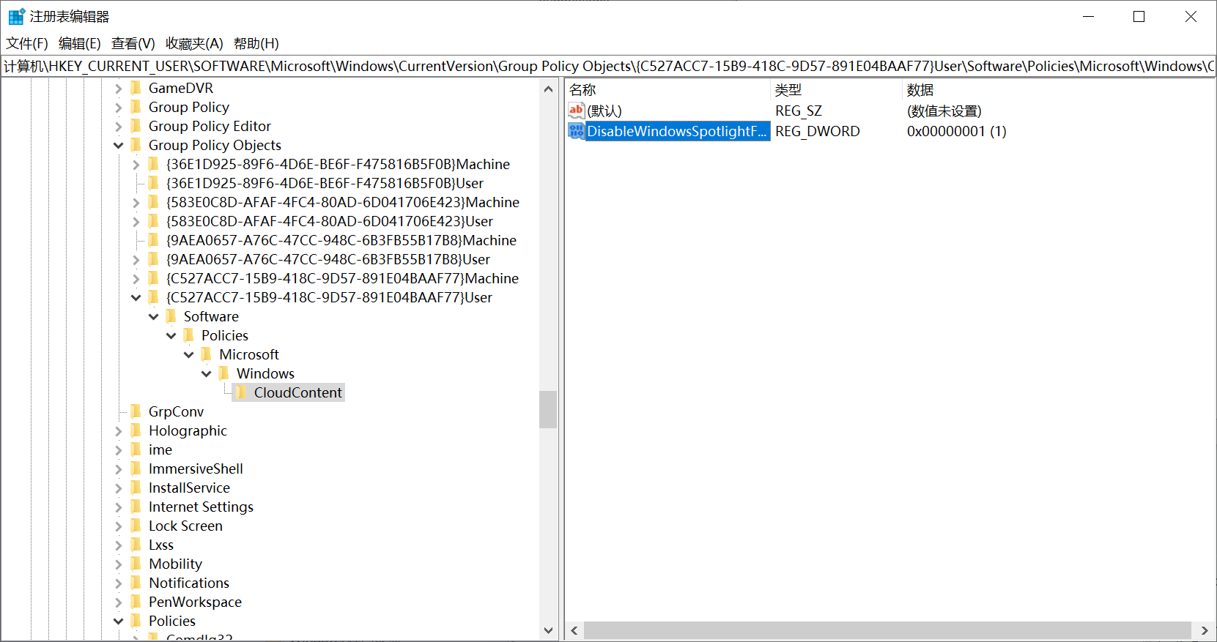

**检查语句**

select data from registry

where key like

"HKEY_CURRENT_USER\SOFTWARE\Microsoft\Windows\CurrentVersion\Group Policy Objects\%User%\Software\Policies\Microsoft\Windows\CloudContent" and name = "DisableWindowsSpotlightFeatures";

**检查结果**

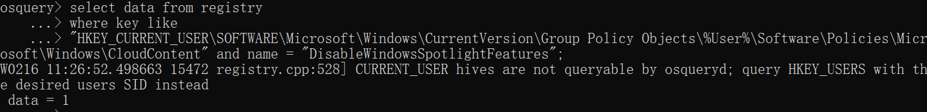

data = 1，则该检查项通过。

**504、Ensure 'Do not use diagnostic data for tailored experiences' is set to 'Enabled'**

**检查语句**

select data from registry

where key like

"HKEY_CURRENT_USER\SOFTWARE\Microsoft\Windows\CurrentVersion\Group Policy Objects\%User%\Software\Policies\Microsoft\Windows\CloudContent" and name = "DisableTailoredExperiencesWithDiagnosticData";

**检查结果**

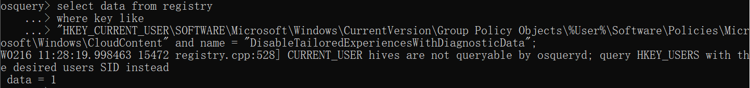

data = 1，则该检查项通过。

**503、Ensure 'Do not suggest third-party content in Windows spotlight' is set to 'Enabled'**

**检查语句**

select data from registry

where key like

"HKEY_CURRENT_USER\SOFTWARE\Microsoft\Windows\CurrentVersion\Group Policy Objects\%User%\Software\Policies\Microsoft\Windows\CloudContent" and name = "DisableThirdPartySuggestions";

**检查结果**

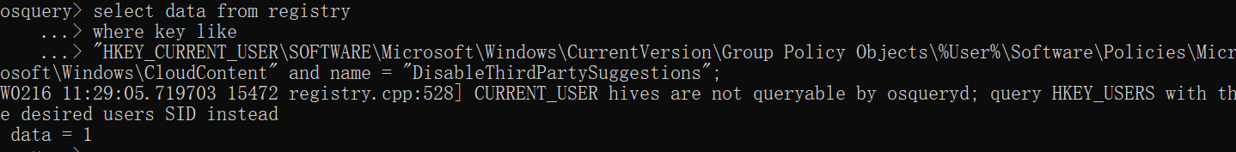

data = 1，则该检查项通过。

**502、Ensure 'Configure Windows spotlight on lock screen' is set to Disabled'**

**检查语句**

select data from registry

where key like

"HKEY_CURRENT_USER\SOFTWARE\Microsoft\Windows\CurrentVersion\Group Policy Objects\%User%\Software\Policies\Microsoft\Windows\CloudContent" and name = "ConfigureWindowsSpotlight";

**检查结果**

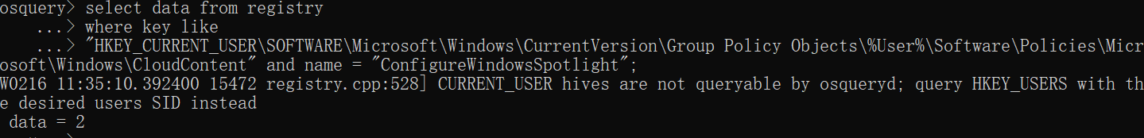

data = 2，则该检查项通过。

#### 486、Disable the Recycle Bin

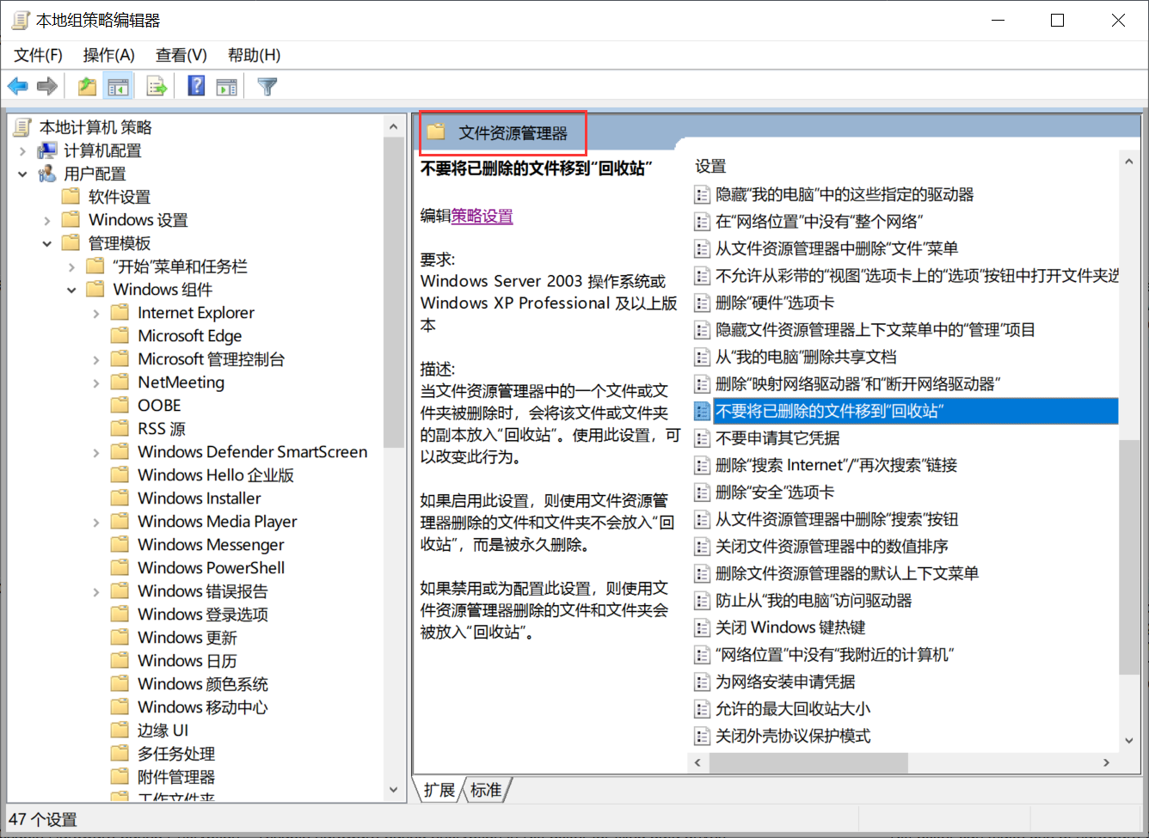

##### 检查语句

select data from registry

where key like

"HKEY_CURRENT_USER\SOFTWARE\Microsoft\Windows\CurrentVersion\Group Policy Objects\%User%\Software\Microsoft\Windows\CurrentVersion\Policies\Explorer" and name = "NoRecycleFiles";

##### 检查结果

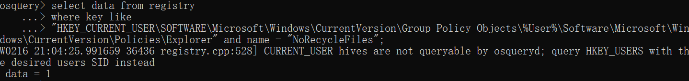

data = 1，则该检查项通过。

#### 385-384、374

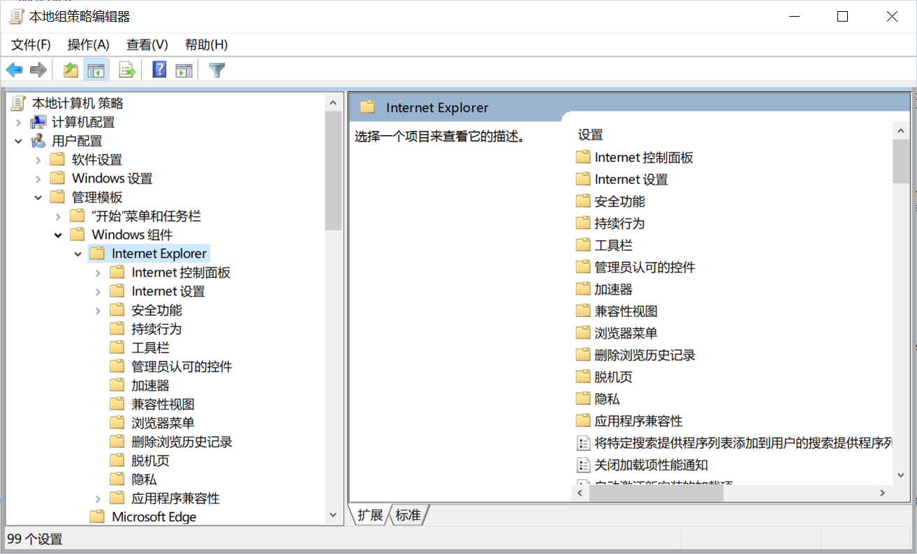

**385、Configure 'Turn on automatic signup'**

**检查语句**

select data from registry

where key like

"HKEY_CURRENT_USER\SOFTWARE\Microsoft\Windows\CurrentVersion\Group Policy Objects\%User%\Software\Policies\Microsoft\IEAK" and name = "NoAutomaticSignup";

**检查结果**

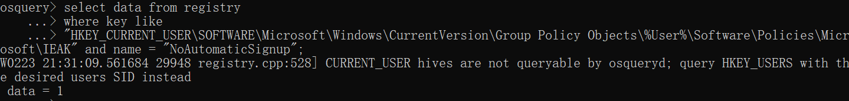

data = 1，则该检查项通过。

**384、Configure 'Turn on the auto-complete feature for user names and passwords on forms'**

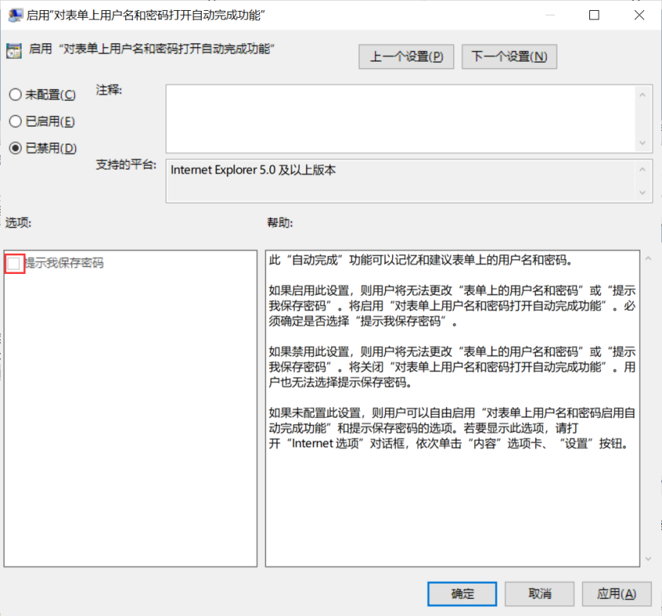

**检查语句**

select data from registry

where key like

"HKEY_CURRENT_USER\SOFTWARE\Microsoft\Windows\CurrentVersion\Group Policy Objects\%User%\Software\Policies\Microsoft\Internet Explorer\Main" and name = "FormSuggest Passwords";

**检查结果**



data = no，则该检查项通过。

**374、Configure 'Help menu: Remove 'Send Feedback' menu option'**

**检查语句**

select data from registry

where key like

"HKEY_CURRENT_USER\SOFTWARE\Microsoft\Windows\CurrentVersion\Group Policy Objects\%User%\Software\Policies\Microsoft\Internet Explorer\Restrictions" and name = "NoHelpItemSendFeedback";

**检查结果**

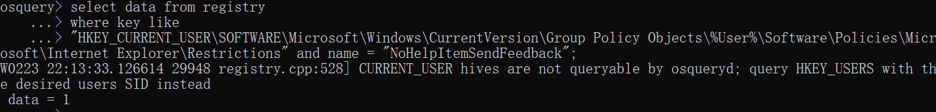

data = 1，则该检查项通过。

# 汇总

## 已完成

525、

select data from registry

where key = "HKEY_CURRENT_USER\SOFTWARE\Microsoft\Windows\CurrentVersion\Group Policy Objects\%Machine%\System\CurrentControlSet\Control\SCMConfig" and name = ” EnableSvchostMitigationPolicy;”

显示data = 1，则该检查项通过。

524、

select status from services

where name = "XboxNetApiSvc";

显示status = STOPPED，则该检查项通过。

523、

select status from services

where name = "XblGameSave";

显示status = STOPPED，则该检查项通过。

522、

select status from services

where name = "XblAuthManager";

显示status = STOPPED，则该检查项通过。

520、

select status from services

where name = "XboxGipSvc";

显示status = STOPPED，则该检查项通过。

519、

select status from services

where name = "RasAuto";

显示status = STOPPED，则该检查项通过。

518、

select status from services

where name = "MSiSCSI";

显示status = STOPPED，则该检查项通过。

517、

select status from services

where name = "LxssManager";

显示status = STOPPED，则该检查项通过。

515、

select status from services

where name = "lfsvc";

显示status = STOPPED，则该检查项通过。

514、

select status from services

where name = "MapsBroker";

显示status = STOPPED，则该检查项通过。

513、

select status from services

where name = "BTAGService";

显示status = STOPPED，则该检查项通过。

512、

select status from services

where name = "bthserv";

显示status = STOPPED，则该检查项通过。

511、

select data from registry

where key like

"HKEY_CURRENT_USER\SOFTWARE\Microsoft\Windows\CurrentVersion\Group Policy Objects\%Machine%\Software\Policies\Microsoft\Windows\Windows Search" and name = "AllowCloudSearch";

显示data = 2，则该检查项通过。

509、

select data from registry

where key like

"HKEY_CURRENT_USER\SOFTWARE\Microsoft\Windows\CurrentVersion\Group Policy Objects\%Machine%\Software\Policies\Microsoft\Windows\CloudContent" and name = "DisableSoftLanding";

显示data = 1，则该检查项通过。

508、

select data from registry

where key like

"HKEY_CURRENT_USER\SOFTWARE\Microsoft\Windows\CurrentVersion\Group Policy Objects\%User%\Software\Policies\Microsoft\Windows\CloudContent" and name = "DisableWindowsSpotlightOnSettings";

显示data = 1，则该检查项通过。

507、

select data from registry

where key like

"HKEY_CURRENT_USER\SOFTWARE\Microsoft\Windows\CurrentVersion\Group Policy Objects\%User%\Software\Policies\Microsoft\Windows\CloudContent" and name = "DisableWindowsSpotlightOnActionCenter";

显示data = 1，则该检查项通过。

506、

select data from registry

where key like

"HKEY_CURRENT_USER\SOFTWARE\Microsoft\Windows\CurrentVersion\Group Policy Objects\%User%\Software\Policies\Microsoft\Windows\CloudContent" and name = "DisableWindowsSpotlightWindowsWelcomeExperience";

显示data = 1，则该检查项通过。

505、

select data from registry

where key like

"HKEY_CURRENT_USER\SOFTWARE\Microsoft\Windows\CurrentVersion\Group Policy Objects\%User%\Software\Policies\Microsoft\Windows\CloudContent" and name = "DisableWindowsSpotlightFeatures";

显示data = 1，则该检查项通过。

504、

select data from registry

where key like

"HKEY_CURRENT_USER\SOFTWARE\Microsoft\Windows\CurrentVersion\Group Policy Objects\%User%\Software\Policies\Microsoft\Windows\CloudContent" and name = "DisableTailoredExperiencesWithDiagnosticData";

显示data = 1，则该检查项通过。

503、

select data from registry

where key like

"HKEY_CURRENT_USER\SOFTWARE\Microsoft\Windows\CurrentVersion\Group Policy Objects\%User%\Software\Policies\Microsoft\Windows\CloudContent" and name = "DisableThirdPartySuggestions";

显示data = 1，则该检查项通过。

502、

select data from registry

where key like

"HKEY_CURRENT_USER\SOFTWARE\Microsoft\Windows\CurrentVersion\Group Policy Objects\%User%\Software\Policies\Microsoft\Windows\CloudContent" and name = "ConfigureWindowsSpotlight";

显示data = 2，则该检查项通过。

501、

select data from registry

where key like

"HKEY_CURRENT_USER\SOFTWARE\Microsoft\Windows\CurrentVersion\Group Policy Objects\%Machine%\Software\Policies\Microsoft\Windows\CurrentVersion\PushNotifications" and name = "NoCloudApplicationNotification";

显示data = 1，则该检查项通过。

500、

select data from registry

where key like

"HKEY_CURRENT_USER\SOFTWARE\Microsoft\Windows\CurrentVersion\Group Policy Objects\%Machine%\Software\Policies\Microsoft\Windows\System" and name = "DisableLockScreenAppNotifications";

显示data = 1，则该检查项通过。

499、

select data from registry

where key like

"HKEY_CURRENT_USER\SOFTWARE\Microsoft\Windows\CurrentVersion\Group Policy Objects\%Machine%\Software\Policies\Microsoft\Windows\Connect" and name = "AllowProjectionToPC";

显示data = 1，则该检查项通过。

498、

select data from registry

where key like

"HKEY_CURRENT_USER\SOFTWARE\Microsoft\Windows\CurrentVersion\Group Policy Objects\%Machine%\Software\Policies\Microsoft\Windows\WCN\UI" and name = "DisableWcnUi";

显示data = 1，则该检查项通过。

496、

select data from registry

where key like

"HKEY_CURRENT_USER\SOFTWARE\Microsoft\Windows\CurrentVersion\Group Policy Objects\%Machine%\Software\Policies\Microsoft\Windows\System" and name = "EnableActivityFeed";

显示data = 0，则该检查项通过。

495、

select data from registry

where key like

"HKEY_CURRENT_USER\SOFTWARE\Microsoft\Windows\CurrentVersion\Group Policy Objects\%Machine%\Software\Policies\Microsoft\SecondaryAuthenticationFactor" and name = "AllowSecondaryAuthenticationDevice";

显示data = 0，则该检查项通过。

494、

select data from registry

where key like

"HKEY_CURRENT_USER\SOFTWARE\Microsoft\Windows\CurrentVersion\Group Policy Objects\%Machine%\Software\Policies\Microsoft\Windows\System" and name = "EnableCdp";

显示data = 0，则该检查项通过。

489、

select data from registry

where key like

"HKEY_CURRENT_USER\SOFTWARE\Microsoft\Windows\CurrentVersion\Group Policy Objects\%Machine%\Software\Policies\Microsoft\FVE" and name = "RDVHardwareEncryption";

显示data = 0，则该检查项通过。

488、

select data from registry

where key like

"HKEY_CURRENT_USER\SOFTWARE\Microsoft\Windows\CurrentVersion\Group Policy Objects\%Machine%\Software\Policies\Microsoft\FVE" and name = "OSHardwareEncryption";

显示data = 0，则该检查项通过。

487、

select data from registry

where key like

"HKEY_CURRENT_USER\SOFTWARE\Microsoft\Windows\CurrentVersion\Group Policy Objects\%Machine%\Software\Policies\Microsoft\FVE" and name = "FDVHardwareEncryption";

显示data = 0，则该检查项通过。

486、

select data from registry

where key like

"HKEY_CURRENT_USER\SOFTWARE\Microsoft\Windows\CurrentVersion\Group Policy Objects\%User%\Software\Microsoft\Windows\CurrentVersion\Policies\Explorer" and name = "NoRecycleFiles";

显示data = 1，则该检查项通过。

483、

select data from registry

where key like

"HKEY_CURRENT_USER\SOFTWARE\Microsoft\Windows\CurrentVersion\Group Policy Objects\%Machine%\Software\Policies\Microsoft\Windows NT\Terminal Services" and name = "fAllowUnsolicited";

显示data = 0，则该检查项通过。

482、

select data from registry

where key like

"HKEY_CURRENT_USER\SOFTWARE\Microsoft\Windows\CurrentVersion\Group Policy Objects\%Machine%\Software\Policies\Microsoft\Windows NT\Terminal Services" and name = "fAllowToGetHelp";

显示data = 0，则该检查项通过。

480、

select data from registry

where key like

"HKEY_CURRENT_USER\SOFTWARE\Microsoft\Windows\CurrentVersion\Group Policy Objects\%Machine%\Software\Policies\Microsoft\Windows\CredentialsDelegation" and name = "AllowSavedCredentialsWhenNTLMOnly" and type = "REG_DWORD";

显示data = 0，则该检查项通过。

479、

select data from registry

where key like

"HKEY_CURRENT_USER\SOFTWARE\Microsoft\Windows\CurrentVersion\Group Policy Objects\%Machine%\Software\Policies\Microsoft\Windows\CredentialsDelegation" and name = "AllowSavedCredentials" and type = "REG_DWORD";

显示data = 0，则该检查项通过。

478、

select data from registry

where key like

"HKEY_CURRENT_USER\SOFTWARE\Microsoft\Windows\CurrentVersion\Group Policy Objects\%Machine%\Software\Policies\Microsoft\Windows\CredentialsDelegation" and name = "AllowSavedCredentials" and type = "REG_DWORD";

显示data = 0，则该检查项通过。

477、

select data from registry

where key like

"HKEY_CURRENT_USER\SOFTWARE\Microsoft\Windows\CurrentVersion\Group Policy Objects\%Machine%\Software\Policies\Microsoft\Windows\CredentialsDelegation" and name = "AllowFreshCredentialsWhenNTLMOnly" and type = "REG_DWORD";

显示data = 0，则该检查项通过。

476、

select data from registry

where key like

"HKEY_CURRENT_USER\SOFTWARE\Microsoft\Windows\CurrentVersion\Group Policy Objects\%Machine%\Software\Policies\Microsoft\Windows\CredentialsDelegation" and name = "AllowDefCredentialsWhenNTLMOnly" and type = "REG_DWORD";

显示data = 0，则该检查项通过。

475、

select data from registry

where key like

"HKEY_CURRENT_USER\SOFTWARE\Microsoft\Windows\CurrentVersion\Group Policy Objects\%Machine%\Software\Policies\Microsoft\Windows\CredentialsDelegation" and name = "AllowDefaultCredentials" and type = "REG_DWORD";

显示data = 0，则该检查项通过。

474、

select data from registry

where key like

"HKEY_CURRENT_USER\SOFTWARE\Microsoft\Windows\CurrentVersion\Group Policy Objects\%Machine%\Software\Policies\Microsoft\Windows\CredentialsDelegation" and name = "RestrictedRemoteAdministration" and type = "REG_DWORD";

显示data = 1，则该检查项通过。

473、

select data from registry

where key like

"HKEY_CURRENT_USER\SOFTWARE\Microsoft\Windows\CurrentVersion\Group Policy Objects\%Machine%\Software\Policies\Microsoft\Windows\CredentialsDelegation" and name = "AllowProtectedCreds" and type = "REG_DWORD";

显示data = 1，则该检查项通过。

472、

select data from registry

where key like

"HKEY_CURRENT_USER\SOFTWARE\Microsoft\Windows\CurrentVersion\Group Policy Objects\%Machine%\Software\Policies\Microsoft\Windows\DriverInstall\Restrictions" and name = "AllowUserDeviceClasses" and type = "REG_DWORD";

显示data = 0，则该检查项通过。

469、

select data from registry

where key like

"HKEY_CURRENT_USER\SOFTWARE\Microsoft\Windows\CurrentVersion\Group Policy Objects\%Machine%\Software\Policies\Microsoft\Windows\OneDrive" and name = "DisableFileSync";

显示data = 1，则该检查项通过。

468、

select data from registry

where key like

"HKEY_CURRENT_USER\SOFTWARE\Microsoft\Windows\CurrentVersion\Group Policy Objects\%Machine%\Software\Policies\Microsoft\PassportForWork" and name = "Enabled";

显示data = 0，则该检查项通过。

464、

select data from registry

where key like

"HKEY_CURRENT_USER\SOFTWARE\Microsoft\Windows\CurrentVersion\Group Policy Objects\%Machine%\Software\Policies\Microsoft\Windows Defender\Spynet" and name = "DisableBlockAtFirstSeen";

显示data = 0，则该检查项通过。

463、

select data from registry

where key like

"HKEY_CURRENT_USER\SOFTWARE\Microsoft\Windows\CurrentVersion\Group Policy Objects\%Machine%\Software\Policies\Microsoft\Windows Defender\Remediation" and name = "Scan_ScheduleDay";

显示data = 0，则该检查项通过。

462、

select data from registry

where key like

"HKEY_CURRENT_USER\SOFTWARE\Microsoft\Windows\CurrentVersion\Group Policy Objects\%Machine%\Software\Policies\Microsoft\Windows Defender\Real-Time Protection" and name = "LocalSettingOverrideDisableOnAccessProtection";

显示data = 0，则该检查项通过。

461、

select data from registry

where key like

"HKEY_CURRENT_USER\SOFTWARE\Microsoft\Windows\CurrentVersion\Group Policy Objects\%Machine%\Software\Policies\Microsoft\Windows Defender\Real-Time Protection" and name = "LocalSettingOverrideRealtimeScanDirection";

显示data = 0，则该检查项通过。

460、

select data from registry

where key like

"HKEY_CURRENT_USER\SOFTWARE\Microsoft\Windows\CurrentVersion\Group Policy Objects\%Machine%\Software\Policies\Microsoft\Windows Defender\Real-Time Protection" and name = "LocalSettingOverrideDisableBehaviorMonitoring";

显示data = 0，则该检查项通过。

459、

select data from registry

where key like

"HKEY_CURRENT_USER\SOFTWARE\Microsoft\Windows\CurrentVersion\Group Policy Objects\%Machine%\Software\Policies\Microsoft\Windows Defender\Real-Time Protection" and name = "LocalSettingOverrideDisableRealtimeMonitoring";

显示data = 0，则该检查项通过。

458、

select data from registry

where key like

"HKEY_CURRENT_USER\SOFTWARE\Microsoft\Windows\CurrentVersion\Group Policy Objects\%Machine%\Software\Policies\Microsoft\Windows Defender\Real-Time Protection" and name = "RealtimeScanDirection";

显示data = 0，则该检查项通过。

457、

select data from registry

where key like

"HKEY_CURRENT_USER\SOFTWARE\Microsoft\Windows\CurrentVersion\Group Policy Objects\%Machine%\Software\Policies\Microsoft\Windows Defender\Real-Time Protection" and name = "DisableOnAccessProtection";

显示data = 0，则该检查项通过。

456、

select data from registry

where key like

"HKEY_CURRENT_USER\SOFTWARE\Microsoft\Windows\CurrentVersion\Group Policy Objects\%Machine%\Software\Policies\Microsoft\Windows Defender\Real-Time Protection" and name = "DisableRawWriteNotification";

显示data = 0，则该检查项通过。

455、

select data from registry

where key like

"HKEY_CURRENT_USER\SOFTWARE\Microsoft\Windows\CurrentVersion\Group Policy Objects\%Machine%\Software\Policies\Microsoft\Windows Defender\Real-Time Protection" and name = "DisableScanOnRealtimeEnable";

显示data = 0，则该检查项通过。

454、

select data from registry

where key like

"HKEY_CURRENT_USER\SOFTWARE\Microsoft\Windows\CurrentVersion\Group Policy Objects\%Machine%\Software\Policies\Microsoft\Windows Defender\MpEngine" and name = "MpCloudBlockLevel";

显示data = 2，则该检查项通过。

453、

select data from registry

where key like

"HKEY_CURRENT_USER\SOFTWARE\Microsoft\Windows\CurrentVersion\Group Policy Objects\%Machine%\Software\Policies\Microsoft\Windows Defender\NIS" and name = "DisableProtocolRecognition";

显示data = 0，则该检查项通过。

452、

select data from registry

where key like

"HKEY_CURRENT_USER\SOFTWARE\Microsoft\Windows\CurrentVersion\Group Policy Objects\%Machine%\Software\Policies\Microsoft\Windows Defender\Scan" and name = "DisableHeuristics";

显示data = 0，则该检查项通过。

451、

select data from registry

where key like

"HKEY_CURRENT_USER\SOFTWARE\Microsoft\Windows\CurrentVersion\Group Policy Objects\%Machine%\Software\Policies\Microsoft\Windows Defender\Scan" and name = "DisablePackedExeScanning";

显示data = 0，则该检查项通过。

450、

select data from registry

where key like

"HKEY_CURRENT_USER\SOFTWARE\Microsoft\Windows\CurrentVersion\Group Policy Objects\%Machine%\Software\Policies\Microsoft\Windows Defender\Signature Updates" and name = "DisableUpdateOnStartupWithoutEngine";

显示data = 0，则该检查项通过。

449、

select data from registry

where key like

"HKEY_CURRENT_USER\SOFTWARE\Microsoft\Windows\CurrentVersion\Group Policy Objects\%Machine%\Software\Policies\Microsoft\Windows Defender\Signature Updates" and name = "AVSignatureDue";

显示data <= 3，则该检查项通过。

448、

select data from registry

where key like

"HKEY_CURRENT_USER\SOFTWARE\Microsoft\Windows\CurrentVersion\Group Policy Objects\%Machine%\Software\Policies\Microsoft\Windows Defender\Signature Updates" and name = "ASSignatureDue";

显示data <= 3，则该检查项通过。

447、

select data from registry

where key like

"HKEY_CURRENT_USER\SOFTWARE\Microsoft\Windows\CurrentVersion\Group Policy Objects\%Machine%\Software\Policies\Microsoft\Windows Defender\Signature Updates" and name = "UpdateOnStartUp";

显示data = 1，则该检查项通过。

445、

select data from registry

where key like

"HKEY_CURRENT_USER\SOFTWARE\Microsoft\Windows\CurrentVersion\Group Policy Objects\%Machine%\Software\Policies\Microsoft\Windows Defender\Real-Time Protection" and name = "LocalSettingOverrideDisableIOAVProtection";

显示data = 0，则该检查项通过。

444、

select data from registry

where key like

"HKEY_CURRENT_USER\SOFTWARE\Microsoft\Windows\CurrentVersion\Group Policy Objects\%Machine%\Software\Policies\Microsoft\Windows Defender Security Center\App and Browser protection" and name = "DisallowExploitProtectionOverride";

显示data = 1，则该检查项通过。

443、

select data from registry

where key like

"HKEY_CURRENT_USER\SOFTWARE\Microsoft\Windows\CurrentVersion\Group Policy Objects\%Machine%\Software\Policies\Microsoft\Windows Defender\Real-Time Protection" and name = "DisableRealtimeMonitoring";

显示data = 0，则该检查项通过。

442、

select data from registry

where key like

"HKEY_CURRENT_USER\SOFTWARE\Microsoft\Windows\CurrentVersion\Group Policy Objects\%Machine%\Software\Policies\Microsoft\Windows Defender\Spynet" and name = "LocalSettingOverrideSpynetReporting";

显示data = 0，则该检查项通过。

441、

select data from registry

where key like

"HKEY_CURRENT_USER\SOFTWARE\Microsoft\Windows\CurrentVersion\Group Policy Objects\%Machine%\Software\Policies\Microsoft\Windows Defender" and name = "PUAProtection";

显示data = 2，则该检查项通过。

438、

select data from registry

where key like

"HKEY_CURRENT_USER\SOFTWARE\Microsoft\Windows\CurrentVersion\Group Policy Objects\%Machine%\Software\Policies\Microsoft\Windows Defender Security Center\App and Browser protection" and name = "DisallowExploitProtectionOverride";

显示data = 1，则该检查项通过。

436、

select data from registry

where key like

"HKEY_CURRENT_USER\SOFTWARE\Microsoft\Windows\CurrentVersion\Group Policy Objects\%Machine%\Software\Policies\Microsoft\Windows\System" and name = "EnableSmartScreen";

显示data = 0，则该检查项通过。

435、

select data from registry

where key like

"HKEY_CURRENT_USER\SOFTWARE\Microsoft\Windows\CurrentVersion\Group Policy Objects\%Machine%\System\CurrentControlSet\Policies\EarlyLaunch" and name = "DriverLoadPolicy" and type = "REG_DWORD";

显示data = 1，则该检查项通过。

434、

select data from registry

where key like

"HKEY_CURRENT_USER\SOFTWARE\Microsoft\Windows\CurrentVersion\Group Policy Objects\%Machine%\Software\Policies\Microsoft\Windows Defender\Windows Defender Exploit Guard\Network Protection" and name = "EnableNetworkProtection";

显示data = 1，则该检查项通过。

433、

select data from registry

where key like

"HKEY_CURRENT_USER\SOFTWARE\Microsoft\Windows\CurrentVersion\Group Policy Objects\%Machine%\Software\Policies\Microsoft\Windows Defender\Scan" and name = "CheckForSignaturesBeforeRunningScan";

显示data = 1，则该检查项通过。

432、

select data from registry

where key like

"HKEY_CURRENT_USER\SOFTWARE\Microsoft\Windows\CurrentVersion\Group Policy Objects\%Machine%\Software\Policies\Microsoft\Windows Defender\Signature Updates" and name = "SignatureUpdateInterval";

显示data = 1，则该检查项通过。

431、

select data from registry

where key like

"HKEY_CURRENT_USER\SOFTWARE\Microsoft\Windows\CurrentVersion\Group Policy Objects\%Machine%\Software\Policies\Microsoft\Windows Defender\Scan" and name = "DisableEmailScanning";

显示data = 0，则该检查项通过。

430、

select data from registry

where key like

"HKEY_CURRENT_USER\SOFTWARE\Microsoft\Windows\CurrentVersion\Group Policy Objects\%Machine%\Software\Policies\Microsoft\Windows Defender\Scan" and name = "DisableRemovableDriveScanning";

显示data = 0，则该检查项通过。

429、

select data from registry

where key like

"HKEY_CURRENT_USER\SOFTWARE\Microsoft\Windows\CurrentVersion\Group Policy Objects\%Machine%\Software\Policies\Microsoft\Windows Defender\Scan" and name = "DisableArchiveScanning";

显示data = 0，则该检查项通过。

428、

select data from registry

where key like

"HKEY_CURRENT_USER\SOFTWARE\Microsoft\Windows\CurrentVersion\Group Policy Objects\%Machine%\Software\Policies\Microsoft\Windows Defender\Real-Time Protection" and name = "DisableBehaviorMonitoring";

显示data = 0，则该检查项通过。

427、

select data from registry

where key like

"HKEY_CURRENT_USER\SOFTWARE\Microsoft\Windows\CurrentVersion\Group Policy Objects\%Machine%\Software\Policies\Microsoft\Windows Defender\Real-Time Protection" and name = "DisableIOAVProtection";

显示data = 0，则该检查项通过。

426、

select data from registry

where key like

"HKEY_CURRENT_USER\SOFTWARE\Microsoft\Windows\CurrentVersion\Group Policy Objects\%Machine%\Software\Policies\Microsoft\Windows Defender\Reporting" and name = "DisableGenericRePorts";

显示data = 1，则该检查项通过。

425、

select data from registry

where key like

"HKEY_CURRENT_USER\SOFTWARE\Microsoft\Windows\CurrentVersion\Group Policy Objects\%Machine%\Software\Policies\Microsoft\Windows Defender\Spynet";

显示data = ，则该检查项通过。

424、

select data from registry

where key like

"HKEY_CURRENT_USER\SOFTWARE\Microsoft\Windows\CurrentVersion\Group Policy Objects\%Machine%\Software\Policies\Microsoft\Windows Defender" and name = "DisableAntiSpyware";

显示data = 0，则该检查项通过。

422、

select data from registry

where key like

"HKEY_CURRENT_USER\SOFTWARE\Microsoft\Windows\CurrentVersion\Group Policy Objects\%Machine%\Software\Policies\Microsoft\Windows\CurrentVersion\Internet Settings\Zones\1" and name = "1800";

显示data = 3，则该检查项通过。

421、

select data from registry

where key like

"HKEY_CURRENT_USER\SOFTWARE\Microsoft\Windows\CurrentVersion\Group Policy Objects\%Machine%\Software\Policies\Microsoft\Windows\CurrentVersion\Internet Settings\Zones\3" and name = "1607";

显示data = 3，则该检查项通过。

420、

select data from registry

where key like

"HKEY_CURRENT_USER\SOFTWARE\Microsoft\Windows\CurrentVersion\Group Policy Objects\%Machine%\Software\Policies\Microsoft\Windows\CurrentVersion\Internet Settings\Zones\3" and name = "1804";

显示data = 3，则该检查项通过。

419、

select data from registry

where key like

"HKEY_CURRENT_USER\SOFTWARE\Microsoft\Windows\CurrentVersion\Group Policy Objects\%Machine%\Software\Policies\Microsoft\Windows\CurrentVersion\Internet Settings\Zones\3" and name = "160A";

显示data = 3，则该检查项通过。

418、

select data from registry

where key like

"HKEY_CURRENT_USER\SOFTWARE\Microsoft\Windows\CurrentVersion\Group Policy Objects\%Machine%\Software\Policies\Microsoft\Windows\CurrentVersion\Internet Settings\Zones\3" and name = "2708";

显示data = 3，则该检查项通过。

417、

select data from registry

where key like

"HKEY_CURRENT_USER\SOFTWARE\Microsoft\Windows\CurrentVersion\Group Policy Objects\%Machine%\Software\Policies\Microsoft\Windows\CurrentVersion\Internet Settings\Zones\3" and name = "2709";

显示data = 3，则该检查项通过。

416、

select data from registry

where key like

"HKEY_CURRENT_USER\SOFTWARE\Microsoft\Windows\CurrentVersion\Group Policy Objects\%Machine%\Software\Policies\Microsoft\Windows\CurrentVersion\Internet Settings\Zones\3" and name = "2104";

显示data = 3，则该检查项通过。

415、

select data from registry

where key like

"HKEY_CURRENT_USER\SOFTWARE\Microsoft\Windows\CurrentVersion\Group Policy Objects\%Machine%\Software\Policies\Microsoft\Windows\CurrentVersion\Internet Settings\Zones\3" and name = "1800";

显示data = 3，则该检查项通过。

414、

select data from registry

where key like

"HKEY_CURRENT_USER\SOFTWARE\Microsoft\Windows\CurrentVersion\Group Policy Objects\%Machine%\Software\Policies\Microsoft\Windows\CurrentVersion\Internet Settings\Zones\3" and name = "1406";

显示data = 3，则该检查项通过。

413、

select data from registry

where key like

"HKEY_CURRENT_USER\SOFTWARE\Microsoft\Windows\CurrentVersion\Group Policy Objects\%Machine%\Software\Policies\Microsoft\Windows\CurrentVersion\Internet Settings\Zones\4" and name = "1806";

显示data = 3，则该检查项通过。

412、

select data from registry

where key like

"HKEY_CURRENT_USER\SOFTWARE\Microsoft\Windows\CurrentVersion\Group Policy Objects\%Machine%\Software\Policies\Microsoft\Windows\CurrentVersion\Internet Settings\Zones\4" and name = "1607";

显示data = 3，则该检查项通过。

411、

select data from registry

where key like

"HKEY_CURRENT_USER\SOFTWARE\Microsoft\Windows\CurrentVersion\Group Policy Objects\%Machine%\Software\Policies\Microsoft\Windows\CurrentVersion\Internet Settings\Zones\4" and name = "1804";

显示data = 3，则该检查项通过。

410、

select data from registry

where key like

"HKEY_CURRENT_USER\SOFTWARE\Microsoft\Windows\CurrentVersion\Group Policy Objects\%Machine%\Software\Policies\Microsoft\Windows\CurrentVersion\Internet Settings\Zones\4" and name = "160A";

显示data = 3，则该检查项通过。

409、

select data from registry

where key like

"HKEY_CURRENT_USER\SOFTWARE\Microsoft\Windows\CurrentVersion\Group Policy Objects\%Machine%\Software\Policies\Microsoft\Windows\CurrentVersion\Internet Settings\Zones\4" and name = "2708";

显示data = 3，则该检查项通过。

408、

select data from registry

where key like

"HKEY_CURRENT_USER\SOFTWARE\Microsoft\Windows\CurrentVersion\Group Policy Objects\%Machine%\Software\Policies\Microsoft\Windows\CurrentVersion\Internet Settings\Zones\4" and name = "2709";

显示data = 3，则该检查项通过。

407、

select data from registry

where key like

"HKEY_CURRENT_USER\SOFTWARE\Microsoft\Windows\CurrentVersion\Group Policy Objects\%Machine%\Software\Policies\Microsoft\Windows\CurrentVersion\Internet Settings\Zones\4" and name = "2104";

显示data = 3，则该检查项通过。

406、

select data from registry

where key like

"HKEY_CURRENT_USER\SOFTWARE\Microsoft\Windows\CurrentVersion\Group Policy Objects\%Machine%\Software\Policies\Microsoft\Windows\CurrentVersion\Internet Settings\Zones\4" and name = "1608";

显示data = 3，则该检查项通过。

405、

select data from registry

where key like

"HKEY_CURRENT_USER\SOFTWARE\Microsoft\Windows\CurrentVersion\Group Policy Objects\%Machine%\Software\Policies\Microsoft\Windows\CurrentVersion\Internet Settings\Zones\4" and name = "1800";

显示data = 3，则该检查项通过。

404、

select data from registry

where key like

"HKEY_CURRENT_USER\SOFTWARE\Microsoft\Windows\CurrentVersion\Group Policy Objects\%Machine%\Software\Policies\Microsoft\Windows\CurrentVersion\Internet Settings\Zones\4" and name = "1407";

显示data = 3，则该检查项通过。

403、

select data from registry

where key like

"HKEY_CURRENT_USER\SOFTWARE\Microsoft\Windows\CurrentVersion\Group Policy Objects\%Machine%\Software\Policies\Microsoft\Windows\CurrentVersion\Internet Settings\Zones\4" and name = "2300";

显示data = 3，则该检查项通过。

402、

select data from registry

where key like

"HKEY_CURRENT_USER\SOFTWARE\Microsoft\Windows\CurrentVersion\Group Policy Objects\%Machine%\Software\Policies\Microsoft\Windows\CurrentVersion\Internet Settings\Zones\4" and name = "1406";

显示data = 3，则该检查项通过。

401、

select data from registry

where key like

"HKEY_CURRENT_USER\SOFTWARE\Microsoft\Windows\CurrentVersion\Group Policy Objects\%Machine%\Software\Policies\Microsoft\Internet Explorer\Feeds" and name = "AllowBasicAuthInClear";

显示data = 0，则该检查项通过。

400、

select data from registry

where key like

"HKEY_CURRENT_USER\SOFTWARE\Microsoft\Windows\CurrentVersion\Group Policy Objects\%Machine%\Software\Policies\Microsoft\Windows\CurrentVersion\Internet Settings\Zones\3" and name = "1A00";

显示data = 65536，则该检查项通过。

399、

select data from registry

where key like

"HKEY_CURRENT_USER\SOFTWARE\Microsoft\Windows\CurrentVersion\Group Policy Objects\%Machine%\Software\Policies\Microsoft\Windows\CurrentVersion\Internet Settings\Zones\4" and name = "1A00";

显示data = 196608，则该检查项通过。

398、

select data from registry

where key like

"HKEY_CURRENT_USER\SOFTWARE\Microsoft\Windows\CurrentVersion\Group Policy Objects\%Machine%\Software\Policies\Microsoft\Windows\CurrentVersion\Internet Settings\Zones\3" and name = "2500";

显示data = 0，则该检查项通过。

397、

select data from registry

where key like

"HKEY_CURRENT_USER\SOFTWARE\Microsoft\Windows\CurrentVersion\Group Policy Objects\%Machine%\Software\Policies\Microsoft\Windows\CurrentVersion\Internet Settings\Zones\4" and name = "2500";

显示data = 0，则该检查项通过。

396、

select data from registry

where key like

"HKEY_CURRENT_USER\SOFTWARE\Microsoft\Windows\CurrentVersion\Group Policy Objects\%Machine%\Software\Policies\Microsoft\Windows\CurrentVersion\Internet Settings\Zones\3" and name = "1A04";

显示data = 3，则该检查项通过。

395、

select data from registry

where key like

"HKEY_CURRENT_USER\SOFTWARE\Microsoft\Windows\CurrentVersion\Group Policy Objects\%Machine%\Software\Policies\Microsoft\Windows\CurrentVersion\Internet Settings\Zones\3" and name = "1609";

显示data = 1，则该检查项通过。

394、

select data from registry

where key like

"HKEY_CURRENT_USER\SOFTWARE\Microsoft\Windows\CurrentVersion\Group Policy Objects\%Machine%\Software\Policies\Microsoft\Windows\CurrentVersion\Internet Settings\Zones\4" and name = "1601";

显示data = 3，则该检查项通过。

393、

select data from registry

where key like

"HKEY_CURRENT_USER\SOFTWARE\Microsoft\Windows\CurrentVersion\Group Policy Objects\%Machine%\Software\Policies\Microsoft\Windows\CurrentVersion\Internet Settings\Zones\4" and name = "1601";

显示data = 3，则该检查项通过。

392、

select data from registry

where key like

"HKEY_CURRENT_USER\SOFTWARE\Microsoft\Windows\CurrentVersion\Group Policy Objects\%Machine%\Software\Policies\Microsoft\Windows\CurrentVersion\Internet Settings\Zones\4" and name = "1609";

显示data = 3，则该检查项通过。

391、

select data from registry

where key like

"HKEY_CURRENT_USER\SOFTWARE\Microsoft\Windows\CurrentVersion\Group Policy Objects\%Machine%\Software\Policies\Microsoft\Windows\CurrentVersion\Internet Settings" and name = "WarnOnBadCertRecving";

显示data = 1，则该检查项通过。

390、

select data from registry

where key like

"HKEY_CURRENT_USER\SOFTWARE\Microsoft\Windows\CurrentVersion\Group Policy Objects\%Machine%\Software\Policies\Microsoft\Windows\CurrentVersion\Internet Settings" and name = "SecureProtocols";

显示data = 2688，则该检查项通过。

389、

select data from registry

where key like

"HKEY_CURRENT_USER\SOFTWARE\Microsoft\Windows\CurrentVersion\Group Policy Objects\%Machine%\Software\Policies\Microsoft\Windows\CurrentVersion\Internet Settings\Zones\3" and name = "1809";

显示data = 0，则该检查项通过。

388、

select data from registry

where key like

"HKEY_CURRENT_USER\SOFTWARE\Microsoft\Windows\CurrentVersion\Group Policy Objects\%Machine%\Software\Policies\Microsoft\Windows\CurrentVersion\Internet Settings\Zones\4" and name = "1809";

显示data = 0，则该检查项通过。

387、

（1）

select data from registry

where key like

"HKEY_CURRENT_USER\SOFTWARE\Microsoft\Windows\CurrentVersion\Group Policy Objects\%Machine%\Software\Policies\Microsoft\Windows\SettingSync" and name = "DisableCredentialsSettingSync";

显示data = 2，则该检查项通过。

（2）

select data from registry

where key like

"HKEY_CURRENT_USER\SOFTWARE\Microsoft\Windows\CurrentVersion\Group Policy Objects\%Machine%\Software\Policies\Microsoft\Windows\SettingSync" and name = "DisableCredentialsSettingSyncUserOverride";

显示data = 1，则该检查项通过。

386、

（1）

select data from registry

where key like

"HKEY_CURRENT_USER\SOFTWARE\Microsoft\Windows\CurrentVersion\Group Policy Objects\%Machine%\Software\Policies\Microsoft\Windows\SettingSync" and name = "DisableWebBrowserSettingSync";

显示data = 2，则该检查项通过。

（2）

select data from registry

where key like

"HKEY_CURRENT_USER\SOFTWARE\Microsoft\Windows\CurrentVersion\Group Policy Objects\%Machine%\Software\Policies\Microsoft\Windows\SettingSync" and name = "DisableWebBrowserSettingSyncUserOverride";

显示data = 1，则该检查项通过。

385、

select data from registry

where key like

"HKEY_CURRENT_USER\SOFTWARE\Microsoft\Windows\CurrentVersion\Group Policy Objects\%User%\Software\Policies\Microsoft\IEAK" and name = "NoAutomaticSignup";

显示data = 1，则该检查项通过。

384、

select data from registry

where key like

"HKEY_CURRENT_USER\SOFTWARE\Microsoft\Windows\CurrentVersion\Group Policy Objects\%User%\Software\Policies\Microsoft\Internet Explorer\Main" and name = "FormSuggest Passwords";

显示data = no，则该检查项通过。

383、

select data from registry

where key like

"HKEY_CURRENT_USER\SOFTWARE\Microsoft\Windows\CurrentVersion\Group Policy Objects\%Machine%\Software\Policies\Microsoft\Internet Explorer\Security" and name = "DisableSecuritySettingsCheck";

显示data = 1，则该检查项通过。

382、

select data from registry

where key like

"HKEY_CURRENT_USER\SOFTWARE\Microsoft\Windows\CurrentVersion\Group Policy Objects\%Machine%\Software\Policies\Microsoft\Internet Explorer\PhishingFilter" and name = "EnabledV8";

显示data = 0，则该检查项通过。

381、

select data from registry

where key like

"HKEY_CURRENT_USER\SOFTWARE\Microsoft\Windows\CurrentVersion\Group Policy Objects\%Machine%\Software\Policies\Microsoft\Internet Explorer\Main" and name = "DisableFirstRunCustomize";

显示data = 1，则该检查项通过。

380、

select data from registry

where key like

"HKEY_CURRENT_USER\SOFTWARE\Microsoft\Windows\CurrentVersion\Group Policy Objects\%Machine%\Software\Policies\Microsoft\Internet Explorer\PhishingFilter" and name = "EnabledV9";

显示data = 0，则该检查项通过。

379、

select data from registry

where key like

"HKEY_CURRENT_USER\SOFTWARE\Microsoft\Windows\CurrentVersion\Group Policy Objects\%Machine%\Software\Policies\Microsoft\Windows\CurrentVersion\Internet Settings\Zones\2" and name = "2301";

显示data = 3，则该检查项通过。

378、

select data from registry

where key like

"HKEY_CURRENT_USER\SOFTWARE\Microsoft\Windows\CurrentVersion\Group Policy Objects\%Machine%\Software\Policies\Microsoft\Windows\CurrentVersion\Internet Settings\Zones\1" and name = "2301";

显示data = 3，则该检查项通过。

377、

select data from registry

where key like

"HKEY_CURRENT_USER\SOFTWARE\Microsoft\Windows\CurrentVersion\Group Policy Objects\%Machine%\Software\Policies\Microsoft\Windows\CurrentVersion\Internet Settings\Zones\3" and name = "2301";

显示data = 3，则该检查项通过。

376、

select data from registry

where key like

"HKEY_CURRENT_USER\SOFTWARE\Microsoft\Windows\CurrentVersion\Group Policy Objects\%Machine%\Software\Policies\Microsoft\Windows\CurrentVersion\Internet Settings\Zones\4" and name = "2301"

显示data = 3，则该检查项通过。

375、

select data from registry

where key like

"HKEY_CURRENT_USER\SOFTWARE\Microsoft\Windows\CurrentVersion\Group Policy Objects\%Machine%\Software\Policies\Microsoft\Internet Explorer\Main" and name = "NoReportSiteProblems";

显示data = yes，则该检查项通过。

374、

select data from registry

where key like

"HKEY_CURRENT_USER\SOFTWARE\Microsoft\Windows\CurrentVersion\Group Policy Objects\%User%\Software\Policies\Microsoft\Internet Explorer\Restrictions" and name = "NoHelpItemSendFeedback";

显示data = yes，则该检查项通过。

373、

select data from registry

where key like

"HKEY_CURRENT_USER\SOFTWARE\Microsoft\Windows\CurrentVersion\Group Policy Objects\%Machine%\Software\Policies\Microsoft\Internet Explorer\Restrictions" and name = "NoCrashDetection";

显示data = 1，则该检查项通过。

372、

select data from registry

where key like

"HKEY_CURRENT_USER\SOFTWARE\Microsoft\Windows\CurrentVersion\Group Policy Objects\%Machine%\Software\Policies\Microsoft\Internet Explorer\Recovery" and name = "AutoRecover";

显示data = 2，则该检查项通过。

371、

select data from registry

where key like

"HKEY_CURRENT_USER\SOFTWARE\Microsoft\Windows\CurrentVersion\Group Policy Objects\%Machine%\Software\Policies\Microsoft\Internet Explorer\SQM" and name = "DisableCustomerImprovementProgram";

显示data = 0，则该检查项通过。

370、

select data from registry

where key like

"HKEY_CURRENT_USER\SOFTWARE\Microsoft\Windows\CurrentVersion\Group Policy Objects\%Machine%\Software\Policies\Microsoft\Internet Explorer\Suggested Sites" and name = "Enabled";

显示data = 0，则该检查项通过。

369、

select data from registry

where key like

"HKEY_CURRENT_USER\SOFTWARE\Microsoft\Windows\CurrentVersion\Group Policy Objects\%Machine%\Software\Policies\Microsoft\Internet Explorer" and name = "AllowServicePoweredQSA";

显示data = 0，则该检查项通过。

368、

select data from registry

where key like

"HKEY_CURRENT_USER\SOFTWARE\Microsoft\Windows\CurrentVersion\Group Policy Objects\%Machine%\Software\Policies\Microsoft\Internet Explorer\FlipAhead" and name = "Enabled";

显示data = 0，则该检查项通过。

367、

select data from registry

where key like

"HKEY_CURRENT_USER\SOFTWARE\Microsoft\Windows\CurrentVersion\Group Policy Objects\%Machine%\Software\Policies\Microsoft\Internet Explorer\Activities" and name = "NoActivities";

显示data = 1，则该检查项通过。

366、

select data from registry

where key like

"HKEY_CURRENT_USER\SOFTWARE\Microsoft\Windows\CurrentVersion\Group Policy Objects\%Machine%\Software\Policies\Microsoft\Internet Explorer\Main" and name = "Enable Browser Extensions";

显示data = no，则该检查项通过。

365、

select data from registry

where key like

"HKEY_CURRENT_USER\SOFTWARE\Microsoft\Windows\CurrentVersion\Group Policy Objects\%Machine%\Software\Policies\Microsoft\Windows\CurrentVersion\Internet Settings\Zones\2" and name = "1409";

显示data = 0，则该检查项通过。

364、

select data from registry

where key like

"HKEY_CURRENT_USER\SOFTWARE\Microsoft\Windows\CurrentVersion\Group Policy Objects\%Machine%\Software\Policies\Microsoft\Windows\CurrentVersion\Internet Settings\Zones\1" and name = "1409";

显示data = 0，则该检查项通过。

363、

select data from registry

where key like

"HKEY_CURRENT_USER\SOFTWARE\Microsoft\Windows\CurrentVersion\Group Policy Objects\%Machine%\Software\Policies\Microsoft\Windows\CurrentVersion\Internet Settings\Zones\3" and name = "1409";

显示data = 0，则该检查项通过。

362、

select data from registry

where key like

"HKEY_CURRENT_USER\SOFTWARE\Microsoft\Windows\CurrentVersion\Group Policy Objects\%Machine%\Software\Policies\Microsoft\Windows\CurrentVersion\Internet Settings\Zones\3" and name = "2105";

显示data = 3，则该检查项通过。

361、

select data from registry

where key like

"HKEY_CURRENT_USER\SOFTWARE\Microsoft\Windows\CurrentVersion\Group Policy Objects\%Machine%\Software\Policies\Microsoft\Windows\CurrentVersion\Internet Settings\Zones\3" and name = "2103";

显示data = 3，则该检查项通过。

360、

select data from registry

where key like

"HKEY_CURRENT_USER\SOFTWARE\Microsoft\Windows\CurrentVersion\Group Policy Objects\%Machine%\Software\Policies\Microsoft\Windows\CurrentVersion\Internet Settings\Zones\3" and name = "2102";

显示data = 3，则该检查项通过。

359、

select data from registry

where key like

"HKEY_CURRENT_USER\SOFTWARE\Microsoft\Windows\CurrentVersion\Group Policy Objects\%Machine%\Software\Policies\Microsoft\Windows\CurrentVersion\Internet Settings\Zones\3" and name = "1206";

显示data = 3，则该检查项通过。

358、

select data from registry

where key like

"HKEY_CURRENT_USER\SOFTWARE\Microsoft\Windows\CurrentVersion\Group Policy Objects\%Machine%\Software\Policies\Microsoft\Windows\CurrentVersion\Internet Settings\Zones\3" and name = "1407";

显示data = 3，则该检查项通过。

357、

select data from registry

where key like

"HKEY_CURRENT_USER\SOFTWARE\Microsoft\Windows\CurrentVersion\Group Policy Objects\%Machine%\Software\Policies\Microsoft\Windows\CurrentVersion\Internet Settings\Zones\3" and name = "140C";

显示data = 3，则该检查项通过。

356、

select data from registry

where key like

"HKEY_CURRENT_USER\SOFTWARE\Microsoft\Windows\CurrentVersion\Group Policy Objects\%Machine%\Software\Policies\Microsoft\Windows\CurrentVersion\Internet Settings\Zones\4" and name = "1409";

显示data = 0，则该检查项通过。

355、

select data from registry

where key like

"HKEY_CURRENT_USER\SOFTWARE\Microsoft\Windows\CurrentVersion\Group Policy Objects\%Machine%\Software\Policies\Microsoft\Windows\CurrentVersion\Internet Settings\Zones\4" and name = "1402";

显示data = 3，则该检查项通过。

354、

select data from registry

where key like

"HKEY_CURRENT_USER\SOFTWARE\Microsoft\Windows\CurrentVersion\Group Policy Objects\%Machine%\Software\Policies\Microsoft\Windows\CurrentVersion\Internet Settings\Zones\4" and name = "2105";

显示data = 3，则该检查项通过。

353、

select data from registry

where key like

"HKEY_CURRENT_USER\SOFTWARE\Microsoft\Windows\CurrentVersion\Group Policy Objects\%Machine%\Software\Policies\Microsoft\Windows\CurrentVersion\Internet Settings\Zones\4" and name = "2103";

显示data = 3，则该检查项通过。

352、

select data from registry

where key like

"HKEY_CURRENT_USER\SOFTWARE\Microsoft\Windows\CurrentVersion\Group Policy Objects\%Machine%\Software\Policies\Microsoft\Windows\CurrentVersion\Internet Settings\Zones\4" and name = "2102";

显示data = 3，则该检查项通过。

351、

select data from registry

where key like

"HKEY_CURRENT_USER\SOFTWARE\Microsoft\Windows\CurrentVersion\Group Policy Objects\%Machine%\Software\Policies\Microsoft\Windows\CurrentVersion\Internet Settings\Zones\4" and name = "1206";

显示data = 3，则该检查项通过。

350、

select data from registry

where key like

"HKEY_CURRENT_USER\SOFTWARE\Microsoft\Windows\CurrentVersion\Group Policy Objects\%Machine%\Software\Policies\Microsoft\Windows\CurrentVersion\Internet Settings\Zones\4" and name = "1407";

显示data = 3，则该检查项通过。

349、

select data from registry

where key like

"HKEY_CURRENT_USER\SOFTWARE\Microsoft\Windows\CurrentVersion\Group Policy Objects\%Machine%\Software\Policies\Microsoft\Windows\CurrentVersion\Internet Settings\Zones\4" and name = "140C";

显示data = 3，则该检查项通过。

348、

select data from registry

where key like

"HKEY_CURRENT_USER\SOFTWARE\Microsoft\Windows\CurrentVersion\Group Policy Objects\%Machine%\Software\Policies\Microsoft\Windows\CurrentVersion\Internet Settings\Zones\4" and name = "1400";

显示data = 3，则该检查项通过。

347、

select data from registry

where key like

"HKEY_CURRENT_USER\SOFTWARE\Microsoft\Windows\CurrentVersion\Group Policy Objects\%Machine%\Software\Policies\Microsoft\Windows\CurrentVersion\Internet Settings\Zones\3" and name = "2200";

显示data = 3，则该检查项通过。

346、

select data from registry

where key like

"HKEY_CURRENT_USER\SOFTWARE\Microsoft\Windows\CurrentVersion\Group Policy Objects\%Machine%\Software\Policies\Microsoft\Windows\CurrentVersion\Internet Settings\Zones\4" and name = "2200";

显示data = 3，则该检查项通过。

345、

select data from registry

where key like

"HKEY_CURRENT_USER\SOFTWARE\Microsoft\Windows\CurrentVersion\Group Policy Objects\%Machine%\Software\Policies\Microsoft\Windows\CurrentVersion\Internet Settings\Zones\4" and name = "1604";

显示data = 3，则该检查项通过。

344、

select data from registry

where key like

"HKEY_CURRENT_USER\SOFTWARE\Microsoft\Windows\CurrentVersion\Group Policy Objects\%Machine%\Software\Policies\Microsoft\Windows\CurrentVersion\Internet Settings\Zones\4" and name = "1803";

显示data = 3，则该检查项通过。

343、

select data from registry

where key like

"HKEY_CURRENT_USER\SOFTWARE\Microsoft\Windows\CurrentVersion\Group Policy Objects\%Machine%\Software\Policies\Microsoft\Windows\CurrentVersion\Internet Settings\Zones\2" and name = "120A";

显示data = 3，则该检查项通过。

342、

select data from registry

where key like

"HKEY_CURRENT_USER\SOFTWARE\Microsoft\Windows\CurrentVersion\Group Policy Objects\%Machine%\Software\Policies\Microsoft\Windows\CurrentVersion\Internet Settings\Zones\1" and name = "120A";

显示data = 3，则该检查项通过。

341、

select data from registry

where key like

"HKEY_CURRENT_USER\SOFTWARE\Microsoft\Windows\CurrentVersion\Group Policy Objects\%Machine%\Software\Policies\Microsoft\Windows\CurrentVersion\Internet Settings\Zones\1" and name = "1209";

显示data = 3，则该检查项通过。

340、

select data from registry

where key like

"HKEY_CURRENT_USER\SOFTWARE\Microsoft\Windows\CurrentVersion\Group Policy Objects\%Machine%\Software\Policies\Microsoft\Windows\CurrentVersion\Internet Settings\Zones\3" and name = "120A";

显示data = 3，则该检查项通过。

339、

select data from registry

where key like

"HKEY_CURRENT_USER\SOFTWARE\Microsoft\Windows\CurrentVersion\Group Policy Objects\%Machine%\Software\Policies\Microsoft\Windows\CurrentVersion\Internet Settings\Zones\3" and name = "1209";

显示data = 3，则该检查项通过。

338、

select data from registry

where key like

"HKEY_CURRENT_USER\SOFTWARE\Microsoft\Windows\CurrentVersion\Group Policy Objects\%Machine%\Software\Policies\Microsoft\Windows\CurrentVersion\Internet Settings\Zones\4" and name = "120A";

显示data = 3，则该检查项通过。

337、

select data from registry

where key like

"HKEY_CURRENT_USER\SOFTWARE\Microsoft\Windows\CurrentVersion\Group Policy Objects\%Machine%\Software\Policies\Microsoft\Windows\CurrentVersion\Internet Settings\Zones\4" and name = "1209";

显示data = 3，则该检查项通过。

336、

select data from registry

where key like

"HKEY_CURRENT_USER\SOFTWARE\Microsoft\Windows\CurrentVersion\Group Policy Objects\%Machine%\Software\Policies\Microsoft\Windows\CurrentVersion\Internet Settings\Zones\4" and name = "2000";

显示data = 3，则该检查项通过。

335、

select data from registry

where key like

"HKEY_CURRENT_USER\SOFTWARE\Microsoft\Windows\CurrentVersion\Group Policy Objects\%Machine%\Software\Policies\Microsoft\Windows\CurrentVersion\Internet Settings\Zones\2" and name = "270C";

显示data = 0，则该检查项通过。

334、

select data from registry

where key like

"HKEY_CURRENT_USER\SOFTWARE\Microsoft\Windows\CurrentVersion\Group Policy Objects\%Machine%\Software\Policies\Microsoft\Windows\CurrentVersion\Internet Settings\Zones\1" and name = "1201";

显示data = 3，则该检查项通过。

333、

select data from registry

where key like

"HKEY_CURRENT_USER\SOFTWARE\Microsoft\Windows\CurrentVersion\Group Policy Objects\%Machine%\Software\Policies\Microsoft\Windows\CurrentVersion\Internet Settings\Zones\1" and name = "1004";

显示data = 3，则该检查项通过。

332、

select data from registry

where key like

"HKEY_CURRENT_USER\SOFTWARE\Microsoft\Windows\CurrentVersion\Group Policy Objects\%Machine%\Software\Policies\Microsoft\Windows\CurrentVersion\Internet Settings\Zones\1" and name = "270C";

显示data = 0，则该检查项通过。

331、

select data from registry

where key like

"HKEY_CURRENT_USER\SOFTWARE\Microsoft\Windows\CurrentVersion\Group Policy Objects\%Machine%\Software\Policies\Microsoft\Windows\CurrentVersion\Internet Settings\Zones\3" and name = "1201";

显示data = 3，则该检查项通过。

330、

select data from registry

where key like

"HKEY_CURRENT_USER\SOFTWARE\Microsoft\Windows\CurrentVersion\Group Policy Objects\%Machine%\Software\Policies\Microsoft\Windows\CurrentVersion\Internet Settings\Zones\3" and name = "1004";

显示data = 3，则该检查项通过。

329、

select data from registry

where key like

"HKEY_CURRENT_USER\SOFTWARE\Microsoft\Windows\CurrentVersion\Group Policy Objects\%Machine%\Software\Policies\Microsoft\Windows\CurrentVersion\Internet Settings\Zones\3" and name = "1001";

显示data = 3，则该检查项通过。

328、

select data from registry

where key like

"HKEY_CURRENT_USER\SOFTWARE\Microsoft\Windows\CurrentVersion\Group Policy Objects\%Machine%\Software\Policies\Microsoft\Windows\CurrentVersion\Internet Settings\Zones\3" and name = "270C";

显示data = 0，则该检查项通过。

327、

select data from registry

where key like

"HKEY_CURRENT_USER\SOFTWARE\Microsoft\Windows\CurrentVersion\Group Policy Objects\%Machine%\Software\Policies\Microsoft\Windows\CurrentVersion\Internet Settings\Zones\3" and name = "2201";

显示data = 3，则该检查项通过。

326、

select data from registry

where key like

"HKEY_CURRENT_USER\SOFTWARE\Microsoft\Windows\CurrentVersion\Group Policy Objects\%Machine%\Software\Policies\Microsoft\Windows\CurrentVersion\Internet Settings\Zones\3" and name = "120c";

显示data = 3，则该检查项通过。

325、

select data from registry

where key like

"HKEY_CURRENT_USER\SOFTWARE\Microsoft\Windows\CurrentVersion\Group Policy Objects\%Machine%\Software\Policies\Microsoft\Windows\CurrentVersion\Internet Settings\Zones\3" and name = "120b";

显示data = 3，则该检查项通过。

324、

select data from registry

where key like

"HKEY_CURRENT_USER\SOFTWARE\Microsoft\Windows\CurrentVersion\Group Policy Objects\%Machine%\Software\Policies\Microsoft\Windows\CurrentVersion\Internet Settings\Zones\4" and name = "1405";

显示data = 3，则该检查项通过。

323、

select data from registry

where key like

"HKEY_CURRENT_USER\SOFTWARE\Microsoft\Windows\CurrentVersion\Group Policy Objects\%Machine%\Software\Policies\Microsoft\Windows\CurrentVersion\Internet Settings\Zones\4" and name = "1200";

显示data = 3，则该检查项通过。

322、

select data from registry

where key like

"HKEY_CURRENT_USER\SOFTWARE\Microsoft\Windows\CurrentVersion\Group Policy Objects\%Machine%\Software\Policies\Microsoft\Windows\CurrentVersion\Internet Settings\Zones\4" and name = "1201";

显示data = 3，则该检查项通过。

321、

select data from registry

where key like

"HKEY_CURRENT_USER\SOFTWARE\Microsoft\Windows\CurrentVersion\Group Policy Objects\%Machine%\Software\Policies\Microsoft\Windows\CurrentVersion\Internet Settings\Zones\4" and name = "1004";

显示data = 3，则该检查项通过。

320、

select data from registry

where key like

"HKEY_CURRENT_USER\SOFTWARE\Microsoft\Windows\CurrentVersion\Group Policy Objects\%Machine%\Software\Policies\Microsoft\Windows\CurrentVersion\Internet Settings\Zones\4" and name = "1001";

显示data = 3，则该检查项通过。

319、

select data from registry

where key like

"HKEY_CURRENT_USER\SOFTWARE\Microsoft\Windows\CurrentVersion\Group Policy Objects\%Machine%\Software\Policies\Microsoft\Windows\CurrentVersion\Internet Settings\Zones\4" and name = "270C";

显示data = 0，则该检查项通过。

318、

select data from registry

where key like

"HKEY_CURRENT_USER\SOFTWARE\Microsoft\Windows\CurrentVersion\Group Policy Objects\%Machine%\Software\Policies\Microsoft\Windows\CurrentVersion\Internet Settings\Zones\4" and name = "2201";

显示data = 3，则该检查项通过。

317、

select data from registry

where key like

"HKEY_CURRENT_USER\SOFTWARE\Microsoft\Windows\CurrentVersion\Group Policy Objects\%Machine%\Software\Policies\Microsoft\Windows\CurrentVersion\Internet Settings\Zones\4" and name = "120c";

显示data = 3，则该检查项通过。

316、

select data from registry

where key like

"HKEY_CURRENT_USER\SOFTWARE\Microsoft\Windows\CurrentVersion\Group Policy Objects\%Machine%\Software\Policies\Microsoft\Windows\CurrentVersion\Internet Settings\Zones\4" and name = "120b";

显示data = 3，则该检查项通过。

315、

select data from registry

where key like

"HKEY_CURRENT_USER\SOFTWARE\Microsoft\Windows\CurrentVersion\Group Policy Objects\%Machine%\Software\Policies\Microsoft\Windows\CurrentVersion\Internet Settings\Zones\2" and name = "2600";

显示data = 3，则该检查项通过。

314、

select data from registry

where key like

"HKEY_CURRENT_USER\SOFTWARE\Microsoft\Windows\CurrentVersion\Group Policy Objects\%Machine%\Software\Policies\Microsoft\Windows\CurrentVersion\Internet Settings\Zones\1" and name = "2600";

显示data = 3，则该检查项通过。

313、

select data from registry

where key like

"HKEY_CURRENT_USER\SOFTWARE\Microsoft\Windows\CurrentVersion\Group Policy Objects\%Machine%\Software\Policies\Microsoft\Windows\CurrentVersion\Internet Settings\Zones\3" and name = "2600";

显示data = 3，则该检查项通过。

312、

select data from registry

where key like

"HKEY_CURRENT_USER\SOFTWARE\Microsoft\Windows\CurrentVersion\Group Policy Objects\%Machine%\Software\Policies\Microsoft\Windows\CurrentVersion\Internet Settings\Zones\3" and name = "2001";

显示data = 3，则该检查项通过。

311、

select data from registry

where key like

"HKEY_CURRENT_USER\SOFTWARE\Microsoft\Windows\CurrentVersion\Group Policy Objects\%Machine%\Software\Policies\Microsoft\Windows\CurrentVersion\Internet Settings\Zones\3" and name = "2004";

显示data = 3，则该检查项通过。

310、

select data from registry

where key like

"HKEY_CURRENT_USER\SOFTWARE\Microsoft\Windows\CurrentVersion\Group Policy Objects\%Machine%\Software\Policies\Microsoft\Windows\CurrentVersion\Internet Settings\Zones\4" and name = "2600";

显示data = 3，则该检查项通过。

309、

select data from registry

where key like

"HKEY_CURRENT_USER\SOFTWARE\Microsoft\Windows\CurrentVersion\Group Policy Objects\%Machine%\Software\Policies\Microsoft\Windows\CurrentVersion\Internet Settings\Zones\4" and name = "2001";

显示data = 3，则该检查项通过。

308、

select data from registry

where key like

"HKEY_CURRENT_USER\SOFTWARE\Microsoft\Windows\CurrentVersion\Group Policy Objects\%Machine%\Software\Policies\Microsoft\Windows\CurrentVersion\Internet Settings\Zones\4" and name = "2004";

显示data = 3，则该检查项通过。

307、

select data from registry

where key like

"HKEY_CURRENT_USER\SOFTWARE\Microsoft\Windows\CurrentVersion\Group Policy Objects\%Machine%\Software\Policies\Microsoft\Windows\CurrentVersion\Internet Settings\Zones\4" and name = "2401";

显示data = 3，则该检查项通过。

306、

select data from registry

where key like

"HKEY_CURRENT_USER\SOFTWARE\Microsoft\Windows\CurrentVersion\Group Policy Objects\%Machine%\Software\Policies\Microsoft\Windows\CurrentVersion\Internet Settings\Zones\4" and name = "2402";

显示data = 3，则该检查项通过。

305、

select data from registry

where key like

"HKEY_CURRENT_USER\SOFTWARE\Microsoft\Windows\CurrentVersion\Group Policy Objects\%Machine%\Software\Policies\Microsoft\Windows\CurrentVersion\Internet Settings\Zones\4" and name = "2400";

显示data = 3，则该检查项通过。

304、

select data from registry

where key like

"HKEY_CURRENT_USER\SOFTWARE\Microsoft\Windows\CurrentVersion\Group Policy Objects\%Machine%\Software\Policies\Microsoft\Windows\Appx" and name = "BlockNonAdminUserInstall";

显示data = 1，则该检查项通过。

302、

select data from registry

where key like

"HKEY_CURRENT_USER\SOFTWARE\Microsoft\Windows\CurrentVersion\Group Policy Objects\%Machine%\Software\Policies\Microsoft\Windows\StorageSense" and name = "AllowStorageSenseGlobal" and type = "REG_DWORD";

显示data = 0，则该检查项通过。

301、

select data from registry

where key like

"HKEY_CURRENT_USER\SOFTWARE\Microsoft\Windows\CurrentVersion\Group Policy Objects\%Machine%\Software\Policies\Microsoft\Windows\Messaging" and name = "AllowMessageSync";

显示data = 0，则该检查项通过。

300、

select data from registry

where key like

"HKEY_CURRENT_USER\SOFTWARE\Microsoft\Windows\CurrentVersion\Group Policy Objects\%Machine%\Software\Policies\Microsoft\Windows\System" and name = "AllowCrossDeviceClipboard" and type = "REG_DWORD";

显示data = 0，则该检查项通过。

## 计算机配置（windows设置 -> 安全设置）

问题：找不到注册表对应位置

[编辑组策略对象上的安全设置‎](https://technet.microsoft.com/en-us/library/cc736516%28v=ws.10%29.aspx)‎

[‎安全配置管理器工具‎](https://technet.microsoft.com/en-us/library/dd349318%28v=ws.10%29.aspx)

[‎存储的用户名和密码‎](https://technet.microsoft.com/en-us/library/cc780436%28v=ws.10%29.aspx)

### 485、Restrict Installation of Software（没有规定限制什么软件）

Computer Configuration > Windows Settings > Security Settings > Application Control Policies > AppLocker

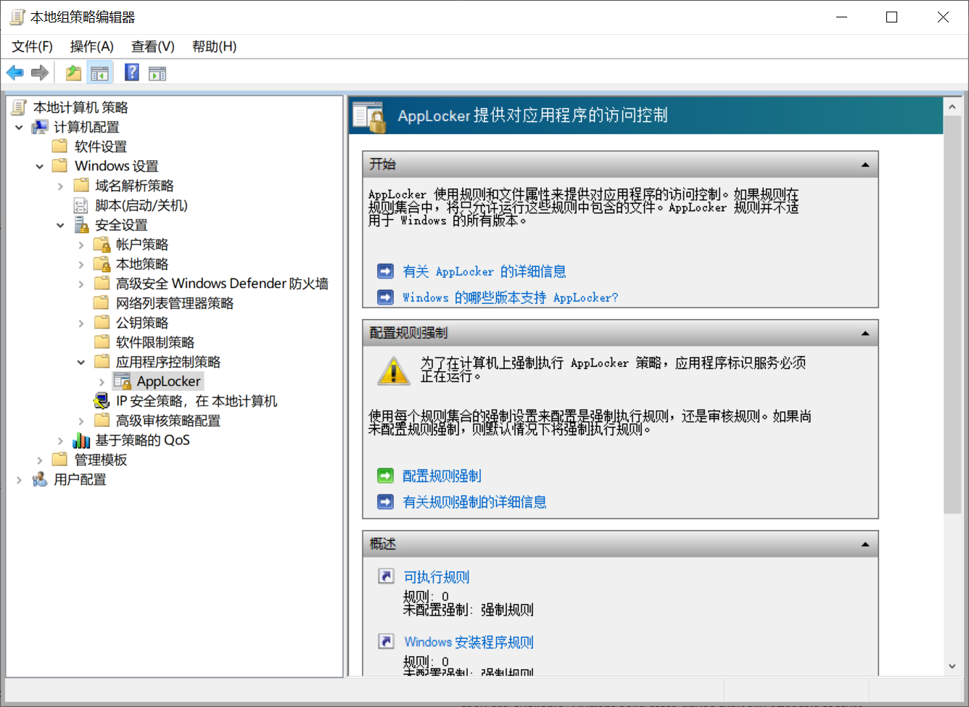

### 481、Disable the policy _Configure Solicited Remote Assistance_.

`Computer Configuration\Policies\Windows Settings\Security Settings\Local Policies\Security Options\Network access: Do not allow storage of passwords and credentials for network authentication`.

[Network access: Do not allow storage of credentials or .NET Passports for network authentication | Microsoft Docs](https://docs.microsoft.com/en-us/previous-versions/windows/it-pro/windows-server-2003/cc779377(v=ws.10)?redirectedfrom=MSDN)

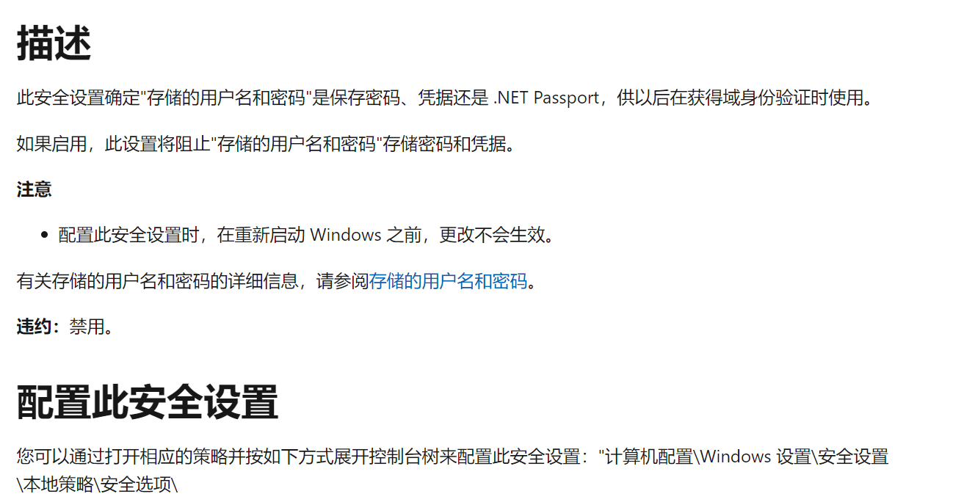

[凭据保险箱概述|微软文档 (microsoft.com)](https://docs.microsoft.com/en-us/previous-versions/windows/it-pro/windows-8.1-and-8/jj554668(v=ws.11))

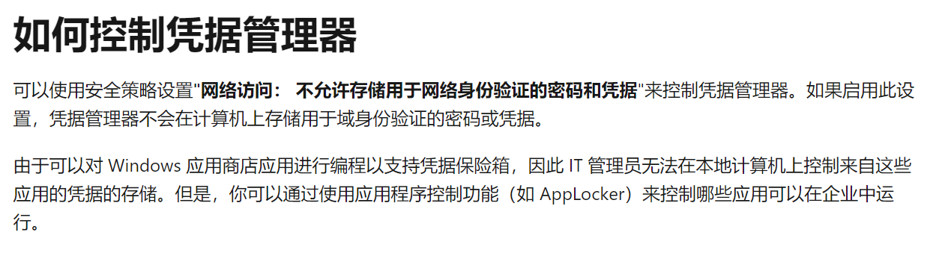

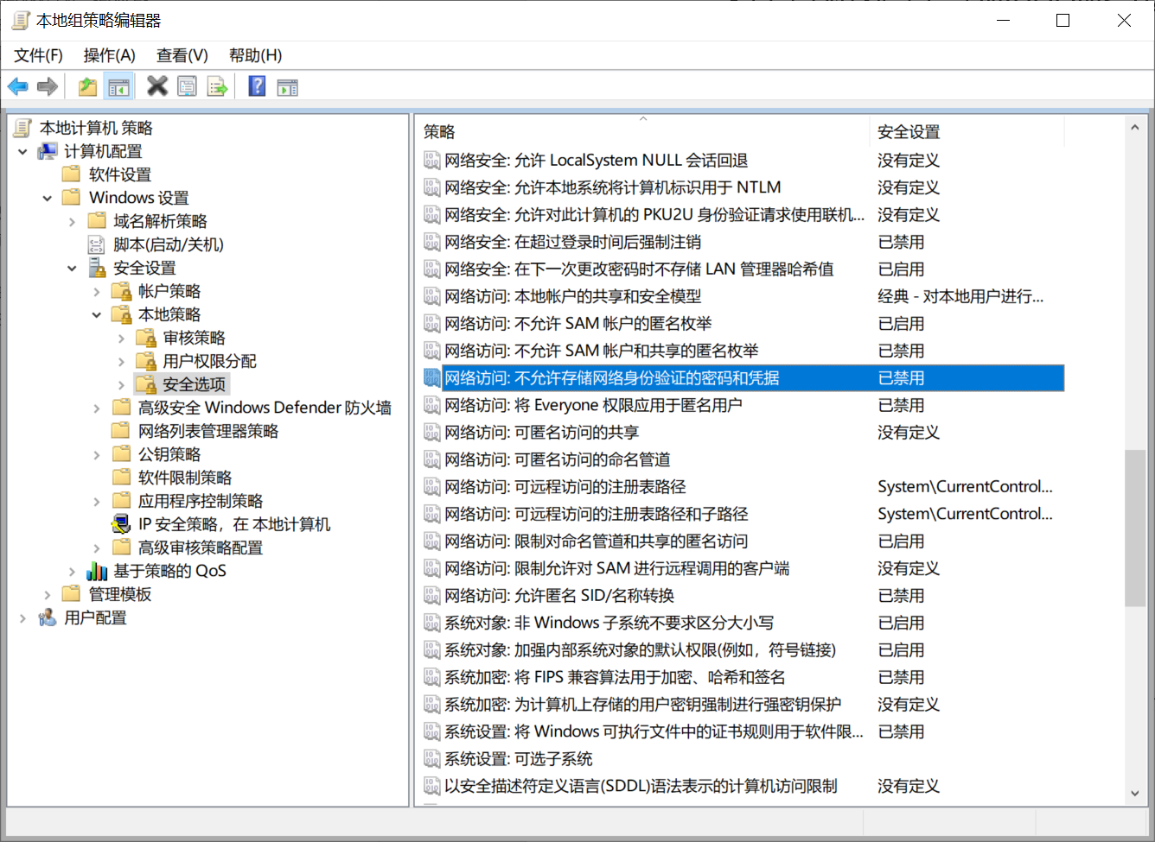

计算机\HKEY_LOCAL_MACHINE\SYSTEM\CurrentControlSet\Services\LanmanServer\Parameters

在注册表中，LanmanServer 是文件服务所使用的名称。

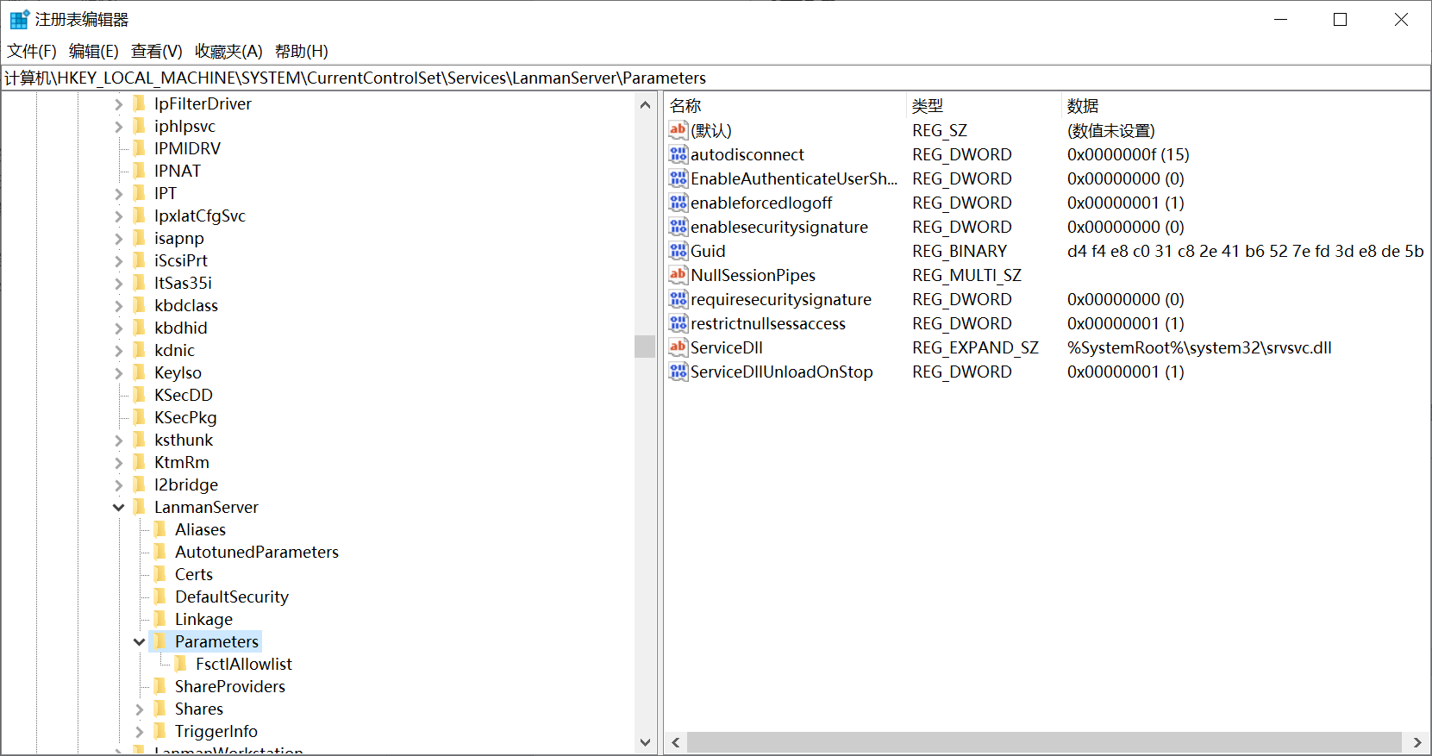

### 467、Force the Use of the Smart Card

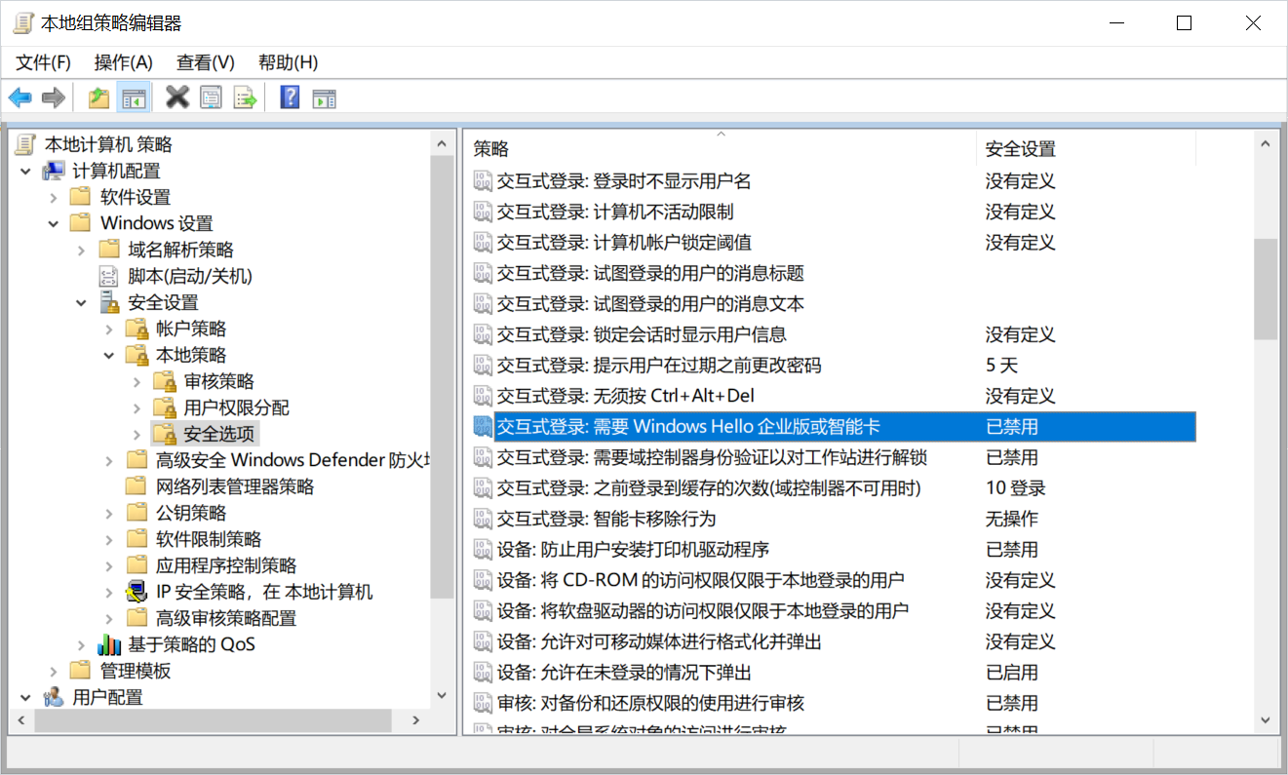

### 466、Restrict Access to the Computer

In the right pane, **remove all accounts and groups** from the policies below

and add only the accounts that need access to the system (e.g., the owner

of the system):

* _Access this computer from the network_,

* _Allow log on locally_.

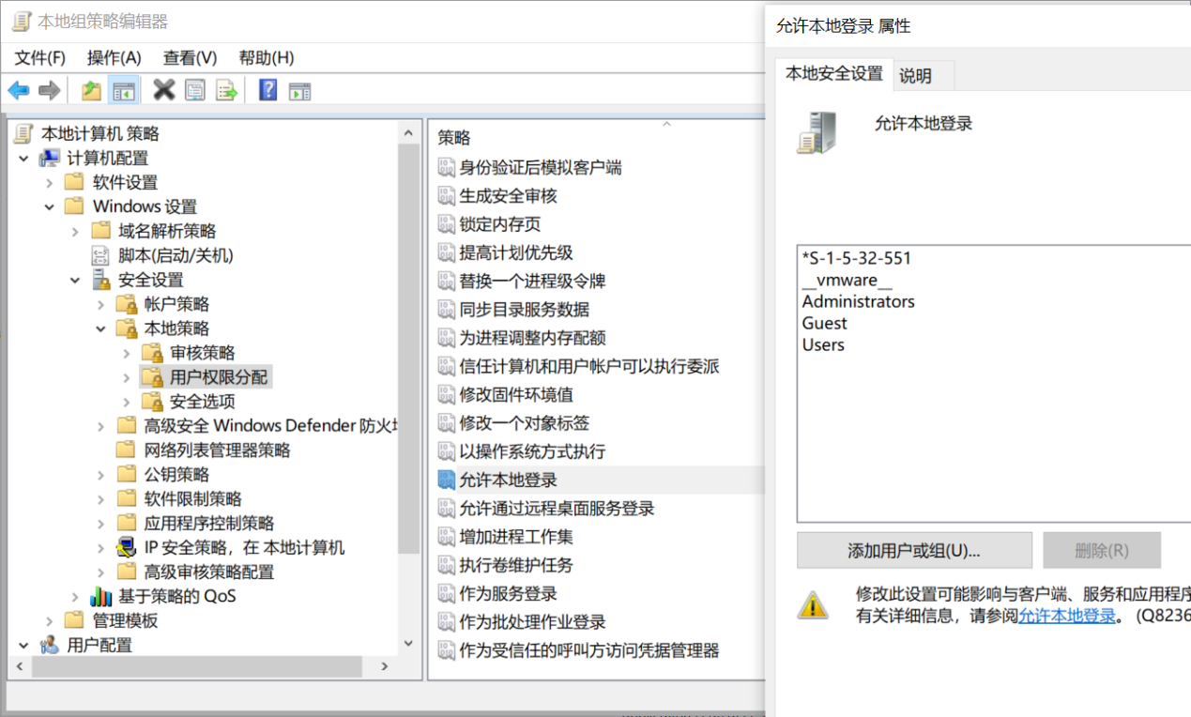

## 有问题

### 两处模糊搜索

#### 493-491（两处模糊搜索）

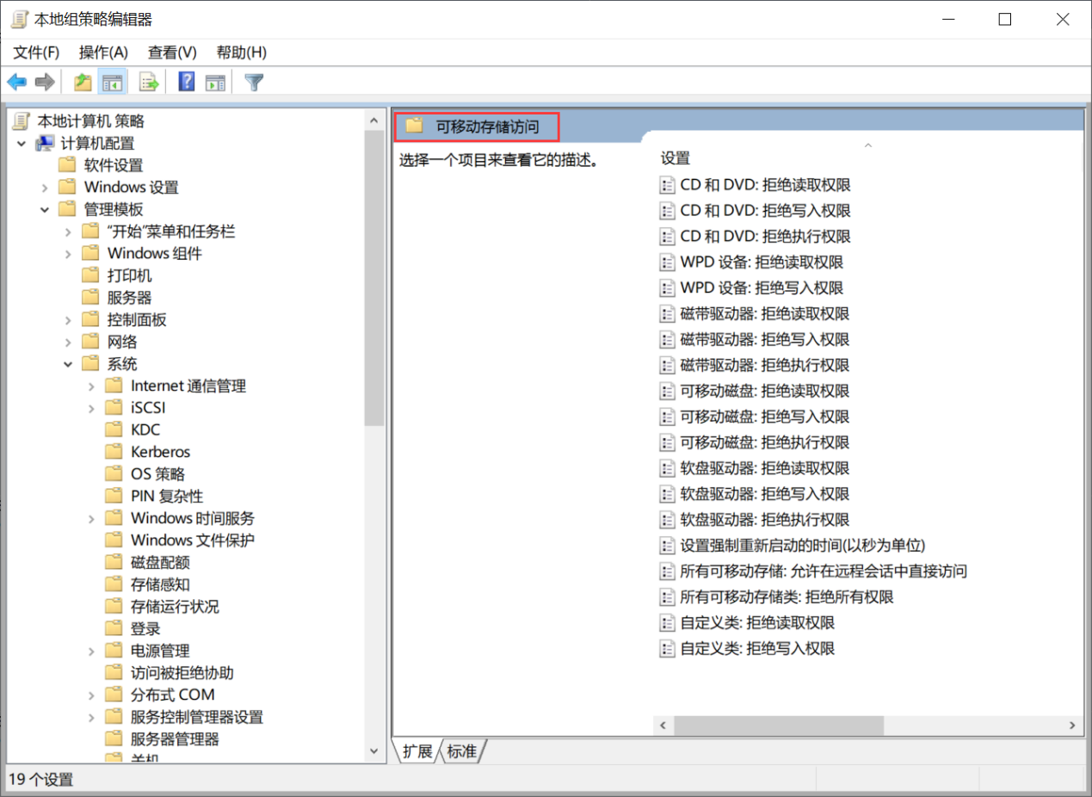

**493、Enable the policy _Removable Disks: Deny execute access_ to deny execute**

**permissions to removable devices.**

**检查语句**

select data from registry

where key like

"HKEY_CURRENT_USER\SOFTWARE\Microsoft\Windows\CurrentVersion\Group Policy Objects\{4EC3404D-2D90-476F-BD6A-EF64639A1E4A}Machine\Software\Policies\Microsoft\Windows\RemovableStorageDevices\{53f5630d-b6bf-11d0-94f2-00a0c91efb8b}" and name = "Deny_Execute";

'

**检查结果**

data = 1，则该检查项通过。

**492、Enable the policy _Removable Disks: Deny write access_ to deny write**

**permissions to removable devices.**

**491、Enable the policy _Removable Disks: Deny read access_ to deny read**

**permissions to removable devices.**

### 找不到

#### 521、Disable the service 'Xbox Game Monitoring (xbgm)'.

原因：自己的笔记本没有这项服务，所以osquery内置表services中没找到这项服务

解决：找一台有这个服务的电脑或者安装这个服务，应该也是同样的检测方法

select status from services

where name = "xbgm";

显示status = STOPPED，则该检查项通过。

#### 516、Disable the service 'Infrared monitor service (irmon)'.

原因：自己的笔记本没有红外服务，所以osquery内置表services中没找到这项服务

解决：找一台有这个服务的电脑或者安装这个服务，应该也是同样的检测方法

select status from services

where name = "irmon";

显示status = STOPPED，则该检查项通过。

#### 510、Disable App-V

[启用 App-V in-V in-box client (Windows 10/11) - Windows Application Management | Microsoft Docs](https://docs.microsoft.com/zh-cn/windows/application-management/app-v/appv-enable-the-app-v-desktop-client)

Application Virtualization（应用程序虚拟化）将 Win32 应用程序作为虚拟应用程序交付给用户

原因：自己的笔记本中没有找到该组策略

#### 465、Ensure 'Enable\Disable Sample collection' is set to 'Enabled'

Computer Configuration\Policies\Administrative Templates\Windows Components\Windows Components\Windows Defender ATP\'Enable\Disable Sample collection

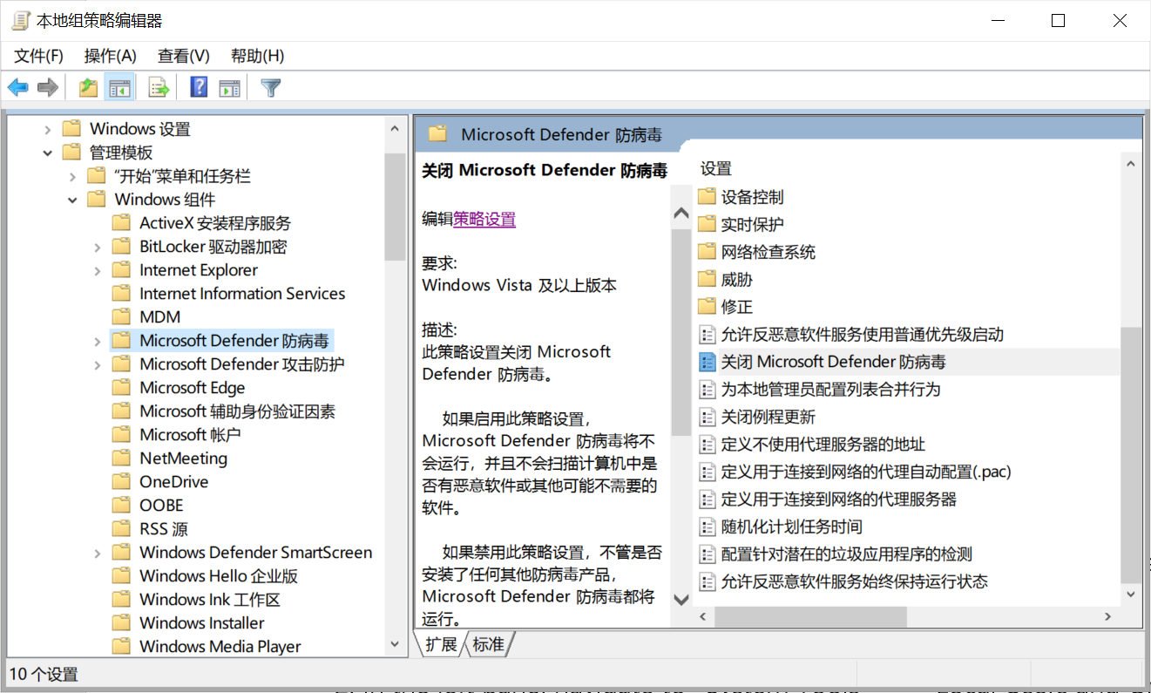

原因：自己的笔记本中没有找到该组策略

#### 446、Ensure 'Configure App Install Control' is set to 'Enabled: Allow apps from Store only'

Computer Configuration\Policies\Administrative Templates\Windows Components\Windows Defender SmartScreen\Explorer\Configure App Install Control

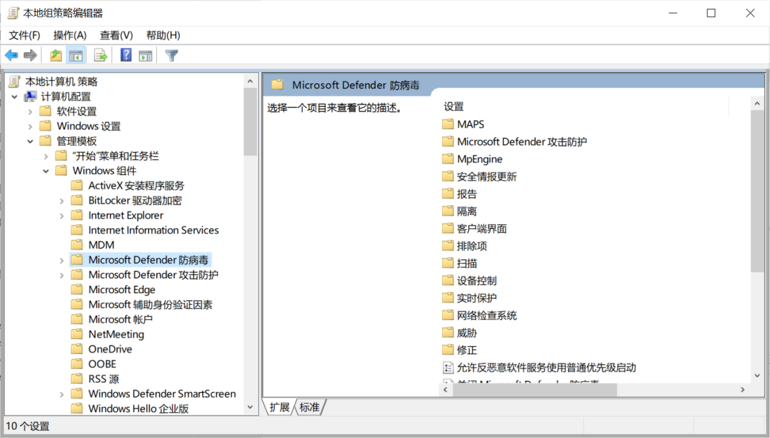

原因：自己的笔记本中没有找到该组策略

### Windows版本问题

#### 439、Lock Exploit Protection Settings (Windows 10, version 1809 and higher)

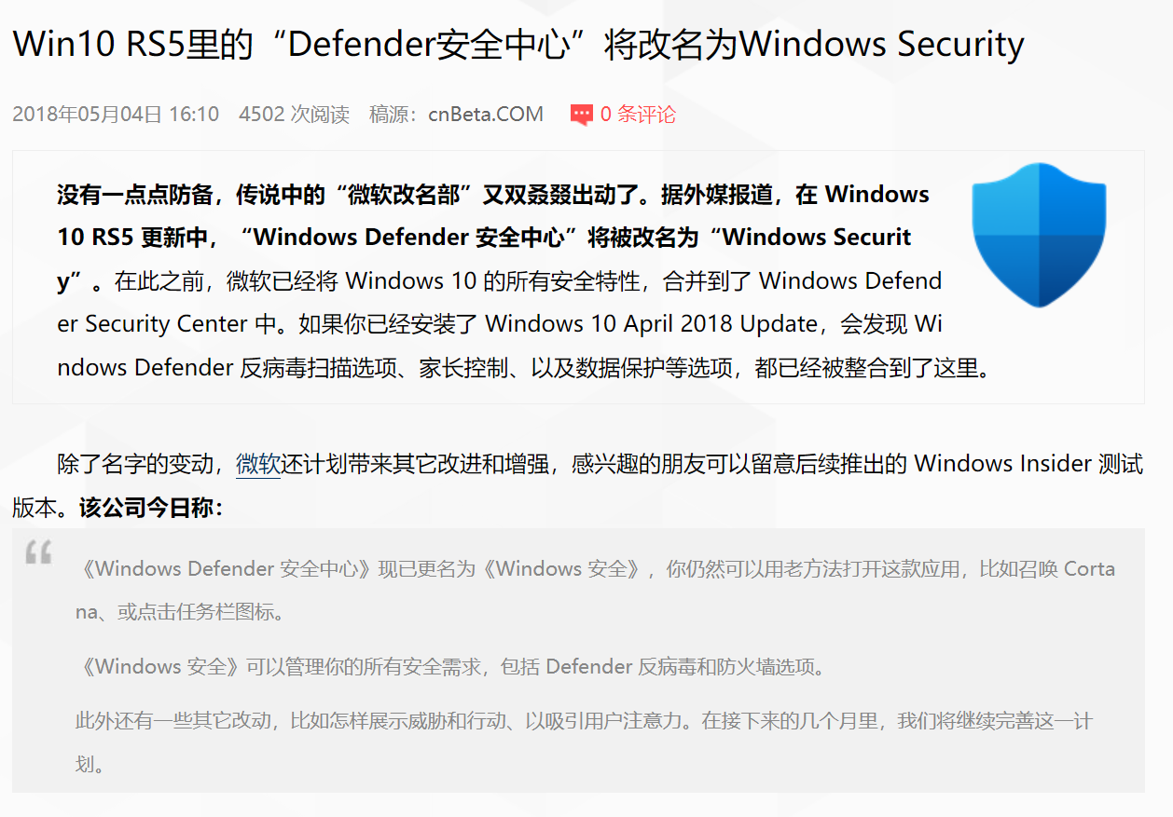

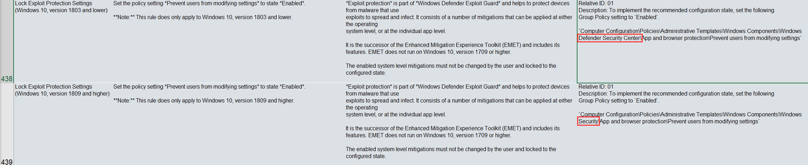

### Pwsh

#### 490、Use Encrypting File System

#### 484、Disable the Server Service

#### 471、Restrict Local Admin Rights

Relative ID: 01

Description: Remove all regular users from the local built-in Administrators group or any

other group with local administrative rights.

1. Open the _Computer Management_ snap-in (compmgmt.msc),

2. In the left pane, navigate to _System Tools_ > _Local Users and Groups_ >

_Groups_,

3. In the right pane, double-click the _Administrators_ group, and remove all

user accounts that are not needed.

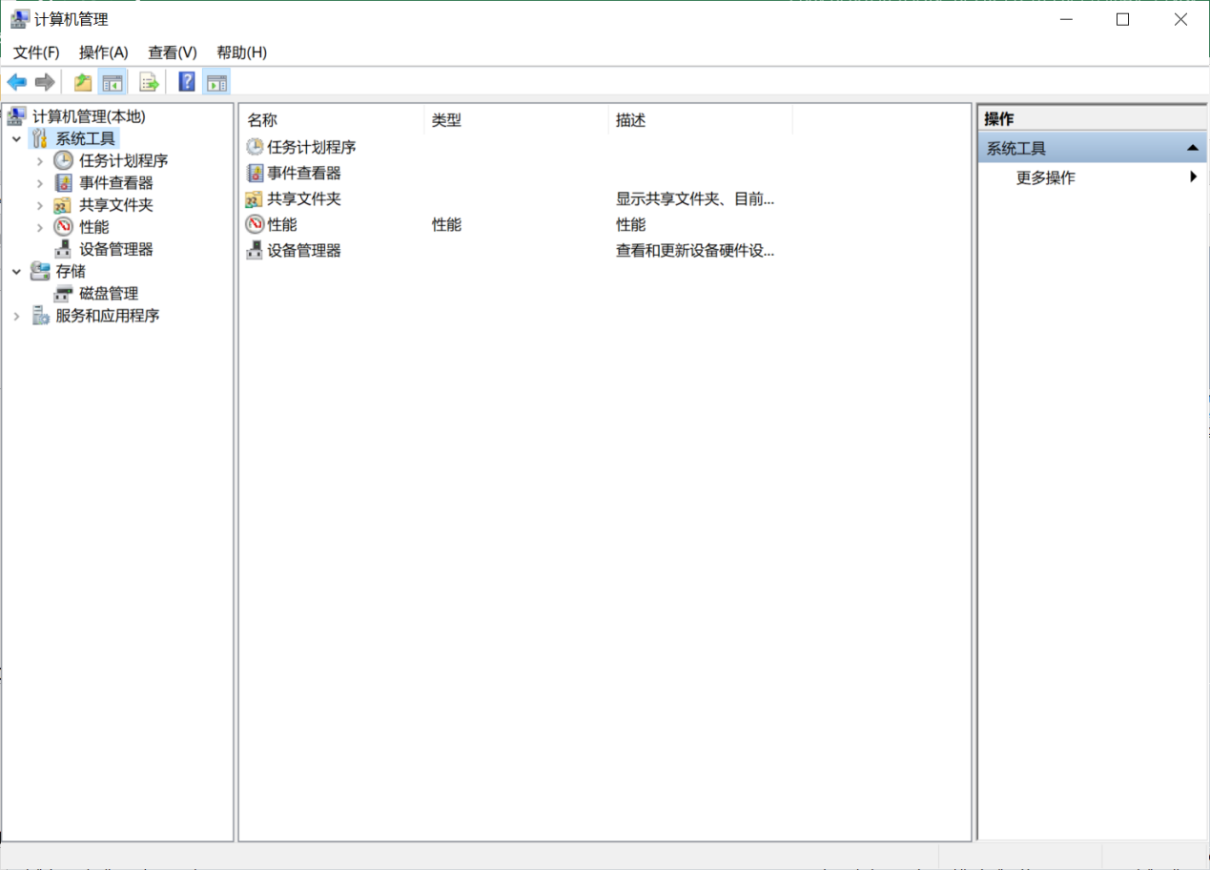

#### 470、Prevent OneDrive from Running at Startup

#### 440、Configure Exploit Protection Adjustments on Application Level

#### 437、Configure Exploit Protection on System Level (Windows 10, version 1803 and higher)

#### 303、Turn on filename extensions

### 检查项不明确

#### 497、Disable _Configuration of wireless settings using Windows Connect Now_.

是否4个都关闭



#### 485、Restrict Installation of Software（没有规定限制什么软件）

Relative ID: 01

Description: You can use _AppLocker_ to restrict the software a user is allowed to install:

1. Open the Group Policy editor (gpedit.msc),

2. In the left pane, navigate to _Computer Configuration_ > _Windows

Settings_ > _Security Settings_ > _Application Control Policies_ >

_AppLocker_,

3. In the left pane, right-click the type of file you want to restrict (i.e.,

_Executable Rules_, _Windows Installer Rules_, _Script Rules_, or

_Packaged app Rules_) and click _Create New Rule..._,

4. Follow the configuration wizard and on the _Conditions_ page, select how

you want to identify the allowed or restricted software (i.e., by

_Publisher_, by _Path_, or by _File Hash_),

5. Keep following the wizard and on the last page click _Create_ to create the

rule.



### 字段不匹配

#### 499、Do Not Allow This PC to Be Projected to

#### 371、Configure 'Prevent participation in the Customer Experience Improvement Program'

### SPJ

#### 423、Enable a Virus Scanner

# 暂存（cmd.go）

package main

import (

    "fmt"

    "os/exec"

)

func main() {

    cmd := exec.Command("cmd", "/C", "osqueryi", "D:\\a.txt")

    fmt.Println(cmd.Run())

    if err := cmd.Run(); err != nil {

        fmt.Println("Error: ", err)

    }

}

# 模板

package main

import (

    "fmt"

    "log"

    registry "golang.org/x/sys/windows/registry"

)

func main() {

    k, err := registry.OpenKey(registry.CURRENT_USER, `SOFTWARE\Microsoft\Windows\CurrentVersion\Group Policy Objects\{583E0C8D-AFAF-4FC4-80AD-6D041706E423}Machine\Software\Policies\Microsoft\Windows\WindowsUpdate\AU`, registry.QUERY_VALUE)

    if err != nil {

        fmt.Printf("Configure Windows Update Failed：未启动")

        log.Fatal(err)

        return

    }

    defer k.Close()

    // 两个选项，3、自动下载并通知安装 和 4、自动下载并计划安装；

    s, _, err := k.GetIntegerValue("AUOptions")

    if err != nil {

        log.Fatal(err)

    }

    if s != 3 && s != 4 {

        fmt.Printf("Configure Windows Update Failed：配置自动更新 错误")

        return

    }

    // 自动维护期间安装，没开启时没有这个注册项

    s, _, err = k.GetIntegerValue("AutomaticMaintenanceEnabled")

    if err != nil {

        fmt.Printf("Configure Windows Update Failed：未开启 自动维护期间安装")

        log.Fatal(err)

        return

    }

    // 安装其他Microsoft产品的更新，没开启时没有这个注册项

    s, _, err = k.GetIntegerValue("AllowMUUpdateService")

    if err != nil {

        fmt.Printf("Configure Windows Update Failed：未开启 安装其他Microsoft产品的更新")

        log.Fatal(err)

        return

    }

    fmt.Printf("Configure Windows Update Success")

}